**Using VisController in TcVis 9.1.5**

## Prerequisite

64 bit Teamcenter Visualization (TcVis) Mockup version 9.1.5.

## Setup

1. Copy the configuration files (ImmersiveConfig.xml, Default.scd, Monitor.vcd) to C:\temp.

Please note that if you put these file into a different directory, you need to modify the file in ImmersiveConfig.xml. Change the lines below

<VCD_File name="C:/temp/Monitor.vcd"/>

<SCD_File name="C:/temp/Default.scd"/>

to reflect the correct directory.

1. Clicking “File->Preferences->Immersive Display”. Select the “Configuration” tab. Load the file from “C:\temp \ImmersiveConfigConfig.xml”, and then Click “Reload”.

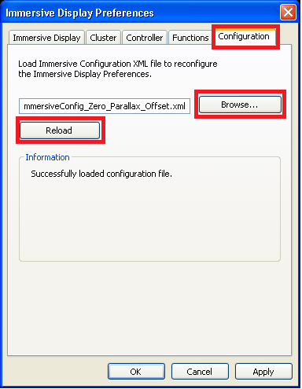

1. Close TcVis (so the configuration can take effect when you launch TcVis next time).

## Run TcVis

1. Launch your VisController server program first.
2. Launch TcVis.
3. Load a JT file.
4. Click “Concept->Immersive Display->World View” to bring up the world view.
5. Click “Window->Tile Horizontally” so you can see both the original window and the world view window.

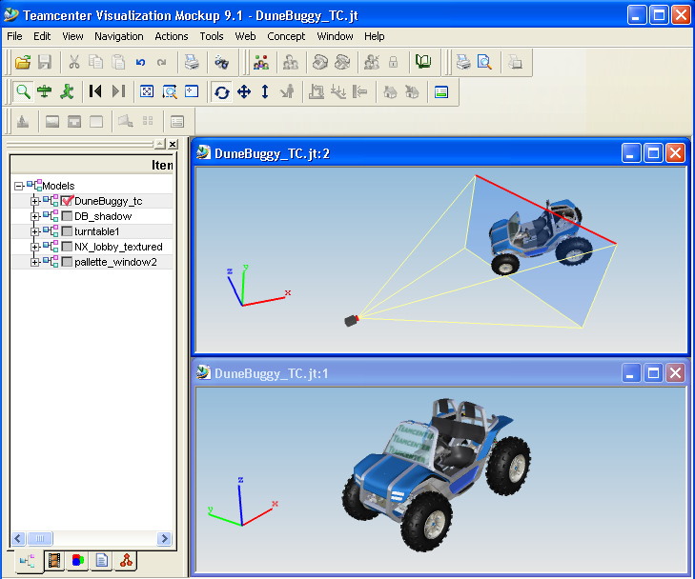

1. Click on the original window and move the camera until you see the model “fits” into the projection screen (partially in front of the projection screen and partially behind the projection screen) in the world view as in the figure above. You may move the camera on the world view as well to give you a better view angle.
2. If the model is either too big or too small to fit into the projection screen, you can use “Actions->Part Transformation” to scale the whole model.
3. After you set up the proper camera angle, activate the immersive display by clicking “Concept->Immersive Display->Activate”. You will be see a 1280x1024 window board-less window, and you should be able to use your VisContoller server program to control the 3D immersive cursor.