**ASSIGNMENT 1 FRONT SHEET**

|  |  |  |  |
| --- | --- | --- | --- |
| **Qualification** | **BTEC Level 5 HND Diploma in Computing** | | |
| **Unit number and title** | Unit 14: Business Intelligence | | |
| **Submission date** |  | **Date Received 1st submission** |  |
| **Re-submission Date** |  | **Date Received 2nd submission** |  |
| **Student Name** |  | **Student ID** |  |
| **Class** |  | **Assessor name** |  |
| **Student declaration**  I certify that the assignment submission is entirely my own work and I fully understand the consequences of plagiarism. I understand that making a false declaration is a form of malpractice. | | | |
|  |  | **Student’s signature** |  |

**Grading grid**

|  |  |  |  |  |  |
| --- | --- | --- | --- | --- | --- |
| P1 | P2 | M1 | M2 | D1 | D2 |
|  |  |  |  |  |  |

|  |  |  |
| --- | --- | --- |
| **❒ Summative Feedback: ❒ Resubmission Feedback:** | | |
| **Grade:** | **Assessor Signature:** | **Date:** |
| **IV Signature:** | | |

**LO1 DISCUSS BUSINESS PROCESSES AND THE MECHANISMS USED TO SUPPORT BUSINESS DECISION-MAKING**

**P1 EXAMINE, USING EXAMPLES, THE TERMS ‘BUSINESS PROCESS’ AND ‘SUPPORTING PROCESSES’**

**WHAT IS BUSINESS INTELLIGENCE?**

* Business intelligence (BI) combines business analytics, data mining, data visualization, data tools and infrastructure, and best practices to help organizations to make more data-driven decisions.
* You can know you’ve got modern business intelligence when you have a comprehensive view of your organization’s data and use that data to drive change, eliminate inefficiencies, and quickly adapt to market or supply changes.
* Business intelligence (BI) developed in the 1980s alongside computer models for decision-making and turning data into insights before becoming specific offering from BI teams with IT-reliant service solutions.
* Modern BI solutions prioritize flexible self-service analysis, governed data on trusted platforms, empowered business users, and speed to insight.
* Much more than a specific “thing,” business intelligence is rather an umbrella term that covers the processes and methods of collecting, storing, and analyzing data from business operations or activities to optimize performance. All of these things come together to create a comprehensive view of a business to help people make better, actionable decisions.
* Over the past few years, business intelligence has evolved to include more processes and activities to help improve performance. These processes include:
  + **Data mining:** Using databases, statistics and machine learning to uncover trends in large datasets.
  + **Reporting**: Sharing data analysis to stakeholders so they can draw conclusions and make decisions.
  + **Performance metrics and benchmarking**: Comparing current performance data to historical data to track performance against goals, typically using customized dashboards.
  + **Descriptive analytics:** Using preliminary data analysis to find out what happened.
  + **Querying:** Asking the data specific questions, BI pulling the answers from the datasets.
  + **Statistical analysis**: Taking the results from descriptive analytics and further exploring the data using statistics such as how this trend happened and why.
  + **Data visualization**: Turning data analysis into visual representations such as charts, graphs, and histograms to more easily consume data.
  + **Visual analysis**: Exploring data through visual storytelling to communicate insights on the fly and stay in the flow of analysis.
  + **Data preparation:** Compiling multiple data sources, identifying the dimensions and measurements, preparing it for data analysis.

## WHY IS BUSINESS INTELLIGENCE IMPORTANT?

* Business intelligence can help companies make better decisions by showing present and historical data within their business context. Analysts can leverage BI to provide performance and competitor benchmarks to make the organization run smoother and more efficiently. Analysts can also more easily spot market trends to increase sales or revenue. Used effectively, the right data can help with anything from compliance to hiring efforts.
* A few ways that business intelligence can help companies make smarter, data-driven decisions:
* Identify ways to increase profit
* Analyze customer behavior
* Compare data with competitors
* Track performance
* Optimize operations
* Predict success
* Spot market trends
* Discover issues or problems.

**HOW BUSINESS INTELLIGENCE WORK?**

Businesses and organizations have questions and goals. To answer these questions and track performance against these goals, they gather the necessary data, analyze it, and determine which actions to take to reach their goals.

On the technical side, raw data is collected from the business’s activity. Data is processed and then stored in data warehouses. Once it’s stored, users can then access the data, starting the analysis process to answer business questions.

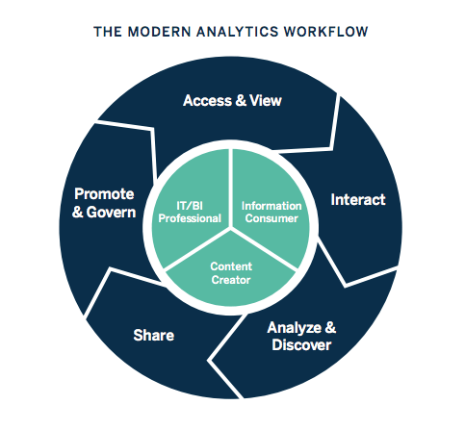

Business intelligence software provides business leaders with the information they need to make more informed business decisions.

Business intelligence is used as a foundation for strategic decision-making eliminating as much of the guesswork and gut-feeling from the decision-making process as possible.

The data sources used to build business intelligence include customer relationship management (CRM) systems like Salesforce.com, supply chain information, sales performance dashboards, marketing analytics, contact center call data and metadata i.e. information describing data.

Business intelligence applications help companies to bring all these disparate sources into a single unified view providing real time reporting, dashboards, and analysis.

**BUSINESS INTELLIGENCE BEST PRACTICES:**

As you weigh up the various business intelligence solutions, there are a number of best practices you should keep in mind.

* **Ease of Use:** Ensure the solution you provide your team with is intuitive and easy to use. If the solution is difficult to use, adoption rates are going to suffer and your business intelligence initiative will not have the desired outcome.
* **Implementation**: You should weigh up how long any tool takes to implement. Consider factors like user training as you assess time to value.
* **Integration:** Consider where your new solution fits in with your existing technology stack. How does it integrate with the tools your team already uses to do their jobs? Is integration an out of the box capability or is it something you are going to have to customize? Being clear on these questions will help you choose the business intelligence solution most suited to your company’s needs.

**EXAMPLE OF BUSINESS INTELLIGENCE?**

**WHAT IS BUSINESS PROCESS?**

Business Process refers to a set of activities or tasks, often connected and automated, triggered by an event to carry out a predetermined specific organizational goal such as a service or a product. Each activity, included in a process, is assigned to a specific member of a team or to an entire group of the business. It is the fundamental building block for several related ideas such as business process management, process automation, etc.

Every business should define its processes, analyze and measure the results to ensure that the process is meeting expectations and is getting better. Usually, these activities can be visualized as a workflow of connected stages that can be performed in parallel or sequentially depending on specific rules or decisions. That means that every person in the company should follow the exact same steps. If someone misses one step, it will probably lead to a disoriented employee and the productivity will be reduced.

**WHY ARE BUSINESS PROCESSES IMPORTANT?**

Business Processes are important because they depict how things and tasks are done inside the company. After that, you can improve them by optimizing them and automating them implementing a BPM software in your business. There are several benefits of using Business Process Management Software in your business such as better collaboration, automation of repetitive tasks which reduce the working time or monitor the performance of every Business Process.

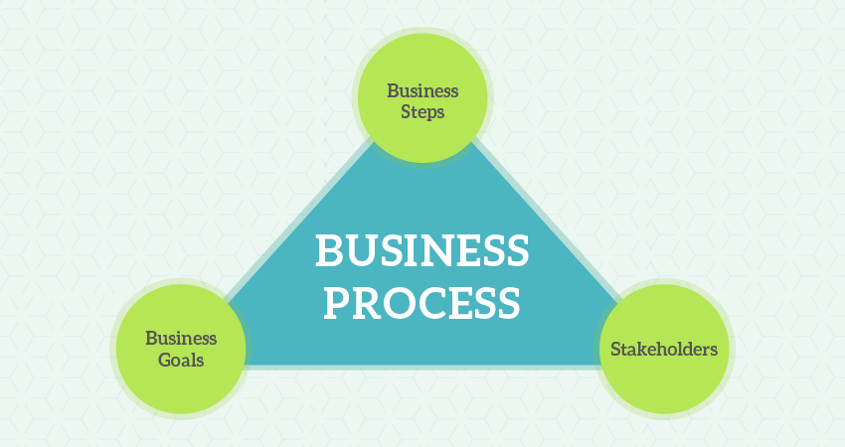

The need for and advantages of a business process are quite apparent in large organizations. A process forms the lifeline for any business and helps it streamline individual activities, making sure that resources are put to optimal use.

**THE 7 STEPS OF THE BUSINESS PROCESS LIFECYCLE**

**Step 1: Define your goals**

* What is the purpose of the process? Why was it created? How will you know if it is successful?

**Step 2: Plan and map your process**

* What are the strategies needed to achieve the goals? This is the broad roadmap for the process.

**Step 3: Set actions and assign stakeholders**

* Identify the individual tasks your teams and machines need to do in order to execute the plan.

## Step 4: Test the process

## Run the process on a small scale to see how it performs. Observe any gaps and make adjustments.

## Step 5: Implement the process

## Start running the process in a live environment. Properly communicate and train all stakeholders.

## Step 6: Monitor the results

## Review the process and analyze its patterns. Document the process history.

## Step 7: Repeat

## If the process is able to achieve the goals set for it, replicate it for future processes.

**BENEFITS OF USING BUSINESS PROCESS SOFTWARE**

BPM solutions are uniquely designed to boost efficiency of processes across verticals and organizations. Implementing them brings a host of business benefits such as:

**Reduction of risks**

* BPM software helps prevent and fix errors and bottlenecks thereby minimizing risks.

**Elimination of redundancies**

* Monitoring processes allows for identification and elimination of duplicated tasks. Implementing BPM software also enhances resource allocation to ensure human effort is invested only in relevant tasks.

**Minimized costs**

* Improved visibility into processes helps zero in on wasteful expenditure. This way costs are kept to a minimum and savings are boosted.

**Improved collaboration**

* Transparency fostered by BPM software boosts collaboration between internal teams as well as external vendors and buyers. Everyone is aware of responsibilities as well as timelines and bottlenecks.

**Agility**

* Optimized processes enable greater agility in organizational operations. Minimized errors, bottlenecks, and duplication facilitate quicker turnaround times.

**Improved productivity**

* When processes are shipshape, approvals are faster and information retrieval is easier. Tasks are routed sequentially without human intervention. These benefits significantly boost productivity of teams.

**Higher efficiency**

* Comprehensive dashboards in BPM software provide bird’s-eye view of process performance. It helps managers ensure that turnaround times are short and accuracy levels are high.

**Higher compliance**

* With BPM software, it’s easier and more methodical to create audit trails and comply with industry regulations and standards.

**EXAMPLE OF BUSINESS PROCESS:**

**WHAT IS SUPPORT PROCESSES?**

* The Supporting Processes is performed to maintain integrity of the product or service developed by “primary processes” as well as it ensures that products and processes comply with predefined provisions and plans. Supporting processes accompany the “primary processes”, which do not typically result in final products of the organization, but rather indirectly contributes to the value added.
* In most companies, IT and HR processes are classified as support processes because they exist to provide support services for the core business processes. Documentation, configuration management, verification, training and audit process are all supporting processes.

**BENEFIT OF SUPPORT PROCESSES?**

The activities are in support processes, aimed at achieving objectives that support other processes that perform a specialized function. These objectives can point to:

* Define necessary to record all the information produced by the process life cycle activities.
* Incorporate activities to identify, control, and statistical evaluation of configurations as well as of version management.
* Define activities to objectively ensure that software products meet the specified requirements and adhere to established plans.
* Specify activities (for the acquirer, the supplier or independent organization) to check software products and services.
* Determine activities (customer, supplier or organization independent) to validate the software products of the software project.
* Perform peer review of both technical and administrative aspects, where they will inspect the condition of the goods produced and the activities undertaken.
* Specify the activities to determine compliance with the requirements, plans and contracts. This process can be used by any of the two parties, where one party (audit) audits the products or activities of the other party (audited).
* Specify a process to analyze and eliminate (solve) the problems (including disagreements), regardless of their nature or origin, which are discovered during the execution of the development, operation, maintenance and other processes.

**EXAMPLE OF SUPPORT PROCESSES**

P2 **COMPARE THE TYPES OF SUPPORT AVAILABLE FOR BUSINESS DECISION-MAKING AT VARYING LEVELS WITHIN AN ORGANISATION**

**WHAT IS DECISION MAKING?**

* Decision making is the process of making choices by identifying a decision, gathering information, and assessing alternative resolutions. Increasing effectiveness in decision making is an important part of maximizing your effectiveness at work.
* Using a step-by-step decision-making process can help you make more deliberate, thoughtful decisions by organizing relevant information and defining alternatives. This approach increases the chances that you will choose the most satisfying alternative possible.
* Individuals throughout organizations use the information they gather to make a wide range of decisions. These decisions may affect the lives of others and change the course of an organization.
* Here are some basic questions you can ask yourself to assess the ethics of a decision.
* Is this decision fair?
* Will I feel better or worse about myself after I make this decision?
* Does this decision break any organizational rules?
* Does this decision break any laws?
* How would I feel if this decision was broadcast on the news?

**THE STEP TO EFFECTIVE DECISION MAKING**

**Step 1: Identify the decision**

* You realize that you need to make a decision. Try to clearly define the nature of the decision you must make. This first step is very important.

**Step 2: Gather relevant information**

* Collect some pertinent information before you make your decision: what information is needed, the best sources of information, and how to get it. This step involves both internal and external “work.”
* Some information is internal: you’ll seek it through a process of self-assessment.
* Other information is external: you’ll find it online, in books, from other people, and from other sources.

**Step 3: Identify the alternatives**

* As you collect information, you will probably identify several possible paths of action, or alternatives.
* You can also use your imagination and additional information to construct new alternatives.
* In this step, you will list all possible and desirable alternatives.

**Step 4: Weigh the evidence**

* Draw on your information and emotions to imagine what it would be like if you carried out each of the alternatives to the end.
* Evaluate whether the need identified in Step 1 would be met or resolved through the use of each alternative.
* As you go through this difficult internal process, you’ll begin to favor certain alternatives: those that seem to have a higher potential for reaching your goal.
* Finally, place the alternatives in a priority order, based upon your own value system.

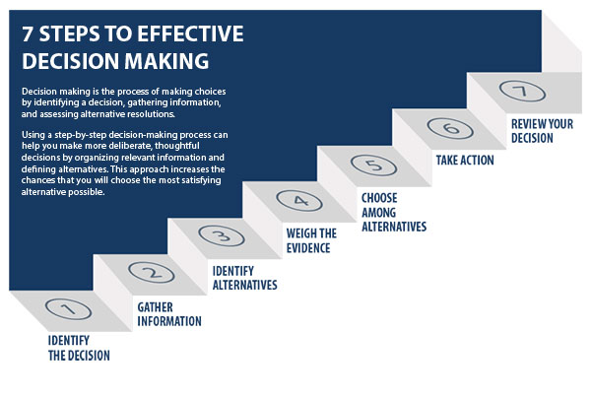

**Step 5: Choose among alternatives**

* Once you have weighed all the evidence, you are ready to select the alternative that seems to be best one for you. You may even choose a combination of alternatives.
* Your choice in Step 5 may very likely be the same or similar to the alternative you placed at the top of your list at the end of Step 4.

**Step 6: Take action**

* You’re now ready to take some positive action by beginning to implement the alternative you chose in Step 5.

**Step 7: Review your decision & its consequences**

* In this final step, consider the results of your decision and evaluate whether or not it has resolved the need you identified in Step 1.
* If the decision has not met the identified need, you may want to repeat certain steps of the process to make a new decision.

**THE TYPES OF SUPPORT AVAILABLE FOR BUSINESS DECISION-MAKING AT VARYING LEVELS WITHIN AN ORGANISATION:**

Information systems are developed for different purposes, depending on the needs of human users and the business. A typical organization has six information systems with each supporting a specific organizational level. These systems include transaction processing systems (TPS) at the operational level, office automation systems (OAS) and knowledge work systems (KWS) at the knowledge level, management information systems (MIS) and decision support Systems (DSS) at the management level and the executive support systems (ESS)at the strategic level.

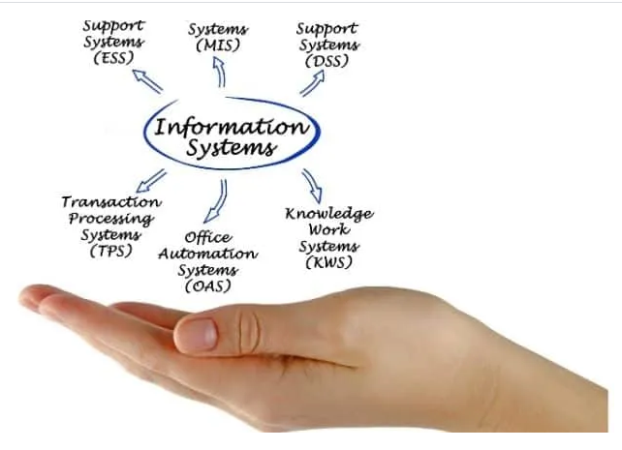

The variety of information systems that analysts may develop is shown in the figure below. Notice that the figure presents these systems from the bottom up, indicating that the operational, or lowest, level of the organization is supported by TPS, and the strategic, or highest, level of semistructured and unstructured decisions is supported by ESS, GDSS, and CSCWS at the top.

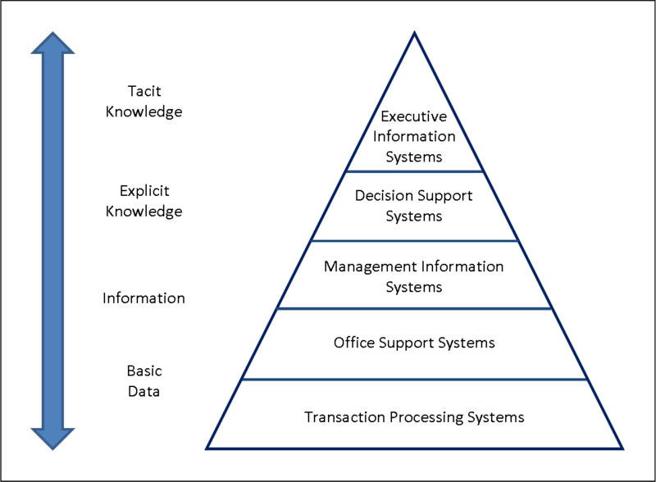

**TRANSACTION PROCESSING SYSTEMS (TPS)**

Every company needs to process transactions in order to perform its daily business operations. A transaction refers to any event or activity that affects the organization. Depending on the organization’s business, transactions may differ from one organization to another. In a manufacturing unit, for example, transactions include order entry, receipt of goods, shipping, etc., while in a bank, transactions include deposits and withdrawals, cashing of cheques, etc.

However, some transactions, including placing orders, billing customers, hiring employees, employee record keeping, etc., are common to all organizations. To support the processing of business transactions, transaction processing systems (TPS) are used in organizations.

Transaction processing systems (TPS) are computerized information systems that were developed to process large amounts of data for routine business transactions such as payroll and inventory. A TPS eliminates the tedium of necessary operational transactions and reduces the time once required to perform them manually, although people must still input data to computerized systems.

Transaction processing systems are boundary-spanning systems that permit the organization to interact with external environments. Because managers look to the data generated by the TPS for up-to-the-minute information about what is happening in their companies, it is essential to the day-to-day operations of business that these systems function smoothly and without interruption.

**OFFICE AUTOMATION SYSTEMS (OAS)**

* An office automation system (OAS) is a collection of communication technology, computers, and persons to perform official tasks. Office automation systems (OAS) support data workers, who do not usually create new knowledge but rather analyze information to transform data or manipulate it in some way before sharing it with, or formally disseminating it throughout, the organization and, sometimes, beyond.
* It executes office transactions and supports official activities at every organizational level. These activities can be divided into clerical and managerial activities.
* Clerical activities performed with the help of an office automation system include preparing written communication, typesetting, printing, mailing, scheduling meetings, calendar keeping. etc.
* Under managerial activities, an office automation system helps in conferencing, creating reports and messages, and controlling the performance of the organization. Many applications like word processing, electronic filing, and e-mail are integrated into the office automation systems.

**KNOWLEDGE WORK SYSTEMS (KWS)**

* A knowledge work system (KWS) is a specialized system built to promote the creation of knowledge and to make sure that knowledge and technical skills are proper integrated into the business.
* Knowledge work systems (KWS) support professional workers such as scientists, engineers, and doctors by aiding them in their efforts to create new knowledge (often in teams), creating and propagating new information and knowledge by providing them the graphics, analytical, communications, document management tools, and allowing them to contribute it to their organization or to society at large.
* The knowledge workers also need to search for knowledge outside the organization. Thus, the knowledge work system must give easy access to external databases. In addition, knowledge work systems should have a user-friendly interface to help users to get the required information quickly and easily.

**MANAGEMENT INFORMATION SYSTEMS (MIS )**

* Management information systems are specially developed to support the planning, controlling, and decision-making functions of middle managers.
* Management information systems (MIS) do not replace transaction processing systems, A management information system (MIS) extracts transaction data from underlying TPSs, compiles them, and produces information products in the form of reports, displays, or responses.
* By requiring people, software, and hardware to function in concert, management information systems support users in accomplishing a broader spectrum of organizational tasks than transaction processing systems, including decision analysis and decision making.
* These information products provide information that conforms to the decision-making needs of managers and supervisors. Management information systems use simple routines like summaries and comparisons which enable managers to take decisions for which the procedure of reaching a solution has been specified in advance.
* To access information, users of the management information system share a common database. The database stores both data and models that help the user interact with, interpret, and apply that data. Management information systems output information that is used in decision making. A management information system can also help integrate some of the computerized information functions of a business.
* Usually, management information systems are used to produce reports on a monthly, quarterly, or yearly basis. However, if managers want to view the daily or hourly data, MIS enables them to do so. In addition, they provide managers online access to the current performance as well as past records of the organization.

**DECISION SUPPORT SYSTEMS (DSS)**

* Decision support systems (DSS) are similar to the traditional management information system because they both depend on a database as a source of data, also serves at the management level of an organization.
* A decision support system departs from the traditional management information system because it emphasizes the support of decision making in all its phases, although the actual decision is still the exclusive province of the decision maker.
* Decision support systems are more closely tailored to the person or group using them than is a traditional management information system. Sometimes they are discussed as systems that focus on business intelligence.
* Decision support systems are designed for every manager to execute a specific managerial task or problem. Generally, they help managers to make semi-structured decisions, the solution to which can be arrived at logically. However, sometimes, they can also help in making complex decisions. To support such decisions, they use the information generated by OASs and TPSs.
* Decision support systems have more analytical power as compared to other information systems. They employ a wide variety of decision models to analyze data or summarize a vast amount of data into a form (usually form of tables or charts) that make the comparison and analysis of data easier for managers. They provide an interactive environment so that the users could work with them directly, add or change data as per their requirements, and ask new questions.
* **EXECUTIVE SUPPORT SYSTEM (ESS)**
* An executive support system (ESS) – an extension of MIS – is a computer-based information system that helps in decision-making at the top-level of an organization. Executive support systems (ESS) help executives organize their interactions with the external environment by providing graphics and communications technologies in accessible places such as boardrooms or personal corporate offices.
* To make effective decisions, they use summarized internal data from MIS and DSS as well as data from external sources about events like new tax laws, new competitors, etc. They filter, compress, and track data of high importance and make it available to the strategic-level managers.
* Although ESS rely on the information generated by TPS and MIS, executive support systems help their users address unstructured decision problems, which are not application specific, by creating an environment that helps them think about strategic problems in an informed way.
* ESS extend and support the capabilities of executives, permitting them to make sense of their environments.The decisions taken with the help of an executive support system are non-routine decisions that affect the entire organization and, thus, require judgment and sight.
* As compared to DSSs, ESSs offer more general computing capabilities, better telecommunications and efficient display options. They use advanced graphics software to display critical information in the form of charts or graphs that help senior executives to solve a wide range of problems.
* Executive support systems help to monitor performance, track activities of competitors, identify opportunities, and forecast trends. They also assist senior managers in answering the following question:
* What business should we do?
* How are our competitors doing the business?
* Which units can be sold and which new units are to be bought?

**COMPARE THE TYPES OF SUPPORT AVAILABLE FOR BUSINESS DECISION-MAKING AT VARYING LEVELS WITHIN AN ORGANISATION:**

|  |  |
| --- | --- |
| **Transaction Processing System** | As the name suggests this system records and processes accuratley and effeciantly daily business transactions. Examples include   * sales order entry * payroll * shipping * stock control * billing   This type of system allows managers to track the flow of transactions through the organisation, it also supports operational level employees in an organisation. TPS reduce costs through the automation of paperwork, serve predefined structured goals and decision making. system outputs then include online and hard copy reports for management and employee paychecks. |
| **Knowledge Management System** | this is a kind of system that supports the capturing, organising and dissemnation of information. it is essentially a system which allows a business to create and share information. It is very useful in a business enviroment where employees are encouraged to express their ideas and knowledge. A KMS can take information of any form e.g. powerpoint word etc. and share it e.g. on an intranet or on a corporate knowledge directory/repositry. it can be very beneficial in creating new ideas for the business however everyone must be willing to share the information they have. |
| **Management Information System** | MIS mainly serves middle management and is concerned with internal sources of information. it provides reports on firms current performance based on data from TPS ( transaction processing system). MIS reports provide answers to routine questions and have a predifined procedure for answering them. For example, an MIS might provide a middle manager with current sales figures, and indicate whether they are on track to meet the months quota. |
| **Decision Support System** | these systems are specifically designed to help management with non routine decision making e.g. where there is uncertainty about the possible outcomes of the decision.  ( essentially “what- if” analysis.). DSS comprise tools and techniques to help gather relevant information and analyse the options and alternatives. Example: what is the impact on production schedule if sales in December double. These systems often use external information, however also take information from TPS and MIS. |
| **Executive Support System** | this kind of system is directed towards senior management.it aids them in making decisions and provides them with relevent data that they require. An ESS can supply the summarized information executives need and yet provide the opportunity to drill down to more detail if necessary. ESS are able to take data form both internal and external sources and condense it down to provide senior management with information they will find useful. ESS rely alot on graphical presentations as this helps executives grasp the information more quickly. it is important that in an every adpting environment that Executive Support Systems are flexible and easy to manipulate. |