Vanna Dao

February 21, 2019

Art 108

1. Title: Empathetic Esketit
2. General Administrative Details

-2-8 players can play the game and players can play as a team.

-This game is made for all ages.

-A single game would take around 30 to 40 minutes.

1. Introduction

- You’re on a quest to color this piece of paper by claiming your territories.

1. Summary of the game system

-The game is played by connecting the dots, each players will have their own color pens, pencils, or markers.

-You can connect the dots in vertical or horizontal.

-The objective of the game is to gain as much territory as possible by connecting the dots to make a shape.

1. Components of the Game

-The games pieces are the color pens, pencils, highlighters, or markers and they represent each individual or teams.

1. Set-Up

-The game board is set up similar to a grid paper but include dots on the intersection parts.

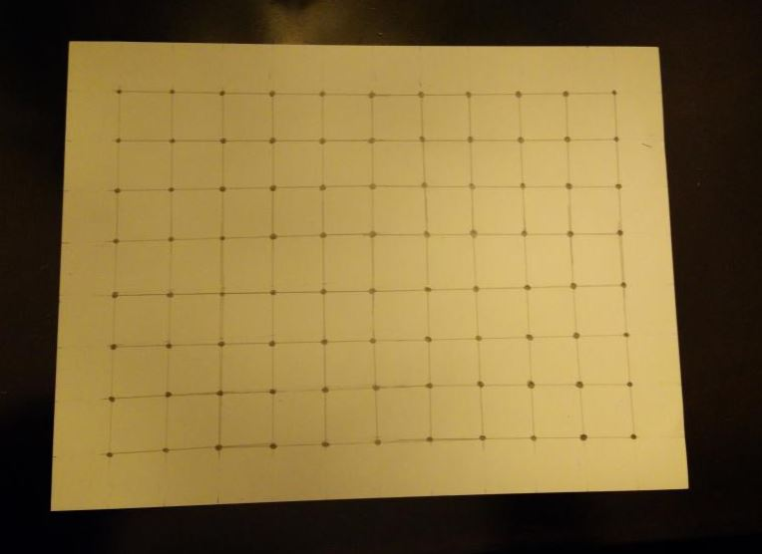

-Each players will need a different color pen or markers.

-A dice will also be needed, a d6 preferred to start the game.

1. Basic Games Structure

- The order will go based on who gets the highest dice number. Before the game starts, each player rolls a dice and whoever gets the highest number goes first. If two people get the same number, then they will go again. The order will go from who gets the highest number to the lowest number.

1. Specific Game Structure

- During a turn, the player first rolls the dice and the number they get, they will draw how many lines. One line counts as connecting one dot to another dot, horizontally or vertically.

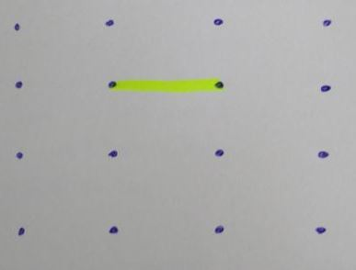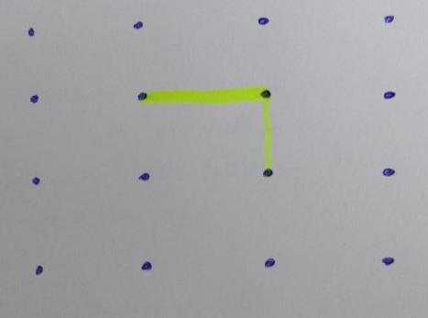

- If the player gets the number four or above, they cannot connect the lines together right away in the same turn.

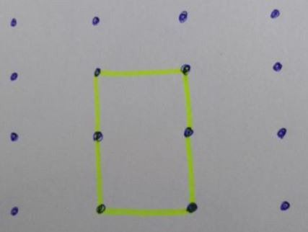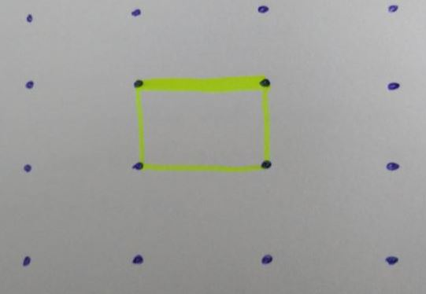

- The player can only go one way without lifting their utensils.

- The first 3 turns, you cannot connect the lines.

- Each time a player connects the lines, the player’s turn will end. For example, if the player with the yellow highlight gets to draw 4 lines but they connected all the lines with 3 lines then their turn ends right away.

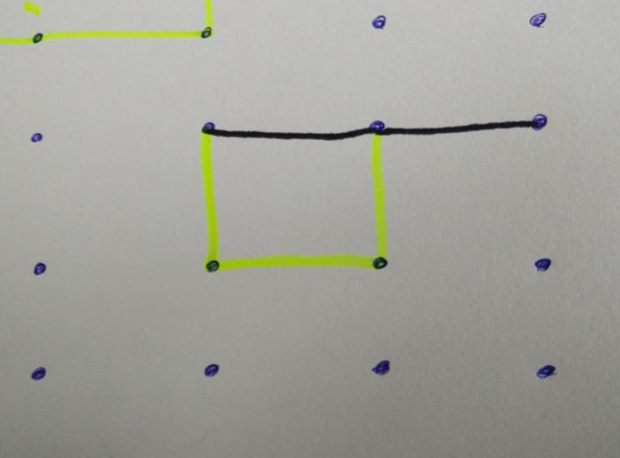

- Another player can finish the shape and the block will be theirs. After getting the shape, it’s best to color or draw something in the shape to know whose shape belongs to.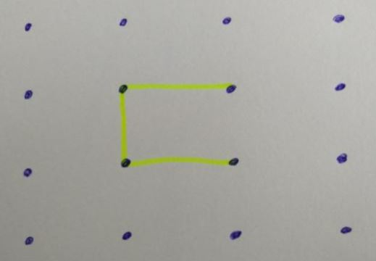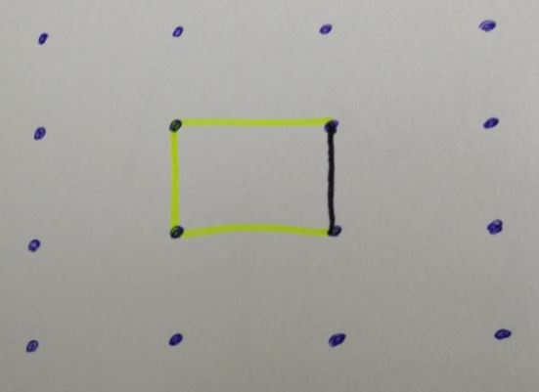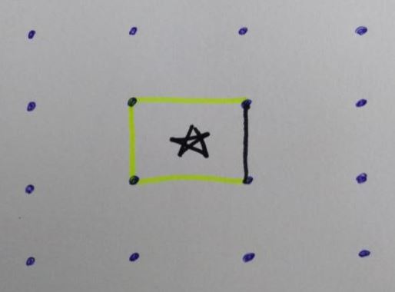

- The player has to start off at a different area on the gameboard away from the completed shape.They can pick any location.

- Players cannot overlap lines.

- The shape can be anything as long as the lines are vertical and horizontal and are connected.

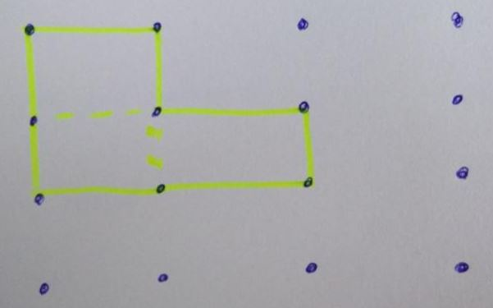

1. Ending the Game

-The game is over when the player reaches 20 points or making 20 squares.

1. Appendix

-Always think and analyze the map before you put your pen onto the game board because once you draw, there’s no going back.