

PARSHVANATH CHARITABLE TRUST'S
- P. Shah Institute of Technology
Thane, 400615

Academic Year: 2022-23
Department of Computer Engineering

CSL605 SKILL BASED LAB COURSE: CLOUD COMPUTING

Mini Project Report

- Title of Project : Online Logbook

- Year and Semester : T.E. (Sem VI)

- Group Members Roll No. & Name :

16. Harmit Saini
22. Vandan Savla

Table of Contents
Sr. No. | Topic | Page No.
1. | Abstract | 3
2. | Introduction | 4
3. | Problem Definition | 5
4. | Description (Include the cloud services used in the project, methodologies used and software requirements) | 6
5. | Implementation details with screen-shots (stepwise) | 8
6. | Learning Outcome | 12

Abstract

This project is aimed at developing an online logbook platform that allows students to document and report their project progress to their specific guides on a weekly basis. The platform will be designed to be user-friendly and accessible to students. The project aims to address the need for an efficient and effective way for students to keep track of their project progress and communicate it with their respective guides.The online logbook platform will allow students to log their weekly activities, report their progress. The platform will also provide a feature for students to interact with their respective guides and receive feedback on their progress. The development of this online logbook platform will help students manage their projects more efficiently and improve communication between students and their guides. The system will also help the guides to monitor the progress of their students' projects more effectively. In summary, this project will serve as a useful tool for students and guides to manage project progress and facilitate effective communication

Introduction

Traditionally, students have maintained handwritten logbooks to document their project progress and report it to their respective guides. However, this offline process is time-consuming, error-prone, lacks standardization, and does not provide an efficient way for guides to monitor progress.

Therefore, this project aims to develop an online logbook platform that can automate the process of documenting and reporting project progress. The online logbook platform will be designed to be user-friendly, accessible to students, and provide an efficient way for guides to monitor their students' progress. The platform will allow students to log their weekly activities, report their progress.

Furthermore, the platform will provide a feature for students to receive feedback on their progress. The development of such a platform will improve the efficiency of the project management process, reduce errors, and facilitate effective communication between students and their guides.

The online logbook platform will have three types of faculties: guides, project coordinators, and admin. Guides can see and write review for their respective groups. Project coordinators will have the ability to change the submission timing, upload logs, and provide feedback. Project coordinators will have additional access to the platform to manage their respective projects. The admin will have complete access to the platform, including the ability to choose who can be a project coordinator.

In addition to these benefits, the online logbook platform will also encourage students to submit their project progress logs on a weekly basis, as it will track the timing of the submission. Unlike the traditional offline process, where students often wait until the end of the project to submit their logs, the online platform will require weekly submissions. This will help students to stay on track with their project progress and allow their respective guides to provide timely feedback.

Moreover, the online platform will also provide an archive of all the previous logs, allowing both students and their guides to track progress over time. This feature will be particularly useful for projects that span over multiple weeks or semesters, as it will provide a comprehensive view of the project progress.

Problem Statement

The current offline process of maintaining handwritten logbooks for documenting and reporting project progress is time-consuming, error-prone, and lacks standardization. This process also makes it difficult for guides to monitor progress, leading to delays in providing feedback and project completion. Therefore, there is a need for an online logbook platform that can automate the process, improve efficiency, reduce errors, and facilitate effective communication between students and their guides. This platform should be user-friendly, accessible to students from various disciplines, and provide an efficient way for guides to monitor their students' progress.

Description

- Google Cloud Platform (GCP): GCP is a cloud computing platform that provides a range of services to host and manage applications. The online logbook application can be hosted on GCP, with access to a variety of services to enhance the functionality and security of the application.

- IAM Users: GCP's Identity and Access Management (IAM) service allows for the management of user access to the online logbook application. IAM allows for the creation of users, groups, and roles, with granular access controls to ensure the security of the application.

- Cloud SQL: Cloud SQL is a fully-managed relational database service provided by GCP. The online logbook data is stored and managed using Cloud SQL, with automatic backups, replication, and patch management, as well as support for various database engines. We’re using MySql for this.

- EC2 Instance: In this project, an EC2 instance refers to a virtual machine hosted on GCP. The online logbook application is hosted on an EC2 instance, which can be configured with the necessary software and dependencies for the application to run.

- GCP as PaaS: GCP is utilized as a Platform-as-a-Service (PaaS), providing a range of services such as serverless computing, storage, and networking, without the need for managing underlying infrastructure.

Methodology Used:

The Agile methodology was used for the online logbook project by dividing it into sprints that focused on delivering functional increments of the application. In the first sprint, the development team focused on building the basic structure of the student side of the application. During this sprint, the development team worked closely with the stakeholders to ensure that the initial requirements were captured accurately.

After completing the initial sprint, the development team moved on to the next sprint, which focused on building the guide side of the application. The development team continued to receive feedback and guidance from the stakeholders during this sprint, and made adjustments to the design and functionality of the application as needed.

Once the basic structure of both the student and guide sides of the application were completed, the development team moved on to subsequent sprints that focused on iterating to higher levels of functionality, such as adding validation and querying the database. Testing was done at the end of each sprint, and feedback was received from the stakeholders to inform the planning of the next sprint.

Finally, once all of the functionality had been implemented and thoroughly tested, the application was uploaded to the Google Cloud Platform using a Docker container. This iterative and incremental approach, with frequent feedback and collaboration between the development team and stakeholders, allowed for a more efficient and effective development process that resulted in a final product that met the needs of the stakeholders and provided value to the end-users.

Software Requirement:
- Any Brower and internet connection
Implementation

- Home page: First you need to login to Student Diary. After that you can access the logbook. The student view is like this. Where guide name topic and group members are shown.
Also pending and filled logs are shown

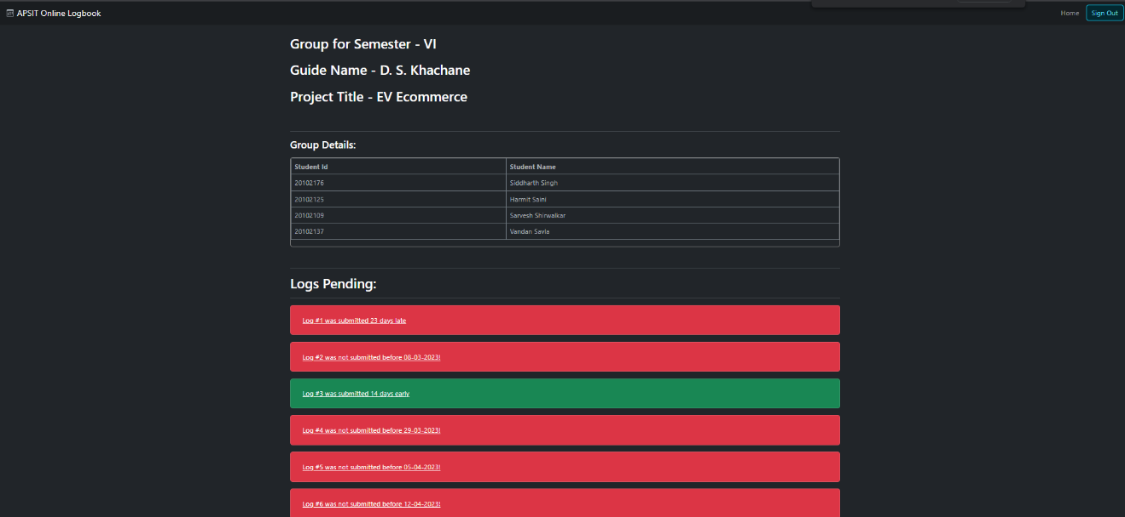

- Logs Table: Students have to fill the progress planned and achieved and submit it so guide can review it.

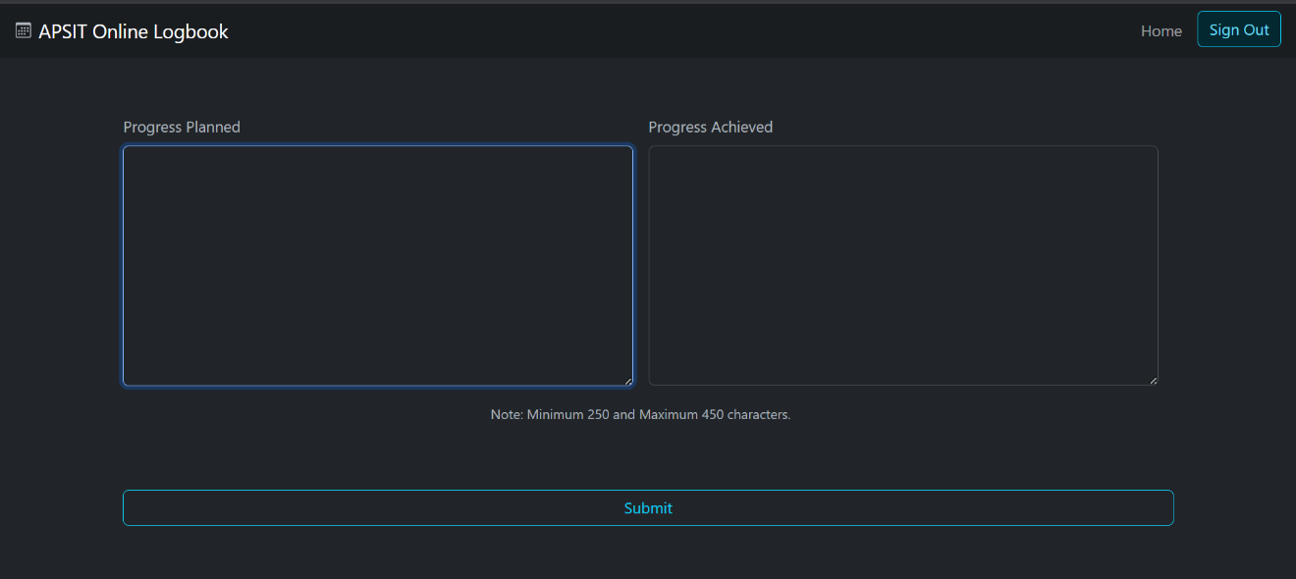

- Filled LogsTable: Student can view the previously filled logs also the date and feedback from guide.

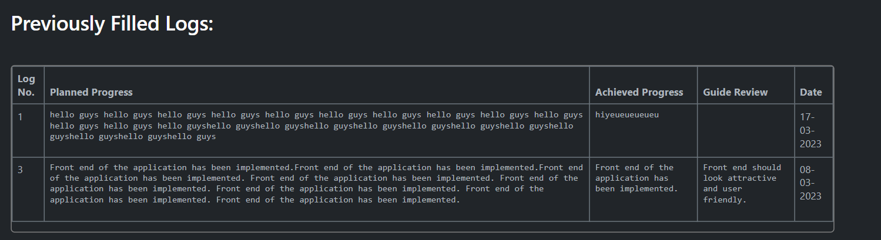

- Guide home page: All the groups under that guide are shown. Guide can download list as excel. He/She can View the submitted logs and review it

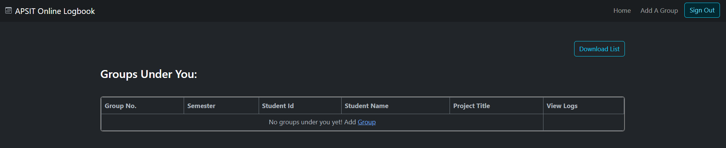

- Add Group page: Guide can add group from here and specified title of project

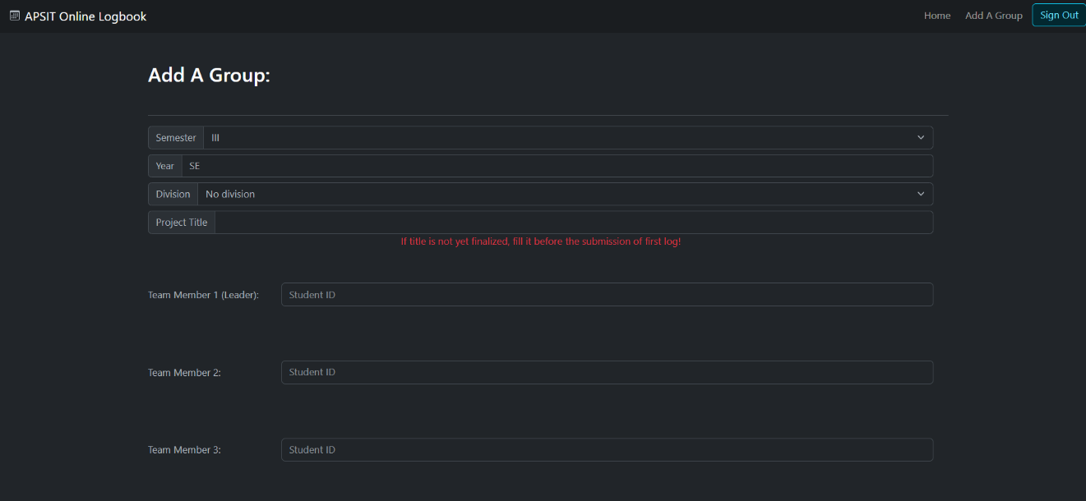

- Project Coordinator View: Here the Project Coordinator rdinator can add logs and deadline.
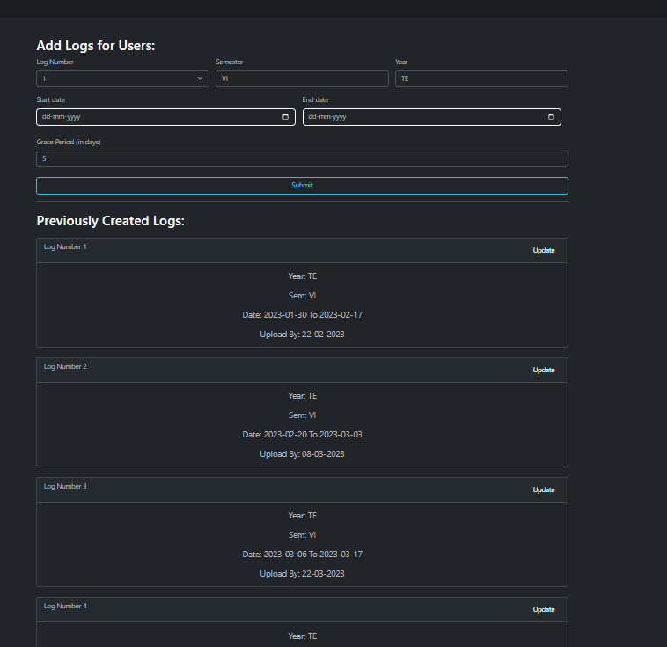
- Project Coordinator View all groups: Here Project Coordinator can view all the groups for which he/she is co-ordinator

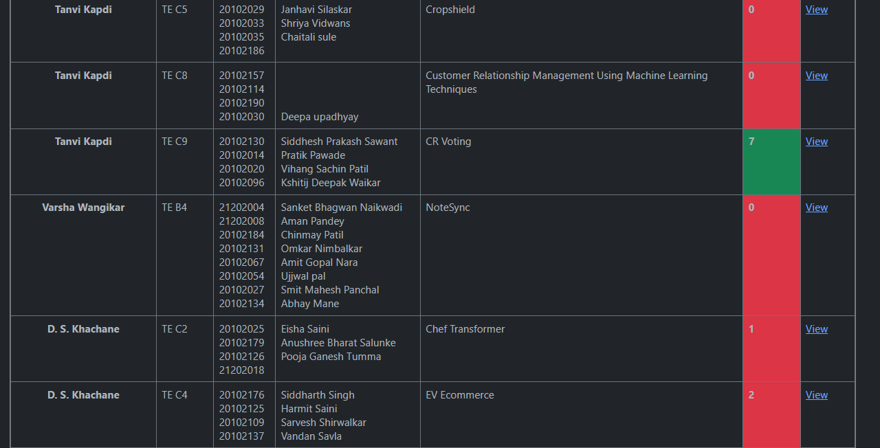

Learning Outcome

working on this mini project, I have gained several valuable learning outcomes related to cloud computing and software development, including practical experience with Google Cloud Platform services, such as IAM users, Cloud SQL, EC2 instance, and PaaS. This experience has helped me understand the benefits and challenges of using cloud computing in software development.

I have also gained hands-on experience with agile methodology and its iterative approach to software development. This approach has enabled me to work collaboratively with stakeholders and deliver functional increments of the application, while receiving frequent feedback and guidance.

Overall, this mini project has provided me with a valuable opportunity to gain practical experience in cloud computing and software development, and develop important skills that will be relevant to my future career in the tech industry. By working on this project, I have gained a deeper understanding of cloud computing technologies and how they can be used to develop software applications, as well as the importance of collaboration and iteration in software development projects.

