# **Blinkit_Sales_Dashboard**

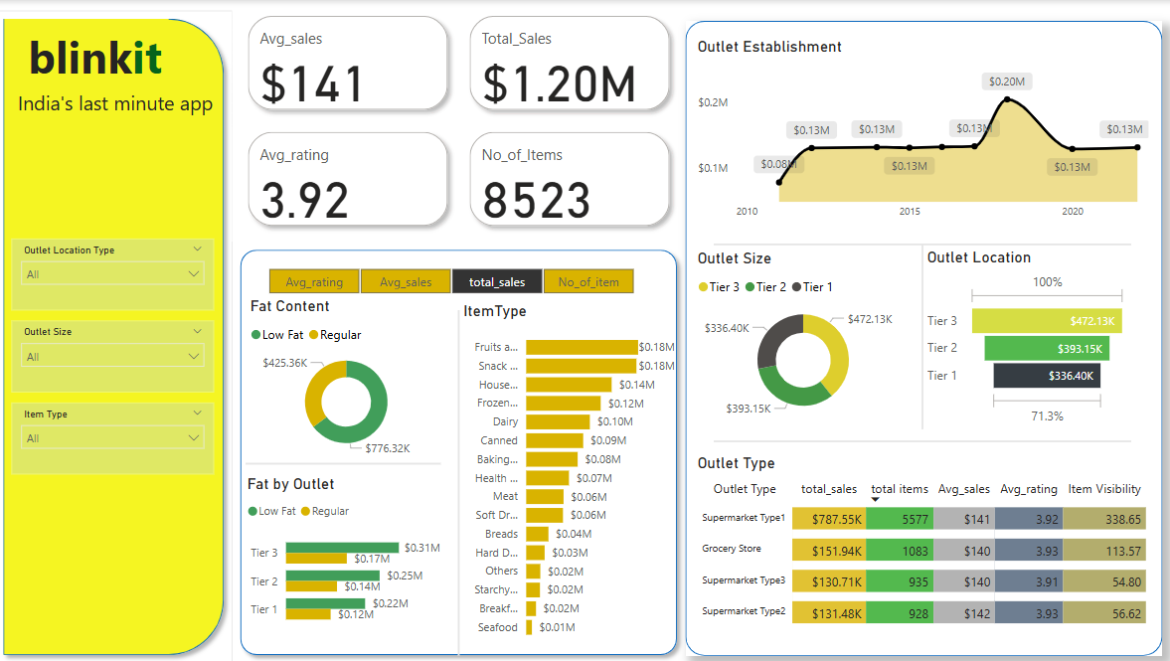

# **INSIGHTS:**

**1.Year-Wise Outlet Establishment:**

**Visualization:** Line Chart showing Total Sales by Year from 2010 – 2020.

Key Patterns:

* Highest Sales and Growth is Observed in 2018 with $0.20M Profit in Sales
* In 2010 – 2012 has Less Growth and Sales as the Business is started at that moment
* After 2018, the Sales became Stabled around $0.13M in 2020 Onwards

**2.Fat Content:**

**Visualization:** Donut chart showing Fat content for Total Sales.

**Key Patterns:**

* Low Fat Items are Generating $425.36K
* Regular Fat Items are Generating $776.32K
* By this Chart, Most of the Customers are Preferring Regular fat items than Low Fat.

**3.Outlet Type Table:**

**Visualization:** Matrix Visualization showing every Outlet sales, Avg_Rating and Items and more

**Key Patterns:**

* **Top Performer**: Supermarket Type 1 ($787.55K in sales)
* **Lowest Performer**: Supermarket Type 3 ($130.71K in sales)

**Supermarket Type 1** significantly leads in all metrics, especially total sales and item visibility, making it a strong model for replication or investment. **Type 3**, with lowest visibility and sales, may need re-evaluation or strategic support.