V E R S I O N C O N T R O L S Y S T E M

Git & GitHub

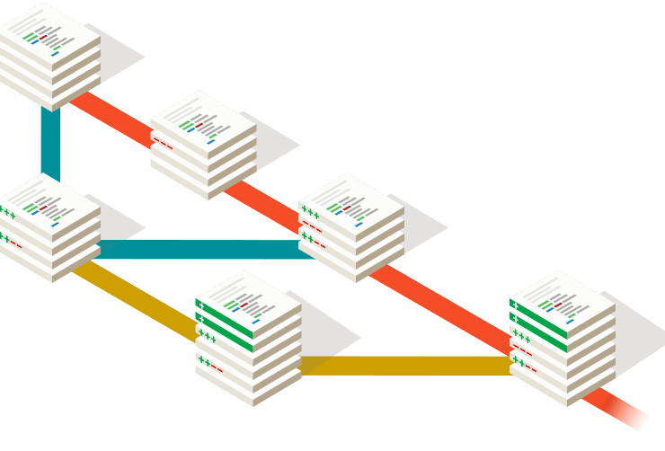Prepared By: Riyaz Ul Haque

Software Engineer



CONSULTADD INC

Copyright © 2021 Consultadd Inc | All Rights Reserved

## Create your first Repository and Commit

**Exercise 1:** Create your first Commit.

### Task:

Initialize your Repository: git init project Exercise-1

Create a file with name index.html

Write code in newly created file

Stage index.html Commit with

‘**Initial Message**.’

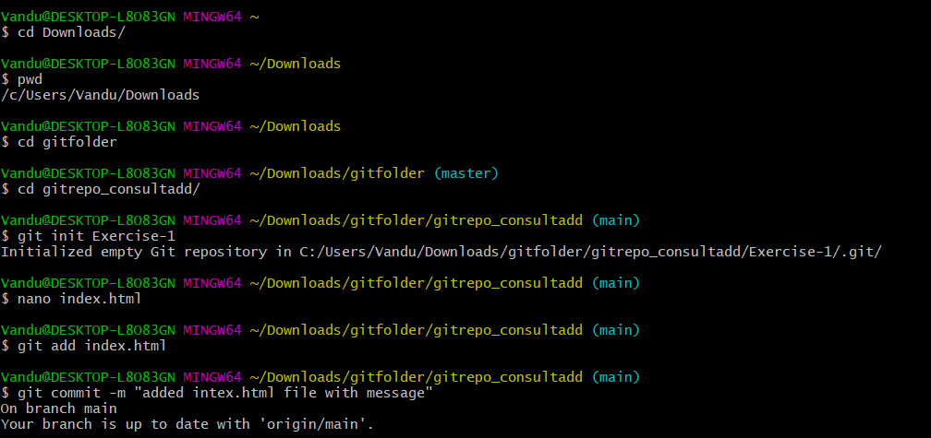

## Commit only one file

**Exercise 2:** Commit only one file.

### Task:

Initialize your Repository: git init Exercise-2

Create a files with names index.html and about.html

Add code in both files.

Stage only one file.

Commit with message:

‘**File x added**.’

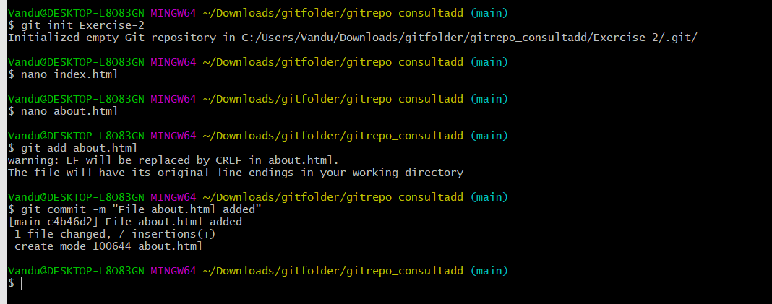

## Modify last commit

**Exercise 3:** Modify last commit.

### Task:

Initialize your Repository: git init project Exercise-3

Create a file with name index.html

Write code in newly created file

Stage index.html

Commit with message ‘adding index.html.’

Add new about.html file with some code.

Now modify message of previous commit as ‘Adding index.html and about.html ’and add about.html file in previous commit.

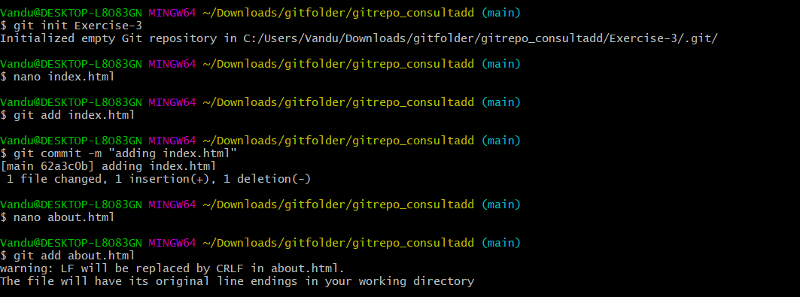

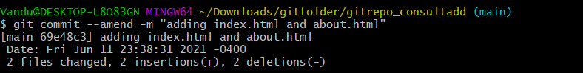

## Create git ignore file

**Exercise 4:** Create git ignore file

### Task:

Initialize your Repository: git init Exercise-4

Create a gitignore file that will ignore

all files with ‘exe’ extension

all files with ‘o’ extension



all files with ‘jar’ extension

the whole libraries directory

\ 





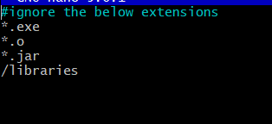

## Save your work with stash

**Exercise 5:** Save your work with stash.

### Task:

Initialize your Repository: git init Exercise-5

Add some random files with code

Now use git stash command to save required files from above files.

(For this exercise don’t send repository just submit git commands and output of git stash list)



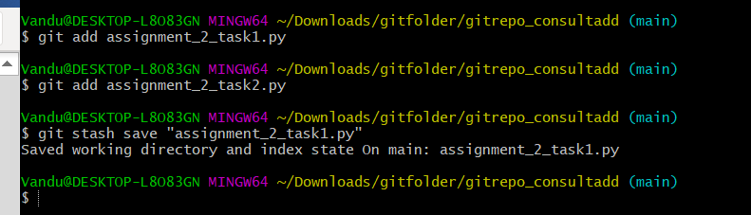

## Reset Previous Commit Keeping changes. (Soft Reset)

**Exercise 6:** Reset Previous Commit Keeping changes. (Soft Reset)

### Task:

Initialize your Repository: git init Exercise-6.

Do some series of commits.

Now use git reset command to reset one of the commit and keep changes in staging area.

In answer also add output of git status command.

## Reset Previous Commit (Hard Reset)

**Exercise 7:** Reset Previous Commit (Hard Reset).

### Task:

Initialize your Repository: git init Exercise-7.

Do some series of commits.

Use git reset command to reset one of the commit without keeping

changes.



## Merge branch (No Conflicts)

**Exercise 8:** Merge branch (No Conflicts).

### Task:

Initialize your Repository: git init Exercise-8

Create index.html file add some code.

Make Commit.

Create new branch from master branch with name **my-feature**.

Add about-us.html file with code and commit changes in my-feature branch.

Now checkout master branch.

Merge my-feature branch into master.

## Merge branch (Conflicts)

**Exercise 9:** Merge branch (Conflicts).

### Task:

Initialize your Repository: git init Exercise-9

Create index.html file add some code.

Make Commit.

Create new branch from master branch with name my-feature.

Add about-us.html file with code

Make changes in index.html

Commit changes in my-feature branch.

Now checkout master branch.

Do some code changes in index.html

Commit changes.

Now merge my-feature branch into master.

You will get conflicts for index.html file. Resolve conflict by selecting both changes for the same index.html file.

# BEST PRACTICES

1. <https://www.katacoda.com/courses/git>
2. [https://learngitbranching.js.org](https://learngitbranching.js.org/)/

**NOTE:** Please go through the above link to complete the exercise in a much more visual way on the Version Control System.

The recommended way is to complete the first one first.



# Timeline

This is just an estimation, please complete at your ease

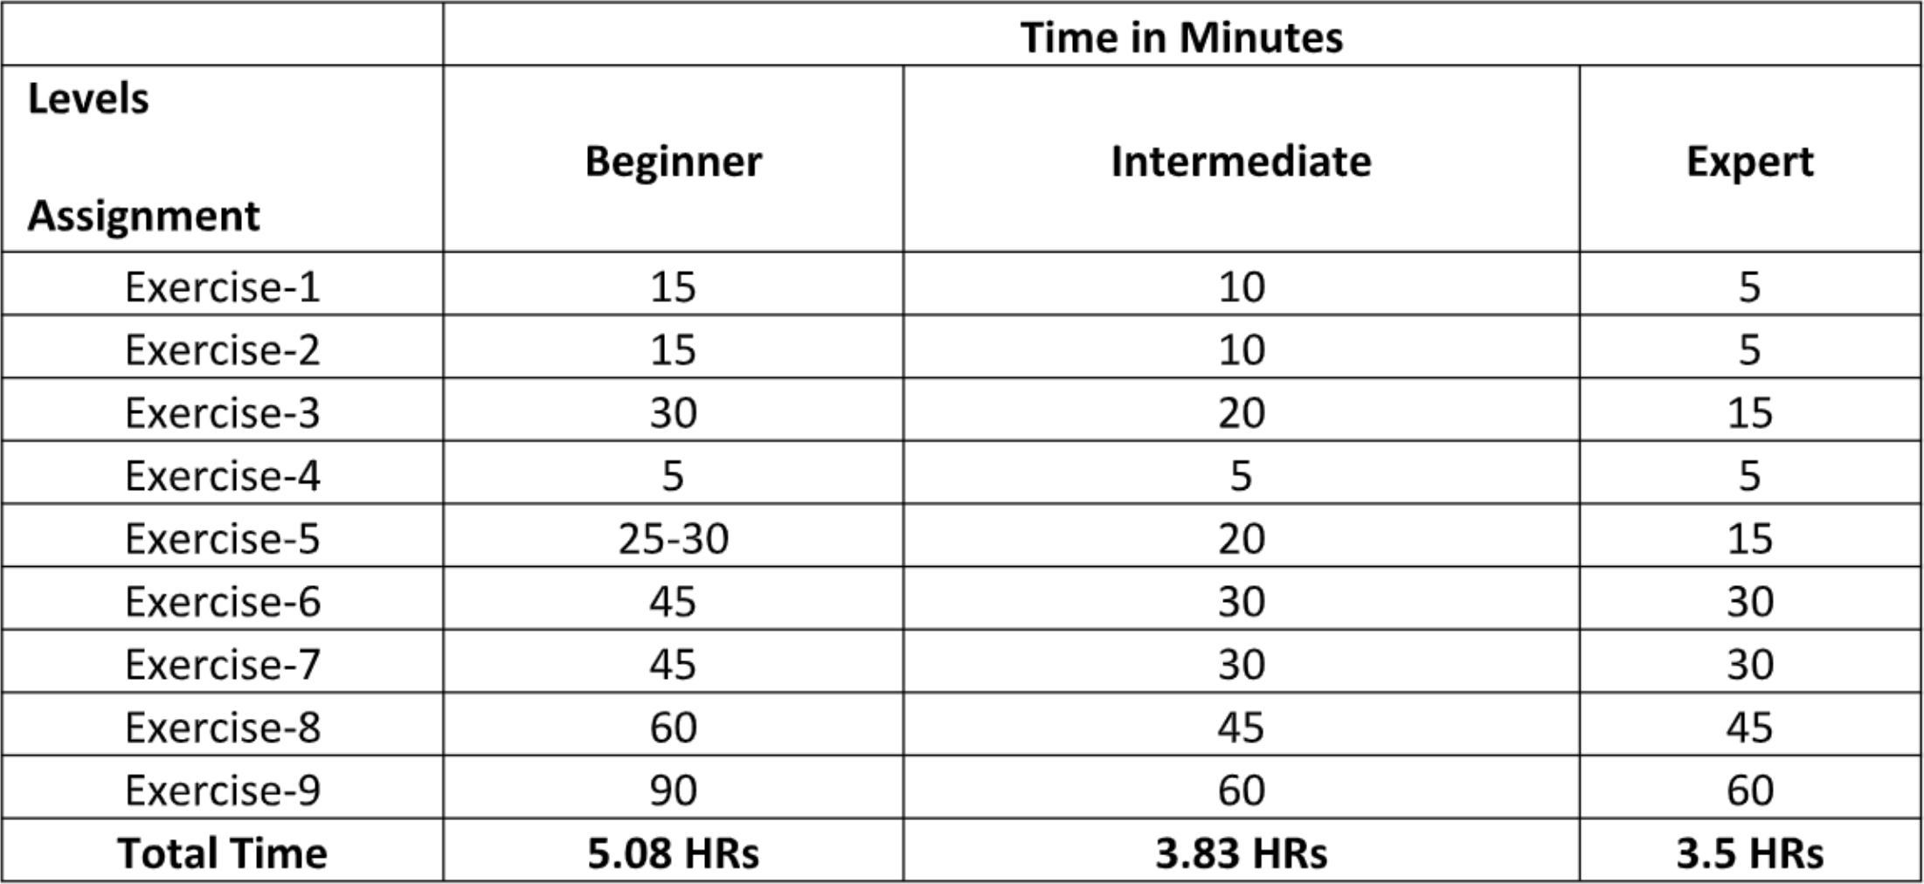

**# c o n s u l t a d d**

**# c o n s u l t a d d t r a i n i n g**

<https://www.facebook.com/ConsultADD/>

<https://www.instagram.com/consultadddinc/> <https://www.linkedin.com/company/consultadd-inc> <https://www.youtube.com/consultaddinc>

Copyright © 2021 Consultadd Inc | All Rights Reserved