FLIGHT DELAY DATA ANALYSIS
A Professional Exploratory Data Analysis Project

Prepared By
Vandana
B.Tech – Computer Science Engineering
Tools: Python, Pandas, NumPy, Matplotlib, Seaborn, Jupyter Notebook / Google Colab
Dataset: Flight_delay[1].csv
Date: 22 August 2026

Table of Contents
Appendix B – Key Project Metrics ...................................... 18
Appendix A – Beginner-Friendly Python Code ............................ 17
23. References ........................................................ 17
22. Future Scope ...................................................... 17
21. Conclusion ........................................................ 17
20. Challenges Faced .................................................. 16
19. Recommendations ................................................... 16
18. Business Insights ................................................. 15
17. Data Visualization ................................................ 14
16. Feature Engineering ............................................... 14
15.3 Pair plot ........................................................ 14
15.2 GroupBy analysis ................................................. 13
15.1 Correlation matrix ............................................... 12
15. Multivariate Analysis ............................................. 12
14.3 Airport and volume analysis ...................................... 11
14.2 Airline comparison ............................................... 10
14.1 Departure delay vs arrival delay ................................. 9
14. Bivariate Analysis ................................................ 9
13.3 Distribution and outlier interpretation .......................... 9
13.2 Univariate analysis – categorical variables ...................... 9
13.1 Univariate analysis – numerical variables ........................ 9
13. Exploratory Data Analysis (EDA) ................................... 9
12.1 Advantages and limitations of the cleaning approach .............. 9
12. Data Cleaning ..................................................... 8
11.1 Important descriptive statistics ................................. 8
11. Data Exploration .................................................. 7
10.2 Verification ..................................................... 7
10.1 What is a DataFrame? ............................................. 7
10. Data Loading ...................................................... 7
9.1 Explanation of the workflow ....................................... 7
9. Project Workflow ................................................... 6
8. Tools and Technologies ............................................. 5
7. Business Questions ................................................. 5
6.1 Column classification and description ............................. 4
6. Dataset Description ................................................ 4
5. Project Objectives ................................................. 4
4. Problem Statement .................................................. 3
3.3 Expected outcome .................................................. 3
3.2 Why the analysis is important ..................................... 3
3.1 What this project is about ........................................ 3
3. Introduction ....................................................... 3
2. Executive Summary .................................................. 3

Note: In Microsoft Word, right-click the Table of Contents and choose “Update Field” to refresh page numbers.

2. Executive Summary
This project analyzes a flight-delay dataset to understand when and why flight arrival and departure delays occur. The supplied raw file contains 484,551 records and 29 columns. The supplied cleaned project dataset contains 304,842 records and the same 29 analytical columns. The notebook supplied with the project documents loading, basic exploration, missing-value handling, duplicate checking, univariate analysis, bivariate analysis, correlation analysis, and multivariate visualization.
The analysis shows a strong relationship between departure delay and arrival delay. In the cleaned dataset, the Pearson correlation between DepDelay and ArrDelay is approximately 0.95. The average arrival delay is 61.03 minutes, while the average departure delay is 57.86 minutes. Recorded delay-cause fields indicate that LateAircraftDelay has the largest total delay minutes, followed by CarrierDelay and NASDelay.
From a business perspective, the results can help an airline or airport focus on operational areas that are associated with delays. Departure punctuality is especially important because flights that leave late tend to arrive late in this dataset. Delay-cause analysis can also help prioritize operational improvement initiatives.
Important limitation: the cleaned file used for this report has Cancelled and Diverted equal to zero for every row. Therefore, this report focuses on delays among the records present in the cleaned dataset and does not make claims about cancellation or diversion behavior.

3. Introduction
Flight delays affect passengers, airline staff, airport operations, aircraft utilization, connecting flights, and overall service quality. Data analysis provides a structured way to identify delay patterns instead of relying only on individual incidents.

3.1 What this project is about
The project uses Python-based data analysis to inspect flight records, clean the data, summarize numerical and categorical variables, study relationships between delay variables, visualize important patterns, and convert those patterns into practical business insights.

3.2 Why the analysis is important
- It helps identify variables strongly associated with arrival delays.
- It allows comparison of delay performance across airlines and airports.
- It helps quantify the contribution of recorded delay causes.
- It provides a foundation for dashboards and future predictive models.

3.3 Expected outcome
The expected outcome is a clean, understandable analysis with evidence-based findings and recommendations.

4. Problem Statement
Airline operations generate large amounts of flight information, but raw records are difficult to interpret directly. The business problem addressed in this project is to understand the patterns associated with flight delays and determine which operational variables and recorded causes are most relevant to delayed arrivals.
By analyzing delay time, departure time, airline, route-related information, airport information, distance, taxi times, and recorded delay causes, organizations can better understand operational bottlenecks and identify areas for improvement.

5. Project Objectives
- Understand the structure and content of the flight dataset.
- Inspect data types, missing values, duplicates, and descriptive statistics.
- Prepare a cleaned dataset for analysis.
- Perform univariate analysis of numerical and categorical variables.
- Study relationships between departure delay, arrival delay, distance, taxi times, and elapsed times.
- Compare delay performance across airlines and days/months represented in the data.
- Analyze recorded causes of delay.
- Create meaningful visualizations including bar charts, scatter plots, and a correlation heatmap.
- Generate business-oriented insights supported by the supplied data.
- Provide practical recommendations and identify future analytical opportunities.

6. Dataset Description
Dataset name: Flight_delay[1].csv. The source file was supplied directly for this project. The original public dataset source is not specified inside the supplied notebook or CSV, so this report does not claim a specific external origin.
Item | Value
Raw rows | 484,551
Raw columns | 29
Cleaned rows | 304,842
Cleaned columns | 29
Date coverage represented | 120 distinct dates; January–April in the supplied cleaned data
Airlines | 13 distinct Airline values; 12 UniqueCarrier codes
Origin airports | 271
Destination airports | 271
Duplicate rows in raw file | 2

6.1 Column classification and description
Column | Type | Description
DayOfWeek | Numerical | Day number used to represent day of week.
Date | Date/Time | Flight date stored as text in the supplied file.
DepTime | Numerical | Actual departure time value.
ArrTime | Numerical | Actual arrival time value.
CRSArrTime | Numerical | Scheduled arrival time.
UniqueCarrier | Categorical | Carrier code.
Airline | Categorical | Airline name.
FlightNum | Numerical | Flight number.
TailNum | Categorical/Text | Aircraft tail/registration identifier.
ActualElapsedTime | Numerical | Actual total elapsed flight time.
CRSElapsedTime | Numerical | Scheduled elapsed time.
AirTime | Numerical | Time spent in the air.
ArrDelay | Numerical | Arrival delay in minutes.
DepDelay | Numerical | Departure delay in minutes.
Origin | Categorical | Origin airport code.
Org_Airport | Categorical/Text | Origin airport name.
Dest | Categorical | Destination airport code.
Dest_Airport | Categorical/Text | Destination airport name.
Distance | Numerical | Flight distance.
TaxiIn | Numerical | Taxi-in time.
TaxiOut | Numerical | Taxi-out time.
Cancelled | Numerical/Binary | Cancellation indicator.
CancellationCode | Categorical | Cancellation code field.
Diverted | Numerical/Binary | Diversion indicator.
CarrierDelay | Numerical | Minutes attributed to carrier delay.
WeatherDelay | Numerical | Minutes attributed to weather delay.
NASDelay | Numerical | Minutes attributed to National Airspace System delay.
SecurityDelay | Numerical | Minutes attributed to security delay.
LateAircraftDelay | Numerical | Minutes attributed to late-arriving aircraft.

7. Business Questions
- How large are the average arrival and departure delays?
- How strongly is departure delay related to arrival delay?
- Which airlines have the highest average arrival delay in the cleaned dataset?
- Which airports have the largest flight volumes?
- Which days of the week have higher average arrival delays?
- How does average delay vary across the months represented in the data?
- Which recorded delay causes contribute the most total delay minutes?
- Are taxi-out and taxi-in times associated with arrival delay?
- What operational patterns should be prioritized for further investigation?

8. Tools and Technologies
Tool | Purpose | Real-world use
Python | Programming language used for analysis. | Automation, analytics, data science, and machine learning.
Pandas | Data loading, cleaning, filtering, grouping, and summarization. | Business reporting and structured data analysis.
NumPy | Numerical arrays and numerical operations. | Scientific and numerical computing.
Matplotlib | Charts and visualizations. | Reports, dashboards, and analytical presentations.
Seaborn | Statistical visualization used in the supplied notebook. | Fast exploratory charts and statistical plots.
Jupyter Notebook / Google Colab | Interactive environment for executing and documenting Python. | Learning, experimentation, and reproducible analysis.

9. Project Workflow
Problem Statement
↓
Dataset Collection
↓
Import Libraries
↓
Load Dataset
↓
Data Exploration
↓
Data Cleaning
↓
Exploratory Data Analysis
↓
Univariate Analysis
↓
Bivariate Analysis
↓
Multivariate Analysis
↓
Feature Engineering
↓
Data Visualization
↓
Business Insights
↓
Recommendations
↓
Conclusion

9.1 Explanation of the workflow
Step | Explanation
Problem Statement | Define the operational question the analysis should answer.
Dataset Collection | Use the supplied flight-delay dataset as the analysis source.
Import Libraries | Load Python packages needed for data and visualization work.
Load Dataset | Read the CSV into a Pandas DataFrame.
Data Exploration | Inspect rows, columns, types, shape, and summary statistics.
Data Cleaning | Handle missing values and duplicates and create the cleaned analysis file.
EDA | Explore distributions, frequencies, and relationships.
Univariate Analysis | Study one variable at a time.
Bivariate Analysis | Study relationships between two variables.
Multivariate Analysis | Study several variables together using correlations and sampled pair plots.
Feature Engineering | Extract useful time information such as month for analysis.
Visualization | Present important patterns visually.
Business Insights | Translate data patterns into practical meaning.
Recommendations | Suggest actions linked to observed patterns.
Conclusion | Summarize the project outcome and limitations.

10. Data Loading
The supplied notebook begins by importing Pandas and NumPy and then reads the CSV file into a DataFrame.
import pandas as pd
import numpy as np
df = pd.read_csv('Flight_delay[1].csv')
display(df.head())

10.1 What is a DataFrame?
A DataFrame is a table-like structure in Pandas. It contains rows and columns and allows a data analyst to filter, summarize, clean, and visualize structured data.

10.2 Verification
The notebook reports a cleaned working shape of 304,842 rows and 29 columns. The supplied cleaned CSV contains the same dimensions.

11. Data Exploration
Function | Purpose | Why used | Project interpretation
head() | Shows the first rows. | Used to verify column names and sample values. | The first records contain flight, airline, airport, time, and delay fields.
tail() | Shows the last rows. | Useful for checking the end of the dataset. | The notebook used it as a basic loading check.
shape | Returns rows and columns. | Quickly measures dataset size. | Cleaned analysis data: 304,842 rows × 29 columns.
columns | Lists column names. | Helps understand available fields. | The dataset contains operational, route, timing, and delay-cause fields.
dtypes | Shows data types. | Identifies numerical vs text fields. | Most measures are numerical; Date is object/text in the file.
info() | Shows structure and non-null counts. | Useful for identifying missing values and types. | The notebook used info() before cleaning.
describe() | Summarizes numerical columns. | Provides count, mean, standard deviation, quartiles, min, and max. | Average ArrDelay is 61.03 minutes in the cleaned data.

11.1 Important descriptive statistics
Variable | Mean | Median | Std. Dev. | Min | Max
ArrDelay | 61.03 | 42.00 | 56.96 | 0.00 | 1525.00
DepDelay | 57.86 | 40.00 | 55.89 | 0.00 | 1521.00
Distance | 741.37 | 594.00 | 562.53 | 0.00 | 4502.00
AirTime | 107.92 | 89.00 | 69.29 | 0.00 | 609.00
TaxiOut | 18.96 | 15.00 | 14.87 | 0.00 | 383.00
TaxiIn | 6.78 | 5.00 | 5.69 | 0.00 | 200.00

12. Data Cleaning
The raw file contains missing values in several fields. The largest raw missing-value counts are Dest_Airport=1479, Org_Airport=1177, and one missing value in many other operational fields. The supplied notebook uses df.fillna(0) and then checks missing values again. It also checks duplicates, applies drop_duplicates(), and checks for remaining NaN values.
Cleaning Step | Method in supplied notebook | Result / interpretation
Missing values | df = df.fillna(0) | All missing values were replaced with 0 in the notebook.
Alternative fill example | df.fillna(df['AirTime'].mean()) | The notebook demonstrates mean imputation but does not assign the result back to df.
Duplicate rows | df.duplicated(); df.drop_duplicates() | Notebook reports 0 duplicates in the cleaned working DataFrame.
Remaining NaN | df.dropna(); total-null check | Notebook reports 0 remaining null values after cleaning.
Data types | df.dtypes / info() | Types were inspected; Date remains object/text in the cleaned CSV.
Unnecessary columns | No columns removed | All 29 original columns are retained.
Outliers | No formal removal method in notebook | Extreme values are retained; they may represent real long delays or unusual operations.

12.1 Advantages and limitations of the cleaning approach
- Advantage: the analysis dataset has no missing values, making downstream calculations straightforward.
- Advantage: duplicate checks reduce the risk of counting identical rows twice.
- Limitation: replacing every missing value with 0 can change the meaning of a field. For example, a missing airport name is not literally airport code 0.
- Limitation: no formal outlier treatment was applied.
- Limitation: the report does not claim that zero-filled values represent true operational measurements.

13. Exploratory Data Analysis (EDA)
EDA is the process of examining the dataset before making conclusions. The supplied notebook performs numerical and categorical univariate analysis, followed by visual exploration and relationship analysis.

13.1 Univariate analysis – numerical variables
Arrival delay has a mean of 61.03 minutes and a median of 42.00 minutes. Departure delay has a mean of 57.86 minutes and a median of 40.00 minutes. The maximum values are much larger than the medians, showing that the delay distributions include high-delay observations.

13.2 Univariate analysis – categorical variables
The cleaned dataset contains 13 Airline values and 12 carrier codes. Southwest Airlines Co. has the largest number of records (80,345).

13.3 Distribution and outlier interpretation
The notebook uses a histogram and box plot for DepTime as representative numerical visualizations. A box plot is useful because it shows the central range and potential extreme observations. Extreme delay values should be investigated rather than automatically removed because unusually long delays can be operationally meaningful.

14. Bivariate Analysis

14.1 Departure delay vs arrival delay
The correlation between DepDelay and ArrDelay is 0.95, indicating a very strong positive linear association in the supplied cleaned data. The scatter plot also shows that higher departure delays generally correspond to higher arrival delays.
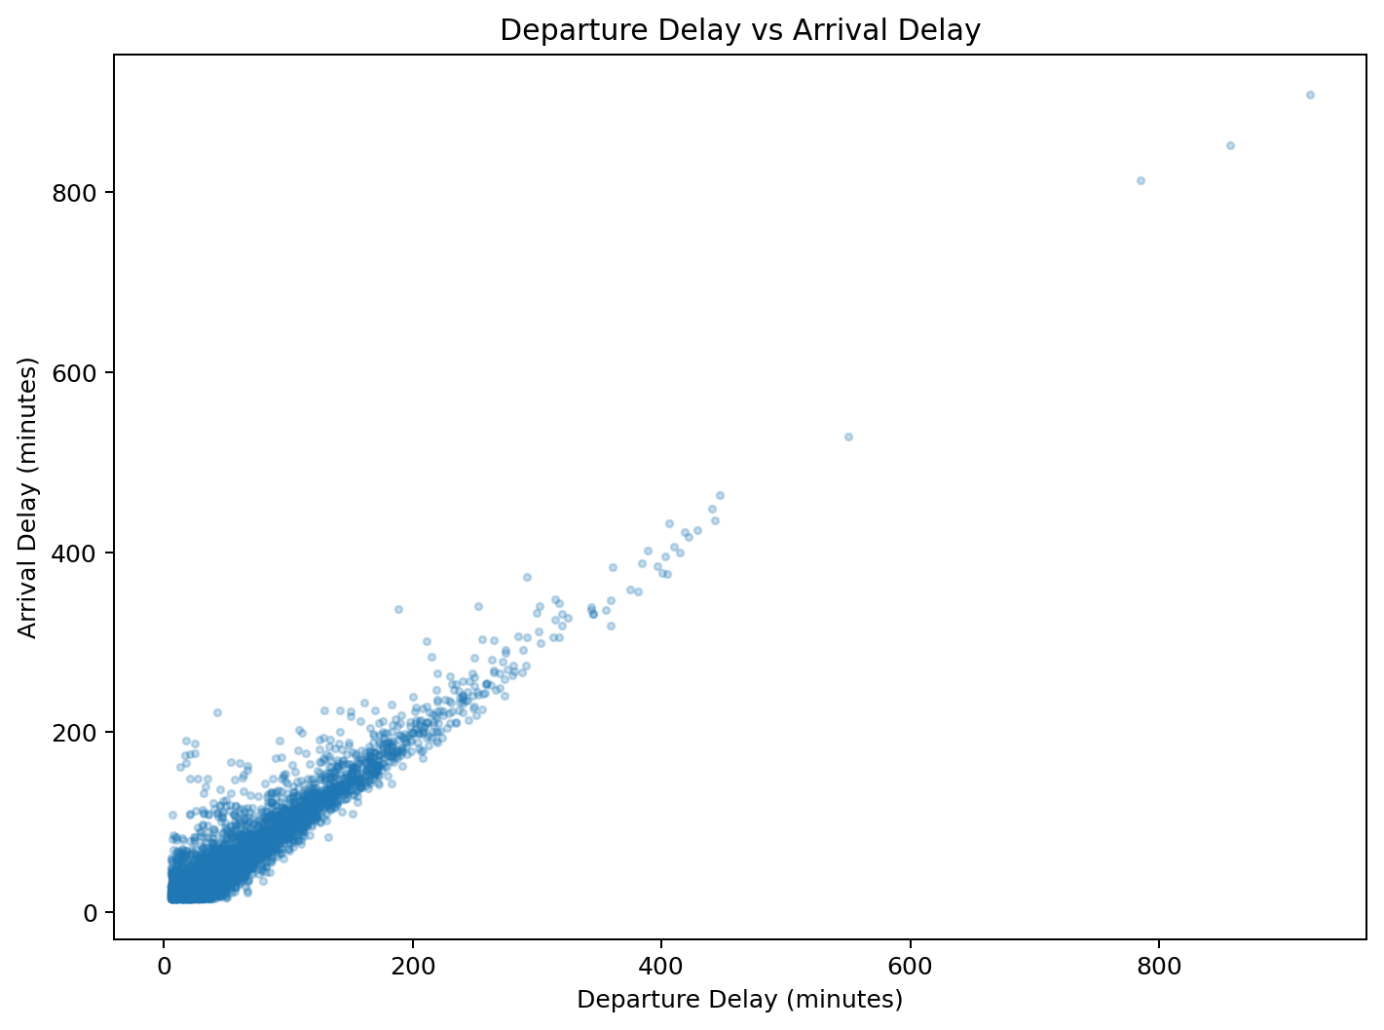
Figure 1. Departure delay and arrival delay relationship.
Business interpretation: reducing departure delays is a practical operational priority because late departures are strongly associated with late arrivals.

14.2 Airline comparison
Average arrival delay varies across airlines in the supplied data. JetBlue Airways has the highest average arrival delay among the named airline groups with more than one record, at 73.06 minutes. Frontier Airlines has the lowest average among the larger groups, at 42.15 minutes. These are descriptive comparisons, not causal judgments.
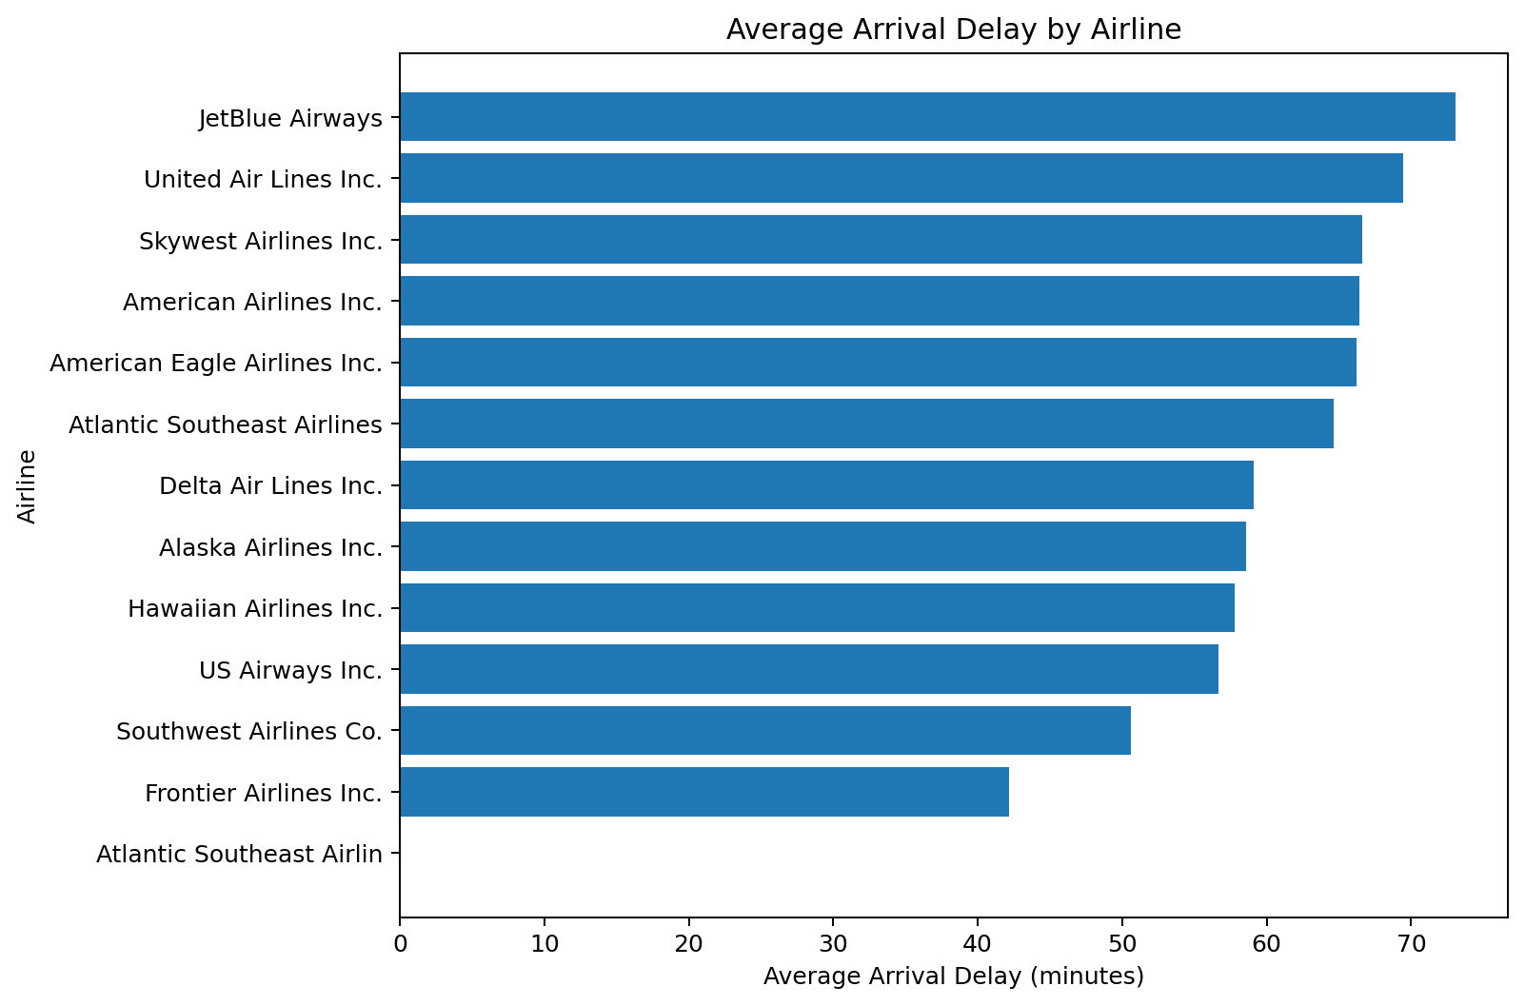
Figure 2. Average arrival delay by airline.

14.3 Airport and volume analysis
Origin | Flights | Average Arrival Delay
ORD | 29,638 | 68.62
ATL | 18,084 | 56.65
DFW | 16,883 | 56.04
DEN | 14,259 | 54.16
LAX | 11,218 | 55.56
LAS | 10,401 | 55.23
SFO | 9,510 | 70.22
PHX | 9,185 | 50.38
SLC | 6,891 | 55.87
MDW | 6,562 | 55.98
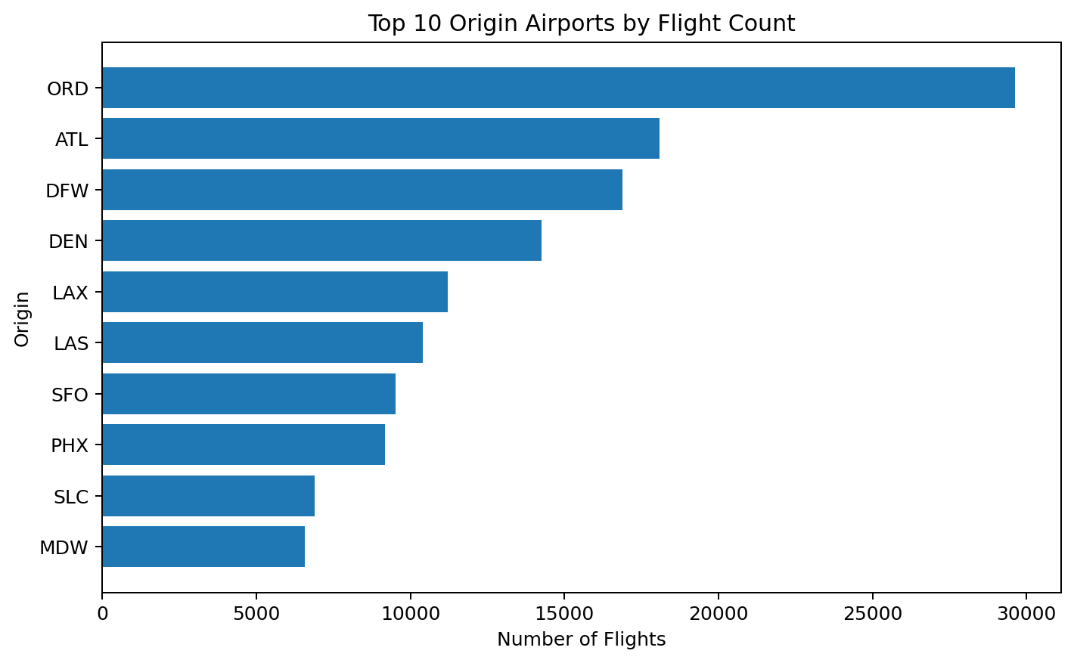
Figure 3. Ten origin airports with the highest flight counts.
ORD is the largest origin by record count (29,638) in the cleaned data. SFO has an average arrival delay of 70.22 minutes among the high-volume origins shown, while ORD averages 68.62 minutes.

15. Multivariate Analysis

15.1 Correlation matrix
The correlation matrix summarizes pairwise linear relationships among selected numerical variables. The strongest relationship with ArrDelay is DepDelay. TaxiOut has a weaker positive relationship with ArrDelay (0.22), while Distance has a very small relationship with ArrDelay (0.02).
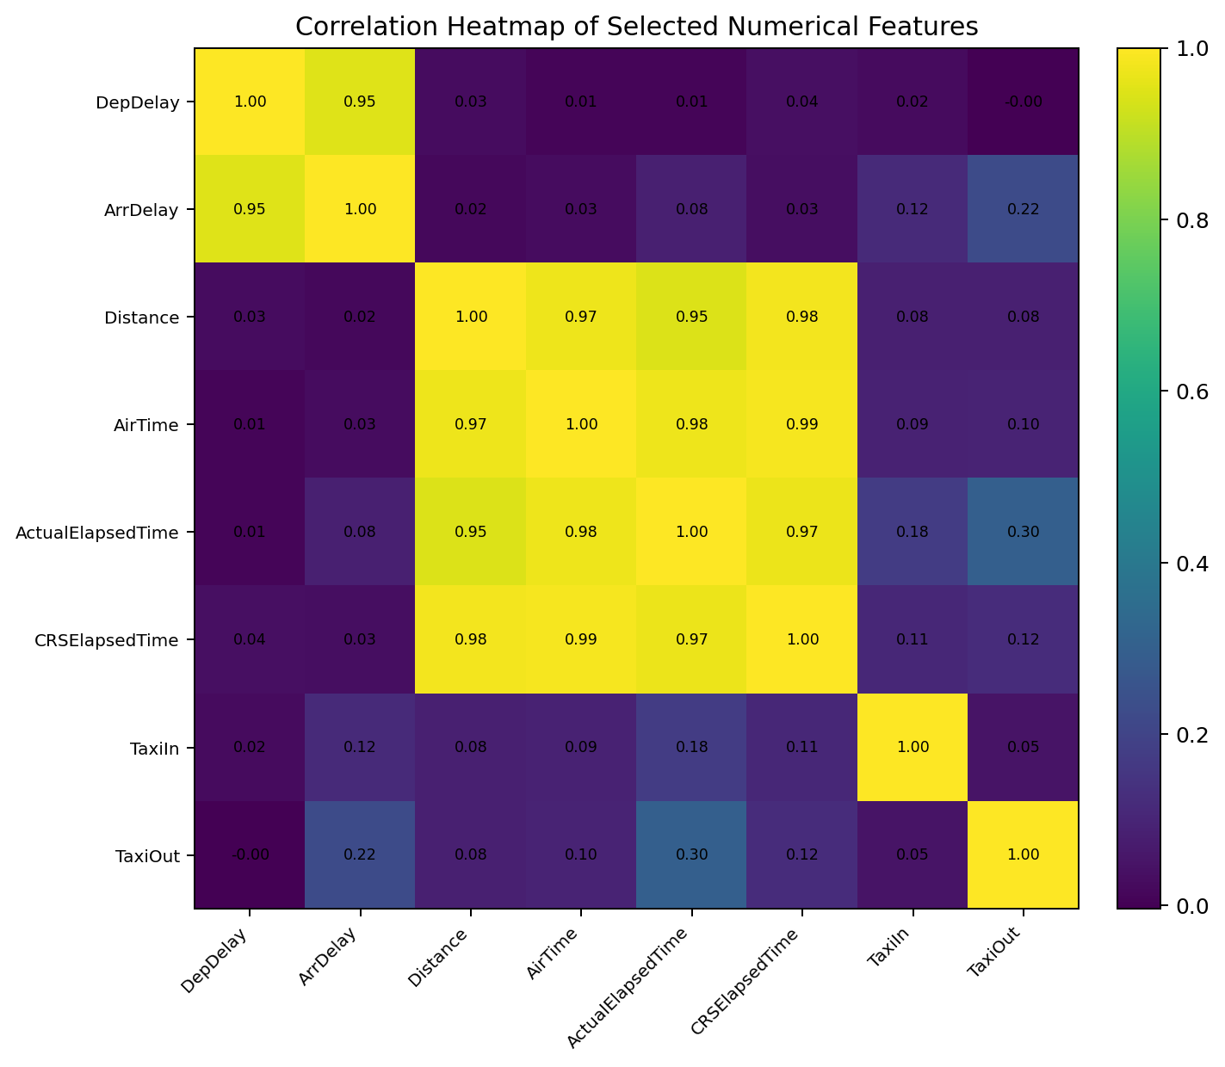
Figure 4. Correlation heatmap of selected numerical variables.

15.2 GroupBy analysis
GroupBy analysis aggregates records by a category so that average delay and flight volume can be compared.
Airline | Flights | Avg ArrDelay | Avg DepDelay
JetBlue Airways | 10,308 | 73.06 | 68.84
United Air Lines Inc. | 36,485 | 69.46 | 66.77
Skywest Airlines Inc. | 35,890 | 66.61 | 61.09
American Airlines Inc. | 39,941 | 66.41 | 61.74
American Eagle Airlines Inc. | 31,490 | 66.20 | 59.29
Atlantic Southeast Airlines | 17,831 | 64.61 | 63.19
Delta Air Lines Inc. | 19,388 | 59.12 | 52.90
Alaska Airlines Inc. | 6,532 | 58.54 | 55.70
Hawaiian Airlines Inc. | 459 | 57.81 | 54.45
US Airways Inc. | 21,549 | 56.66 | 54.67

15.3 Pair plot
The supplied notebook creates a pair plot using a 5,000-row sample and selected numerical variables: DepTime, ArrTime, ActualElapsedTime, ArrDelay, DepDelay, and Distance. Sampling keeps the visualization manageable while still allowing broad pattern inspection.
selected_numerical_cols = [
'DepTime', 'ArrTime', 'ActualElapsedTime',
'ArrDelay', 'DepDelay', 'Distance'
]
sns.pairplot(df[selected_numerical_cols].sample(n=5000, random_state=42))

16. Feature Engineering
Feature engineering means creating a new analytical variable from existing information. The supplied notebook itself does not create a large set of engineered business features, but the date field can be safely transformed into a month for descriptive trend analysis.
New feature | How created | Business benefit
Month | Extract month from Date | Allows comparison of average delay across months represented in the data.
Delay category (optional future feature) | Group ArrDelay into business bands such as 0–14, 15–59, 60+ minutes | Useful for dashboards and classification models.
The second feature is suggested for future analysis rather than claimed as part of the supplied notebook. The report therefore does not use it to create findings.

17. Data Visualization
Chart | Objective | Chart type | Reason selected
Average arrival delay by airline | Compare airline-level delay performance. | Horizontal bar chart | Makes category comparison easy.
Departure vs arrival delay | Understand the relationship between two delay measures. | Scatter plot | Shows direction and strength of association.
Correlation heatmap | Compare numerical relationships simultaneously. | Heatmap | Compact view of multiple correlations.
Delay causes | Compare total recorded delay minutes by cause. | Bar chart | Highlights the largest recorded contributors.
Monthly average delay | Compare average delay across months represented. | Bar chart | Simple time-period comparison.
Top origin airports | Show where the largest number of records originate. | Bar chart | Highlights high-volume locations.
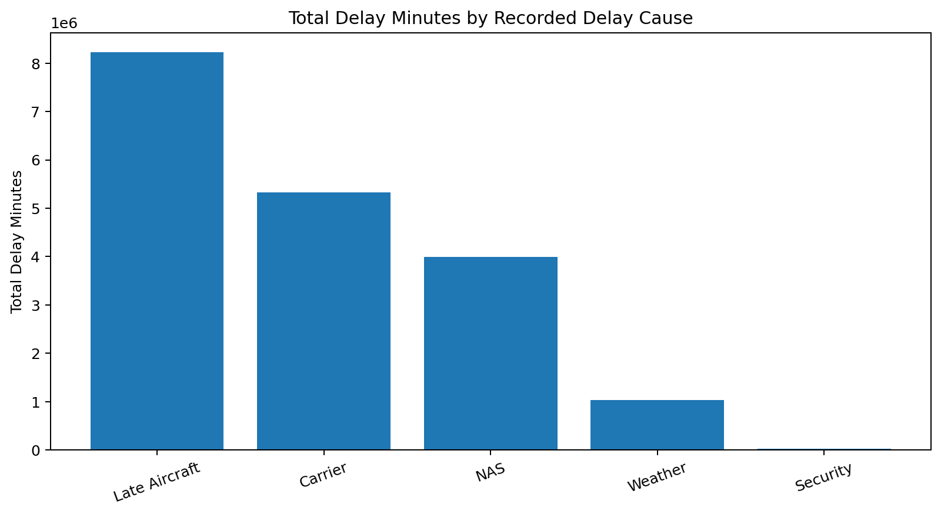
Figure 5. Total recorded delay minutes by cause.
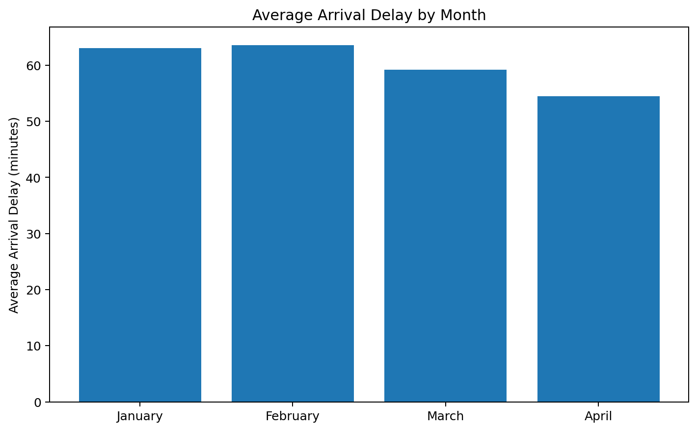
Figure 6. Average arrival delay by month represented in the cleaned data.

18. Business Insights
- Arrival delay averages 61.03 minutes, while departure delay averages 57.86 minutes.
- Departure delay has a correlation of 0.95 with arrival delay, making departure punctuality the clearest relationship identified in this analysis.
- LateAircraftDelay is the largest recorded delay-cause category by total minutes (8,219,990 minutes), followed by CarrierDelay (5,328,456) and NASDelay (3,997,195).
- Southwest Airlines Co. has the largest number of flight records (80,345) in the cleaned dataset.
- JetBlue Airways has the highest average arrival delay among the named airline groups with more than one record (73.06 minutes).
- ORD is the highest-volume origin airport in the cleaned dataset (29,638 records).
- Among the months represented, March has the lowest average arrival delay (59.25 minutes), while February has the highest (63.61 minutes).
- TaxiOut has a modest positive correlation with arrival delay (0.22), much weaker than the departure-delay relationship.
- Cancelled and Diverted are constant at zero in the cleaned dataset, so cancellation/diversion patterns cannot be analyzed from this cleaned file.

19. Recommendations
Recommendation | Why suggested | Expected business benefit
Prioritize departure punctuality | Because DepDelay and ArrDelay are strongly related, operational teams should investigate processes that cause flights to leave late. | Potentially reduces downstream arrival delays and disruption to connecting operations.
Investigate late-aircraft propagation | LateAircraftDelay has the largest total recorded delay minutes in the dataset. | Understanding aircraft rotation and turnaround dependencies may help reduce delay propagation.
Review carrier and NAS-related causes | CarrierDelay and NASDelay are the next largest recorded contributors. | Targeted operational reviews can focus on airline-controlled processes and airspace/system constraints.
Monitor high-volume airports | Large airports such as ORD generate many records and therefore represent important operational environments for monitoring. | Improvements at high-volume locations can affect many flights.
Build an operational dashboard | Track average delay, departure delay, arrival delay, airline, airport, and cause metrics regularly. | Supports faster monitoring and management decisions.

20. Challenges Faced
- The raw file contains missing values in airport-name and operational fields.
- The notebook uses fillna(0), which is simple but can reduce semantic accuracy for text fields.
- The Date column is stored as object/text and requires parsing before time-based analysis.
- The dataset contains extreme delay values, so interpretation must distinguish real operational extremes from data errors.
- The cleaned dataset has no variation in Cancelled and Diverted, limiting those analyses.
- The supplied notebook includes representative visualizations rather than every possible chart, which is appropriate for keeping exploratory work manageable.

21. Conclusion
This project analyzed 304,842 cleaned flight records across 29 columns using Python-based data analysis. The work covered data loading, exploration, missing-value handling, duplicate checks, univariate analysis, bivariate analysis, correlation analysis, group-based comparison, and visualization.
The most important finding is the strong relationship between departure delay and arrival delay (correlation 0.95). The analysis also shows that LateAircraftDelay contributes the largest total recorded delay minutes, while airline and airport-level performance varies.
The project demonstrates how a beginner-friendly Python workflow can convert a large operational dataset into structured business insights. The conclusions are descriptive and based only on the supplied cleaned dataset; they should not be interpreted as causal proof.

22. Future Scope
- Create an interactive Power BI dashboard for airline, airport, route, and delay-cause monitoring.
- Build a machine-learning model to predict whether a flight will experience a high arrival delay.
- Engineer time-based features such as departure hour, month, day-of-week, and route-level historical delay rates.
- Create route-level and airport-level performance benchmarks.
- Use a more semantically careful missing-value strategy instead of replacing all missing values with zero.
- Investigate outliers and data-quality rules before predictive modeling.
- Automate regular ingestion and reporting for near-real-time operational monitoring.
- Add cancellation and diversion analysis using a source dataset that retains meaningful variation in those fields.

23. References
Dataset:
- Flight_delay[1].csv – user-supplied project dataset.
- cleaned_flight_delay_data.csv – cleaned dataset produced by the supplied notebook.
Python and analysis documentation:
- Python Documentation: https://docs.python.org/3/
- Pandas Documentation: https://pandas.pydata.org/docs/
- NumPy Documentation: https://numpy.org/doc/
- Matplotlib Documentation: https://matplotlib.org/stable/
- Seaborn Documentation: https://seaborn.pydata.org/
Note: The supplied files do not specify the original public source of the flight dataset. The references above therefore distinguish the user-provided dataset from general technical documentation.

Appendix A – Beginner-Friendly Python Code
# Import libraries
import pandas as pd
import numpy as np
import matplotlib.pyplot as plt
import seaborn as sns
# Load data
df = pd.read_csv('Flight_delay[1].csv')
# Basic exploration
print(df.shape)
print(df.columns)
print(df.dtypes)
df.info()
display(df.describe())
# Missing values
print(df.isnull().sum())
# Cleaning used in the supplied notebook
df = df.fillna(0)
df = df.drop_duplicates()
df = df.dropna()
# Save cleaned data
df.to_csv('cleaned_flight_delay_data.csv', index=False)
# Correlation heatmap
numerical_cols = df.select_dtypes(include=np.number).columns
sns.heatmap(df[numerical_cols].corr(), annot=True, fmt='.2f')
plt.title('Correlation Matrix of Numerical Features')
plt.show()
# Departure delay vs arrival delay
sns.scatterplot(x='DepDelay', y='ArrDelay', data=df.sample(5000, random_state=42))
plt.title('Departure Delay vs Arrival Delay')
plt.show()

Appendix B – Key Project Metrics
Metric | Value
Raw dataset rows | 484,551
Cleaned dataset rows | 304,842
Columns | 29
Average arrival delay | 61.03 min
Median arrival delay | 42.00 min
Average departure delay | 57.86 min
Median departure delay | 40.00 min
DepDelay–ArrDelay correlation | 0.95
Largest recorded delay cause by total minutes | LateAircraftDelay
Highest-volume airline | Southwest Airlines Co.
Highest-volume origin | ORD

