NAME: SRI DURGA R
BRANCH: AI&DS
ROLL NO: 241801273
GITHUB LINK: https://github.com/Sridurga99/WEB-TECHNOLOGY-AND-MOBILE-APPLICATIONS-WEEK-2/tree/main

WTMA LAB MANUAL – CSS PROGRAMS
Experiment – CSS Stylesheets & Animation

Program 1: Develop and demonstrate the usage of Inline, Internal and External style sheet using CSS

Aim
To design a simple web page and demonstrate the usage of:
- Inline CSS
- Internal CSSss
- External CSS

Software Required
  - OS: Windows / Linux
  - Editor: VS Code / Notepad++
  - Browser: Chrome / Firefox

Theory
CSS (Cascading Style Sheets) is used to control presentation of HTML elements such as:
  - Colors
  - Fonts
  - Layout
  - Spacing Types of CSS:
- Inline CSS – applied directly inside an HTML tag
- Internal CSS – written in <style> tag inside <head> section
- External CSS – written in a separate .css file and linked using <link> tag

Steps / Procedure

Inline CSS
  - Open VS Code / Notepad++.
  - Create a new file and save as inline.html.
  - Write basic HTML structure.
  - Apply CSS directly inside tags using the style="" attribute:
    - Example: style="color: blue; text−align: center;"
  - Save the file.
  - Open inline.html in a browser (Chrome/Firefox).
  - Verify that styles are applied inside individual elements.

Internal CSS
  - Create a new file and save as internal.html.
  - Write basic HTML structure.
  - Inside <head> section, add <style> ... </style> block.
  - Write CSS rules for elements like:
    - body, h1, p, button
  - Save the file.
  - Open internal.html in browser.
  - Verify that styles are applied through internal stylesheet.

External CSS
  - Create a new file and save as external.html.
  - Create another file and save as style.css in the same folder.
  - In external.html, link CSS using:
  - <link rel="stylesheet" href="style.css">
  - In style.css, write the CSS rules for:
    - body, h1, p, button

  - Save both files.
  - Open external.html in browser.
  - Confirm webpage formatting is applied from external file.

Program Code

Inline CSS Example File: inline.html
<!DOCTYPE html>
<html>
<head>
<title>Inline CSS Example</title>
</head>
<body>
<h1 style="color: blue; text−align: center;">WTMA Inline CSS</h1>

<p style="font−size: 18px; color: green;"> This paragraph is styled using Inline CSS.
</p>

<button style="background: orange; padding: 10px; border: none;"> Click Me
</button>
</body>
</html>

Internal CSS Example File: internal.html
<!DOCTYPE html>

<html>
<head>
<title>Internal CSS Example</title>

<style> body {
font−family: Arial; background−color: #f4f4f4;
}

h1 {
color: darkred; text−align: center;
}

p {
font−size: 18px; color: navy; margin: 20px;
}

button { background−color: green; color: white;
padding: 10px 15px; border: none; border−radius: 5px;
}

</style>
</head>
<body>
<h1>WTMA Internal CSS</h1>
<p>This content is styled using Internal CSS.</p>
<button>Submit</button>
</body>
</html>

External CSS Example File 1: external.html
<!DOCTYPE html>
<html>
<head>
<title>External CSS Example</title>
<link rel="stylesheet" href="style.css">
</head>
<body>
<h1>WTMA External CSS</h1>
<p>This page uses External CSS file.</p>
<button>Login</button>
</body>
</html>

File 2: style.css
body {
font−family: Verdana; background−color: #e8f0ff;
}

h1 {
color: purple; text−align: center; margin−top: 30px;
}

p {
font−size: 18px; color: #333; margin: 20px;
}

button {
background−color: #ff0066; color: white;
padding: 10px 20px; border: none; border−radius: 6px;
}

Output
- Inline styles visible directly in HTML tags
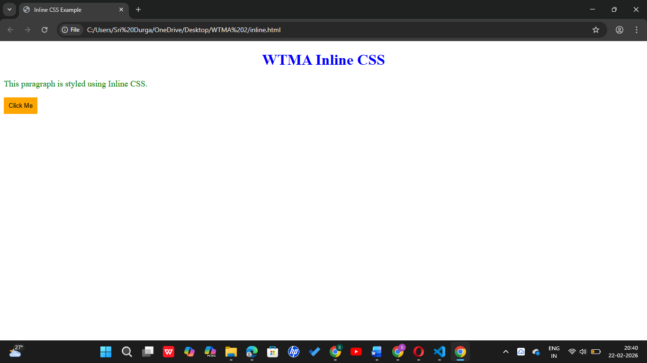
- Internal CSS applied through <style> section
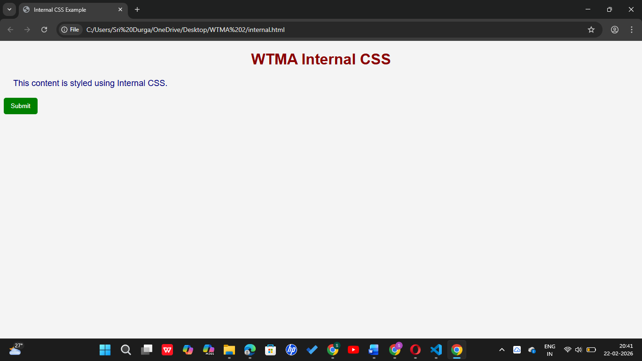
- External CSS applied through .css file
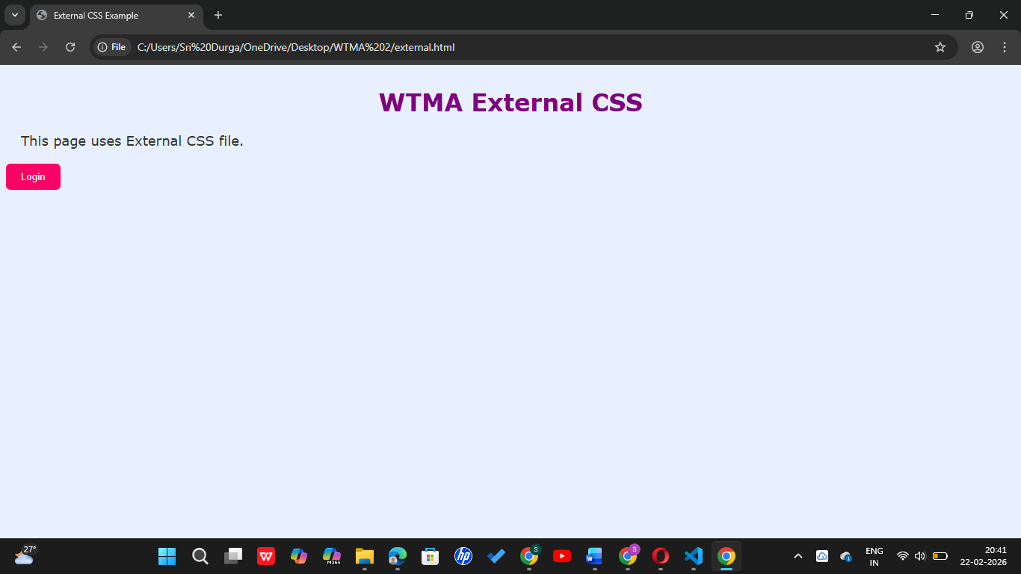

Result:
Thus, Inline, Internal and External stylesheets were implemented and demonstrated successfully using CSS.

Program 2: Design a Student Record Web Page Using CSS Keyframe Animation

Aim
To design a Student Record webpage and apply CSS keyframe animation for text/card effects.

Software Required
- VS Code / Notepad++
- Browser: Chrome

Theory
CSS Keyframe Animation is used to create animations by defining key points of style changes over time.
Syntax:
@keyframes animationName { 0% { }
100% { }
}

Steps / Procedure
  - Open VS Code / Notepad++.
  - Create a new file and save as student_record_animation.html.

  - Write the HTML structure for:
    - Student Record Title
    - Student details displayed using a <table>
  - Create a container <div> with class card to show the student record.
  - Inside <style> tag, apply CSS for:
    - body (background + center alignment)
    - card (width, padding, border−radius, shadow)
    - table (borders + spacing)
  - Create keyframe animations using:
    - @keyframes slideIn (card comes from top with fade−in)
    - @keyframes glowText (title color glow effect)
  - Apply animations using:
  - animation: slideIn 2s ease; and
animation: glowText 2s infinite alternate;
  - Save the file.
  - Run the HTML file in browser.
  - Verify:
    - Card slides in smoothly
    - Title text glows continuously

Program Code

File: student_record_animation.html
<!DOCTYPE html>
<html>
<head>
<title>Student Record − Animation</title>
<style>

body {
font−family: Arial, sans−serif; background: #f2f2f2; display: flex; justify−content: center; align−items: center;
height: 100vh;
}

.card {
width: 450px; padding: 25px; background: white; border−radius: 12px;
box−shadow: 0px 0px 15px rgba(0,0,0,0.2); animation: slideIn 2s ease;
}

h2 {
text−align: center; color: darkblue;
animation: glowText 2s infinite alternate;
}

table {
width: 100%; margin−top: 15px;
border−collapse: collapse;

}

td {
padding: 10px; border: 1px solid #ccc;
}

.label { font−weight: bold;
background: #e0e0ff; width: 40%;
}

/* Keyframe Animations */ @keyframes slideIn {
from {
transform: translateY(−60px); opacity: 0;
}
to {
transform: translateY(0); opacity: 1;
}
}

@keyframes glowText { from {
color: darkblue;

text−shadow: 0 0 5px skyblue;
}
to {
color: red;
text−shadow: 0 0 10px orange;
}
}

</style>
</head>

<body>
<div class="card">
<h2>Student Record</h2>

<table>
<tr>
<td class="label">Student Name</td>
<td>Rahul Sharma</td>
</tr>
<tr>
<td class="label">Roll Number</td>
<td>CS101</td>
</tr>
<tr>
<td class="label">Course</td>
<td>B.Tech CSE</td>
</tr>

<tr>
<td class="label">Semester</td>
<td>4</td>
</tr>
<tr>
<td class="label">Email</td>
<td>rahul@gmail.com</td>
</tr>
<tr>
<td class="label">Phone</td>
<td>9876543210</td>
</tr>
</table>
</div>
</body>
</html>

Output:

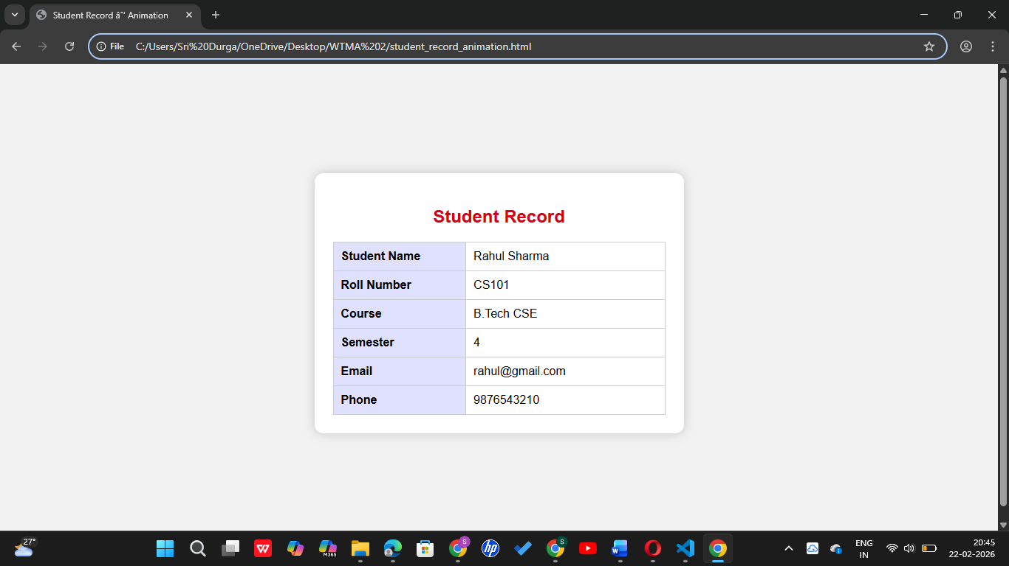

Result
Thus, a Student Record Web Page was designed and CSS keyframe animation was implemented successfully.

