**CS5525-S21 Assignment-5**

**(Dataproc and BigQuery on GCP)**

**Name: Vandana Maddi** **ID: 16307527**

**Task-01: Install Cloud SDK**

**Step-01:** Installing GCloud SDK

**Step-02:** Setup GCloud SDK and using **“gcloud info”** , **“gcloud init”** commands

**Step-03:** Configuring account and project using gcloud init command

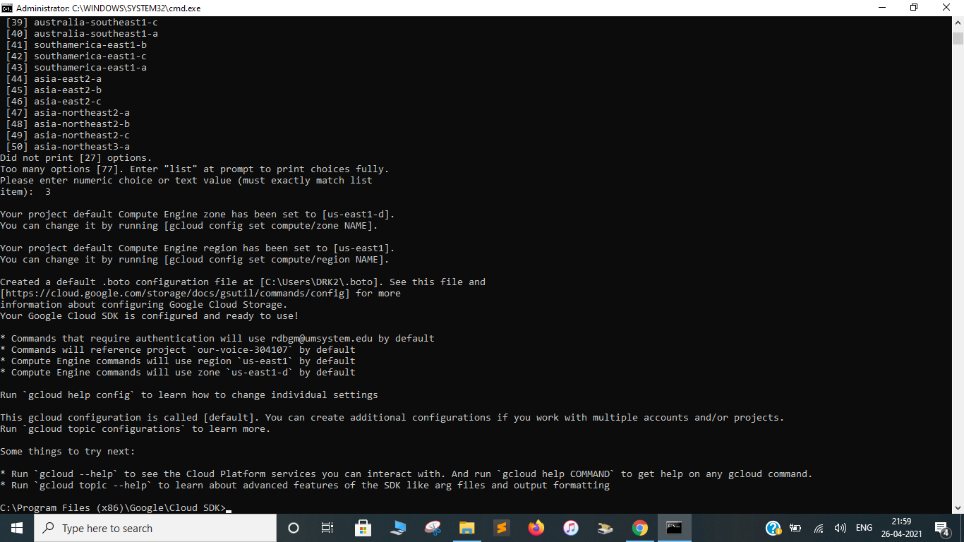

**Task-02: Dataproc**

**Step-01:** Going through the GCP documentation, First select the project through GCP Console and Enable API as per the instructions.

Select the project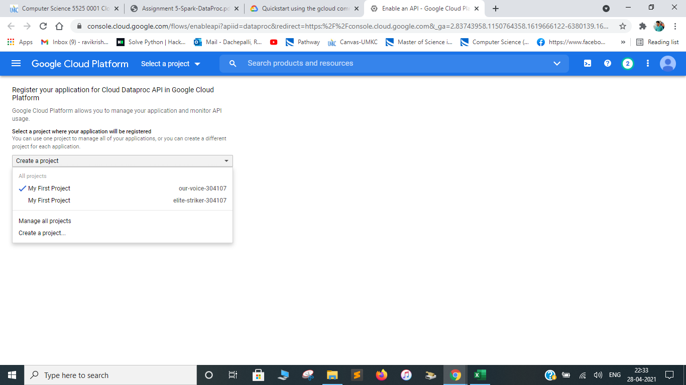

Enable API after selecting the project

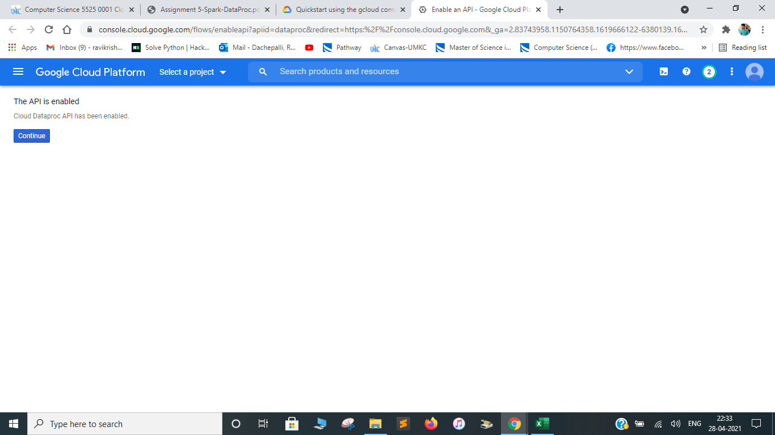

**Step-02:** Using SDK, create a cluster using the following command.

**Command: gcloud dataproc clusters create example-cluster --region=region**

A cluster will be created with one master node and two worker nodes as in the following picture.

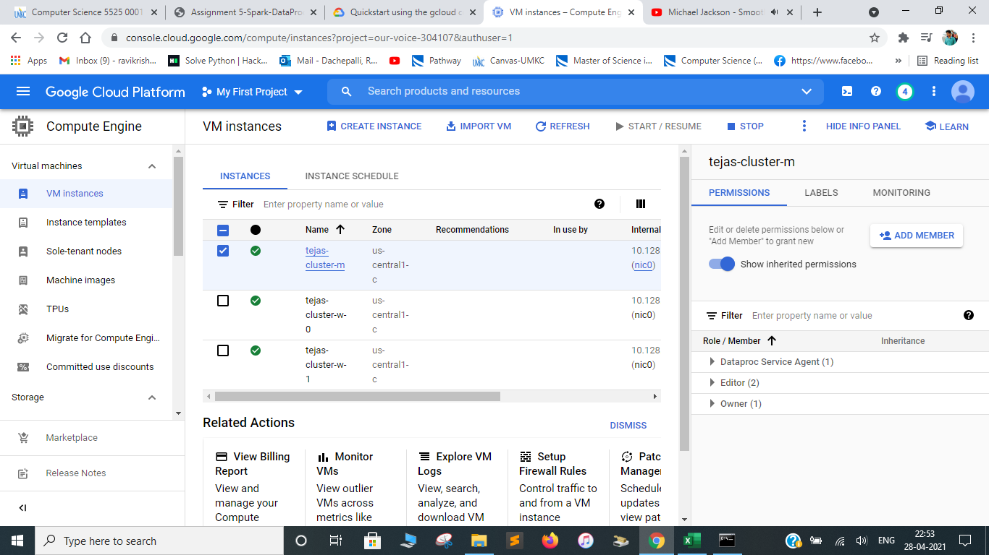

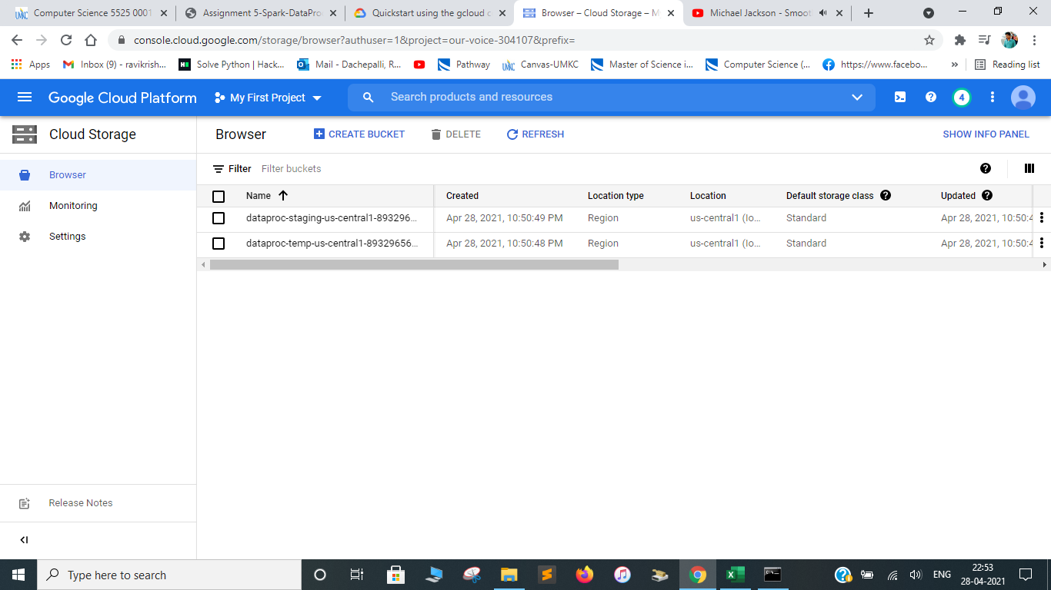

**Step-03:** To submit a Job, use the following command.

**Command:** gcloud dataproc jobs submit spark --cluster tejas-cluster \ --region=*us-central1* \ --class=org.apache.spark.examples.SparkPi \ --jars=file:///usr/lib/spark/examples/jars/spark-examples.jar – 1000

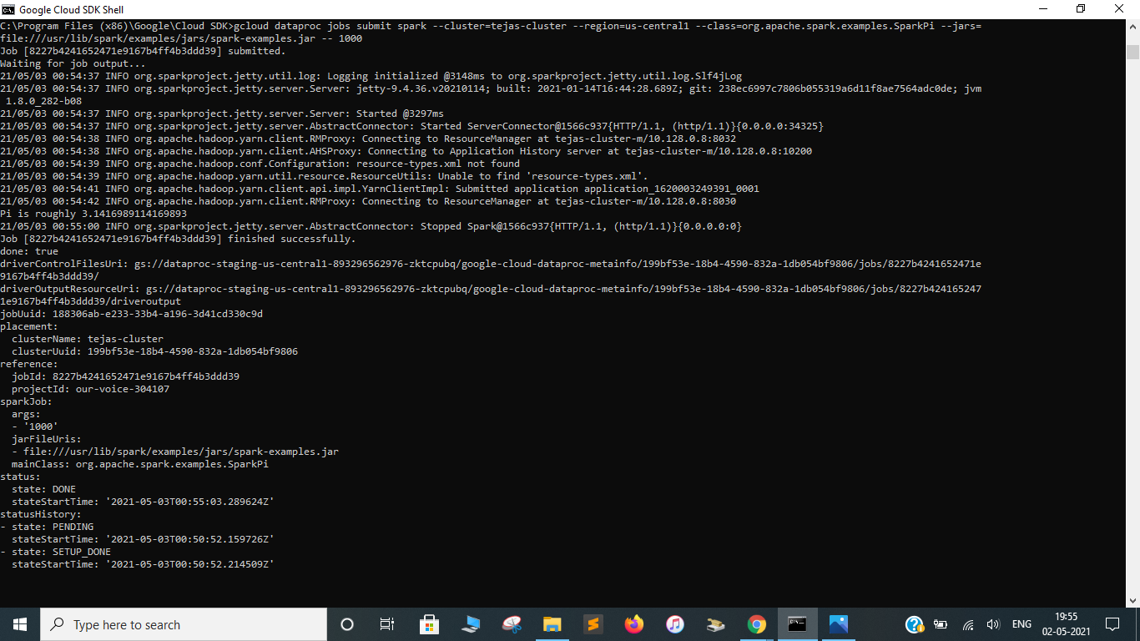

Job created

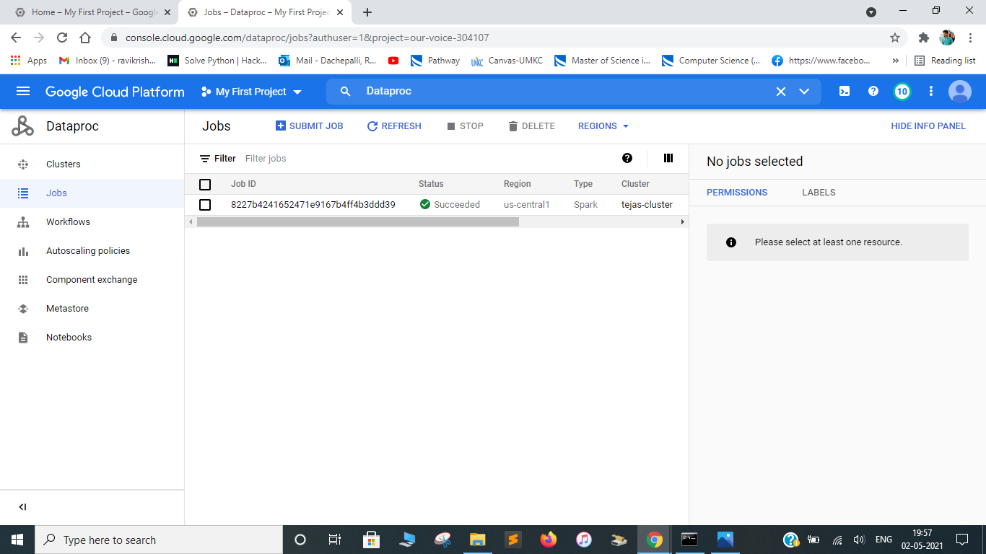

**Step-04:** Calculate the pi-value. Here, the pi value is 3.1416989114169893

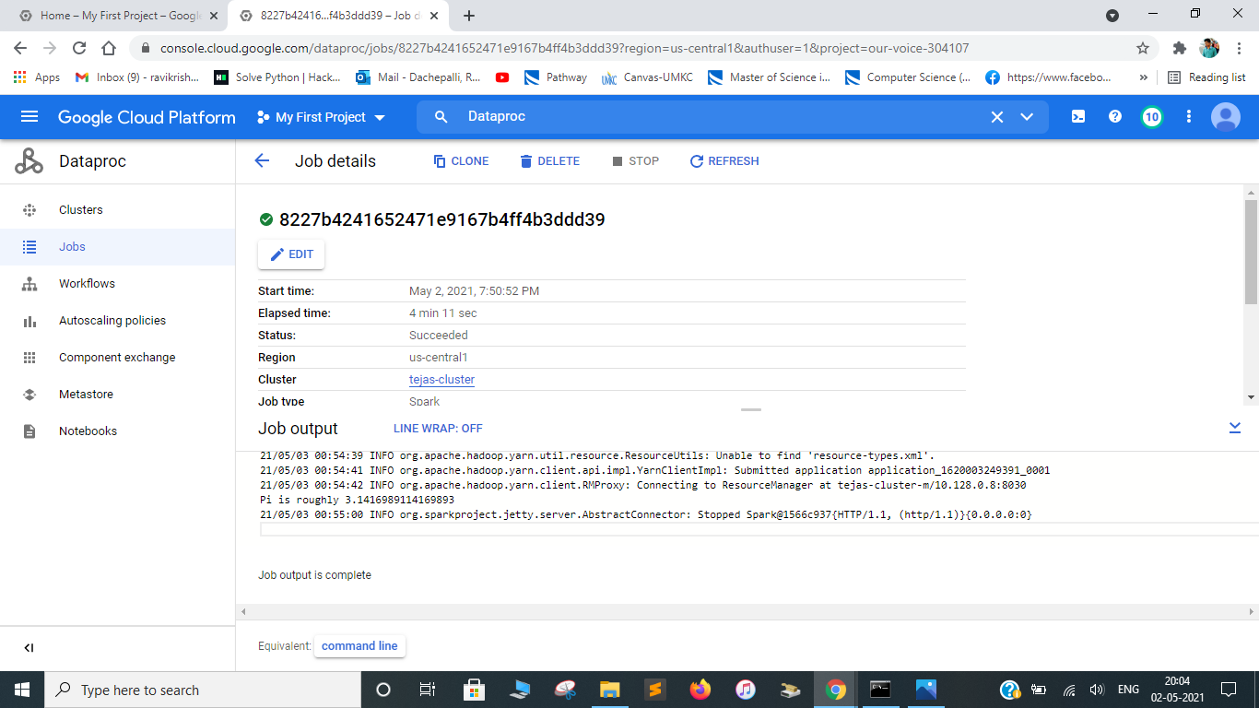

**Task-03: BigQuery**

**Step-01:** Exploring BigQuery and learning how to use front-end UI to perform query.

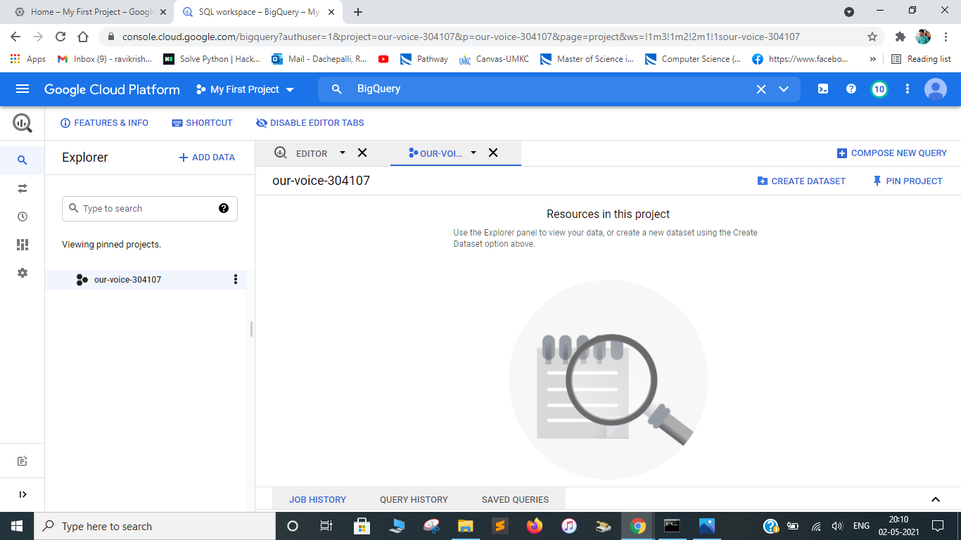

**Step-02:** Learning how to load data into BigQuery.

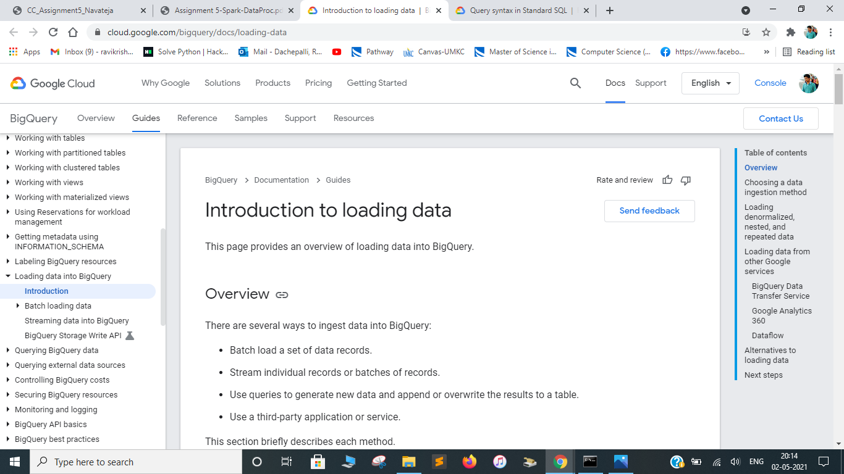

**Step-03:** Checking out the BigQuery SQL documentation as a reference for query syntax.

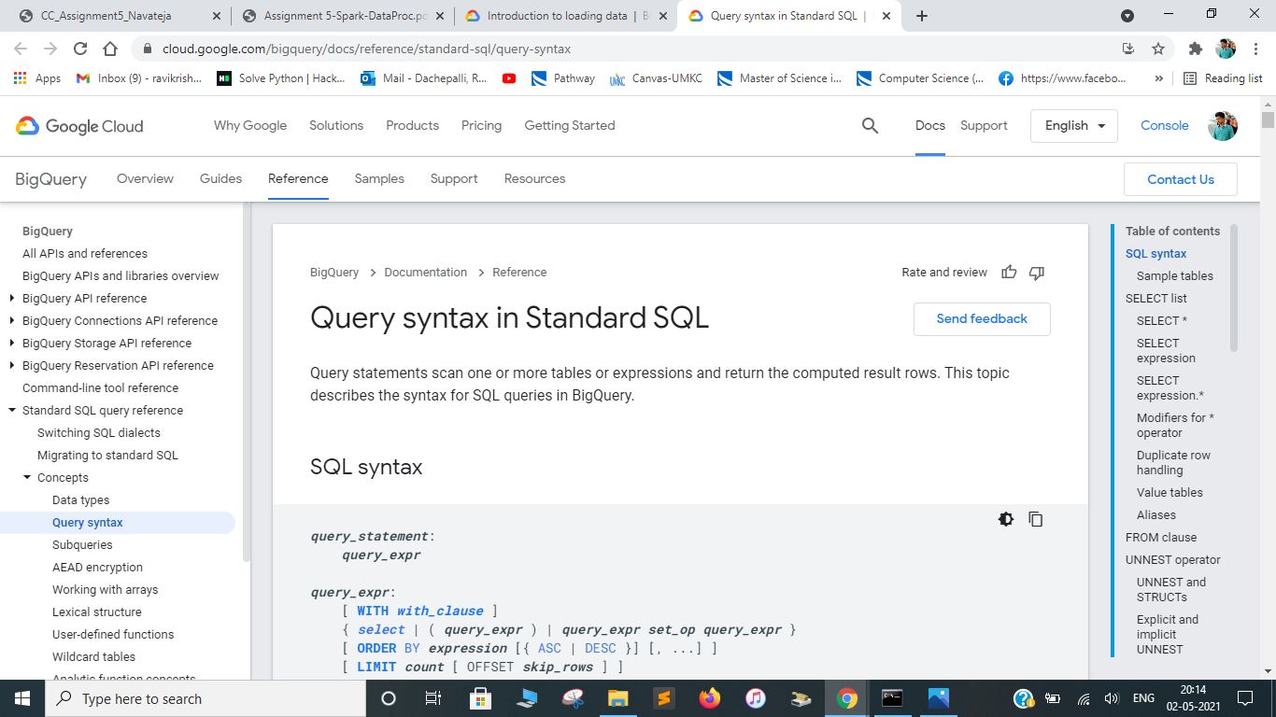

**Step-04:** Enabling BigQuery and loading github public data.

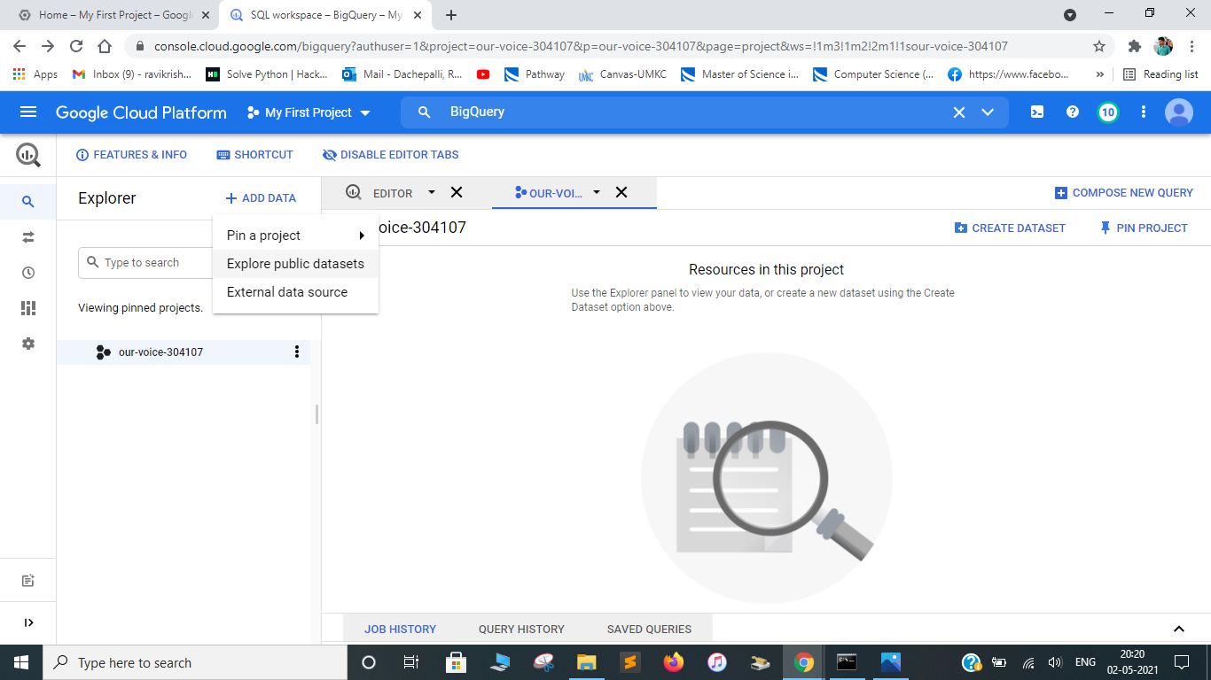

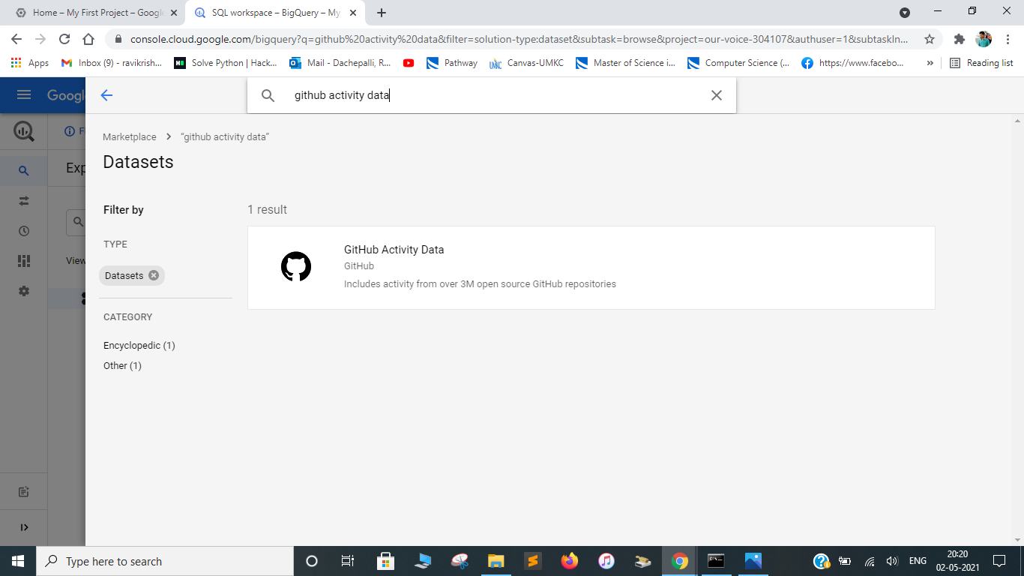

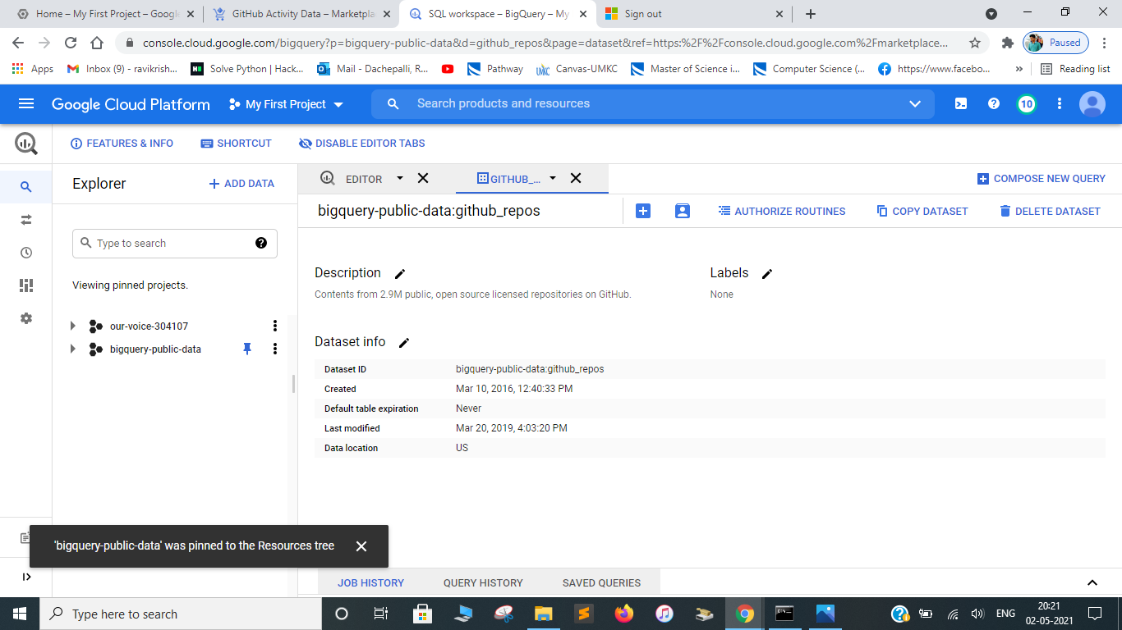

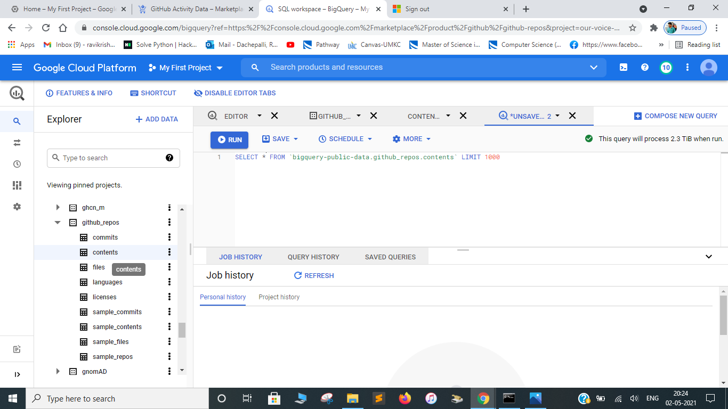

**Step-05:** Query github data through the following sql query and display the output.

**Query:** SELECT subject AS subject, COUNT(*) AS num_duplicates FROM `bigquery-public-data.github_repos.sample_commits` GROUP BY subject ORDER BY num_duplicates DESC LIMIT 1000

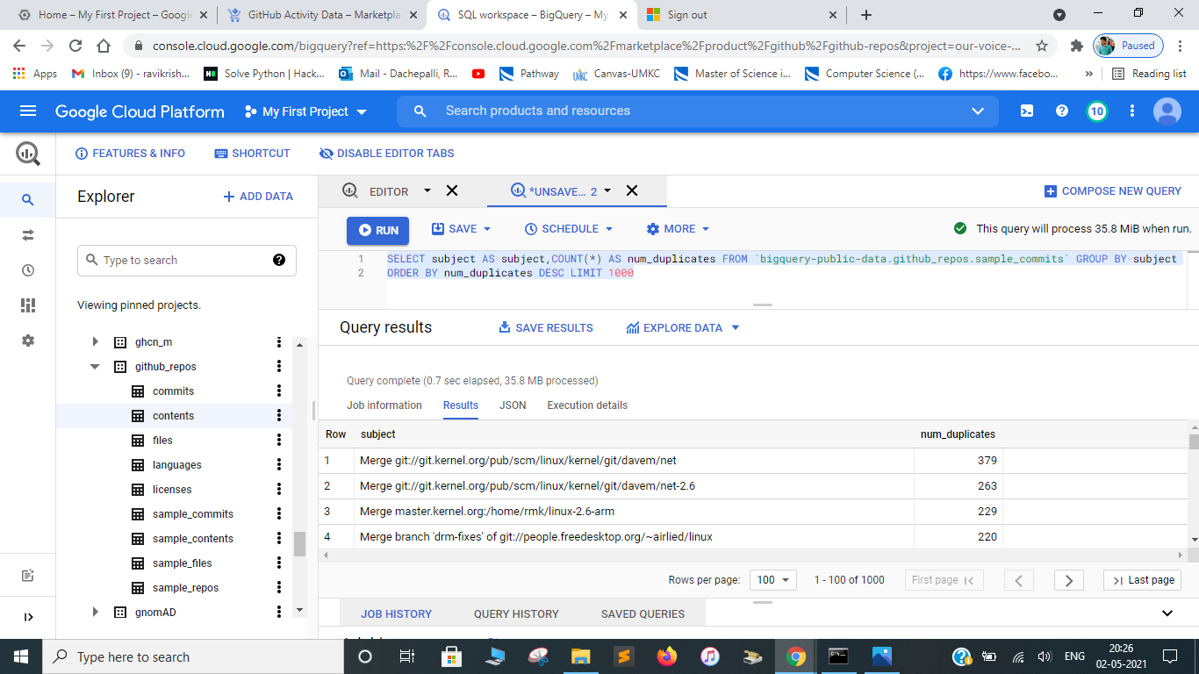

**Step-06:** Delete the clusters create in dataproc to avoid charges and for cloud hygiene.

**Challenges:**

1. Got few errors while running the commands in SDK and rectified them after going through the gcp documentation.
2. A little bit confusion when loading the github public data in BigQuery.

**Fun Part:**

1. Going through documentation and experiencing the big data tools on cloud platform.
2. Gone through the optional resources provided and they are quite interesting where I have spent almost 3 hours reading them.