**Name: Vandana C R**

**Batch No: B22**

**Date: 01-Dec-2022**

**Assignment : learn git push and pull commands try them on your own repository**

**Git Push**

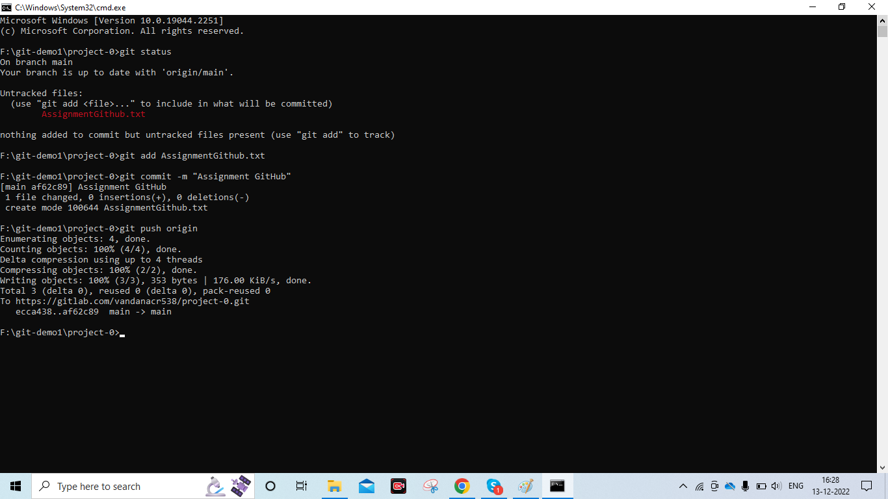

**Git Pull**

