Contents
1. Introduction
2. Technology Used
3. Ember CLI
4. Node.js
5. Best Practices / Third Party Tools Used
5.1 Used Ember CLI
5.2 Used super
5.3 Followed DDAU
5.4 Created reusable components
5.5 Used third party services like geolocation service
5.6 Used google map i.e. g-map for displaying the map
5.7 Created node.js web services to integrate the google map APIs
5.8 Used bootstrap-sass for layout
5.9 Written Basic unit test cases
6. Application Deployment
7. Steps to Run the application
7.1 Installation
7.2 Running / Development
7.3 Running Tests
7.4 Running / Production
7.5 Screen shots

Dominos(Restaurants) Listing Directory With Ember CLI

- Introduction :
We are providing the Dominos shop list or any restaurant list with user current location or with city provided by user.
We are getting the shop list nearby to user current location. And we are listing the same in table and on google map.
We have provided the restaurant input box so that we can get the list of user provided reaturant near by to user current location.
We have provided the city input box, so that we can get the list of user provided reaturant with user provided city.
- Technology Used :
We are using the Google's geolocation web services to get the user current location and use the same for getting the shop lists nearby to that location. Similarly we are using Google Map APIs to get the Dominos shop list with city name.
- Ember CLI :
We are using the Ember CLI which provides the basic framework for our application.
- Node.js :
We are integrating the Google Map APIs in Node.js web services. And we are calling the node's web services to get the shop list.
- Best Practices / Third Party Tools Used :
We have included the following points while implementing the application.
1. Used Ember CLI : We have implemented the application with the use of Ember CLI utility. Which provide the basic application structure.

2. Used super : When overriding the framework methods use super()
Link : https://poteto.github.io/component-best-practices/#/super

3. Followed DDAU : Followed Data Down and Action Up strategy.
Link : https://poteto.github.io/component-best-practices/#/ddau

4. Created reusable components : Created reusable componants, so that we can minimise the code size by reusing the same. i.e. Created places-lists componant and using the same for displaying the Dominos list from user's current location as well as list from city.
Link : https://poteto.github.io/component-best-practices/#/lifecycle

5. Used third party services like geolocation service : Used Google's geolocation web services to get the location details.
Link : https://developers.google.com/maps/documentation/geolocation/intro

6. Used google map i.e. g-map for displaying the map : Used the ember's g-map addon to implement the google map in our application.
Link : https://www.npmjs.com/package/ember-cli-g-maps

7. Created node.js web services to integrate the google map APIs : Created Node.js web services to integrate the google map APIs for getting the Dominos shop list.

8. Used bootstrap-sass for layout : Used Ember CLI bootstrap sass for layout.
Link : https://www.npmjs.com/package/ember-cli-bootstrap

9. Written Basic unit test cases : Written the basic unit test cases for application like verifying the user current location, basic controller test cases etc.
Link : https://ember-cli.com/testing

- Application Deployment :
Deployed the client application(i.e. Ember CLI application) and Server application(i.e.Node server application) on Heroku Production environment.
Now our application is Production ready.
Link Referred : http://www.programwitherik.com/deploy-your-ember-application-to-heroku/
- Steps to Run the application :
You will need the following things properly installed on your computer.
・ Ember CLI
・ Git
・ Node.js (with NPM)
・ Bower
・ PhantomJS
1. Installation
・ git clone <repository-url>this repository
・ change into the new directory
・ npm install
・ bower install

2. Running / Development

・ ember server
・ Visit our app at http://localhost:4200.
3. Running Tests
・ ember test

4. Running / Production

・ Visit our app at
Link : https://stormy-hollows-68393.herokuapp.com/

- Screen shots :
1. Getting the Domonis list near by current location
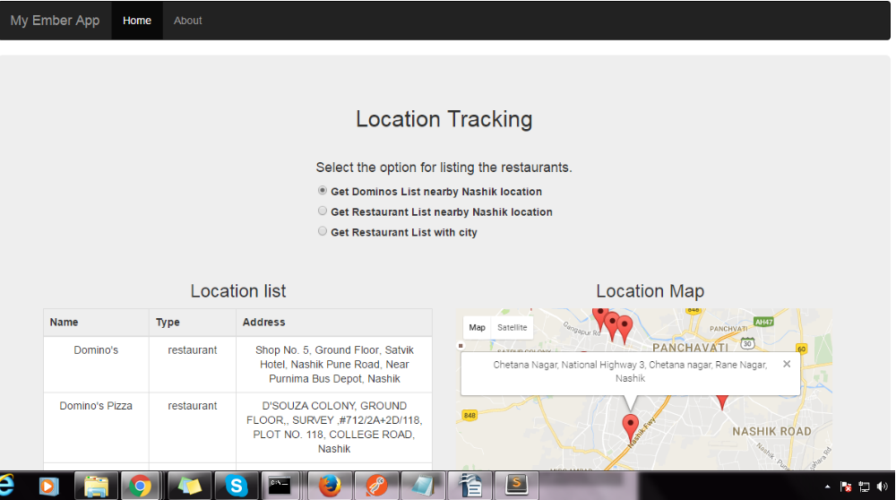
2. Getting the user entered restaurant list near by current location
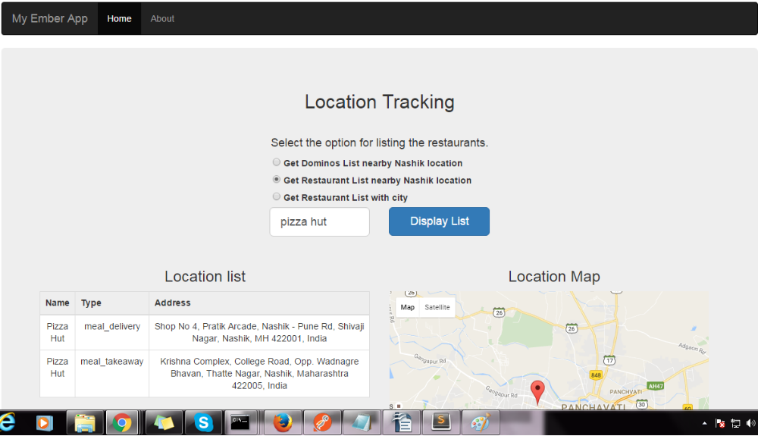
3. Getting the restaurant list near by user provided city
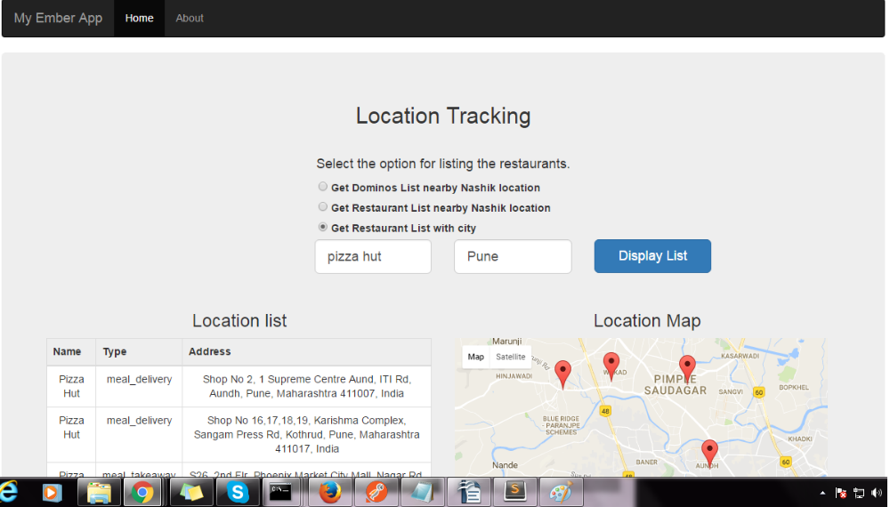
4. Getting the information about the application
