1. **what is relational logical operators write an example ?**

It will give the relation between two operands and returns the output true or false

EX:- >,<,>=,<=

1. **how to find the ascii valu of any char ?**

Using ord()

Code:- output:-

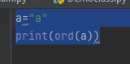 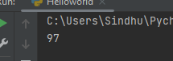

1. **x=3 o/p x=27 -> use pow fun**

Code:- output:-

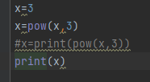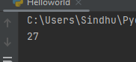

1. **x=[1,2,3,4,4,5] remove only frst and last ele using slicing**

Code:- output:-

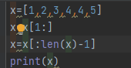 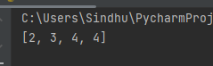

1. **x=[1,2,3,1,2,3]->convert list to set and set to tuple**

Code:- output:-

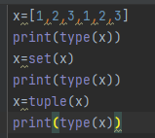 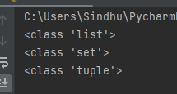

**7) write a exmple of ternary operator?**

a,b=10,20

C=a if a<b else b

Print©

1. **=100 ,=200 o/p _+_ ?**

Code:- output:-

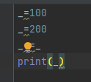 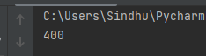

1. **a=1 ,b=20 condition is (a and b) True or False ?**

**false**

1. **a="python" multiply a with three times?**

Code:- output:-

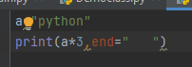 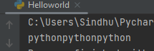

1. **a=' ' ,b=3 multifly by b and find the len of a ?**

Code:- output:-

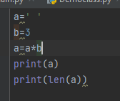 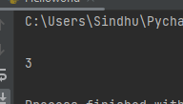

1. **a=123.5 a=123 using floor fun(import math module) ?**

Code:- output:-

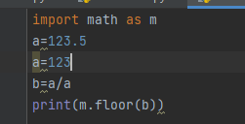 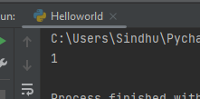

1. **generate numbers(10,1) reverse ordr using range fun ? o/p : 10,9,8,7 ...1**

**Code:-**

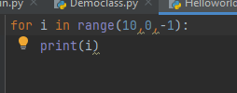

Output:-

