1. **what is interpreter and compiler ?**

Ans:-Interpreter executes the code line by line and consumes more execution time .

Compiler executes full program at a time hence consumes less execution time.

1. **X="BAD" check chr(97-32) is exits or not ?**

Code:-

1. **a=3,b=6 swap two numbers using bitwise operaators ?**

Code:- output:-

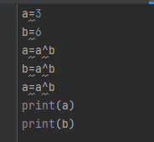 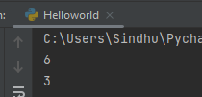

1. **what are logical operators with example ?**

Used on condtion operator returns true or false

EX:- And , OR ,not

1. **convert int to (bin and str) format?**

Code:- output:-

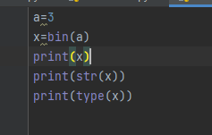 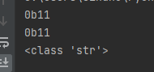

**7) diff b/w list and tuple**

List is a collection of diifrent type of data elements. We can change values in list since its mutable.

* List allows dulpicates

* Syntax varname=[]

*We can add dataelement inside list

*insertion order is preserved

Tuple is exactly same as a list but we cant change the tuple values because it is im mutable  
 *tuple is contant  
 *syntax =var_namr=()  
 syntax =var_namr=tuple()

1. **x={'A':100,'B'=200,'A':300} is it correct ? if correct what is the val of A?**

Above dir syntax is wrong in place = we need to give : .

1. **what is range and write syntax ?**

Range data type represents the sequence of numbers  
 *Range also immutable we cant chnage the range values  
 *Syntax : Range(stindx,endindx,stepping)

1. **x=[1,2,3,4] -> o/p is [1,8,27,64] -> use pow or exponent**

Code:- output:-

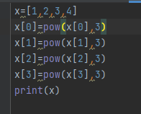 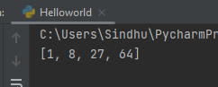

1. **a=10,b=20 find the biggest of two numbers using ternary operator ?**

Code:- output:-

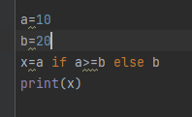 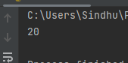

1. **x=list(range(1,11)) -> get only even numbers print in list ?**

1. **x=[1,2,3,4,3] -> reverse the list**

Code:- output:-

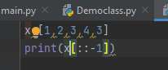 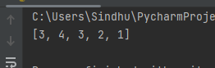

1. **a=2, b=3 (use << left shift) what is the output ?**

Code:-

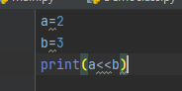 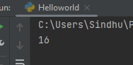

1. **x="HELLO" output is EL ?**

Code:-

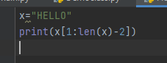 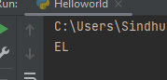

1. **x=[1,2,3,4,5,3,5] ->Remove duplicates from list o/p [1,2,3,4,5]**

Code:-

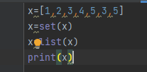 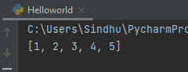

1. **how to add two strings ?**

We can add two strings using plus(+) operator