**Conditional Statements**

1. **If statement:-**

EX**:-** code:- output

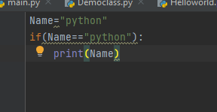 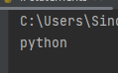

1. **if else**

**Ex:1** Code:-

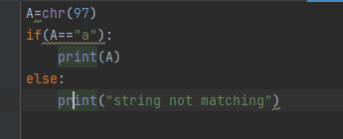

Output:- 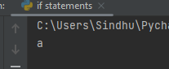

EX:2

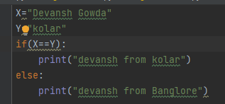

Output

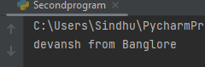

1. **if elif else**

Code:-

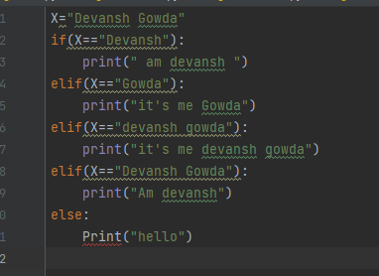

Output:-

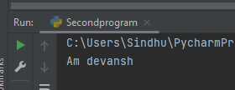

**EX:-2**

**Code:-**

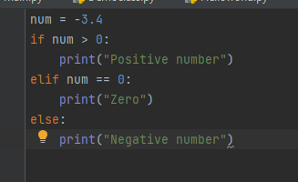

Output:-

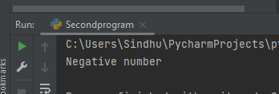

1. **Nested if**

**EX:-1 code:-**

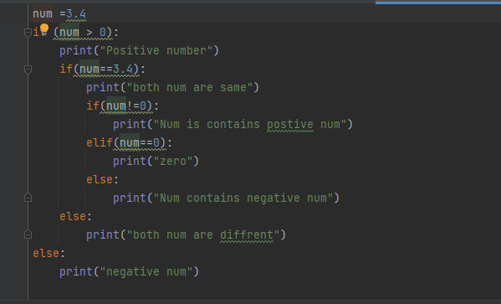

Output:-

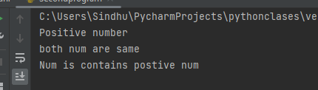

**EX:2**

**Code:**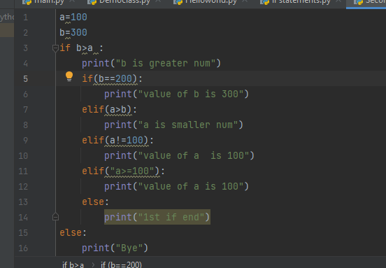

Output:-

