- diff b/w list and set
List is a collection of diifrent type of data elements. We can change values in list since its mutable.
* List allows dulpicates
* Syntax varname=[]
*We can add dataelement inside list
*insertion order is preserved
Set is a collection of different type of data elements . it’s mutable
* list dones’nt allow duplicates
*syntax: varname={val1,val2..}
* *insertion order is not preserved

- x=[1,2,3,4,5,3,5] ->Remove duplicates from list o/p [1,2,3,4,5]
Code:-
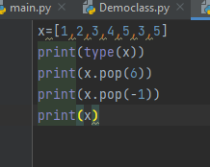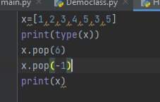
Output:-
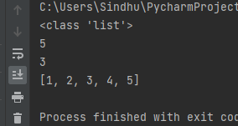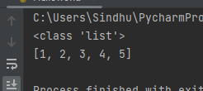

- x=[1,2,3] -> o/p -> x=[10,20,30]
Code:-
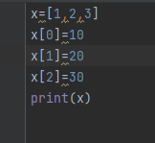
Output:-
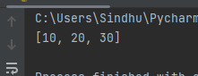

- print odd and even numbers from range
Even Num:-
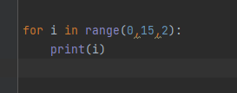
output

Odd num:-
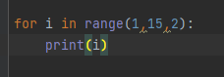
Output:-
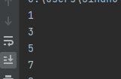

- x=[1,2,3,4,5] -> get even numbers from x using slicing
Code:-
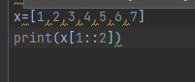
Output:-
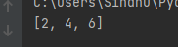

7)x=[1,2,3] -> reverse the list using slicing
Code:-
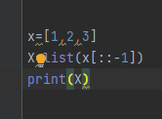
Output:-
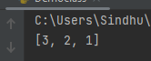
8)x=(1,2,3,4) -> how to change the tuple data
We can tuple data by using list
Code:-
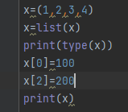
Output:-
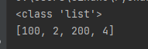

- swap two numbers without usigng third variable
Code:-
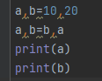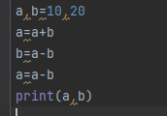
Output:-
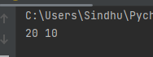

- how to convert number into binary
By using bin()

- x=[1,2,3,4,5] -> [1,8,27,64,125] -> use exponent ope
Code:-
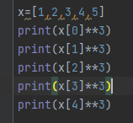
Output:-
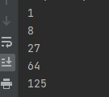

- what is Dictionary and write syntax
Dictionaries are used to store data values in key: value and we can change values and keys but do not allow duplicates
Syntax:-varname={key:value,key:value…….}

- create a dic and get only values from dictionry
Code:-
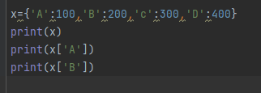
Output:-
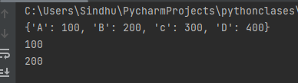

- x={0} ,y={'A':1,'B':124} what is diff b/w x,y
X is a set
Y is a dictionary

