1. What is SDLC ?

|  |  |
| --- | --- |
| Requirement Collection/Gathering | Establish Customer Needs |
| Analysis | Model and specify the requirements - “what”. |
| Design | Model and specify a solution - “why” |
| Implementation | Constriction a solution in software |
| Testing | Validate the solution against the requirement |
| Maintance | Repair defect and adapt the solution to the new requirement |

Ans:

1. What is Software Testing?

Ans: Testing is the process of evaluating a system or its component(s) with the intent to

find that whether it satisfies the specified requirements or not.

Software testing is a process used to identify the correctness, completeness & quality

of development computer software .

1. What is Agile Methodology?

Ans: It is a ambulation iterative and increment model.

It divides the software into small incremental builds, this build are provided in

iterations, that means the big project are divided into small chunks (iterations).

1. What is SRS?

Ans: SRS is a complete description of the behavior of the system to be developed.

SRS contains use case diagram that description all the interation user will have with

the software application.

1. What is OOP?

Ans: Identifying objects and assigning responsibilities to these objects.

Object Oriented Programming is way at writing the programs in orgainzed way .

An object is like a black box.

1. Write Basic Concept of OOPS?

Ans: • Object

• Class

• Encapsulation

• Inheritance

• Polymorphism

• Overriding

• Overloading

• Abstraction

1. What is Object?

Ans: Object is a collection at data member and member function.

An object represents an individual, identifiable item, unit, or entity, either real or

abstract, with a well-defined role in the problem domain.

1. What is Class?

Ans: Class is collection at data member and member function.

A class represents an abstraction of the object and abstracts the properties and

behavior of that object.

1. What is Encapsulation?

Ans: The process wrapping the data in a single unit. To secure the data from outside

world. Encapsulation is the practice of including in an object everything it needs

hidden from other objects. The internal state is usually not accessible by other

objects.

1. What is Inheritance?

Ans: Inheritance means that one class inherits the characteristics of another class. This is

also called a “is a” relationship.

Making a class from an existing class. Deriving the attribute of some other class.

1. What is Ploymorphism?

Ans: One name multiple form.

It allows different objects to respond to the same message in different ways, the

response specific to the type of the object.

1. Write SDLC phases with basic introduction?

Ans:

1. **Analysis Phases:-** Details on computer programming languages and environments, machines, packages, application architecture, distributed architecture layering, memory size, platform, algorithms, data structures, global type definitions, interfaces, and many other engineering details are established.
2. **Design Phases:**- Design Architecture Document

Implementation Plan   
 Critical Priority Analysis

Performance Analysis

Test Plan

1. **Implementation Phases:-** In the implementation phase, the team builds the components either from scratch or by composition.

• Implementation – Code

• Critical Error Removal

1. **Testing Phases:-** The testing phase is a separate phase which is performed by a different team after the implementation is completed. Simply stated, quality is very important. Many companies have not learned that quality is important and deliver more claimed functionality but at a lower quality level.
2. **Maintenance Phases:-** Maintenance is the process of changing a system after it has been deployed.

• Corrective maintenance: identifying and repairing defects

• Adaptive maintenance: adapting the existing solution to the new

platforms.

* Perfective Maintenance: implementing the new requirements

1. Explain Phases of the Waterfall Model?

Ans: The waterfall is unrealistic for many reasons, especially:

• Requirements must be “frozen” to early in the life cycle

• Requirements are validated too late

1. **Analysis Phases:-** Details on computer programming languages and environments, machines, packages, application architecture, distributed architecture layering, memory size, platform, algorithms, data structures, global type definitions, interfaces, and many other engineering details are established.
2. **Design Phases:**- Design Architecture Document

Implementation Plan   
 Critical Priority Analysis

Performance Analysis

Test Plan

1. **Implementation Phases:-** In the implementation phase, the team builds the components either from scratch or by composition.

• Implementation – Code

• Critical Error Removal

1. **Testing Phases:-** The testing phase is a separate phase which is performed by a different team after the implementation is completed. Simply stated, quality is very important. Many companies have not learned that quality is important and deliver more claimed functionality but at a lower quality level.
2. **Maintenance Phases:-** Maintenance is the process of changing a system after it has been deployed.

• Corrective maintenance: identifying and repairing defects

• Adaptive maintenance: adapting the existing solution to the new

platforms.

* Perfective Maintenance: implementing the new requirements

1. Write Phases of spiral model?

Ans: Spiral Model is very widely used in the software industry as it is in synch with the

natural development process of any product i.e. learning with maturity and also

involves minimum risk.

• When costs there are a budget constraint and risk evaluation is important.

• For medium to high-risk projects.

• Long-term project commitment because of potential changes to economic

priorities as the requirements change with time.

1. Planning:- determination of objectives, alternatives and constraints.
2. Risk Analysis:- analysis of alternatives and identification/ resolution of risks
3. Customer Evaluation:- Assessment of the result of engineering.
4. Engineering:- Development of the “next level” product.
5. Explain working methodology of agile model and also write pros and cons?

Ans: It is a ambination iterative and increment model.

It divides the software into small incremental builds, this build are provided in

iterations, that means the big project are divided into small chunks (iterations).

**Pros:**

* Changing Requirements can be accommodated.
* Requirements can be captured more accurately.
* Users see the system early.
* Easy to manage

**Cons:**

* Management is more complex
* End of project may not be known early
* Process is complex
* Spiral may go indentifily.

1. Draw use case on Online Book Shopping?

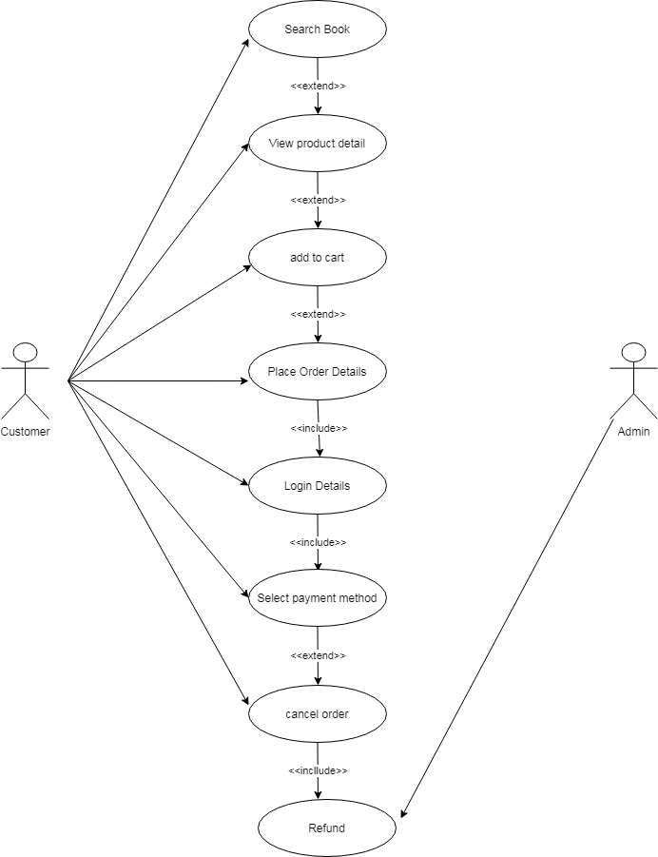

1. Draw use case on Online Shopping Product using COD.

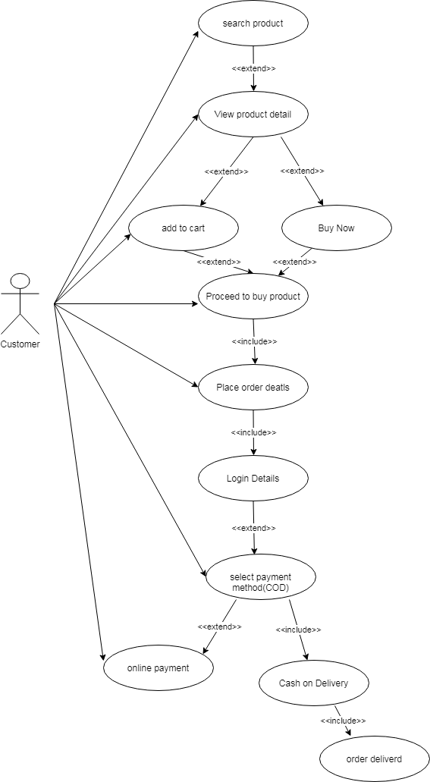

1. Draw use case on Online bill payment system (Paytm)?

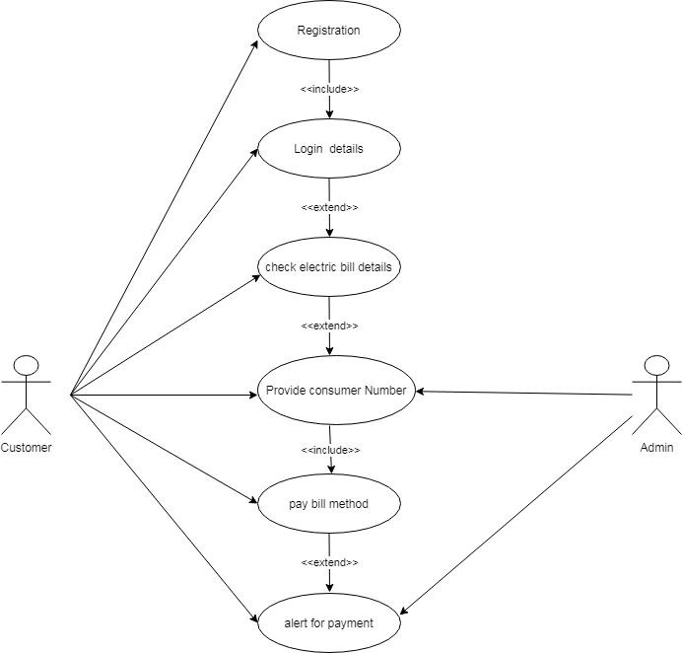

1. Draw use case on online shopping product using payment gateway?

