Count Divisors
HackerEarth
https://www.hackerearth.com/practice/basic-programming/input-output/basics-of-input-output/practice-problems/algorithm/count-divisors/

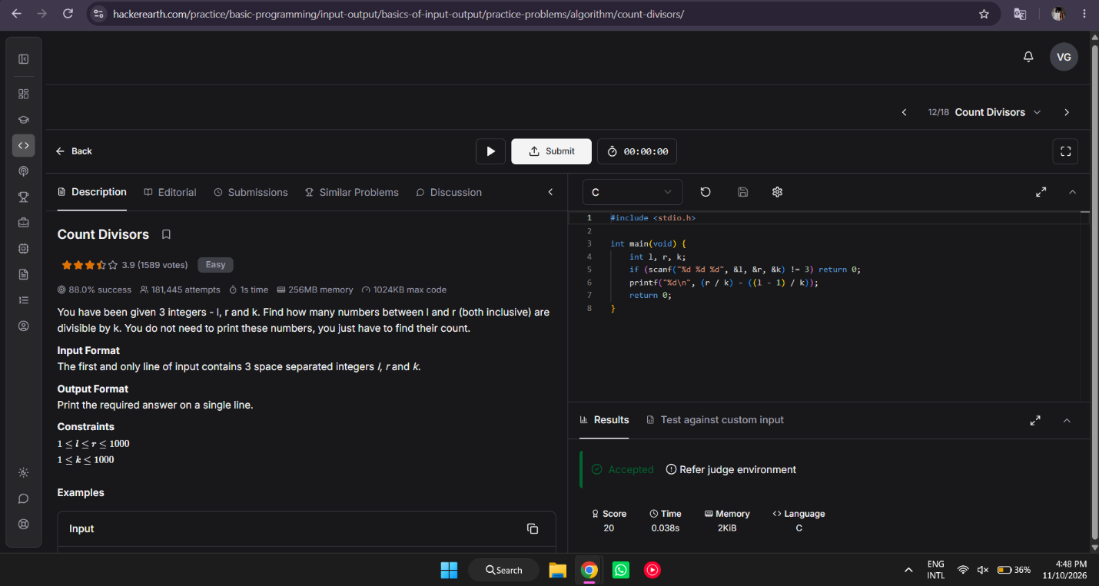

#include <stdio.h>

int main(void) {
int l, r, k;
if (scanf("%d %d %d", &l, &r, &k) != 3) return 0;
printf("%d\n", (r / k) - ((l - 1) / k));
return 0;
}

