Digit Sum
HackerEarth
https://www.hackerearth.com/problem/algorithm/digit-sum-4/

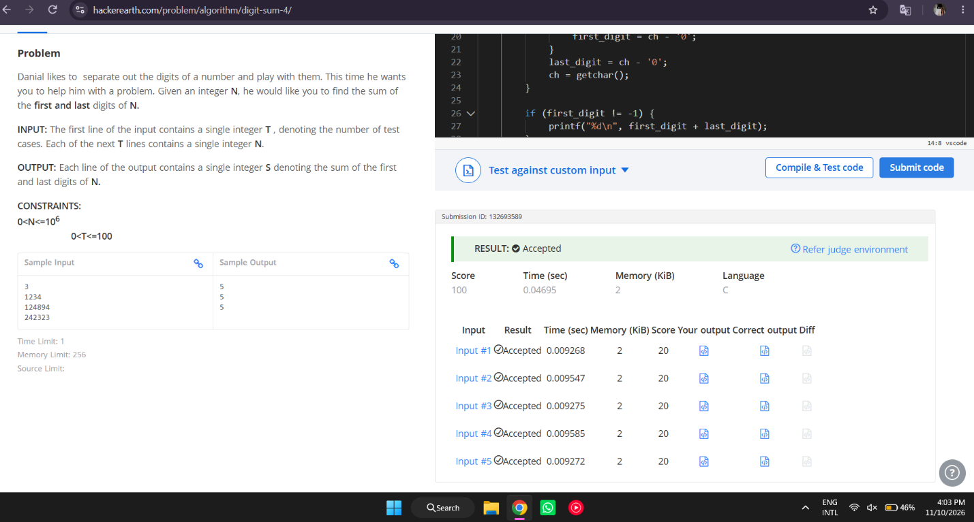

#include <stdio.h>

int main(void) {
int t;
if (scanf("%d", &t) != 1) {
return 0;
}

while (t--) {
int ch;
int first_digit = -1;
int last_digit = -1;

while ((ch = getchar()) != EOF && (ch == ' ' || ch == '\n' || ch == '\t' || ch == '\r'));

while (ch >= '0' && ch <= '9') {
if (first_digit == -1) {
first_digit = ch - '0';
}
last_digit = ch - '0';
ch = getchar();
}

if (first_digit != -1) {
printf("%d\n", first_digit + last_digit);
}
}

return 0;
}

