Factorial!
HackerEarth
https://www.hackerearth.com/practice/basic-programming/input-output/basics-of-input-output/practice-problems/algorithm/find-factorial/

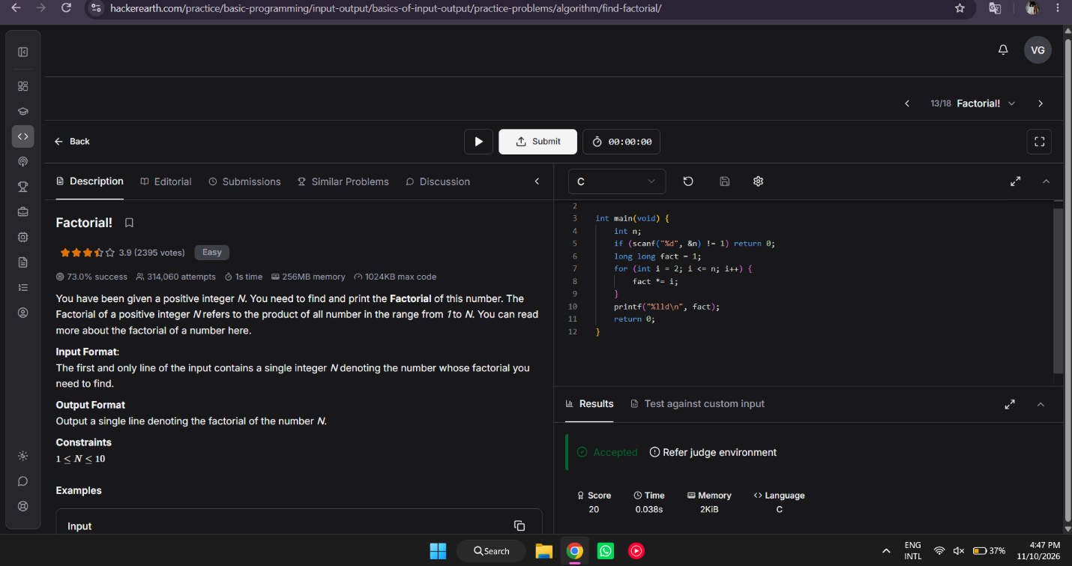

#include <stdio.h>

int main(void) {
int n;
if (scanf("%d", &n) != 1) return 0;
long long fact = 1;
for (int i = 2; i <= n; i++) {
fact *= i;
}
printf("%lld\n", fact);
return 0;
}

