Prime Numbers
HackerEarth
https://www.hackerearth.com/problem/algorithm/prime-numbers/

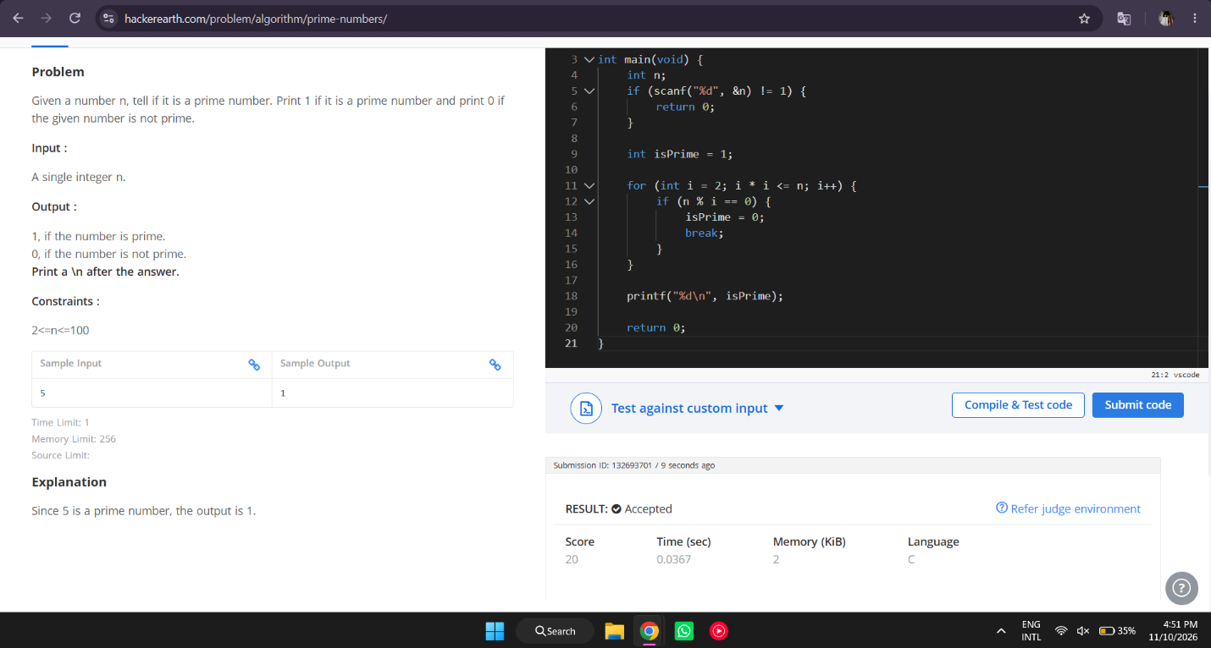

#include <stdio.h>

int main(void) {
int n;
if (scanf("%d", &n) != 1) {
return 0;
}

int isPrime = 1;

for (int i = 2; i * i <= n; i++) {
if (n % i == 0) {
isPrime = 0;
break;
}
}

printf("%d\n", isPrime);

return 0;
}

