Read From STDIN, Write to STDOUT
HackerEarth
https://www.hackerearth.com/practice/basic-programming/input-output/basics-of-input-output/practice-problems/algorithm/io-exercise/

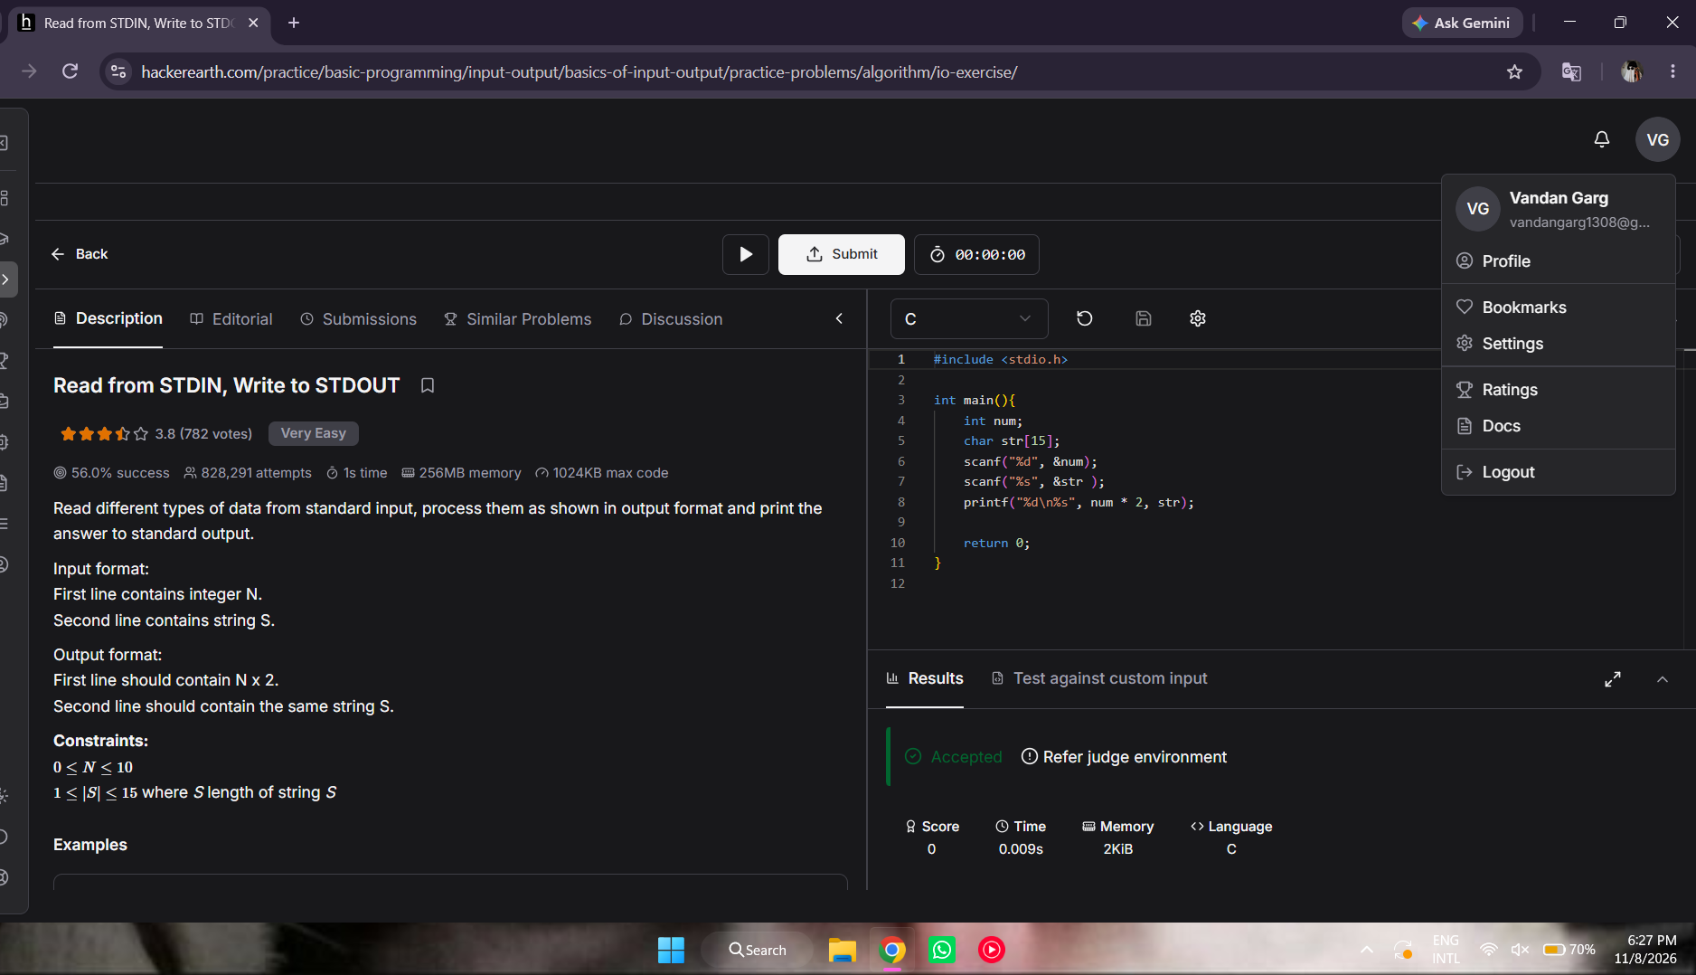

#include <stdio.h>

int main(){
int num;
char str[15];
scanf("%d", &num);
scanf("%s", &str );
printf("%d\n%s", num * 2, str);

return 0;
}

