Roy and Profile Picture
HackerEarth
https://www.hackerearth.com/practice/basic-programming/input-output/basics-of-input-output/practice-problems/algorithm/roy-and-profile-picture/

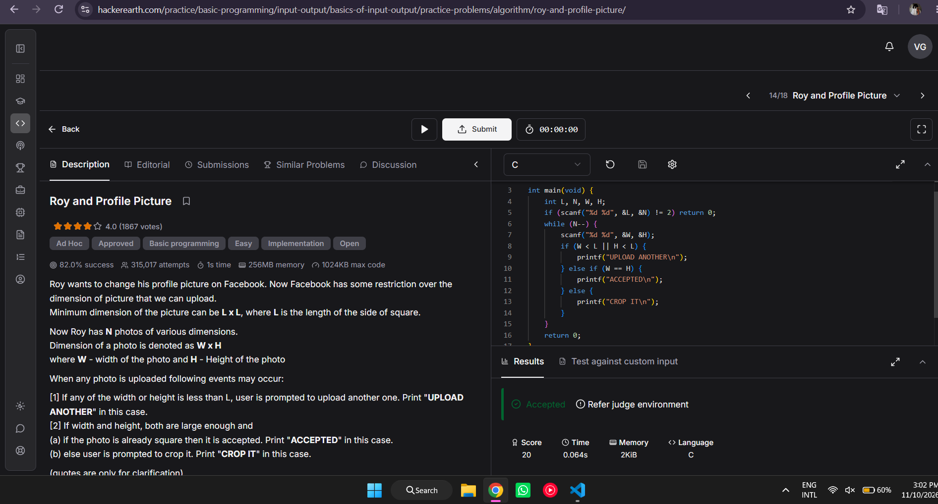

#include <stdio.h>

int main(void) {
int L, N, W, H;
if (scanf("%d %d", &L, &N) != 2) return 0;
while (N--) {
scanf("%d %d", &W, &H);
if (W < L || H < L) {
printf("UPLOAD ANOTHER\n");
} else if (W == H) {
printf("ACCEPTED\n");
} else {
printf("CROP IT\n");
}
}
return 0;
}

