For Loop in C
HackerRank
https://www.hackerrank.com/challenges/for-loop-in-c/problem

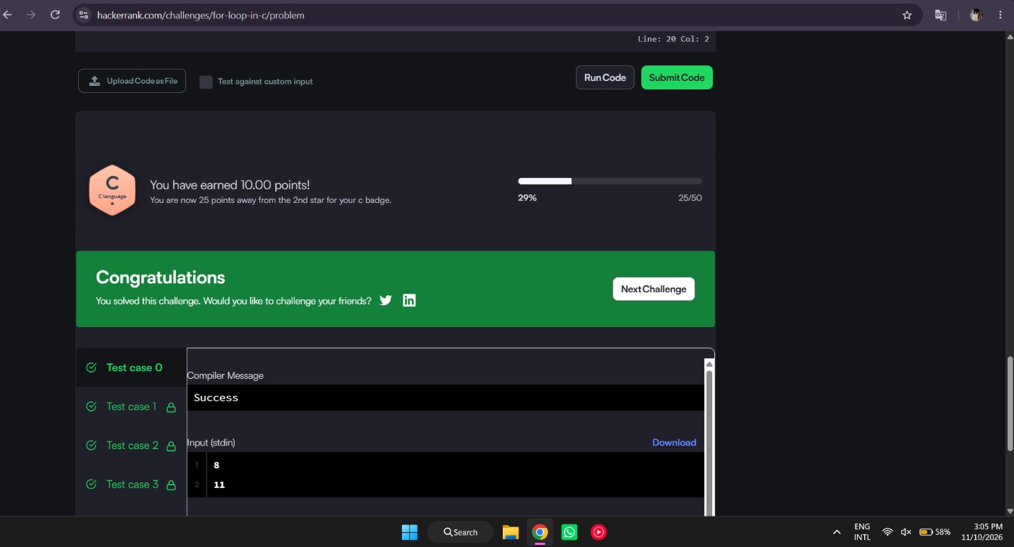
#include <stdio.h>

int main(void) {
int a, b;
if (scanf("%d %d", &a, &b) != 2) return 0;

static const char *names[] = {
"", "one", "two", "three", "four",
"five", "six", "seven", "eight", "nine"
};

for (int i = a; i <= b; i++) {
if (i >= 1 && i <= 9) {
printf("%s\n", names[i]);
} else {
printf("%s\n", (i % 2 == 0) ? "even" : "odd");
}
}
return 0;
}

