Subtract The Product and Sum of Digits on an Integer
LeetCode- 1281
https://leetcode.com/problems/subtract-the-product-and-sum-of-digits-of-an-integer/description/

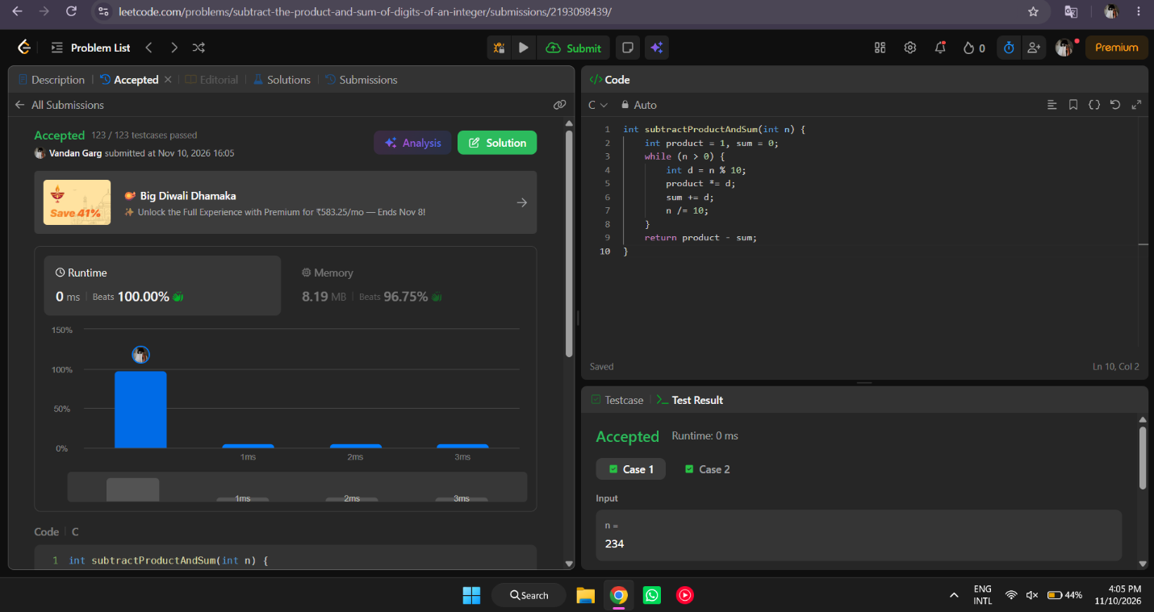

int subtractProductAndSum(int n) {
int product = 1, sum = 0;
while (n > 0) {
int d = n % 10;
product *= d;
sum += d;
n /= 10;
}
return product - sum;
}

