Counts Operations to obtain zero
LeetCode- 2169
https://leetcode.com/problems/count-operations-to-obtain-zero/description/

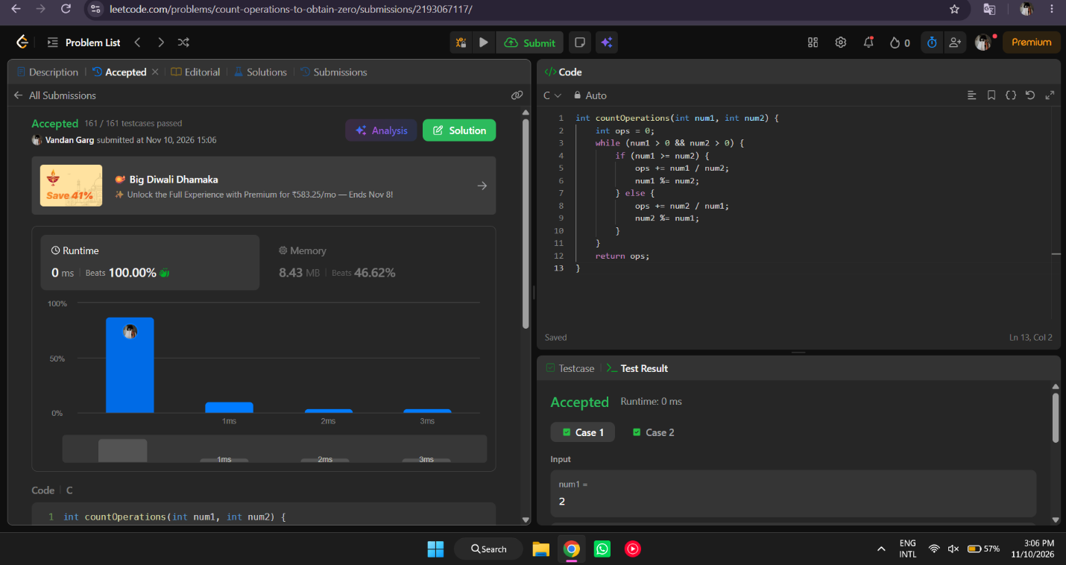

int countOperations(int num1, int num2) {
int ops = 0;
while (num1 > 0 && num2 > 0) {
if (num1 >= num2) {
ops += num1 / num2;
num1 %= num2;
} else {
ops += num2 / num1;
num2 %= num1;
}
}
return ops;
}

