Power of two
LeetCode-231
https://leetcode.com/problems/power-of-two/description/

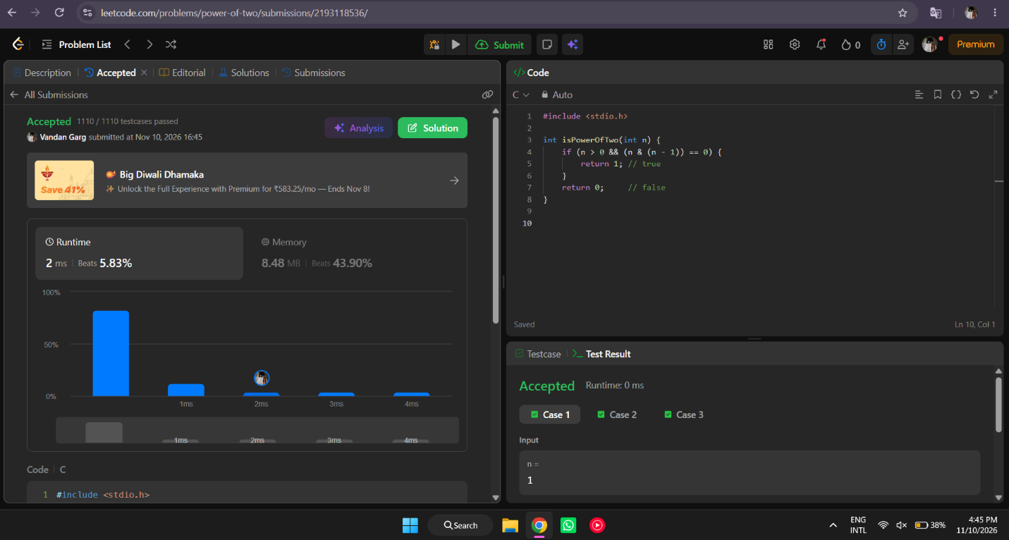

#include <stdio.h>

int isPowerOfTwo(int n) {
if (n > 0 && (n & (n - 1)) == 0) {
return 1; // true
}
return 0; // false
}

