Smallest Even Multiple
LeetCode- 2413
https://leetcode.com/problems/smallest-even-multiple/

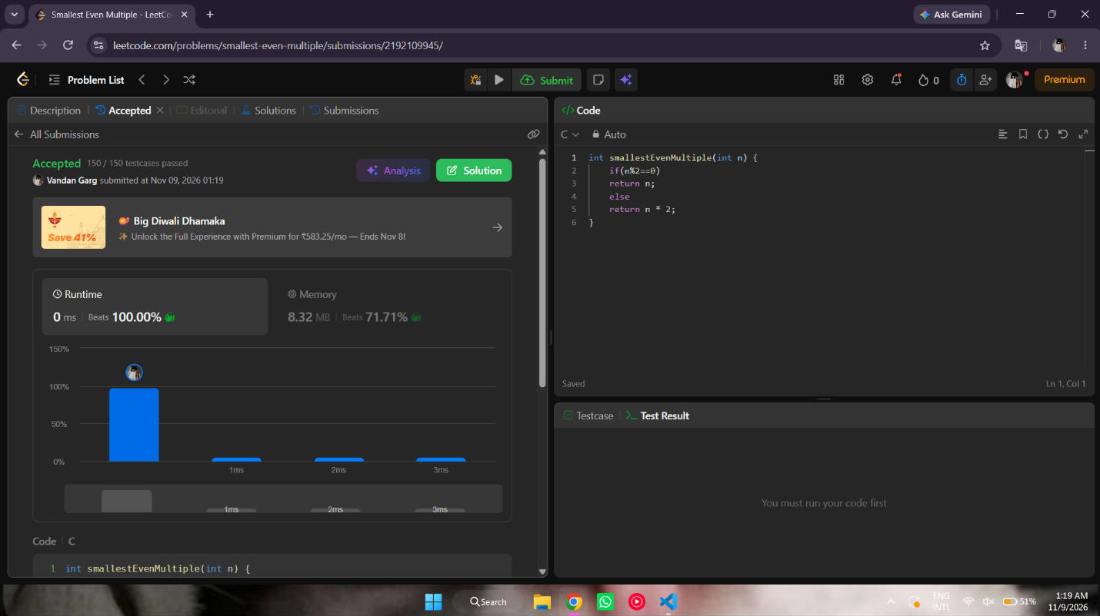

int smallestEvenMultiple(int n) {
if(n%2==0)
return n;
else
return n * 2;
}

