Count the Digits that divide a number
LeetCode- 2520
https://leetcode.com/problems/count-the-digits-that-divide-a-number/description/

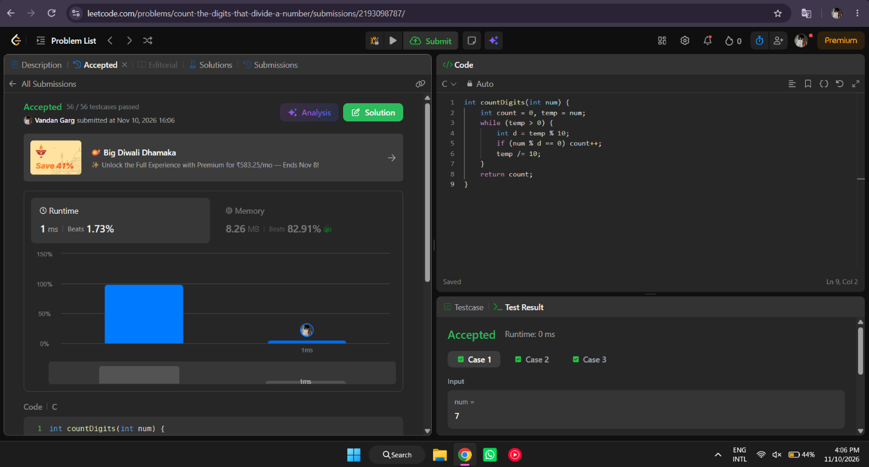

int countDigits(int num) {
int count = 0, temp = num;
while (temp > 0) {
int d = temp % 10;
if (num % d == 0) count++;
temp /= 10;
}
return count;
}

