Calculate Delayed Arrival Time
LeetCode- 2651
https://leetcode.com/problems/calculate-delayed-arrival-time/description/

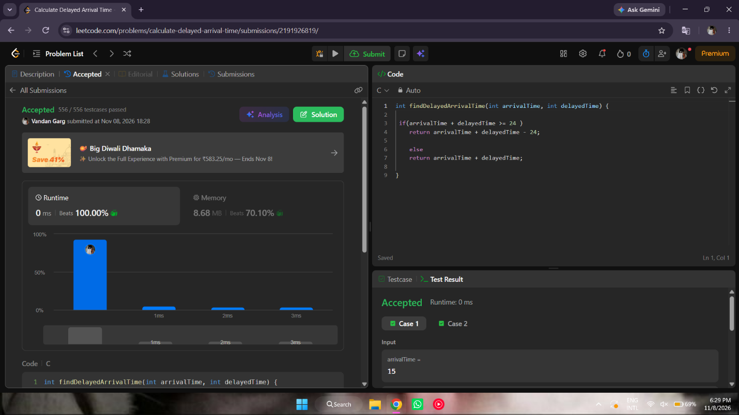

int findDelayedArrivalTime(int arrivalTime, int delayedTime) {

if(arrivalTime + delayedTime >= 24 )
return arrivalTime + delayedTime - 24;

else
return arrivalTime + delayedTime;

}

