Sum Multiplies
LeetCode- 2652
https://leetcode.com/problems/sum-multiples/description/

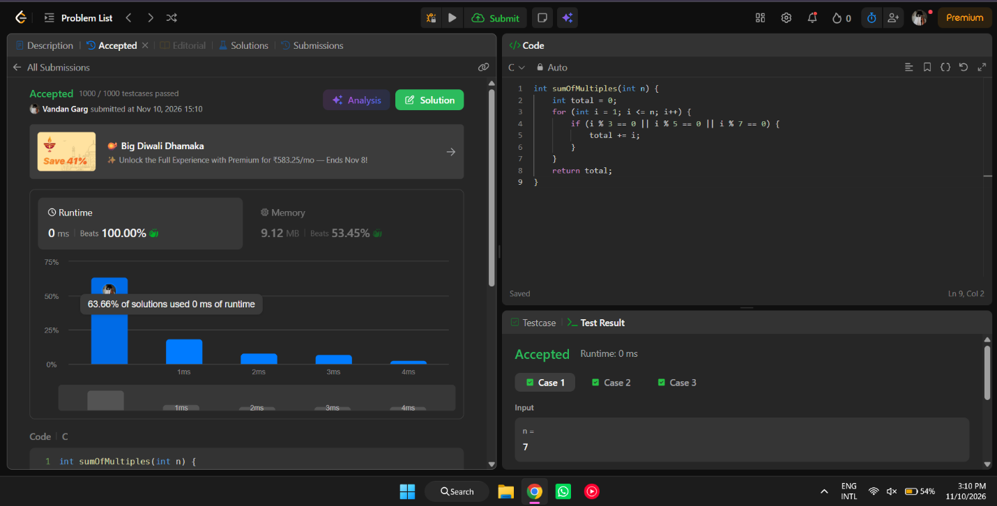

int sumOfMultiples(int n) {
int total = 0;
for (int i = 1; i <= n; i++) {
if (i % 3 == 0 || i % 5 == 0 || i % 7 == 0) {
total += i;
}
}
return total;
}

