Total Distance Traveled
LeetCode- 2739
https://leetcode.com/problems/total-distance-traveled/description/

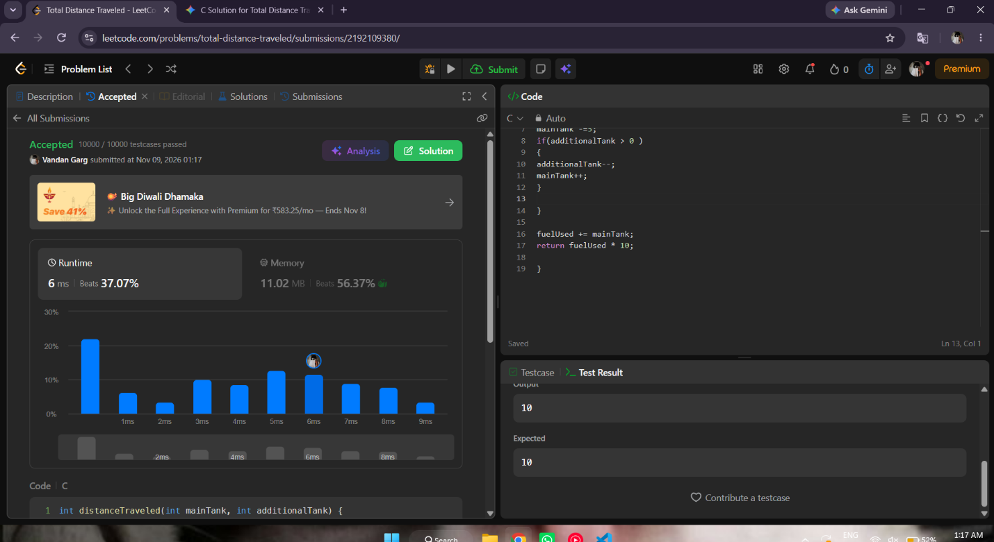

int distanceTraveled(int mainTank, int additionalTank) {
int fuelUsed = 0;

while(mainTank>=5){
fuelUsed +=5;
mainTank -=5;
if(additionalTank > 0 )
{
additionalTank--;
mainTank++;
}

}

fuelUsed += mainTank;
return fuelUsed * 10;

}

