Power Of three
LeetCode-326
https://leetcode.com/problems/power-of-three/

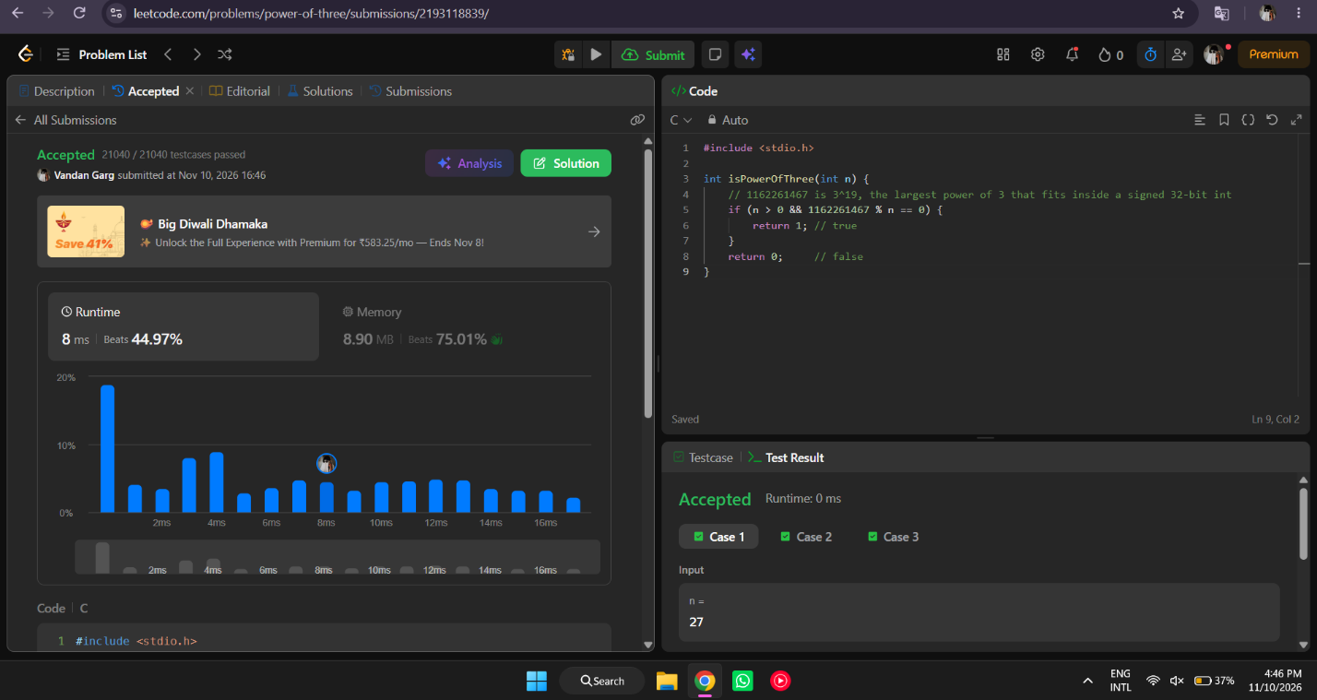

#include <stdio.h>

int isPowerOfThree(int n) {

if (n > 0 && 1162261467 % n == 0) {
return 1;
}
return 0;
}

