Reverse Integer
LeetCode-7
https://leetcode.com/problems/reverse-integer/description/

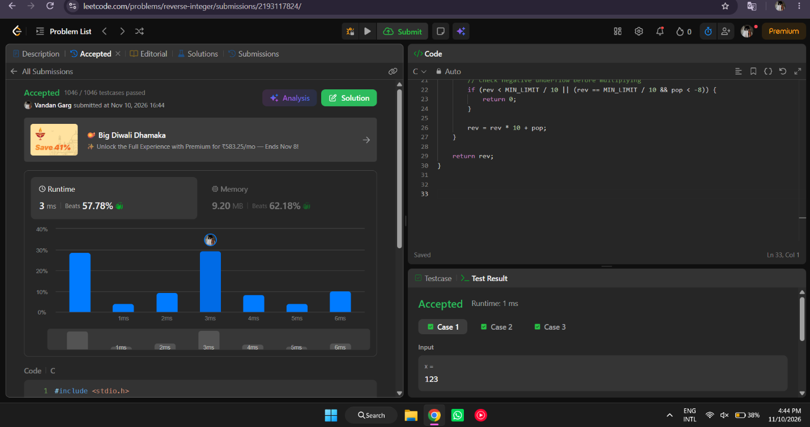

#include <stdio.h>

int reverse(int x) {
int rev = 0;

const int MAX_LIMIT = 2147483647;
const int MIN_LIMIT = -2147483648;

while (x != 0) {
int pop = x % 10;
x /= 10;

if (rev > MAX_LIMIT / 10 || (rev == MAX_LIMIT / 10 && pop > 7)) {
return 0;
}

if (rev < MIN_LIMIT / 10 || (rev == MIN_LIMIT / 10 && pop < -8)) {
return 0;
}

rev = rev * 10 + pop;
}

return rev;
}

