Palindrome Number
LeetCode-9
https://leetcode.com/problems/palindrome-number/description/

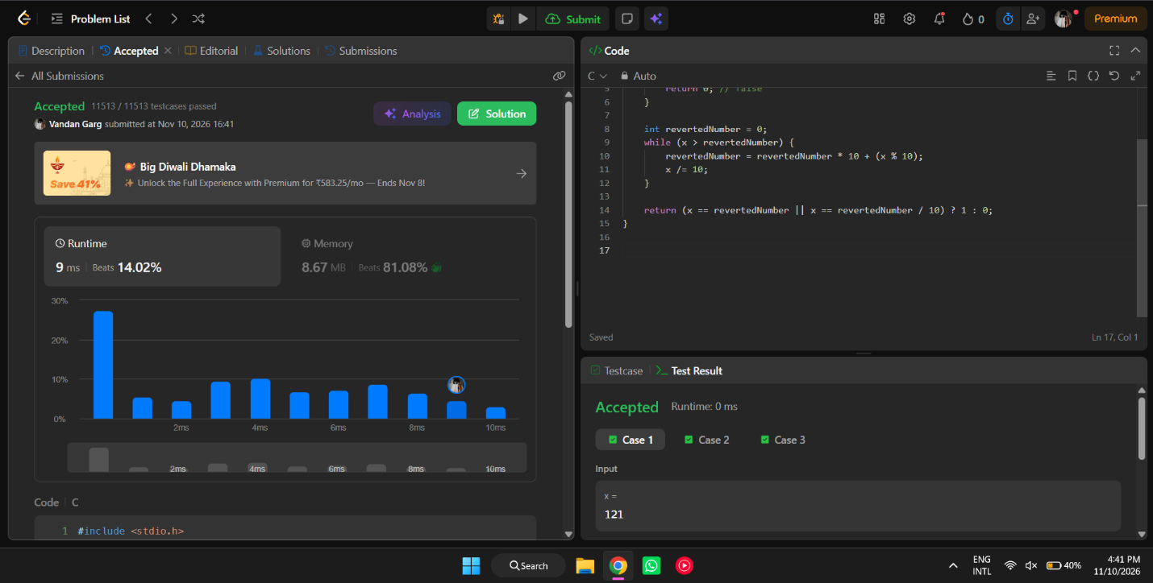

#include <stdio.h>

int isPalindrome(int x) {
if (x < 0 || (x % 10 == 0 && x != 0)) {
return 0; // false
}

int revertedNumber = 0;
while (x > revertedNumber) {
revertedNumber = revertedNumber * 10 + (x % 10);
x /= 10;
}

return (x == revertedNumber || x == revertedNumber / 10) ? 1 : 0;
}

