# **SELF DRIVING CAR**

**By Felix Vandemaele**

**User Manual**

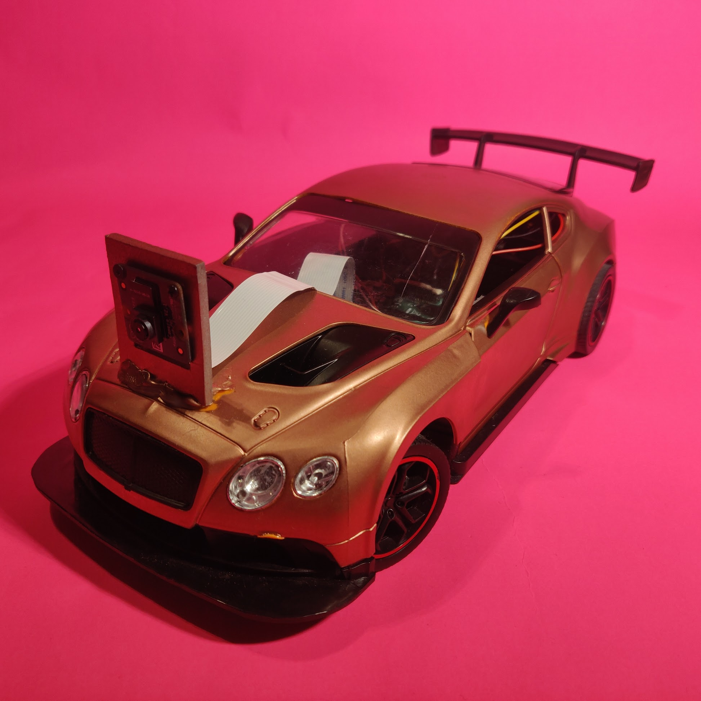

**Step 1:**

Plug your Raspberry Pi into the power bank with the micro USB cable.

**Step 2:**

Connect to the Raspberry Pi using Putty or terminal on your laptop. If you connect via terminal use the command:

ssh <username>@<hostname>

**Step 3:**

Log in to the Raspberry Pi with your username and password.

**Step 4:**

Navigate to the folder in which the drive.py file is located.

cd code/

**Step 5:**

Put the car inside the track and start the car by running ‘drive.py’.

python3 drive.py

The script has multiple parameters.

* “ -r ” : This sets the resolution. Default is (640 x 480).
* “ -l “ : This enables the headlights of the car.
* “ -s “ : This sets the speed of the car in a straight line. Default is set to 60.
* “ -f “ : This sets the amount of frames taken per second. Default is set to 32.

**Step 6:**

The car will keep driving until you stop it. To stop the car press:

*CTRL + C*