Does AI change the shock resilience of countries?

Research question
We investigate whether exposure to AI moderates a countries’ resilience to shocks in uncertainty and geopolitical risk. Two AI-related channels are distinguished: a structural channel related to ICT/AI investment and a cyclical channel linked to a countries’ exposure to the global semiconductor cycle. The response of economic growth to the shocks and the moderating effect of both AI-related channels are assessed by a panel local projection model, estimated for seven euro area countries. Annex # provides more details.

Structural channel
The literature finds that ICT/AI-investment can improve shock resilience by enhancing firms’ flexibility, information processing and supply chain management (Moujahid et al., 2025). We estimate the effect of the structural channel by,

GDPᵢ,ₜ₊ₕ = αᵢ,ₕ + β₁,ₕ Shockₜ + β₂,ₕ Fᵢₜ + β₃,ₕ(Shockₜ × Fᵢₜ) + ΓₕXᵢ,ₜ + εᵢ,ₜ₊ₕ

F is a smooth transition function distinguishing low- and high-ICT investment (the state variable) across time and countries i. Coefficient of interest β₃ captures to what extent this investment dampens or amplifies the impact of shocks on GDP growth. Vector X includes controls (one lag of GDP and a time trend).
ICT/AI investment is measured by investment in ICT equipment and computer software and databases as share of total gross fixed capital formation. Chart # shows that the ICT/AI-related investment ratio varies across time and countries, with AT, FR and NL having relatively high shares.
As alternative state variable we include the number of investments and patent applications in AI fields in F. The time dimension of these data is limited, as shown in Chart # for investment.

Chart # ICT-investment over total investment Chart # Number of investments in AI
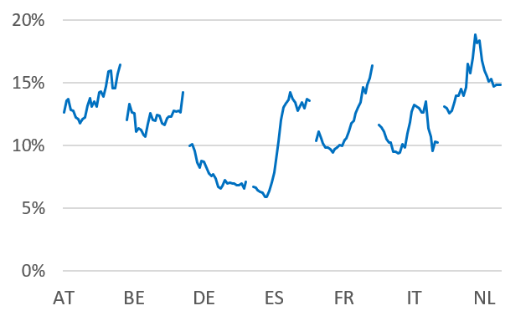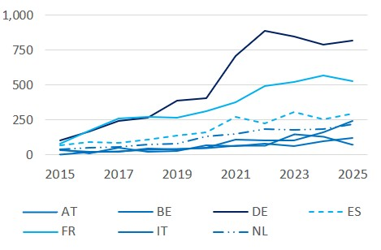
Note: annual series 2000-2024 (Eurostat) Note: annual series 2015-2025 (ETOs CAT)

Cyclical channel
A countries’ exposure to the global semiconductor cycle can indicate positive trade effects from AI-related global activity. This holds in particular for economies on the AI-supply side. We estimate the effect of the cyclical channel by,

GDPᵢ,ₜ₊ₕ = αᵢ,ₕ + β₁Shockₜ + β₂Fᵢₜ + β₃Dₜ + β₄(Shockₜ×Fᵢₜ) + β₅(Shockₜ×Dₜ) + β₆(Shockₜ×Fᵢₜ×Dₜ) + ΓₕXᵢ,ₜ + εᵢ,ₜ₊ₕ

F is a smooth transition function distinguishing low- and high-correlation of the national stock index to the global semiconductor index (SOX). Coefficients of interest β₄ and β₆ capture to what extent this semiconductor exposure moderates the effects of uncertainty or geopolitical shocks on GDP growth. Vector X includes controls (one lag of GDP and a time trend).
Dummy variable D distinguishes booms and busts in the semiconductor cycle, assuming that its moderating effect varies between the two regimes (high AI-exposure might mitigate the impact of shocks if the semiconductor index rises and amplify the shock impact if the index falls).
Chart # shows that the semiconductor exposure of IT and NL have increased since 2020, with NL having the highest correlation with the semiconductor cycle.

Chart # Exposure to semiconductor index
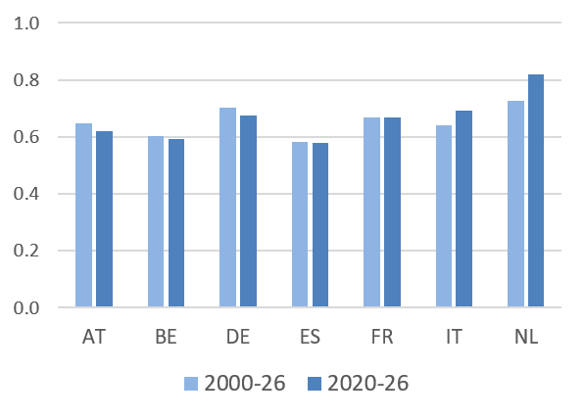
Note: exposure is measured as correlation between national stock index and global semiconductor index (8 quarter rolling correlation of quarterly log returns; source: Yahoo Finance).

Shocks
We take into account shocks in global uncertainty and geopolitical risk. The former is proxied by the World Uncertainty Index (WUI), constructed by the IMF. Geopolitical risk is measured by the GPR index, developed by Caldara and Iacoviello. We extract the unexpected component from the shock series by taking the residual from an autoregressive model and include this as shock variable in the model.

Results
Baseline
Charts #.a-b show the impact of the shocks on economic growth, excluding the AI-related channels. The impact follows from a ‘baseline’ autoregressive panel model for GDP growth. The cumulative impulse responses show that uncertainty shocks have a (borderline) significant negative impact on annual economic growth. Geopolitical shocks have no significant growth impact in this simple model.

Chart # Impact of shocks on GDP growth
- Uncertainty shock b. Geopolitical shock
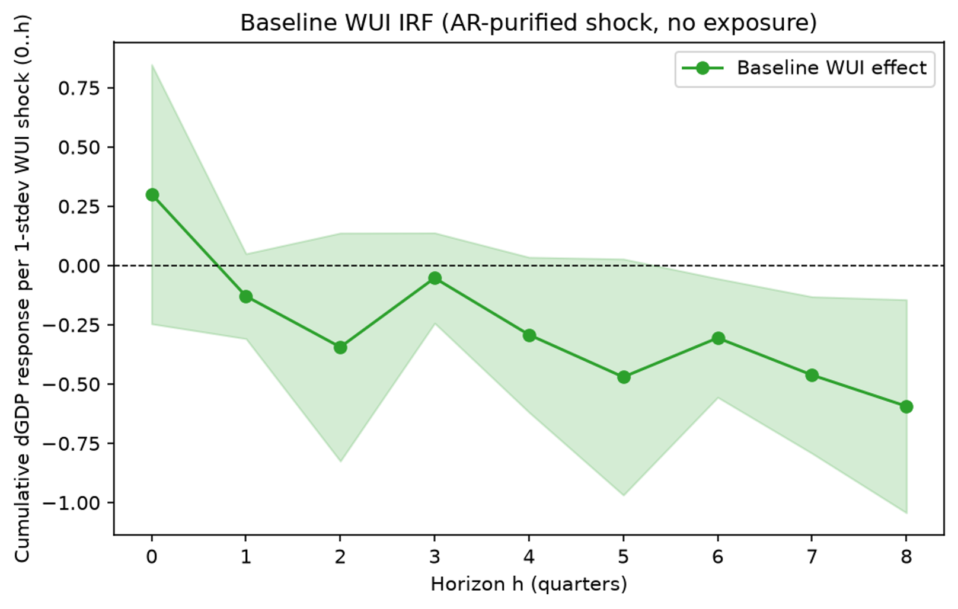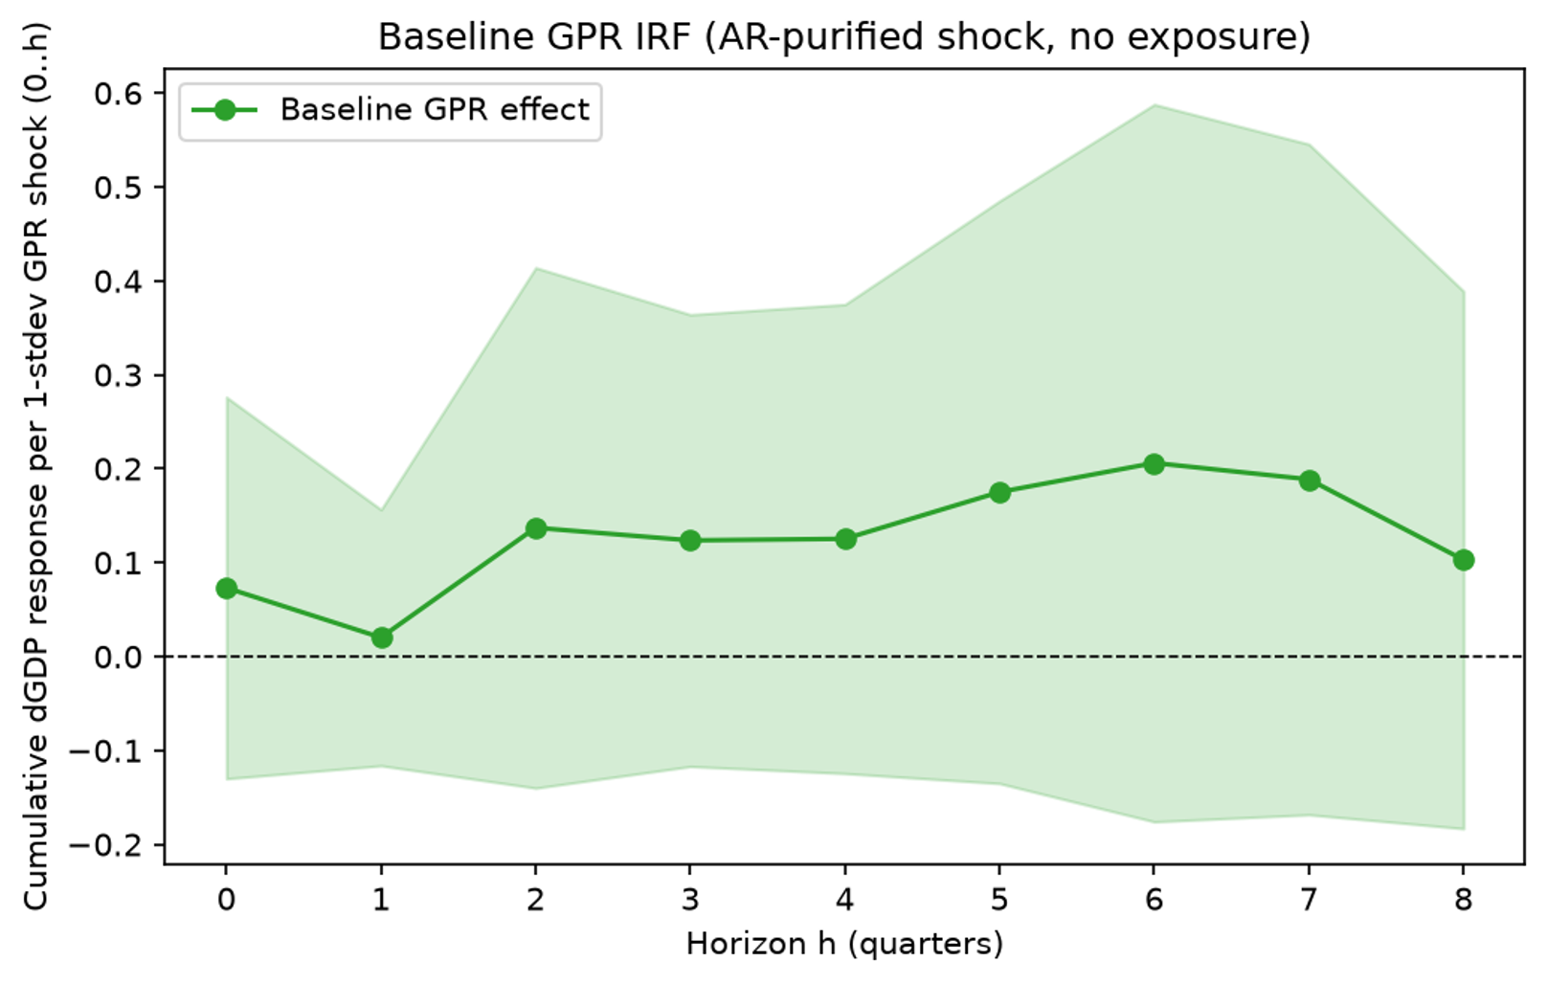
Note: cumulative impulse response of annual GDP growth to 1 stdev shock and 90% c.i.

Structural channel
Chart # shows the cumulative moderating effect of ICT investment. A positive response means that a higher ICT investment ratio dampens the negative shock impact on growth (consistent with enhanced firm-level resilience) and a negative response means that it amplifies the shock impact.
It turns out that there is some dampening effect of uncertainty shocks in the short-run, although this moderating effect is not statistically significant (panel a). With regard to geopolitical shocks, higher ICT-investment significantly dampens the shock impact in NL (panel b), a country with a relatively high ICT investment ratio. No such moderating effect is found for the panel of countries.

Chart # Moderating effect of ICT-investment on shock impact
- Uncertainty shock b. Geopolitical shock
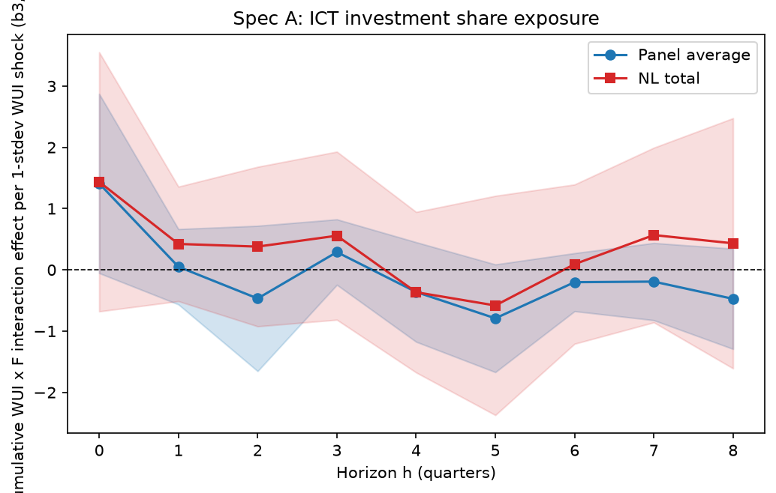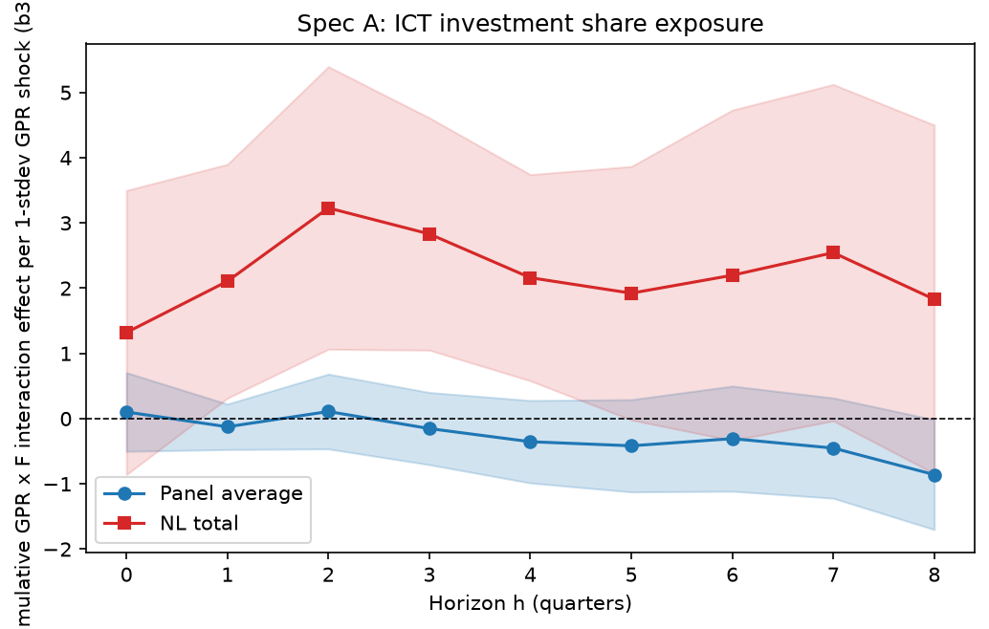
Note: cumulative effect of ICT-investment on impact of 1 stdev shock and 90% c.i.

Chart # shows the cumulative moderating effects of patents and investment in AI for the country panel. The effect is generally not significant. Only at certain lags, it is borderline significantly positive for uncertainty shocks (mitigating effect, panel a) and significantly negative for geopolitical shocks (amplifying effect, panel b).

Chart # Moderating effect of AI patents and investment on shock impact, country panel
- Uncertainty shock b. Geopolitical shock
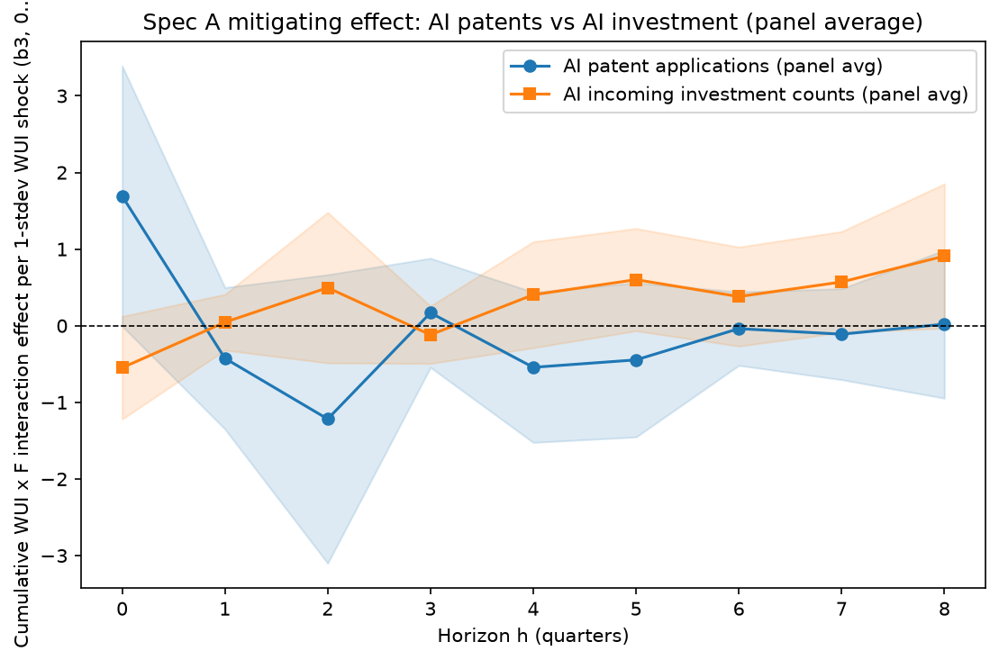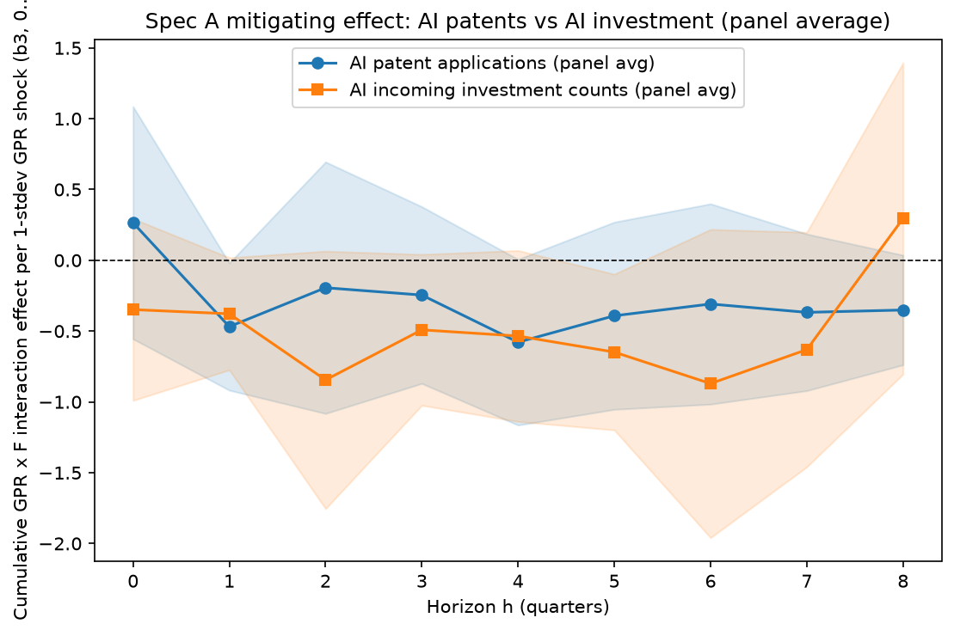
Note: cumulative effect of AI patents and investment on impact of 1 stdev shock and 90% c.i.

Cyclical channel
Chart # shows the cumulative moderating effect of semiconductor exposure. A positive response means that higher semiconductor exposure dampens the negative impact of the shock on growth (for instance owing to trade benefits from the AI-related activity) and a negative response means that it amplifies the shock impact.
In the boom regime, the impact of uncertainty shocks is dampened by semiconductor exposure in the short-run (panel a). The offsetting effect is significant for NL, a country with relatively high semiconductor exposure. There is no significant moderating effect of in case of the geopolitical shocks (panel b).

Chart # Moderating effect of semiconductor exposure on impact uncertainty shock in boom regime
- Uncertainty shock b. Geopolitical shock
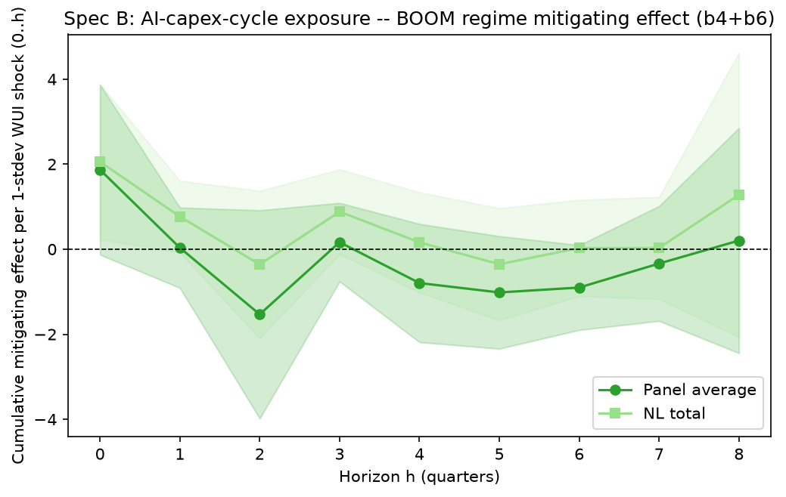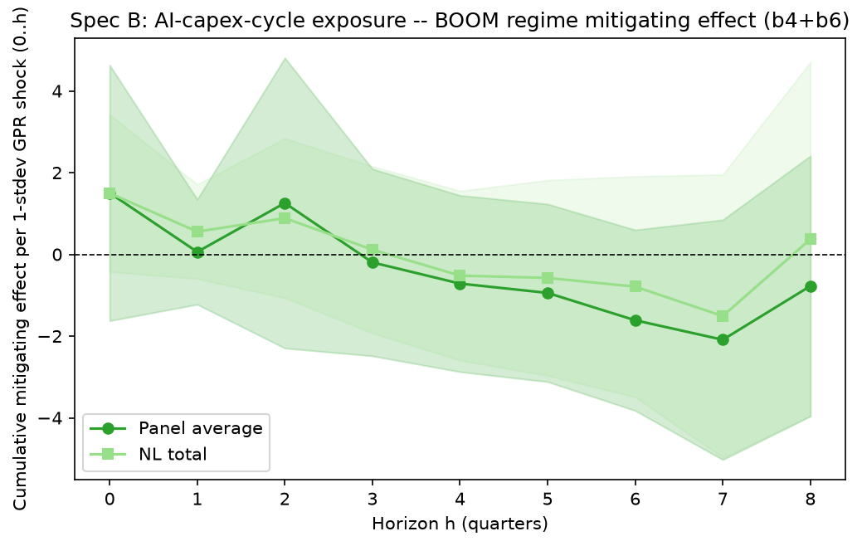
Note: cumulative effect of semiconductor exposure on impact of 1 stdev shock and 90% c.i.

In the bust regime, the impact of uncertainty shocks is amplified by semiconductor exposure in the short-run, as shown by the (borderline) significant negative impulse responses (panel a). The same result for geopolitical shocks is found for the panel of countries panel (panel b).

Chart # Moderating effect of semiconductor exposure on impact uncertainty shock in bust regime
- Uncertainty shock b. Geopolitical shock
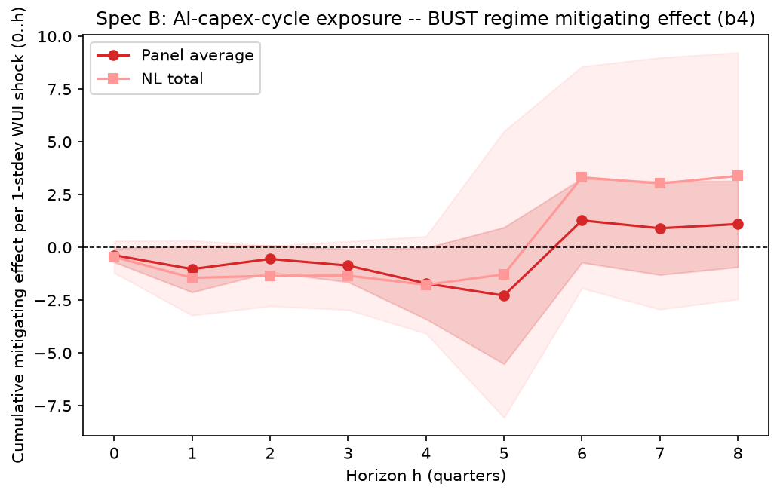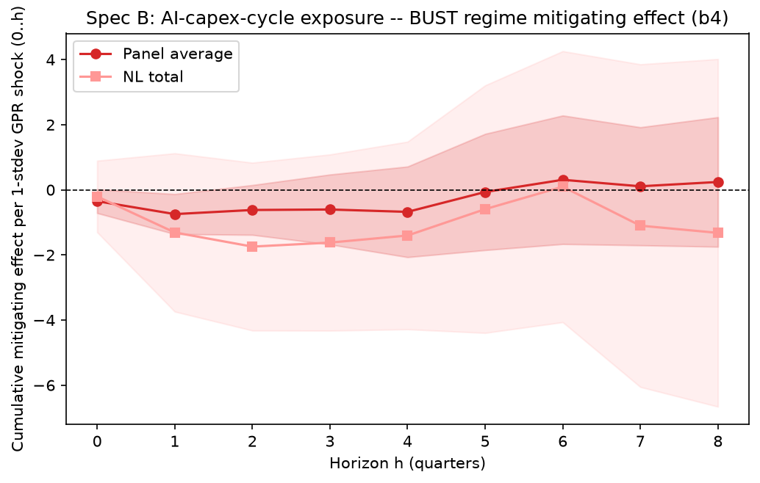
Note: cumulative effect of semiconductor exposure on impact of 1 stdev shock and 90% c.i.

Annex

Variables
GDP growth is included as year-on-year percentage change of quarterly GDP chain-linked volumes, seasonally & calendar adjusted (source Eurostat).
As state variables in smooth transition function F we include the ICT investment ratio, the number of patents and investment in AI and the correlation between the national stock index and the semiconductor index (SOX).
The numerator of the ICT investment ratio is gross ICT equipment (Eurostat code N1132G) plus gross computer software and databases (Eurostat code N1173G) – numerator. The denominator is gross total fixed assets (Eurostat asset10, code N1132G). Numerator and denominator in current prices.
The numbers of patent applications and investments (incoming number of investment counts) in all AI fields are annual series for the period 2015-2025 (ETO's country activity tracker).
Semiconductor exposure is measured by the 8 quarter rolling correlation between the quarterly log return of national stock index and the global semiconductor index (source: Yahoo Finance).
The state variables in F are standardized. The logistic transition steepness (theta in function F) is set at 2.0.

Model
The model includes country fixed effects αᵢ and controls for a time trend.
Boom and bust regimes are determined by the median of the 4 quarter moving average of log return SOX index. Thresholding at the median implies that boom and bust each cover close to half the sample.
Standard errors are Driscoll-Kraay (in Python script, robust to heteroskedasticity, within-country serial correlation and cross-sectional dependence across countries). Standard errors are cluster-robust (in Stata do file).

Code
The code (Python and Stata) and data of this project are stored here.

The country panel includes Germany, France, Italy, Spain, Netherlands, Belgium, Austria. The sample period is 2000Q1-2026Q2.
A time trend rather than time-fixed-effects are included, since the latter would create an identification problem (fixed effect time dummies are collinear with variables that are common across countries within a quarter, such as the shock variable).
The moderating effect is β₄ in the bust regime (D=0) and β₄ + β₆ in the boom regime (D=1).
The moderating effect measures how the impact of the shock on GDP growth changes (the marginal effect on GDP growth) for a change in the value of transition function F. The impulse responses show the mitigating effect of a change from F=0 to F=1.
The time dimension is too limited for single country estimations.

