Does AI enhance the resilience of euro area economies?

Research question
We investigate whether exposure to AI enhances a countries’ economic resilience. Two AI-related channels are distinguished: a structural channel related to ICT/AI investment and a cyclical channel linked to a countries’ exposure to the global semiconductor cycle. Resilience is measured by positive economic growth surprises. The analysis is conducted for a panel of the 10 largest euro area countries. Annex # provides more details.

Economic resilience
The literature defines resilience as the extent to which an economy bounces back to its previous growth path after an external shock (Hill, 20..). From that point of view, a positive growth surprise (realization higher than the forecast) is an indicator of resilience. Trade openness is found one of the contributing factors to positive growth surprises, as well as the digitalization of economies (20..) and – in recent literature – the implementation of AI.

Structural channel
The literature finds that ICT/AI-investment can improve shock resilience by enhancing firms’ flexibility, information processing and supply chain management (Moujahid et al., 2025).
ICT/AI investment is measured by investment in ICT equipment and computer software and databases as share of total gross fixed capital formation. Chart # shows that the ICT/AI-related investment ratio varies across time and countries, with AT, FR and NL having relatively high shares.
As alternative variable we include the number of investments and patent applications in AI fields.

Chart # ICT-investment over total investment Chart # Number of investments in AI

Note: annual series 2000-2024 (Eurostat) Note: annual series 2015-2025 (ETOs CAT)

Cyclical channel
A countries’ exposure to the global semiconductor cycle can indicate positive trade effects from AI-related global activity. This holds in particular for economies on the AI-supply side.

Marktcorrelatie (stock_corr) als signaal van mondiale tech-integratie: = openheid // eenzelfde patroon als Export (below wint normaal, above wint in schokjaren) — een economie sterk gecorreleerd met de halfgeleidercyclus lijkt in schokperiodes juist mee te bewegen met een mondiaal (tech-gedreven) herstel.
Voor de stock_corr-variabele is er een bijzonder treffend, direct vergelijkbaar precedent op sectorniveau: de wereldwijde halfgeleideromzet presteerde in 2020 beter dan verwacht ondanks de coronapandemie, aangedreven door de groei in cloud computing en de vraag naar apparatuur voor thuiswerken en -leren (IDC/BusinessWire). Een jaar later groeide de wereldwijde chipmarkt met 25,6% — het hoogste groeicijfer in 11 jaar — en overtrof daarmee de verwachtingen door de sterke digitale vraag (Rapidus/WSTS). Dit is letterlijk een "growth surprise" op sectorniveau: voorspellers gingen aanvankelijk uit van een krimp, en de realisatie viel structureel positiever uit. Voor landen wier beurs sterk meebeweegt met de halfgeleidercyclus (jouw stock_corr-variabele) is het aannemelijk dat dit sectorbrede verrassingseffect doorwerkt in de nationale groeicijfers, vooral in de shockjaren zelf — precies het patroon dat je in de "above"-kolom voor shockjaren ziet.

AI cycle contrary to oil price shocks, hedge for countries to adverse supply shocks.
[chart]

Low- and high-correlation of the national stock index to the global semiconductor index (SOX). Dummy variable D distinguishes booms and busts in the semiconductor cycle, assuming that its moderating effect varies between the two regimes (high AI-exposure might mitigate the impact of shocks if the semiconductor index rises and amplify the shock impact if the index falls).
Chart # shows that the semiconductor exposure of IT and NL have increased since 2020, with NL having the highest correlation with the semiconductor cycle.

Chart # Exposure to semiconductor index
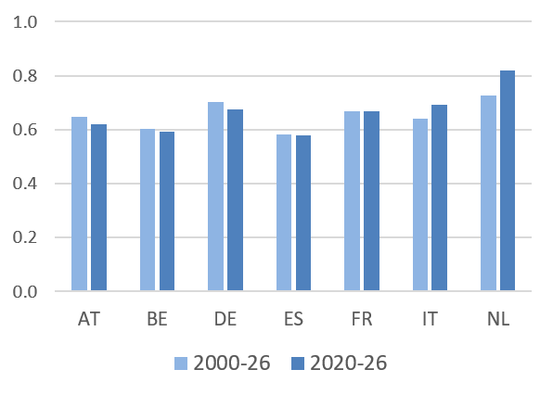
Note: exposure is measured as correlation between national stock index and global semiconductor index (8 quarter rolling correlation of quarterly log returns; source: Yahoo Finance).

Shocks
2020, 2022, 2025

Results
Baseline
Charts #.a-b show

Chart # Impact of shocks on GDP growth
- Uncertainty shock b. Geopolitical shock

Note: cumulative impulse response of annual GDP growth to 1 stdev shock and 90% c.i.

Structural channel
Chart # shows

Chart # Moderating effect of ICT-investment on shock impact
- Uncertainty shock b. Geopolitical shock

Note: cumulative effect of ICT-investment on impact of 1 stdev shock and 90% c.i.

Cyclical channel
Chart # shows

Annex

Variables
GDP growth surprises European Commission Spring and Autumn forecasts. Realization of annual growth in the forecasted year.

GDP growth is included as year-on-year percentage change of quarterly GDP chain-linked volumes, seasonally & calendar adjusted (source Eurostat).
As state variables in smooth transition function F we include the ICT investment ratio, the number of patents and investment in AI and the correlation between the national stock index and the semiconductor index (SOX).
The numerator of the ICT investment ratio is gross ICT equipment (Eurostat code N1132G) plus gross computer software and databases (Eurostat code N1173G) – numerator. The denominator is gross total fixed assets (Eurostat asset10, code N1132G). Numerator and denominator in current prices.
The numbers of patent applications and investments (incoming number of investment counts) in all AI fields are annual series for the period 2015-2025 (ETO's country activity tracker).
Semiconductor exposure is measured by the 8 quarter rolling correlation between the quarterly log return of national stock index and the global semiconductor index (source: Yahoo Finance).
The state variables in F are standardized. The logistic transition steepness (theta in function F) is set at 2.0.

Model
The model includes country fixed effects αᵢ and controls for a time trend.
Boom and bust regimes are determined by the median of the 4 quarter moving average of log return SOX index. Thresholding at the median implies that boom and bust each cover close to half the sample.
Standard errors are Driscoll-Kraay (in Python script, robust to heteroskedasticity, within-country serial correlation and cross-sectional dependence across countries). Standard errors are cluster-robust (in Stata do file).

Code
The code (Python and Stata) and data of this project are stored here.

The country panel includes Germany, France, Italy, Spain, Netherlands, Belgium, Austria, Finland, Ireland, Portugal The sample period is 2000Q1-2026Q2.

