AI and shock resilience:

Indications from euro area economies

Abstract
We examine whether euro area economies with greater ICT/AI exposure are more likely to show positive GDP growth surprises, particularly during global shocks. Country-clustered bivariate tests are combined with linear and non-linear panel regression models. We find that ICT/AI corporate investment is associated with a higher probability of a positive surprise, while ICT/AI-related export exposure is associated with positive surprises in shock-years. We do not find such results for AI-related equity investment and exposure to semiconductor stock market movements. We conclude that economic resilience owing to ICT/AI activities is channel-specific.

1. Introduction
The semiconductor and AI-related technology cycle has expanded rapidly since the mid-2010s despite a series of large global shocks. The COVID-19 pandemic, the energy and inflation shock and geopolitical tensions all impacted the macroeconomic outlook. Yet the relative performance of semiconductor stock index remained on a pronounced upward path, even as global uncertainty occasionally spiked (Figure 1). This motivates the research question whether greater exposure to ICT- and AI-related activity make economies more resilient to shocks.

Figure 1. Semiconductor-sector performance and global uncertainty
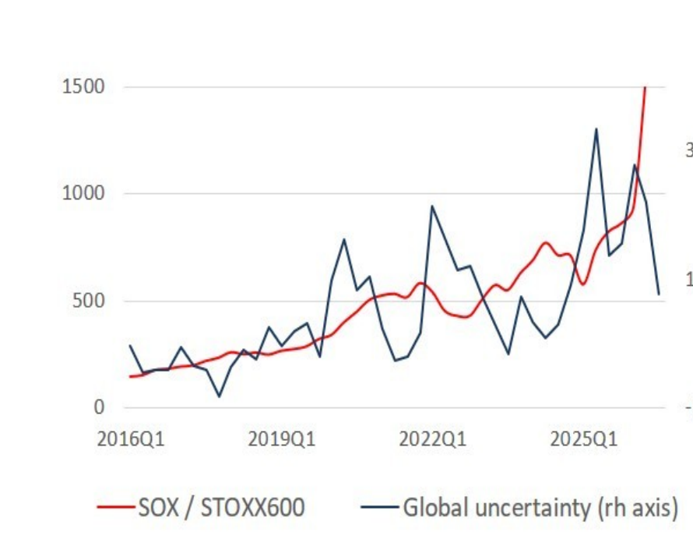
Note: The semiconductor series is the SOX index relative to the STOXX Europe 600; global uncertainty is a standardised composite of the EPU, GPR and VIX uncertainty indices.

We analyse the question by relating ICT/AI-related activity to GDP growth surprises. In our study, a positive growth surprise is associated with realised real GDP growth exceeding the European Commission forecast of a countries’ GDP growth. Forecasts embed the information and expectations prevailing when they were produced. Outperformance therefore implies that an economy evolved more favourably than the forecaster anticipated. It is thus an expectations-based proxy for economic resilience, commonly understood as an economy’s capacity to bounce back from negative shocks (Eichengreen et al., 2024).

We examine four channels through which ICT/AI exposure may shape resilience: 1) ICT/AI investment of firms. This captures the digital capacities of an economy, which can improve the flexibility to respond to shocks; 2) Incoming AI equity investment, measuring financing of innovative applications. The access to such finance can make economies more agile to a changing environment; 3) ICT/AI-related exports, capturing the exposure to global technology demand; 4) National stock-market correlation with the semiconductor index. This indicates financial-market exposure to the global semiconductor cycle. Both the trade and stock market channels reflect an economies’ exposure to a global (semiconductor) factor, which may influence a countries’ cyclical performance.

We estimate the relationship between the four ICT/AI-related channels and positive GDP growth surprises for a panel of 10 euro area countries. We apply country-clustered bivariate tests and linear and non-linear panel regression models. It appears that positive growth surprises are more common in shock years. ICT/AI corporate investment has a positive average association with the probability of a positive surprise. ICT/AI-related export exposure has an additional shock-year association with positive growth surprises. AI equity investment and semiconductor-market correlation do not yield significant relationships with growth surprises. Overall, we find that the relationship depends on the channel, timing and nature of the shock.

2. Related literature and channels

2.1 Economic resilience and growth surprises
Economic resilience is commonly understood as an economy’s capacity to cope with shocks, limit economic damage and recover quickly. Hill et al. (2008) associates resilience to several related outcomes: resistance, recovery, reorientation and renewal. Eichengreen et al. (2024) operationalise resilience as the strength of the economic recovery after negative shocks. They show that trade openness and exchange-rate flexibility are associated with stronger recovery, while rapid pre-crisis credit growth and financial openness can weaken it. The literature thus motivates an expectation-adjusted outcome to measure resilience: if realised growth exceeds a forecast made shortly after the shock, the economy has absorbed or recovered from the disturbance stronger and quicker than anticipated.

2.2 Investment channel
Digital investment can strengthen resilience by enabling firms’ production and strategies to quickly adapt to uncertainty in the external environment. Papaioannou (2023) finds that European economies with higher ICT intensity suffered smaller output losses during the COVID-19 shock. Abidi et al. (2022) similarly report that digitally enabled firms experienced smaller sales declines than digitally constrained firms Bilal et al. (2024), using data for 100 countries, find that ICT mitigated the growth consequences of COVID-19. The effect need not be immediate or linear. Yan et al. (2024) report an inverted-U relationship between digital transformation and corporate resilience. We distinguish corporate ICT/AI fixed investment from incoming AI equity deals as separate channels. The former is closer to firm’ productive capital; the latter captures the access to finance for innovative enterprises in the AI field. As such, AI equity investment reflect the ease of adopting ICT/AI-related technologies by firms.

2.3 Trade and financial-market channels
International trade offers a another channel. ICT and semiconductor goods are deeply embedded in global investment and supply chains. During the pandemic, demand for such goods accelerated even while other sectors contracted. Countries with a larger export base in ICT/AI-related products may therefore receive an countercyclical external-demand impulse during periods of shocks. This mechanism is consistent with the broader finding of Eichengreen et al. (2024) that trade openness can support recovery by allowing external demand to substitute for weak domestic demand. It also implies state dependence: export exposure can be beneficial when a shock raises digital demand, but harmful when the disturbance originates in the ICT/AI-related sector and their market prices.

The stock-market measure captures a related but less direct channel. A high correlation between a national equity index and the SOX semiconductor index indicates that the country’s stock market valuation is closely tied to the global chip cycle. That relationship could transmit favourable semiconductor demand to financing conditions and confidence in a country. It can equally transmit valuation corrections and global risk repricing. Because the variable is a financial co-movement measure rather than a measure of domestic production or exports, we treats it as an exposure indicator rather than a direct measure of productive AI capacity.

3. Data and empirical approach

3.1 Data
The GDP growth surprise is based on European Commission Spring and Autumn forecast vintages and data of realised annual GDP growth. For each country in the panel and for each forecast observation, the growth surprise is constructed as realised growth minus forecast growth. The binary outcome equals one when this difference is positive. Both current-year and next-year forecast horizons are used. The binary-outcome sample contains 548 observations for ten euro area countries over 2011–2025; 120 observations correspond to 2020, 2022 and 2025. These years are classified as shock years, because they coincide with peaks in the composite global uncertainty measure (Figure 1).

Spring and Autumn forecasts differ in terms of the information that is available at the time of the forecast. Moreover, forecasts for t+1 are normally more uncertain than forecasts for the current year. The regression models therefore include forecast vintage control variables. The four exposure channels enter the regressions one period lagged. This is particularly relevant for ratio variables in shock years: using the variable from the shock year can create a denominator effect if aggregate investment, exports or GDP used in the denominator falls because of the shock. As controls we include state-aid and trade openness.

The panel of countries covers Austria, Belgium, Finland, France, Germany, Ireland, Italy, the Netherlands, Portugal and Spain. The ICT/AI variables are defined as 1) ICT/AI-related investment as share of total gross fixed capital investment; 2) the number of incoming AI equity investment; 3) ICT/AI-related goods exports as a share of total goods export; 4) Rolling correlation of national stock-market index with global semiconductor stock price index (SOX). Annex Table A1 report the construction, timing and sources of the variables used in the empirical analysis.

3.2 Unconditional bivariate tests
For each ICT/AI exposure variable the observations are divided at the time-varying median into lower- and higher-exposure groups. The share of positive growth surprises is then compared across groups, both for all years and for the shock-year subsample. The figures also compare, within each exposure group, the all-year and shock-year proportions. These comparisons are descriptive: they do not condition on country, target-year or forecast-type effects.

Inference recognises that observations for the same country are repeated and potentially dependent. Each percentage comparison is implemented as a difference in means of the binary surprise indicator, with a country-clustered sandwich covariance estimator and the same finite-sample cluster correction used in the regressions. This is equivalent to a simple LPM with the relevant group indicator and country-clustered inference. Asterisks mark lower-versus-higher exposure comparisons within a period; plus signs mark the all-year versus shock-year comparison within the same exposure group. With only ten countries, these tests should be read as indicative and not as precise large-cluster approximations.

3.3 Panel binary-response models

Benchmark fixed-effects linear probability model
The benchmark binary-response model is a fixed-effects linear probability model (LPM). Let Dᵢⱼₜ equal one when realised growth for country i and target year t exceeds the forecast in observation j. Let Xᵢ,ₜ₋₁ denote the standardised one period lagged ICT/AI exposure variable (limiting mechanical simultaneity with the growth surprise); Qₜ is the shock-year indicator; Zᵢⱼₜ contains the standardised controls and forecast-type indicators; αᵢ and τₜ denote country and target-year effects. Each focal exposure is estimated separately. The three benchmark specifications are:

Dᵢⱼₜ = αᵢ + τₜ + βXᵢ,ₜ₋₁ + φ′Zᵢⱼₜ + εᵢⱼₜ | (1)
Dᵢⱼₜ = αᵢ + τₜ + βXᵢ,ₜ₋₁ + γ(Xᵢ,ₜ₋₁ × Qₜ) + φ′Zᵢⱼₜ + εᵢⱼₜ | (2)
Dᵢⱼₜ = αᵢ + τₜ + βHᵢ,ₜ₋₁ + γ(Hᵢ,ₜ₋₁ × Qₜ) + φ′Zᵢⱼₜ + εᵢⱼₜ | (3)

Here Hᵢ,ₜ₋₁ equals the standardised exposure when it is above the sample median and zero otherwise. Because Qₜ is constant within a target year, its main effect is absorbed by τₜ. In model (1), β is the average all-year association. In model (2), γ is the additional association in shock years for the continuous exposure. In model (3), γ is the additional shock-year association in the upper-exposure part of the distribution. LPM coefficients are already marginal effects: β = 0.08 means that a one-standard-deviation increase in exposure is associated with an eight-percentage-point higher probability of a positive surprise. Country-clustered standard errors allow arbitrary heteroskedasticity and within-country dependence; t-tests use country-cluster degrees of freedom.

Correlated-random-effects probit model
A correlated-random-effects (CRE) probit using the Mundlak formulation is the nonlinear robustness model. The nonlinear robustness model is a CRE probit. A conventional random-effects probit assumes that persistent country heterogeneity is independent of the entire history of ICT/AI exposure, an implausibly strong restriction when digital investment and trade structures are correlated with institutions, income, human capital, innovation capacity and industrial specialisation. The Mundlak approach addresses this concern by decomposing each time-varying regressor into its within-country deviation and country mean (Mundlak, 1978). For the plain specification:

P(Dᵢⱼₜ = 1 | X, Z, aᵢ) = Φ[α + τₜ + βW(Xᵢ,ₜ₋₁ − X̄ᵢ) + βB X̄ᵢ + φW′(Zᵢⱼₜ − Z̄ᵢ) + φB′Z̄ᵢ + aᵢ]
aᵢ ~ N(0, σₐ²)

Models (2) and (3) apply the same within/between decomposition to the exposure–shock interaction and to the above-median interaction. The direct forecast-vintage indicators enter in levels, while continuous time-varying controls receive the Mundlak decomposition. The coefficients of interest are βW for model (1) and γW for models (2) and (3): they describe within-country relationships after persistent between-country differences are separated out. βB and γB are informative about between-country differences but are not the focal resilience parameters.

Raw probit coefficients affect a latent index and are not percentage-point probability effects. We therefore report population-averaged marginal effects, obtained by integrating fitted probabilities over the estimated country random-intercept distribution and averaging the observation-level derivatives. Delta-method inference uses the country-clustered covariance matrix with the common finite-sample correction. The CRE probit is a robustness model rather than a causal solution: the Mundlak terms accommodate correlation with persistent observed regressor histories, but time-varying omitted variables and reverse causality can remain.

4. Results

4.1 Positive growth surprises are more common in shock years
Positive growth surprises account for about 54 percent of the full set of forecast observations and 78 percent of observations in the three shock years (Figure 2). The difference is statistically significant in the country-clustered comparison. This does not mean that output levels were high in 2020, 2022 or 2025. It means that realised annual growth more often exceeded the forecast attached to the relevant country, vintage and horizon. One interpretation is that forecasters appropriately marked down growth when uncertainty rose but, on average, marked it down by more than subsequent outcomes warranted. Another is that policy support and private adaptation limited the realised damage relative to the information available at the time of the forecast.

Figure 2. Share of positive growth surprises
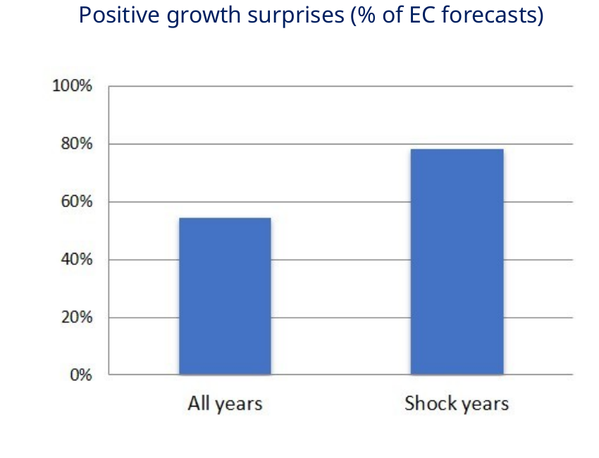
Note: The full sample contains 548 forecast observations; the shock-year sample contains 120 observations for 2020, 2022 and 2025. The difference is evaluated with country-clustered inference.

4.2 Unconditional evidence: channel-specific patterns
The unconditional comparisons distinguish a structural investment pattern from a state-dependent trade pattern. For ICT/AI-related corporate investment, the higher-exposure group has a significantly larger share of positive surprises over all years. Both lower- and higher-exposure groups display substantially higher positive-surprise shares in shock years, but their within-shock difference is not significant. This pattern is consistent with installed digital capital supporting performance generally, while the common features of the selected shock years raise the surprise rate for both groups.

Figure 3a. Comparisons for ICT/AI corporate investment and equity investment

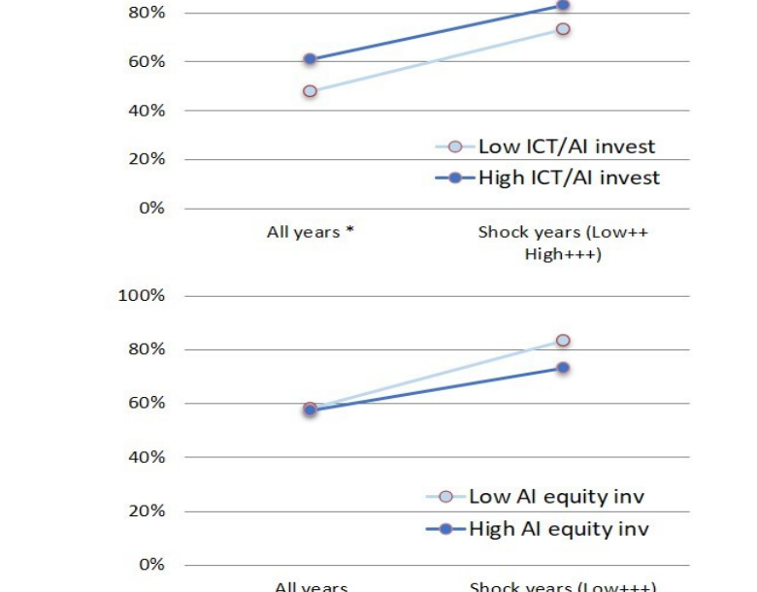

Note: Asterisks compare lower- and higher-exposure groups within a period; plus signs compare all years with shock years within a group. Inference is clustered by country.

Incoming AI equity investment behaves differently. The lower- and higher-exposure groups are nearly indistinguishable in the full sample. In the shock subsample, the lower-exposure group has a higher positive-surprise share, although the cross-group difference is not statistically significant. This weak reversal is compatible with delayed returns or absorption costs, but the bivariate evidence cannot identify those mechanisms. It is equally possible that AI equity investment is concentrated in economies or years with different unobserved conditions.

The export measure produces the sharpest shock-specific contrast. Lower- and higher-export-exposure groups have similar positive-surprise shares in the full sample. In shock years, the higher-exposure group rises much more strongly and exceeds the lower-exposure group; the within-shock difference is statistically significant in the updated country-clustered test. This is the descriptive result most consistent with strong external demand for ICT and semiconductor goods during recent disturbances.

Figure 3b. Comparisons for ICT/AI-related exports and semiconductor-market correlation

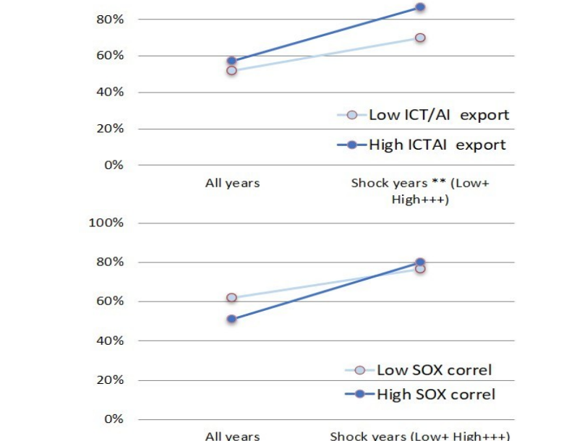
Note: Asterisks compare lower- and higher-exposure groups within a period; plus signs compare all years with shock years within a group. Inference is clustered by country.

The semiconductor-correlation measure does not show the same cross-group result. The surprise share rises in shock years for both groups, but lower and higher semiconductor-market correlation are not significantly different from one another in either period. The contrast between exports and market correlation is informative: direct trade exposure to the product cycle appears more closely related to macroeconomic outperformance than comovement of broad national equity indices with semiconductor equities.

4.3 Panel regression evidence
The results of the panel regression are summarized in Table 1.

Table 1. Results panel regression models
Exposure variable | Linear probability model |  |  | CRE probit average marginal effects
 | (1) | (2) | (3) | (4) | (5) | (6)
 | beta | gamma | gamma | beta-W | gamma-W | gamma-W
ICT/AI-related investment | 0.08* | 0.10 | 0.08 | 0.09* | 0.09 | 0.08
Equity investments in AI | -0.10 | -0.03 | -0.05 | -0.11 | -0.06 | -0.08
ICT/AI-related exports | 0.07 | 0.07* | 0.06* | 0.06 | 0.08** | 0.07**
Semiconductor-index correlation | -0.01 | -0.41 | -0.59 | -0.01 | -0.45 | -0.67

Note: Columns (1) and (4) report the average all-year association. Columns (2) and (5) report the additional shock-year association using the continuous exposure. Columns (3) and (6) use the above-median exposure transformation. For the LPM, coefficients are marginal effects and can be read as probability changes for a one-standard-deviation increase. CRE-probit entries are population-averaged marginal effects based on the within-country coefficients after integrating over the country random intercept. All models include time effects, standardised controls for state aid/GDP and lagged trade openness, and forecast-vintage indicators. Inference uses country-clustered sandwich covariance estimates with the same finite-sample correction throughout. *, ** and *** denote significance at 10%, 5% and 1%, respectively.

ICT/AI-related corporate investment
The benchmark LPM associates a one-standard-deviation increase in lagged ICT/AI corporate investment with an eight-percentage-point increase in the probability of a positive growth surprise; the CRE-probit average marginal effect is nine percentage points. Both estimates are significant at the 10 percent level. The shock-interaction estimates are also positive but imprecise in both model classes. The evidence therefore supports a positive average relationship rather than a statistically distinct shock-year amplification. This is consistent with a broad organisational-flexibility channel that operates in ordinary years as well as during disturbances.

AI equity investment
AI equity-investment coefficients are negative in every specification, ranging from approximately −0.03 to −0.11 on the probability scale, but none is statistically significant. The direction matches the descriptive indication that higher incoming AI equity investment is not a short-run buffer. However, the estimates do not justify a conclusion that AI investment causes weaker resilience. Deal counts may be a noisy proxy for productive capacity, GDP scaling may introduce measurement variation, and the payoff horizon may extend beyond the annual forecast window.

ICT/AI-related exports
Lagged ICT/AI-related export exposure has no statistically significant average effect in model (1). Its additional shock-year association is positive and statistically significant in both interaction variants. In the LPM, a one-standard-deviation increase in the continuous exposure is associated with a further seven-percentage-point rise in the probability of a positive surprise during shock years; the above-median interaction yields six percentage points. The corresponding CRE-probit marginal effects are eight and seven percentage points, both significant at the 5 percent level. The close probability-scale agreement across the linear and nonlinear models is the strongest regression finding in the paper and confirms the country-clustered bivariate pattern.

Semiconductor-market correlation
The average association of national-market correlation with the SOX index is essentially zero in both models. The shock interactions are negative and numerically large, but they are not statistically significant. Because correlation estimates can be volatile, especially when aggregated from rolling quarterly windows, the result should not be overinterpreted. The available evidence simply does not establish that financial-market comovement with the semiconductor cycle increases the probability of aggregate growth outperformance.

5. Discussion
The findings reject a one-dimensional account of AI exposure. Corporate investment, equity financing, product exports and stock-market comovement represent different stages and transmission mechanisms. Treating them as interchangeable would conceal the main result: broad digital capital is associated with positive surprises on average, whereas ICT/AI exports show an additional relationship specifically in shock years. The first pattern is compatible with a persistent capacity to reorganise production and information flows. The second is compatible with the unusual demand composition of the pandemic and subsequent technology cycle.

The LPM–CRE comparison strengthens this interpretation without eliminating identification concerns. The LPM permits arbitrary correlation between time-invariant country characteristics and the exposures through country fixed effects, and its coefficients are direct percentage-point effects. The CRE probit imposes a nonlinear probability function and a normally distributed remaining country intercept but relaxes ordinary random-effects independence through country means of the time-varying regressors. Similar marginal effects across the two models indicate that the qualitative conclusions are not driven by the linear probability functional form. They do not prove causality or validate the stronger assumptions of either specification.

Several limitations matter. First, there are only ten country clusters. The finite-sample correction and cluster degrees of freedom are appropriate, but asymptotic cluster-robust inference can still be fragile. A wild-cluster bootstrap for the benchmark LPM would be a useful additional check. Second, only three shock years are labelled, and those episodes are not independent replications of a common treatment. The pandemic, the energy shock and the 2025 uncertainty episode differ in origin and sectoral incidence. Third, all three occur during a structural AI and semiconductor upswing. The export result may therefore identify exposure to a favourable technology-demand configuration rather than a general-purpose buffer against any shock.

Fourth, the ratios are vulnerable to measurement and denominator effects. Lagging the exposure variables and using lagged GDP beneath contemporaneous state aid reduce mechanical movements caused by a shock-year denominator, but they cannot remove all endogeneity. Policy support responds to expected weakness, trade structure changes slowly, and investment may anticipate future conditions. Fifth, the positive-surprise outcome conflates resilience with forecast error. Forecast-type controls and fixed effects address systematic vintage, horizon, country and target-year differences, but unforeseen country-specific news remains part of the dependent variable.

The policy implication is correspondingly conditional. Sustained ICT investment may contribute to general adaptability, supporting policies that facilitate digital infrastructure, complementary skills and organisational adoption. Export specialisation in ICT/AI goods can provide a powerful external-demand channel when shocks accelerate digital spending, but it can also concentrate risk. If a future disturbance begins with an AI-capex retrenchment, semiconductor oversupply, export restrictions or a valuation correction, the same countries that benefited in 2020–2025 may be more exposed. Resilience policy should therefore combine digital capacity with diversification rather than treating high AI exposure as an unconditional hedge.

6. Conclusion
This paper studies whether ICT- and AI-related exposure is associated with the probability that realised GDP growth exceeds European Commission forecasts in ten euro area countries. The updated evidence covers 2011–2025, uses one-period-lagged focal exposures, applies country-clustered tests throughout, and distinguishes a fixed-effects LPM benchmark from a Mundlak CRE-probit robustness model. Forecast-vintage indicators and standardised controls for state aid relative to lagged GDP and lagged trade openness are included.

Positive growth surprises are markedly more common in the three designated shock years than in the full sample: approximately 78 percent versus 54 percent. Lagged ICT/AI corporate investment has a positive average association with the probability of a positive growth surprise, on the order of eight to nine percentage points for a one-standard-deviation increase. Lagged ICT/AI-related export exposure has no clear average association but a positive additional shock-year association, significant in both the LPM and CRE probit. Incoming AI equity investment and semiconductor-market correlation do not show robust resilience-enhancing relationships.

The similarity of LPM effects and CRE-probit marginal effects supports functional-form robustness, not a causal interpretation. The evidence is best read as an indication that digital resilience is channel-specific. Installed ICT capital may support broad economic flexibility, while export specialisation appears to have mattered because recent shocks coincided with unusually strong demand for technology goods. The small country panel, the limited number of shock episodes and the possibility of sector-originating shocks warrant restraint. A natural next step is to supplement the benchmark inference with wild-cluster-bootstrap procedures and to test whether the export relationship survives a wider set of shocks whose origins are outside—and within—the AI sector.

References
Abidi, N., El Herradi, M., & Sakha, S. (2022). Digitalization and resilience: Firm-level evidence during the COVID-19 pandemic. IMF Working Paper 2022/034. https://doi.org/10.5089/9798400201073.001
Bilal, M., Aqib, S., & Raza, A. (2024). Strengthening economic resilience through ICT during the COVID-19 pandemic: Evidence from 100 countries. Discover Sustainability, 5, 534. https://doi.org/10.1007/s43621-024-00729-x
Cameron, A. C., & Miller, D. L. (2015). A practitioner’s guide to cluster-robust inference. Journal of Human Resources, 50(2), 317–372.
Eichengreen, B., Park, D., & Shin, K. (2024). Economic resilience: Why some countries recover more robustly than others from shocks. Economic Modelling, 136, 106748. https://doi.org/10.1016/j.econmod.2024.106748
European Commission. European Economic Forecast, Spring and Autumn vintages, 2011–2025.
European Commission. EU State Aid Scoreboard.
Eurostat. Gross fixed capital formation, nominal GDP and Comext international trade in goods databases.
Hill, E. W., Wial, H., & Wolman, H. (2008). Exploring regional economic resilience. Institute of Urban and Regional Development Working Paper 2008-04.
Mundlak, Y. (1978). On the pooling of time series and cross section data. Econometrica, 46(1), 69–85. https://doi.org/10.2307/1913646
Papaioannou, S. K. (2023). ICT and economic resilience: Evidence from the COVID-19 pandemic. Economic Modelling, 128, 106500. https://doi.org/10.1016/j.econmod.2023.106500
Wooldridge, J. M. (2019). Correlated random effects models with unbalanced panels. Journal of Econometrics, 211(1), 137–150. https://doi.org/10.1016/j.jeconom.2018.12.010
World Bank. World Development Indicators: Trade openness.
Yan, A., Ma, H., Zhu, D., & Xie, J. (2024). Digital transformation and corporate resilience: Evidence from China during the COVID-19 pandemic. Quantitative Finance and Economics, 8(4), 779–814. https://doi.org/10.3934/QFE.2024030.

Annex A. Variable construction
Table A1 reports how each variable is constructed and its source. The column timing reports that in the regressions the ICT/AI exposure variables and trade openness are lagged by one period, while state aid is measured in the target year and divided by lagged GDP.

Table A1. Variables, construction, timing, and sources

Variable | Construction | Timing | Source
Positive growth surprise | Indicator equal to one when realised annual real GDP growth exceeds the corresponding European Commission forecast. | Target year t; Spring and Autumn vintages for t and t+1 | European Commission forecasts and outturns
ICT/AI-related investment | Share of selected ICT- and AI-related asset/industry investment in total gross fixed capital formation. | t−1; 2024 carried forward when 2025 is unavailable | Eurostat
AI equity investment | Incoming equity-investment counts in AI-related fields, scaled by GDP. | t−1 | Emerging Technology Observatory, Country Activity Tracker; GDP data
ICT/AI-related exports | Exports of HS 847150, 847180, 847330, 848610, 848620, 848630, 848640 and 848690 as a share of total goods exports. | t−1 | Eurostat Comext, HS 2022
Semiconductor-market correlation | Rolling eight-quarter correlation between the national equity index and the Philadelphia Semiconductor Index (SOX). | Annualised t−1 value | Yahoo Finance
State-aid control | State aid in t divided by nominal GDP in t−1; standardised before estimation. | Aid at t; denominator at t−1 | EU State Aid Scoreboard; Eurostat GDP
Trade-openness control | Exports plus imports divided by GDP; standardised before estimation. | t−1 | World Bank
Forecast-type controls | Autumn-vintage indicator, t+1-horizon indicator, and their interaction. | Same forecast observation as the dependent variable | Constructed from forecast metadata

Note: The exposure measures and control variables are standardised. Each exposure variable is estimated in a separate set of models. The lag structure is designed to address endogeneity and denominator effects.

