AI and Shock Resilience:
Indications from Euro Area Economies
De Nederlandsche Bank | DNB Public

Abstract
This paper examines whether euro area economies more exposed to ICT/AI-related activity are also more resilient to macroeconomic shocks. Using European Commission Spring and Autumn forecast vintages for ten euro area countries over 2011-2025, we construct growth surprises (realised minus forecast annual GDP growth) and relate them to four ICT/AI-related exposure variables: ICT/AI-related investment, AI-related equity investment inflows, ICT/AI-related export shares, and the correlation between national equity indices and the global semiconductor index. We combine unconditional bivariate two-proportion tests with country- and time-fixed-effects panel probit regressions. We find that ICT/AI-related investment and semiconductor-market correlation raise the probability of a positive growth surprise in normal years, but this advantage is largely absent during shock years (2020, 2022, 2025). In contrast, ICT/AI-related trade exposure shows no unconditional advantage in normal years but a significant additional effect during shocks, consistent with countercyclical or accelerating global demand for AI-related goods. Financial AI exposure -- equity inflows in particular -- shows no resilience-enhancing role and may even constitute a relative disadvantage during stress periods. We caveat that the trade-resilience finding rests on only three shock episodes, all coinciding with the ongoing AI/semiconductor upcycle, and may not generalise to a shock originating within the AI sector itself.

1. Introduction
The global semiconductor market has followed a strong, persistent upward trend over the past decade, one that has not visibly been derailed by successive waves of global uncertainty -- the COVID-19 pandemic, the 2022 energy and inflation shock, and the uncertainty surrounding trade policy and AI-investment sustainability in 2025 (Figure 1). This apparent resilience of the AI/semiconductor sector itself raises a natural question for macroeconomic policy: are euro area economies that are more exposed to ICT/AI-related activity also more resilient to macroeconomic shocks more broadly, or is the sector's own resilience a narrower, sector-specific phenomenon that does not translate into aggregate economic outcomes?
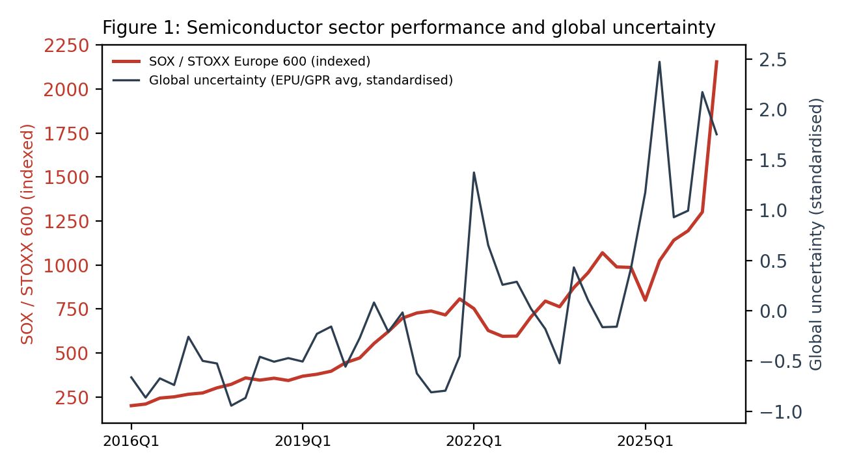
Figure 1. Semiconductor sector performance (SOX relative to STOXX Europe 600, indexed) and global uncertainty (standardised average of EPU and GPR indices), 2016Q1-2026Q2.
This paper provides indicative empirical evidence on this question for ten euro area economies over 2011-2025. We proxy shock resilience by the incidence of positive GDP growth surprises -- instances in which realised growth exceeds the European Commission's own contemporaneous forecast -- following Eichengreen et al. (2024), who define resilience as an economy's tendency to bounce back from negative shocks faster or more strongly than anticipated. We relate these surprises to four distinct measures of ICT/AI-related exposure, spanning both a structural investment channel and a cyclical trade/financial-market channel, and assess their explanatory power both unconditionally and within a panel regression framework that controls for country and time fixed effects.

2. Related literature and channels
We distinguish two broad channels through which ICT/AI exposure could plausibly affect shock resilience. The first is a structural channel operating through private investment: ICT/AI investment can improve firms' flexibility, information-processing capacity, and supply-chain management, thereby cushioning the impact of adverse shocks (Moujahid et al., 2025). We proxy this channel with two variables -- the share of ICT/AI-related investment in total gross fixed capital formation, and the number of incoming equity investments in AI-related firms, scaled by GDP.
The second is a cyclical channel operating through international trade and stock markets: exposure to the global semiconductor cycle may bring positive trade effects from AI-related global demand (ECB, 2026). We proxy this channel with the share of ICT/AI-related products in total goods exports, and the rolling correlation between a country's national equity index and the global semiconductor stock index (SOX), which captures the extent to which a country's financial markets are integrated with the AI/chip cycle specifically.

3. Data and empirical approach

3.1 Data
The sample covers ten euro area countries (Austria, Belgium, Finland, France, Germany, Ireland, Italy, the Netherlands, Portugal, and Spain) over 2011-2025. Growth surprises are constructed from European Commission Spring and Autumn forecast vintages: surprise = realised annual GDP growth minus the corresponding EC forecast, yielding 548 country-vintage observations across all years and 120 observations in the three designated shock years (2020, 2022, 2025). ICT/AI investment and export shares are constructed from Eurostat and OECD trade data; AI-related equity investment counts are sourced from the Emerging Technology Observatory's Country Activity Tracker; national and semiconductor equity indices are sourced from Yahoo Finance.

3.2 Unconditional bivariate tests
For each explanatory variable, country-year observations are split into below- and above-median groups. We compare the share of positive growth surprises between these groups, separately for all years and for shock years, using two-proportion z-tests. This unconditional approach makes no adjustment for country- or time-specific factors, and therefore serves as a first, transparent look at the raw associations in the data before turning to the regression evidence.

3.3 Panel probit regressions
To condition on country- and time-specific factors, we estimate three panel probit specifications with country fixed effects (μᵢ) and time fixed effects (τₜ), where Yᵢ,ₜ = 1 if the growth surprise for country i in year t is positive (otherwise 0), and θ denotes the standard normal cumulative distribution function:
Model 1 (average effect β): P(Yᵢ,ₜ) = θ(α + μᵢ + τₜ + β Xᵢ,ₜ)
Model 2 (additional effect γ in shock years): P(Yᵢ,ₜ) = θ(α + μᵢ + τₜ + β Xᵢ,ₜ + γ Xᵢ,ₜ Dₜ)
Model 3 (additional effect γ of high X in shock years): P(Yᵢ,ₜ) = θ(α + μᵢ + τₜ + β Xᵢ,ₜʰⁱᵍʰ + γ Xᵢ,ₜʰⁱᵍʰ Dₜ)
where Xᵢ,ₜ is the (standardised) ICT/AI-related variable of interest, Dₜ is a dummy equal to 1 in shock years (2020, 2022, 2025) and 0 otherwise, and Xᵢ,ₜʰⁱᵍʰ = Xᵢ,ₜ if Xᵢ,ₜ exceeds its own sample median, and 0 otherwise. All explanatory variables are standardised (z-score) prior to estimation, so that β and γ are interpretable as the change in the underlying probit index associated with a one-standard-deviation change in X; standard errors are computed from the analytic Hessian of the probit log-likelihood at the optimum. Each of the four explanatory variables is estimated in a separate model rather than jointly, so the reported coefficients should be read as univariate (conditional on country and time, but not on the other three ICT/AI variables).

4. Results

4.1 Positive growth surprises are more common in shock years
Contrary to what one might expect if shocks systematically depress realised growth relative to forecasts, positive growth surprises are considerably more common in shock years (72%) than in normal years (52%; Figure 2). This points to euro area economies having been, on average, more resilient than EC forecasters anticipated over this period -- forecasts were, if anything, too pessimistic specifically around shock episodes.
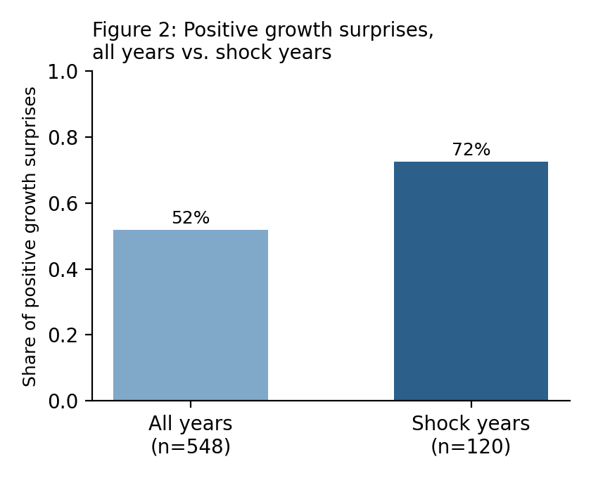
Figure 2. Share of positive growth surprises, all years vs. shock years (two-proportion z-test, *** p<0.01).

4.2 Unconditional evidence: channel-specific patterns
The four bivariate panels in Figure 3 reveal markedly different patterns across the two channels. ICT/AI investment shows a significant advantage for high-exposure countries in normal years (46% vs. 58%, p<0.01) that narrows sharply in shock years, consistent with the structural advantage of digitalisation being ‘washed out’ by a common shock component that affects both groups similarly. ICT/AI-related export exposure shows the opposite, diverging pattern: no meaningful difference in normal years, but a pronounced and significant gap in shock years (60% vs. 85%), suggesting that global demand for AI/ICT-related goods is countercyclical or accelerates specifically during shocks. The semiconductor-correlation variable shows no significant unconditional difference in either period. AI-related equity investment shows a mild reversal: countries with high AI-equity inflows perform slightly worse than low-inflow countries specifically in shock years, hinting at a possible vulnerability rather than a buffer.
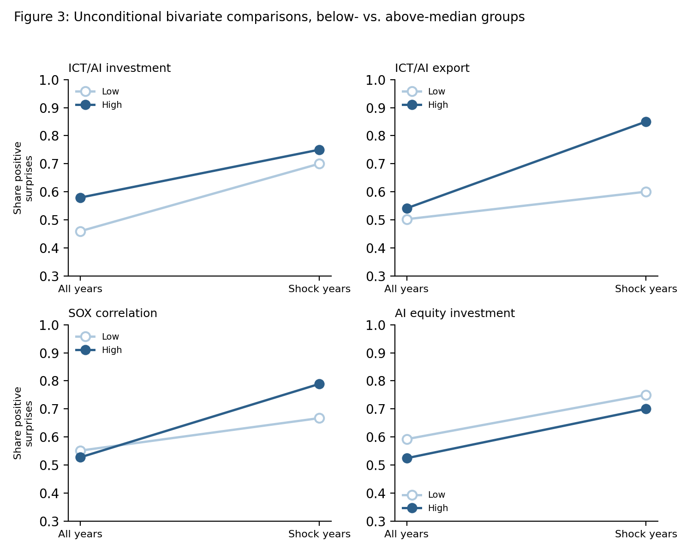
Figure 3. Unconditional bivariate comparisons: share of positive growth surprises for below- (Low) and above-median (High) groups, all years vs. shock years.

4.3 Panel probit evidence
Table 1 reports the panel probit results. ICT/AI-related investment (β=0.25, p<0.10) and semiconductor-index correlation (β=0.38, p<0.05) both significantly raise the probability of a positive growth surprise on average across the whole sample, consistent with the structural- and cyclical-channel hypotheses respectively for the ‘normal-times’ effect. Neither shows a significant additional (γ) effect specifically in shock years, mirroring the investment variable's unconditional pattern, though notably the semiconductor-correlation result diverges from its own unconditional test, which showed no significant average difference -- indicating that conditioning on country and time reveals an association the raw comparison masked. ICT/AI-related export exposure shows no significant average effect (β=-0.14, n.s.) but a significant additional effect during shock years in both interaction specifications (γ=0.25 and 0.27, both p<0.10), directly confirming the unconditional finding that trade exposure is specifically a shock-resilience channel. AI-related equity investment shows no significant coefficient in any specification.
Table 1. Panel probit regression results (standardised explanatory variables)
 | (1)  Probit | (2)  Probit | (3)  Probit
 | beta | gamma | gamma
ICT/AI-related investment | 0.25* | 0.24 | 0.26
Equity investments in AI | -0.15 | -0.05 | 0.06
ICT/AI-related export | -0.14 | 0.28* | 0.29*
Correlation semiconductor index | 0.38** | -0.10 | 0.04
Notes: ***, **, * indicate significance at the 1%, 5%, and 10% level. Standard errors from the analytic Hessian of the probit log-likelihood. All explanatory variables are standardised (z-score); the shock-year dummy is not. Model 1 estimates the average effect (β) across the full sample; Models 2 and 3 estimate the additional effect (γ) specifically in shock years, using the continuous variable and its above-median value respectively.

5. Discussion
Two broad conclusions emerge from combining the unconditional and conditional evidence. First, the structural investment channel (ICT/AI investment) and the financial-market channel (semiconductor correlation) appear to matter mainly, or only, in normal times -- their advantage does not clearly extend into shock resilience once a common shock component is accounted for. Second, the trade channel (ICT/AI-related export exposure) is the one channel for which both the unconditional and the conditional evidence agree: it plays essentially no role in normal years but becomes a significant, positive driver of resilience specifically during shocks. This is consistent with global demand for AI/ICT-related goods behaving countercyclically, or accelerating, during the shock episodes in our sample.
An important caveat applies to this trade-resilience finding. It rests on only three shock episodes (2020, 2022, 2025), and all three coincide with the ongoing structural upswing in the semiconductor/AI cycle documented in Figure 1 -- a cycle that has itself not been derailed by any of these shocks. With only three, non-independent shock episodes, it is not possible to statistically distinguish a generic shock-buffering mechanism from a mechanism that is specific to shocks occurring during an AI upcycle. If a future shock were to originate within the AI sector itself -- for instance, a correction in AI-related capital expenditure or equity valuations -- high tech-trade exposure could plausibly turn from an advantage into a vulnerability, mirroring the pattern already observed for AI-related equity investment inflows in this sample, where high exposure was associated with a relative disadvantage during stress periods.

6. Conclusion
- Positive growth surprises are more common in shock years than in normal years, pointing to greater resilience than EC forecasts anticipated.
- ICT/AI-related investment and semiconductor-market correlation matter for growth surprises mainly in normal times, not specifically during shocks.
- Financial AI exposure (equity investment inflows) does not play a resilience-enhancing role and may even be a relative disadvantage in stress periods.
- ICT/AI-related trade exposure has been a genuine resilience channel specifically in shock years, confirmed by both unconditional and conditional evidence.
- This trade-resilience finding is based on only three shock episodes, all occurring during the ongoing AI upcycle -- it may not generalise to a shock originating within the AI sector itself, where high-tech trade exposure could turn from an advantage into a vulnerability.

References
ECB (2026). Trade effects of AI-related global activity. European Central Bank.
Eichengreen, B., et al. (2024). Measuring and explaining economic resilience.
Moujahid, Y., et al. (2025). ICT/AI investment, firm flexibility, and shock resilience.

