Ha Maurice,

Veel dank voor je suggesties. Je kritiek op de FE probit is terecht, de clustered SE ondervangen dat niet. Daarom hebben we nu voor onze onderzoeksvraag (impact van ICT/AI variabele op probability positive growth surprise - wat een binary response varable is) hebben we nu een LPM geschat (met country-clustered SE). En als alternatief Schatten we een correlated random-effects probit (Mundlak CRE probit). De coefficient schattingen van beide methoden zijn vergelijkbaar (marginale effecten en significantie), ook vergelijkbaar met onze originale aanpak (probit FE, die we niet meer zullen gebruiken).

Probit because we estimate whether ICT exposure changes the probability that growth exceeds the forecast (discrete event).

[robustness check] OLS with dummy for positive surprises as the dependent variable. The linear probability model directly gives percentage-point effects, handles fixed effects easily and- using your country-clustered standard errors - is a useful benchmark. Its disadvantages are possible fitted probabilities outside 0–1 and constant marginal effects.

Linear probability model (LPM) has important advantages:
- Coefficients are immediately interpretable as percentage-point changes in the probability.
- Country and time fixed effects are straightforward.
- Interaction coefficients have a direct interpretation.
- It does not assume that the probability follows a normal cumulative distribution.
- It avoids the incidental-parameters complication of fixed-effects probit.
- Country-clustered inference is easy to implement.
LPM coefficient of (0.06) means that a one-standard-deviation increase in ICT exposure is associated with a 6-percentage-point increase in the probability of a positive surprise.

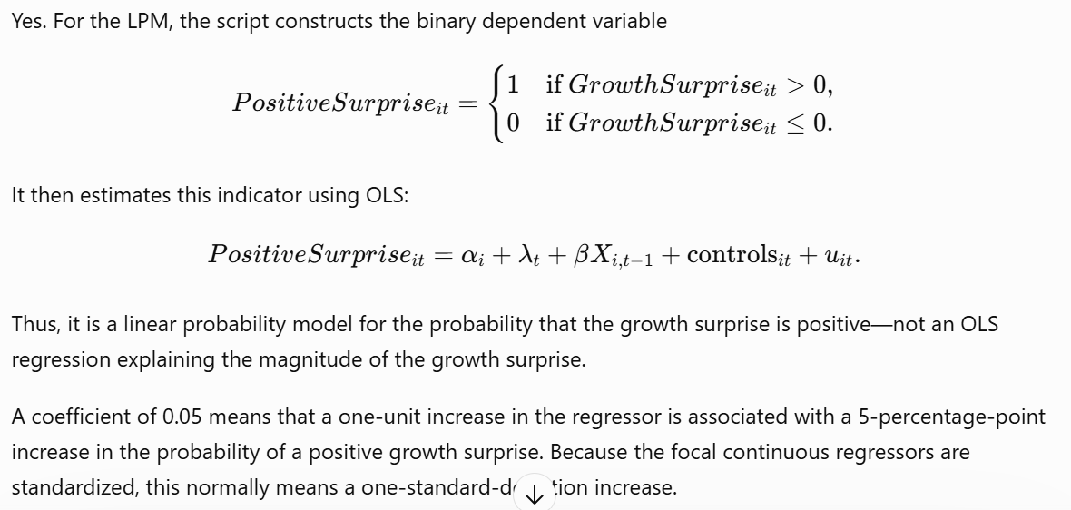

Probit keeps predicted probabilities between zero and one, but its coefficients are effects on an unobserved latent index—not changes in probability. You should therefore report average marginal effects, or predicted-probability changes, alongside or instead of raw probit coefficients.

Our binary-response regressions do not use the continuous growth surprise as the dependent variable. They define a binary dummy variable = 1 when realised growth exceeds the corresponding forecast and zero otherwise. The probit model therefore examines whether ICT exposure is associated with the probability of a positive forecast error, whereas our OLS regressions examine the magnitude of the continuous forecast error. We agree that probit is not the only possible estimator of this probability. We therefore also report a linear probability model and logit estimates as robustness checks and present average marginal effects for the probit specification.
added LPM estimation using OLS with country and time fixed effects.
Binary dependent variable: \(1(\text{growth surprise}>0)\).
Added plain, shock-interaction and above-median-interaction LPM variants.
Applied the same controls, standardization, lag structure and country-clustered covariance correction.
LPM inference uses country-cluster degrees of freedom.
Added detailed LPM results below the logit results.
Replaced models (4)–(6) in the compact “Regression results” table with LPM estimates.
Retained the continuous-growth-surprise OLS tables elsewhere.
Ensured missing growth surprises are excluded rather than classified as zero.
Updated the explanatory text throughout.

Yes—country-clustered standard errors are appropriate and common for a fixed-effects LPM using panel data.
Fixed effects and clustered covariance address different problems:
Country fixed effects control for time-invariant differences between countries.
Time fixed effects control for common period-specific shocks.
Country clustering adjusts inference for heteroskedasticity and correlation among observations from the same country over time.

Referee is identifying a genuine issue, and country-clustered standard errors do not solve it. Clustering changes the estimated uncertainty around the coefficients; it does not remove bias from the estimator or relax the random-effects independence assumption.
Country fixed effects permit all these time-invariant factors to be correlated with ICT. Standard random effects do not.
… persistent unobserved country characteristics cannot be correlated with ICT exposure. FE => In your setting, this is a strong—and arguably heroic—assumption. ICT investment and export exposure are likely correlated with persistent country characteristics.
The strongest practical solution: correlated random-effects probit

Answer:
We agree that unconditional fixed-effects probit may be affected by the incidental-parameters problem and that conventional random-effects probit requires the country-specific effect to be independent of ICT exposure—an assumption that may be restrictive in a cross-country setting. We therefore use a country- and time-fixed-effects linear probability model as our primary binary-outcome specification. As a nonlinear robustness exercise, we estimate a correlated random-effects probit using the Mundlak formulation, including country means of the time-varying explanatory variables and controls. This permits persistent unobserved country heterogeneity to be correlated with ICT exposure. Inference accounts for within-country dependence.

We doen toch wat econ vuurwerk door Schatten van Mundlak correlated random-effects probit (Mundlak CRE probit): a country random intercept, time fixed effects, and within/between decompositions of ICT and the enabled time-varying controls.

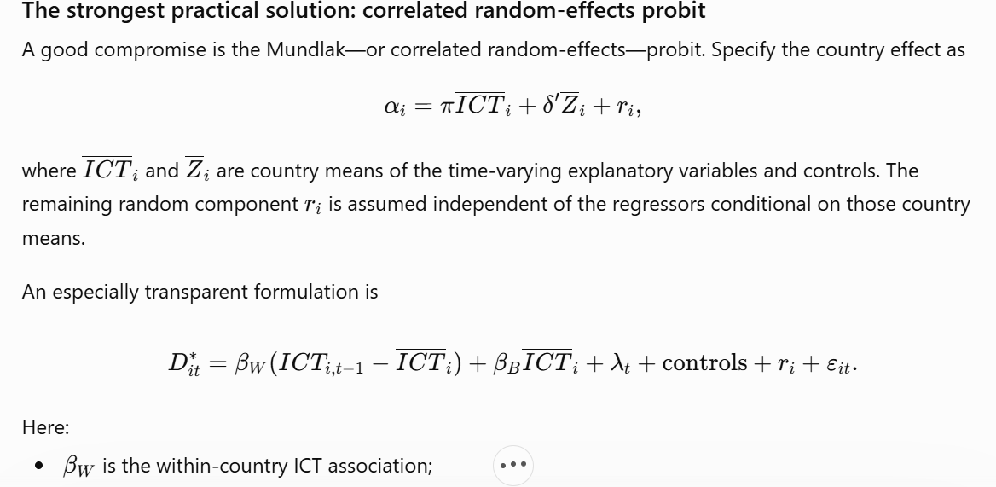


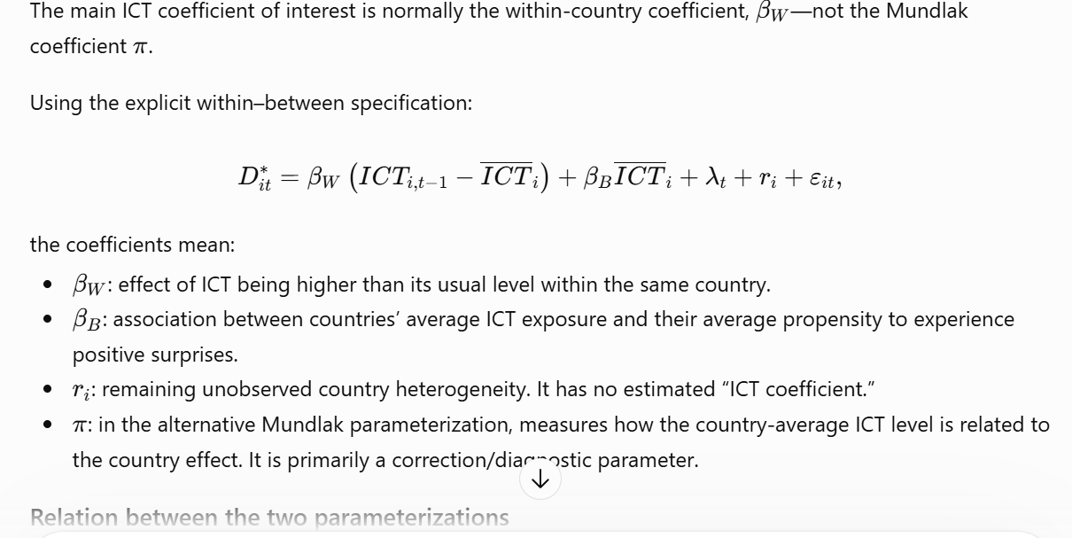

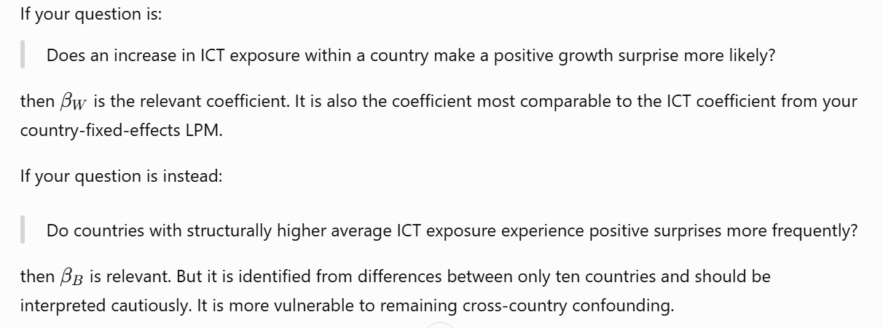

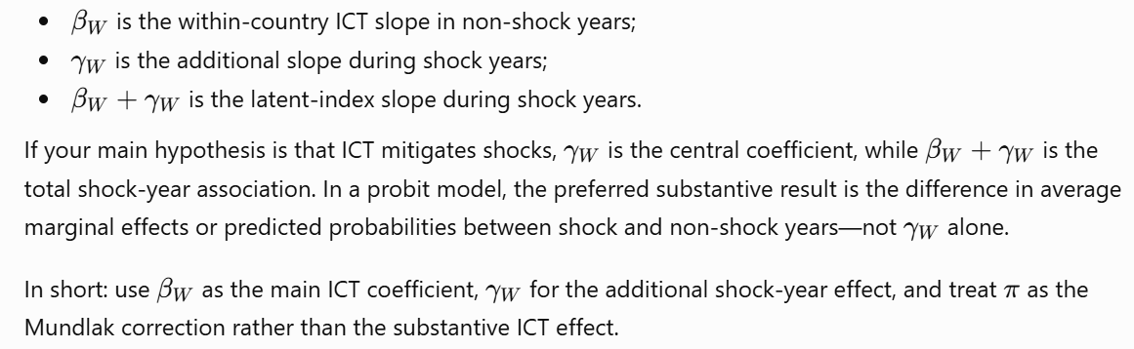

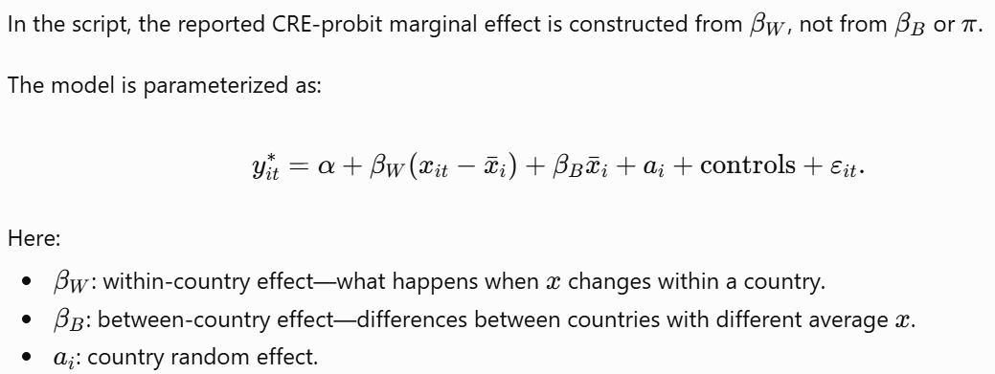

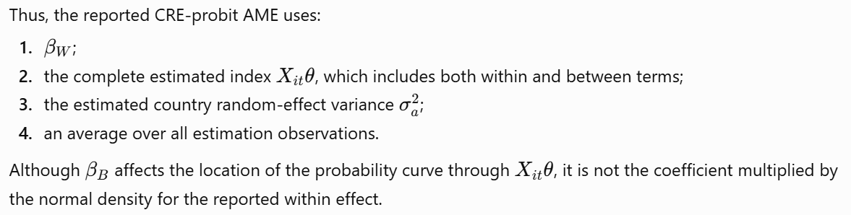

The regression (estimated coefficients) outcomes in the xls table of the CRE probot are quite similar as the outcomes of the original FE probit
Yes, that can be expected. It is not by itself evidence that the CRE probit was implemented incorrectly.
- The central reason is that the reported CRE coefficient is the within-country coefficient:
$$y_{it}^{*}=β_{W}\left(x_{it}-{\overline{x}}_{i}\right)+β_{B}{\overline{x}}_{i}+a_{i}+\text{time FE}+ε_{it}.$$
- Your original fixed-effects probit also identified the ICT coefficient mainly from changes within a country over time. Consequently, $β_{W}$from the CRE probit and the coefficient from the country-dummy probit can be quite similar.
- Similarity is particularly plausible when:
- the same observations, time fixed effects, controls and standardization are used;
- most identifying variation is within countries;
- the Mundlak country means adequately capture the correlation between ICT exposure and persistent country heterogeneity;
- the estimated country random-effect variance is relatively small;
- the country effects are approximately described by the included country means.
- However, the coefficients are not guaranteed to be identical. The FE probit estimates a separate intercept for every country, whereas the CRE probit assumes a normally distributed country random intercept and models its correlation with the regressors through their country means. Because probit coefficients are latent-index coefficients, differences in the treatment of unobserved heterogeneity can also affect their scale.
- The most useful checks are therefore:
- Compare the exact estimation samples and $N$.
- Examine SD(country random effect). A value near zero helps explain similar estimates.
- Inspect $β_{B}$and $γ_{B}$, preferably with a joint test of all Mundlak country-mean terms.
- Check whether the CRE optimizer converged and whether the random-effect variance is at its lower bound.
- Compare average marginal effects, not only raw probit coefficients.
- A significant joint test of the country means would indicate that ordinary random effects—without the Mundlak correction—would be inappropriate. It does not imply that $β_{W}$must differ strongly from the former FE-probit estimate. In fact, similar within coefficients combined with significant country-mean terms would be a perfectly coherent result: the correlation with country heterogeneity matters, but correcting for it does not materially change the estimated within-country ICT relationship.
- With only around ten country clusters, I would also emphasize coefficient stability and confidence intervals rather than small changes in individual p-values.

use the fixed-effects LPM as the benchmark and the correlated random-effects probit as the nonlinear robustness check.
- The LPM-FE is attractive because:
- Country fixed effects can be included without the nonlinear incidental-parameters problem.
- \(\beta\) and \(\gamma\) have an immediate probability interpretation: a coefficient of 0.05 is 5 percentage points.
- It does not require normally distributed country random effects.
- It allows the country effects to be arbitrarily correlated with ICT exposure.
- Country-clustered inference is straightforward.
The CRE probit then checks whether the conclusions survive:
- imposing a nonlinear probability function;
- accounting for a country random intercept;
- allowing correlation between that random intercept and the regressors through Mundlak country means.
- For comparison, report the CRE-probit average marginal effects alongside the LPM coefficients. Raw \(\beta_W\) and \(\gamma_W\) are latent-index coefficients and therefore are not directly comparable to the LPM’s percentage-point effects.
- A suitable paper formulation would be:
- Our benchmark estimates use a linear probability model with country and time fixed effects. This specification avoids the incidental-parameters problem associated with nonlinear fixed-effects binary-response models and allows time-invariant country heterogeneity to be arbitrarily correlated with ICT exposure. Standard errors are clustered by country. As a nonlinear robustness check, we estimate a correlated random-effects probit model using the Mundlak approach, including country means of all time-varying regressors. We report within-country coefficients and average marginal effects.
• Replaced all three probit estimations with Mundlak correlated random-effects probit.
• Added a country random intercept and time fixed effects.
• Decomposed time-varying regressors and enabled controls into within-country deviations and country means.
• Models (1)–(3) in “Regression results” now report:
- beta_w for the plain specification.
- gamma_w for the interaction specifications.
• Detailed output also reports beta_B, gamma_B, and the estimated country random-effect standard deviation.
• Retained country-clustered sandwich standard errors and finite-sample correction.
- One remaining concern is that you have only approximately ten country clusters. Your \(G-1\) cluster degrees-of-freedom correction is appropriate, but I would ideally supplement the benchmark LPM inference with wild cluster-bootstrap p-values or confidence intervals. That is likely more consequential than choosing between LPM and probit.
- So my recommended hierarchy is:
- Benchmark: LPM with country and time fixed effects.
- Main nonlinear robustness check: Mundlak CRE probit.
- Comparison: signs, significance and especially average marginal effects.
- Inference robustness: wild cluster bootstrap for the LPM, given the small number of countries.

I’ll reorganize the compact table so models (1)–(3) are the LPM specifications and models (4)–(6) are the CRE-probit specifications. I’ll then add six parallel AME columns in H–M; for the LPM these equal the reported probability coefficients, while for CRE probit I’ll calculate population-averaged marginal effects after integrating over the country random effect, with delta-method clustered inference.

The referee is identifying a genuine issue, and country-clustered standard errors do not solve it. Clustering changes the estimated uncertainty around the coefficients; it does not remove bias from the estimator or relax the random-effects independence assumption.
Suppose the latent-index model is
\[ D^*_{it}=\beta ICT_{i,t-1}+\lambda_t+\alpha_i+\varepsilon_{it}, \qquad D_{it}=1(D^*_{it}>0), \]
where \(\alpha_i\) represents unobserved, time-invariant country characteristics.
- The fixed-effects probit problem
Your present implementation includes country dummies in an ordinary probit model. This is often called an unconditional fixed-effects or LSDV probit.
It must estimate one \(\alpha_i\) for every country. In nonlinear models, estimation error in those country effects can contaminate the estimate of \(\beta\). This is the incidental-parameters problem. Unlike fixed-effects logit, probit has no conditional likelihood that removes the country effects.
The problem is most prominent when there are many countries and few observations per country. Your setting is somewhat unusual—only ten countries, but multiple years and forecasts—so the conventional asymptotic argument does not fit perfectly. Nevertheless, finite-sample bias, separation and unstable country-dummy estimates remain legitimate concerns.
- What random-effects probit assumes
A conventional random-effects probit treats the country effect as random:
\[ \alpha_i\sim N(0,\sigma_\alpha^2), \]
and assumes
\[ \alpha_i\perp ICT_{i1},ICT_{i2},\ldots,ICT_{iT}, \]
conditional on the included controls.
That means persistent unobserved country characteristics cannot be correlated with ICT exposure. In your setting (FE), this is a strong—and arguably heroic—assumption. ICT investment and export exposure are likely correlated with persistent characteristics such as:
- institutional quality;
- income and economic development;
- industrial structure;
- innovation capacity;
- education and human capital;
- fiscal capacity;
- forecastability and data quality.
Country fixed effects permit all these time-invariant factors to be correlated with ICT. Standard random effects do not.
Moreover, random-effects probit combines within-country and between-country variation. Therefore, its ICT coefficient is not directly comparable to the within-country fixed-effects coefficient unless the model is formulated carefully.
- Clustering does not solve this
Country-clustered standard errors allow:
- heteroskedasticity;
- serial dependence within countries;
- arbitrary covariance among observations belonging to the same country.
They do not correct:
- incidental-parameters bias in fixed-effects probit;
- correlation between random effects and ICT in random-effects probit;
- omitted-variable bias;
- endogeneity of ICT;
- measurement error.
Thus, estimating a standard RE probit with clustered SE would still retain the potentially heroic assumption:
\[ E(\alpha_i\mid ICT_{i1},\ldots,ICT_{iT})=0. \]
- The strongest practical solution: correlated random-effects probit
A good compromise is the Mundlak—or correlated random-effects—probit. Specify the country effect as
\[ \alpha_i=\pi\overline{ICT}_i+\delta'\overline{Z}_i+r_i, \]
where \(\overline{ICT}_i\) and \(\overline{Z}_i\) are country means of the time-varying explanatory variables and controls. The remaining random component \(r_i\) is assumed independent of the regressors conditional on those country means.
An especially transparent formulation is
\[ D^*_{it} = \beta_W(ICT_{i,t-1}-\overline{ICT}_i) + \beta_B\overline{ICT}_i + \lambda_t + \text{controls} + r_i+\varepsilon_{it}. \]
Here:
- \(\beta_W\) is the within-country ICT association;
- \(\beta_B\) captures between-country differences;
- correlation between persistent ICT levels and the country effect is explicitly accommodated.
Country means should be added for all relevant time-varying regressors, not only ICT—including enabled controls and, where appropriate, interaction variables.
You can also test whether the country-mean terms are jointly significant. If they are, conventional random effects is rejected in favour of correlated random effects. With only ten countries, however, such a test will have limited power.
- Recommended empirical strategy
For your paper, I would use:
- Fixed-effects LPM as the primary binary-outcome model.
This permits arbitrary correlation between persistent country characteristics and ICT and avoids nonlinear incidental-parameters bias.
- Correlated random-effects probit as the principal nonlinear robustness check.
Include country means of the time-varying regressors—the Mundlak adjustment—and retain time fixed effects.
- Standard random-effects probit only as an additional comparison.
Do not rely on it as the preferred model unless you can defend independence between country effects and ICT.
- Country-clustered inference or, preferably with ten countries, wild-cluster-bootstrap inference.
- Average marginal effects for the probit, rather than interpreting raw probit coefficients as probability changes.
A suitable response to the referee would be:
We agree that unconditional fixed-effects probit may be affected by the incidental-parameters problem and that conventional random-effects probit requires the country-specific effect to be independent of ICT exposure—an assumption that may be restrictive in a cross-country setting. We therefore use a country- and time-fixed-effects linear probability model as our primary binary-outcome specification. As a nonlinear robustness exercise, we estimate a correlated random-effects probit using the Mundlak formulation, including country means of the time-varying explanatory variables and controls. This permits persistent unobserved country heterogeneity to be correlated with ICT exposure. Inference accounts for within-country dependence.
That addresses the referee’s concern more convincingly than replacing fixed-effects probit with an unadjusted random-effects probit.

