The entire unity project has more than 100 files, which makes it too big to be added to github.

So, I just added the C# script “Instantiate”, which contains the codes to generate the scene we want. Below are the steps to follow:

1. Create an empty GameObject using the menu **GameObject > Create Empty**.

2. Add the script to the new GameObject as a component by dragging it onto the empty GameObject.

3. Create a prefab and drag it from the **Project window** into the **My Prefab** field in the script component.

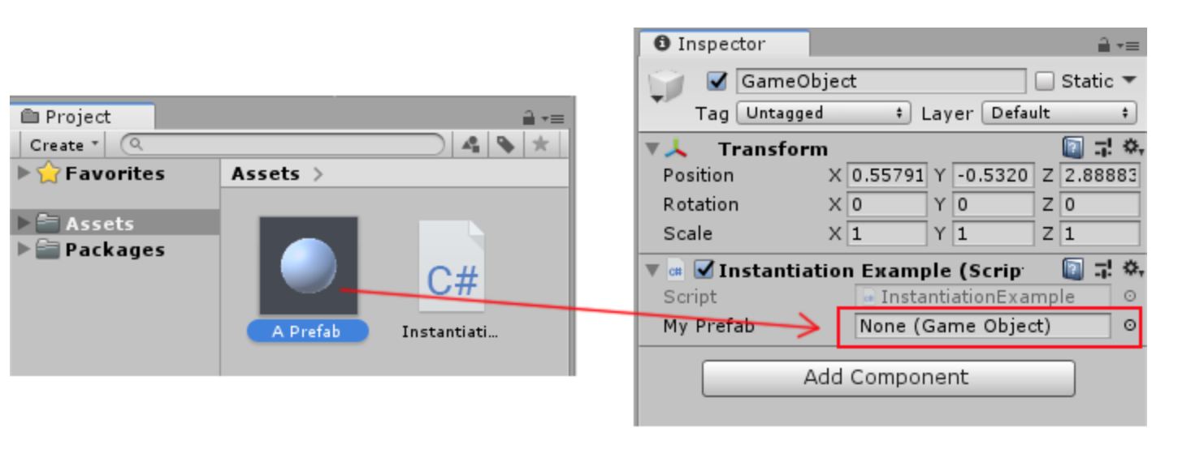

You can try any prefab, however, if you use the same rollerball prefab, changes to the RollerBall prefab should be made:

1. create the prefab by dragging it from assets to the scene to change its property
2. unselect the “Use Gravity” in Rigidbody, otherwise the objects will be falling at run time
3. unselect Ball(Script) and Ball User Control (Script) underneath to avoid error

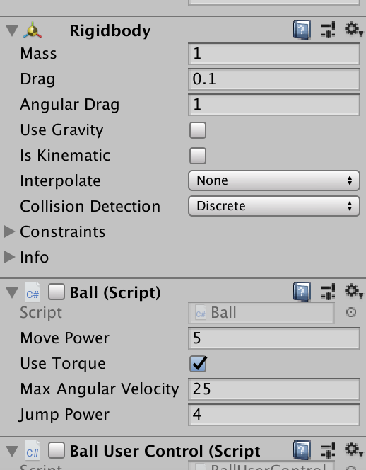

1. besides the prefab, select overrides and choose apply all

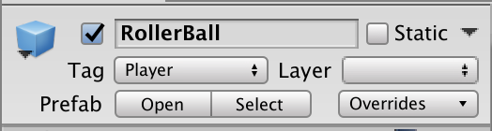

1. delete this object and the property will applied to all the prefabs we create later

Make sure to put the file coordinate_data.csv inside the project, otherwise the path would not be found.

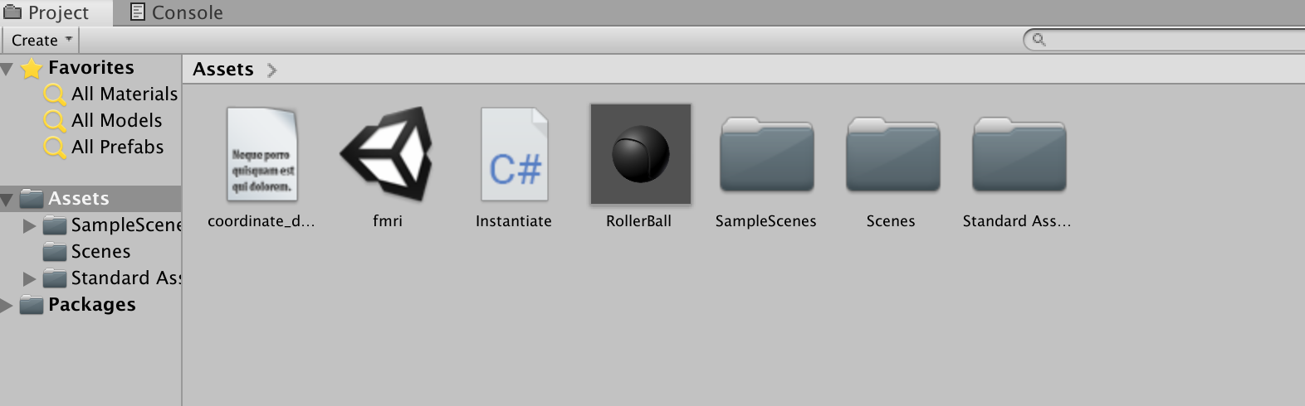

Awesome! Now start play mode and it should work. If not, contact me.