Simple CRUD with Report using

Language : VB.NET, SQL Server, and Crystal Reports Free Source Code
Submitted by Stephen Murigi Kiiru on Wednesday, August 18, 2021 - 13:43.
Language
Visual Basic .NET
Discover more
Application software
App
Crystal Reports
SQL Server
software
Software
SQL
MS SQL SERVER
Microsoft SQL Server
crystal report
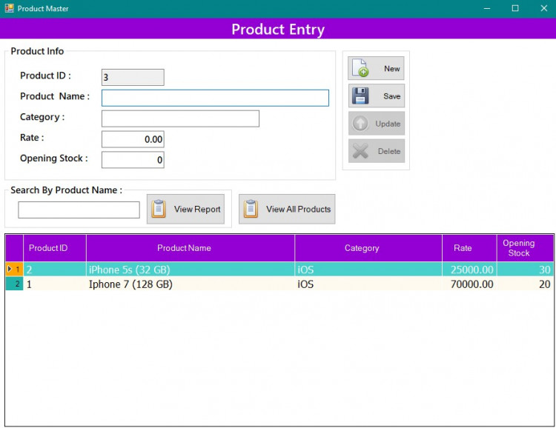
This is a VB.NET Program that has a CRUD Operation that stands for Create, Read, Update, and Delete functionalities. The application is a software-based program that uses MS SQL Server Database. In this CRUD Program, the application stores a list of products details which are the product id, name, category, rate, and quantity. Using this simple project, you will learn how to handle the mentioned functionalities in VB.NET and MS SQL Server Database. The system also has Report Generation using SAP Crystal Reports. The product list has a Search in table feature.

Features
- Create New Product
- List Product using DataGridView
- Update Product Details
- Delete Product w/ Confirmation
- Search Product in Table
- Generate Report

How to Operate/Use
- To create or add new product details to the list, click the New Button and fill up all the text fields on the form. Then click the Save Button afterward.
- To update product details, select your desired product to update in the DataGridView/Table. After that, the product details will automatically fill in the current data in each text field on the form. Change the fields you want to updated and click the Update button.
- To delete the product, same as updating the details, select the product from the Table first then click the Delete Button. After that, the confirmation popup box will show.
- The Search feature will query from the database the product which product name is equal or contains the entered value in the search box/text field.

These are some Snapshots

Main Form
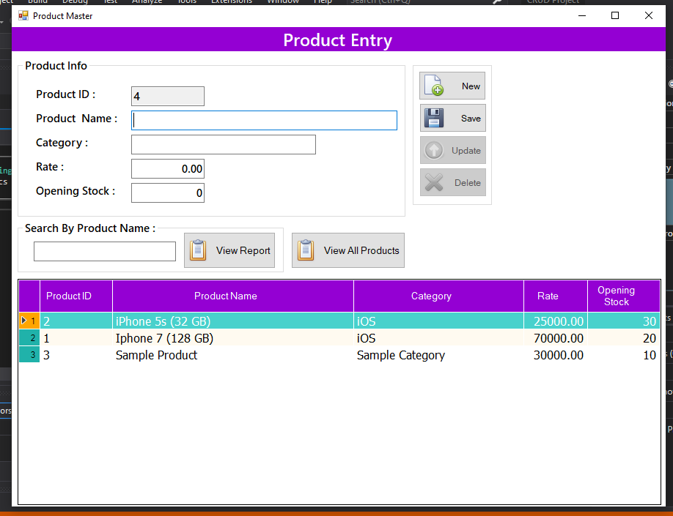
Discover more
Application software
database
Application
SQL
App
Reports
Report
Database
Visual Studio
crystal report

Updating Product Details
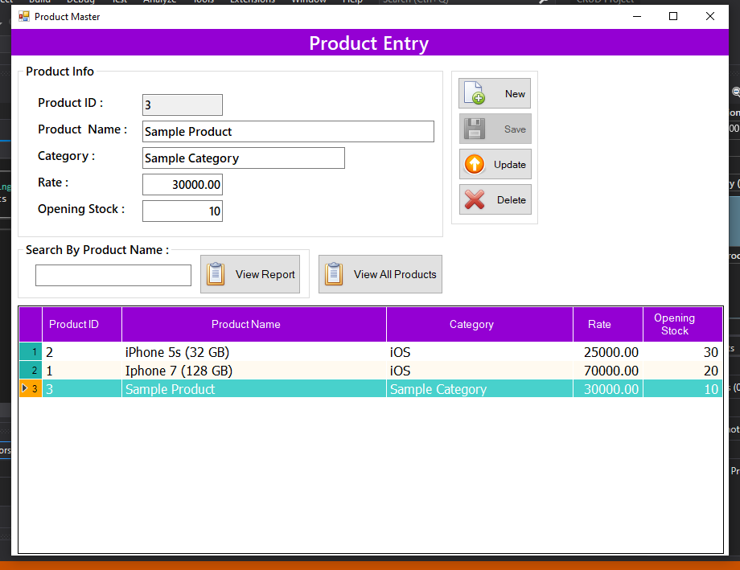

Delete Confirmation
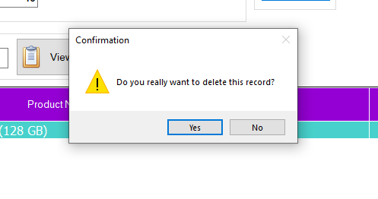
Discover more
database
MySQL
Application
MS SQL Server
SAP Crystal Reports
Database
net
Reports
Report
crystal report

Search
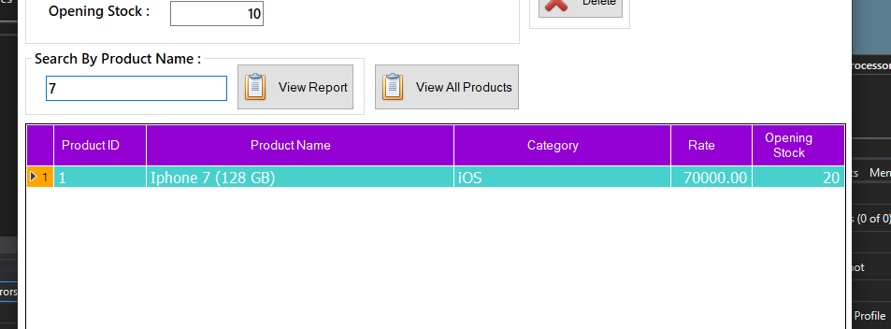

Report
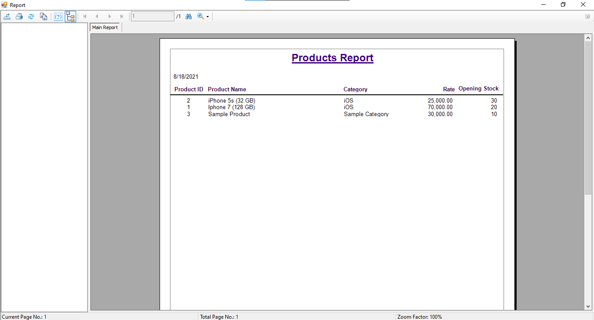
The source code is free to download. Fee free to download and modify the source code to enhance your programming capabilities using VB.NET, MS SQL Server Database, and SAP Crystal Reports
Discover more
.NET Core
Application
SQL
database
Application software
MS SQL SERVER
SAP Crystal Reports
DB
net
software

How to Run ??
Requirements
Download and Install the following
- Microsoft Visual Studio Software 2010 or later version
- Microsoft SQL Express Server
- Microsoft SQL Server Management Studio
- SAP Crystal Reports
Installation/Setup
Discover more
Reports
MySQL
Application software
net
Microsoft Visual Studio
Software
SAP Crystal Reports
DB
SQL SERVER
SQL Server
- Download and Extract the provided source code zip file. (download button is located below)
- Locate the SQL Backup File (.BAK) inside the extracted source code folder. The file is known as CRUD_DB.bak located inside the Database Script folder.
- Open your MS SQL Server Management Studio and connect to a server. Then, restore the SQL Backup File (.bak).
- Locate the solution file inside the extracted source code folder. The file is known as CRUD Project.sln.
- Open the solution file with your MS Visual Studio Software.
- Configure the connection string based on your server. The connection string can be changed at the ConnectionString.vb file.
- Press the F5 key on your keyboard to run this Simple CRUD Program.

DEMO

Username :Admin

Password :admin

