Hard Part-1

1. I can build web applications using the shiny R package to produce an interactive output. The idea is to use shiny package along with rgbif package. rgbif package includes gbifmap function which gives a map output when provided with some input. For eg-

key <- name_backbone(name='Puma concolor')$speciesKey
dat <- occ_search(taxonKey=key, return='data', limit=100)
gbifmap(dat)

Instead of using the rgbif, we can build this feature using maps and mapproj package also.

On implementation, user can give input in the form of drop-downs, sliders etc.(see figure for an example representation) to give input to the gbif map function that is running in the server.R of the web application. This would definitely help inexperienced users.

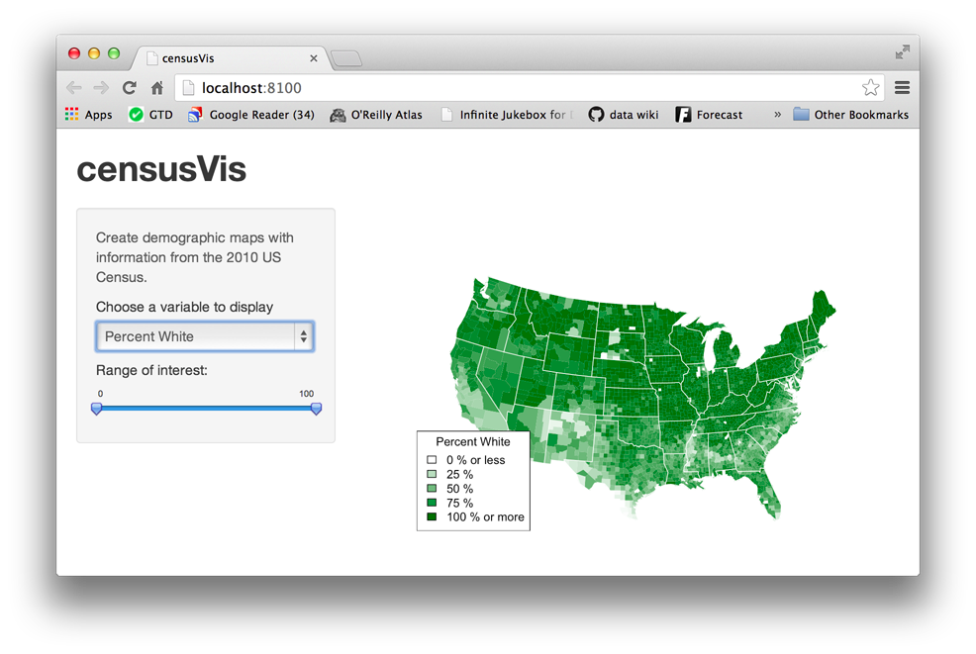

2. Outputs from shiny and other output plots can be made more interactive using plotly package (https://plot.ly/r/) . They provide functions to build various kinds of statistical figures like pie charts, histograms that give interactive details.
This can be used to compare data for different species, years, region and make data analysis a much better experience.

3. Proper documentation of all the functions can be done to produce a detailed tutorial along with reference to the whole package.

Hard part-2

Darwin Core data broadly consists of nine parts namely Record-level terms, Occurence, Event, Location, Identification, Taxon, GeologicalContext, ResourceRelationship & MeasurementOrFact. All these contain different fields of data regarding a particular occurence. That is a lot of data about a single sample. For a particular search, a list of dataframes can be built where each dataframe consists of Terms of one of the 9 parts.

Further, every field/term from nine different parts can be given a slot of numeric ( like OccurenceID) or character( like countryCode) as required. Also, every character input can have an appropriate size limit set for standardisation. These slots combine to form the dataframe. The whole list can also have one more dataframe that consists of metadata (data about data), comprising of count of occurences, no of NULL values etc. Fields related to date can be handled with R’s standard date and time types POSIXlt and POSIXct.

Taking analogy from linear algebra, a “sparse dataframe” can be built if possible in situations where very less data is available and most of the fields are set to NULL for various occurences. This will speed up performance time of various functions applied on the large data structure.

Further, extending the rgeospatialquality functions, more fields can be flagged so that values conform to the DarwinCore Standard leading to stadardisation of data.

