Concepts regarding NLP
- Intents
- Entities
- Slots
- Actions
- Stories

Features:
- Data Generation
A user can generate training data for the chat bot by clicking the data generation button which accesses the Rasa data generation utility.
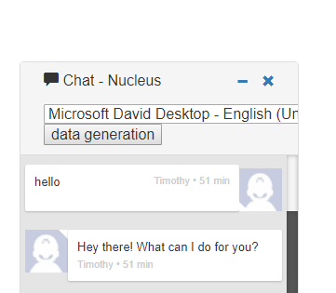

Rasa data generation utility helps generate training data based on the keywords provided and the type of questions chosen by the user. It gives the user the option to define his own intents and to choose whether he wants to define entities or not.

The types of questions provided are:
  - What : eg. what do you mean by ____?
  - How : eg. how is ____ done?
  - How many : eg. how many __________?
  - When : eg. When does _____ take place?
  - After : eg. what happens after ____?
  - Before : eg. what happens before ____?
  - Where (process) : eg. where does ____ take place?
  - Where (object) : eg. where is ____ located?
  - Other : This covers the question that do not come under the above types. In this, intent has to be defined by the user.
eg. Keyword : hi
Intent: greet
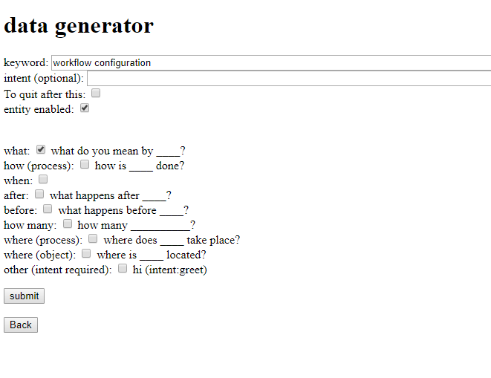
After clicking 'Submit', the utility takes the data given by the user, creates the questions required and converts it into structured data in the form:

{
"text": "what is workflow configuration?",
"intent":"what_workflow_configuration",
"entity":[
{
"start":8,
"end":16,
"value":"workflow",
"entity":"workflow"
},

{
"start":17,
"end":30,
"value":"configuration",
"entity":"configuration"
}
]
}

The converted data is then stored in a file in the data folder of the application – testData.json.
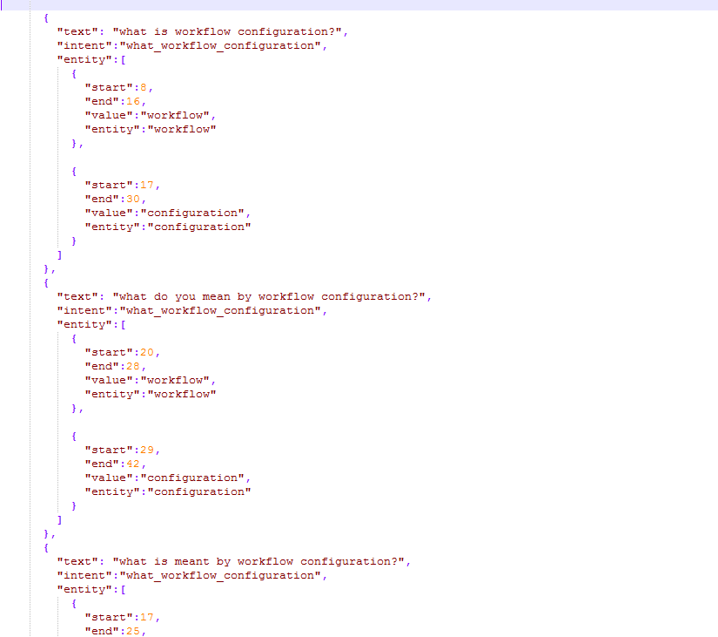
- Text based chat
The user can chat with the bot through text by writing in the text box provided. The bot will receive the message, interpret it and reply on the basis of the intent. With the addition of the Web Speech API, the bot also speaks out the replies given by the bot.
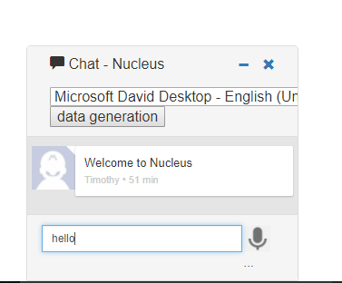
The user input

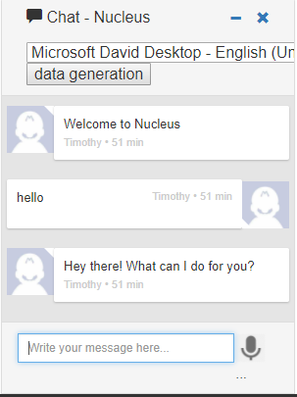
The reply by the bot on the basis of its interpretation of the input

- Speech based chat
The user can chat with the bot through speech by clicking on the microphone icon and speaking in the microphone. The speech is converted into text and is displayed in the chatbox. The message is then interpreted by the bot and the reply is both written and spoken by the chat bot.
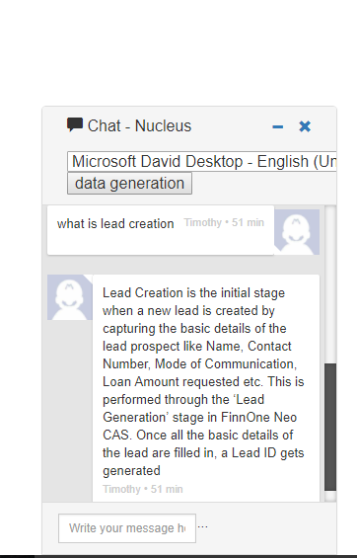
The user input through microphone

Technology Used
- Rasa Stack
It is an open source framework in python used to create chat bots. It has two components – Rasa NLU and Rasa Core:
  - Rasa NLU: This is responsible for the natural language understanding of the chatbot. Its purpose is to predict the intent and extract entities given an input sentence. Intent dictates how the chatbot should respond to an input from a user. Entities are used to make responses more customized
  - Rasa Core: The second component, Rasa Core, is the next component in Rasa stack pipeline. It takes structured input in the form of intents and entities (output of Rasa NLU or any other intent classification tool), and chooses which action the bot should take using a probabilistic model. It directs the flow of the conversation.

The flow of data within Rasa
(explain the channels)
- Flask
Flask is a micro web framework written in Python based on Werkzeug and Jinja2. It is used to connect web user interface with python backend. It is classified as a micro-framework because it does not require particular tools or libraries. It has no database abstraction layer, form validation, or any other components where pre-existing third-party libraries provide common functions.

- Web Speech API
Web Speech API is used for speech recognition and text to speech. It defines a complex interface called SpeechRecognition. The only browser that supports this API is Google chrome. This is why my chatbot can only be used in Google Chrome.

File structure
- Chatbot
  - data
    - data.json
    - stories.md
  - templates
    - layout.html
    - index.html
    - index_data.html
  - static
    - imgs
      - mic.jpg
    - js
      - cleantest.js
  - models
    - nlu
    - dialogues
  - domain.yml
  - nlu_model.py
  - nlu_model_config.py
  - train.py
  - train_online.py
  - run.py
  - custom2.py
  - actions.py

description of the files left
    - Domain – This is a YAML file in which the domain where the chat bot will work is defined. This includes definition of intents, entities, slots and actions.

Snippet of the domain definition of my chat bot
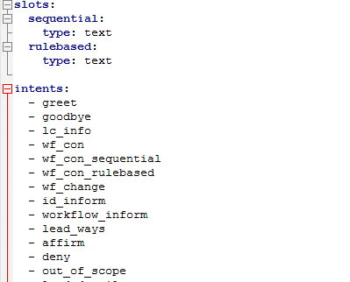
    - Data – This is a json file which contains the data on which the bot is trained. Each intent needs atleast 10 different types of user inputs. Based on this data, a probabilistic model is created for Rasa Core to use to run the bot.

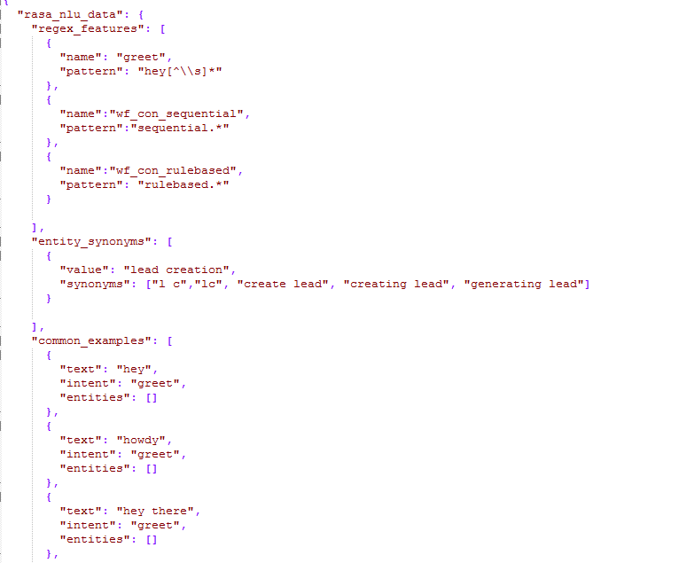

    - Stories – This is a MD file that defines all possible flows of conversation. This implements the unstructured form of dialogue, making the conversation with the chatbot more natural. Stories can be defined by the creator of chatbot or can be generated through training of the bot.

Snippet of stories.md

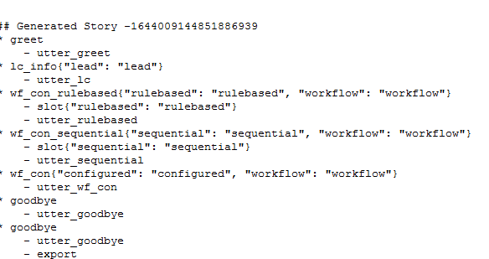

    - nlu_model – This is a python file used to create the NLU models and store them. The NLU models help identify intents and extract entities when the bot is running by determining the confidence level of the bot. The models are stored in the models folder.

Output of nlu_model.py

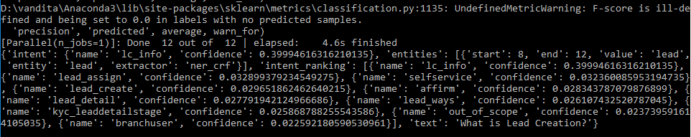

    - train – This is a python file used to train the bot using arbitrary dialogue flows and storing the models formed (whichever will persist) in models folder

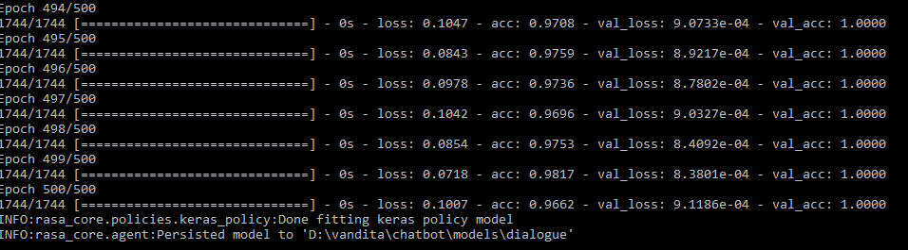
    - train_online – This is used to interactively train the chat bot and generate stories in a process that is known as Supervised Learning

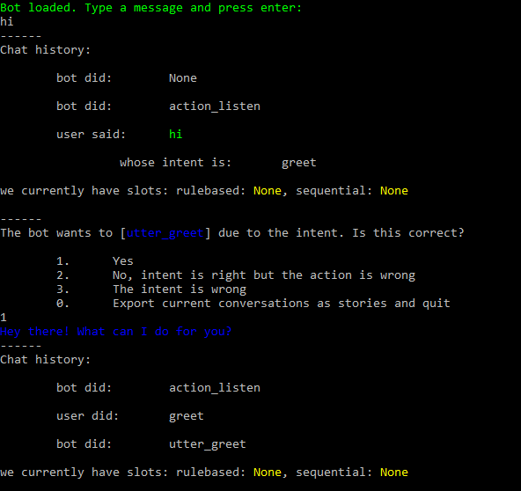

    - run – This is the python file that runs the bot. It imports the custom channel created in the custom2.py. It defines the interpreter, tracker, domain as well as models to be used and thus calls the agent using these variables as parameters to implement the running of the chatbot.

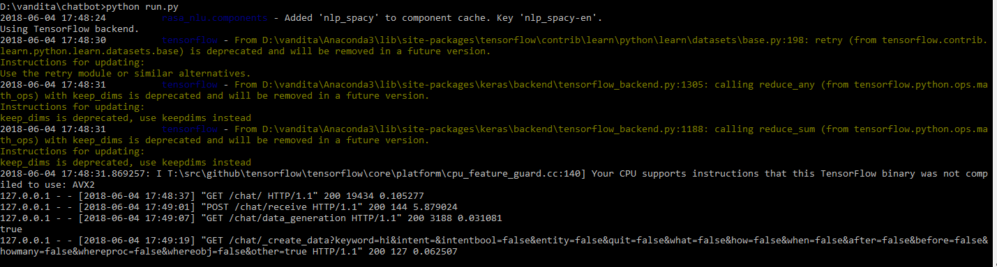

    - Custom2 – This is the python file in which I defined a customized channel for input and output of the chat bot. Using Flask, it serves the post request which carries the user input to be interpreted and returns the chat bot reply as well as it services the get requests for various html files and methods for data generation utility.

    - Cleartest – This is the javascript file used to convert speech to text using the Web Speech API and then send the text as input to be interpreted.

