Chatbot for Nucleus Softwares

4 Weeks Training Project Report

By

Vandita Goyal

B.Tech Computer Science (3rd Year),

Malaviya National Institute of Technology, Jaipur

under the Supervision of Mr Ankur Chaturvedi

CERTIFICATE

This is to certify that the Project titled “Chatbot for Nucleus softwares” , submitted by Vandita Goyal, embodies the bonafide work done by him/her under my supervision.

__________________________

Signature of the Manager

Place: NEW DELHI

Date: 05/06/18

Acknowledgement

This report gives the details of the project work done in four weeks’ summer training, under the supervision of Mr. Ankur Chaturvedi.

I am very grateful to my Project Coordinator Mr Ankur Chaturvedi and mentor Mr Ayush Bansal for their guidance and support, without which this project would not have been possible. I would also like to take this opportunity to thank the NSBT division at Nucleus Softwares Exports Ltd. for giving me this opportunity.

____________________

Signature of the Student

Name: Vandita Goyal

Date: 05/6/18

1. Introduction: 4
1.1 Concepts required for NLP 5
2. Features: 5
2.1 Overall Data flow: 5
2.2 Data Generation 6
2.3. Text based chat 9
2.4. Speech based chat 11
3. Technology Used: 12
3.1. Rasa Stack 12
3.1.1 The flow of data within Rasa 12
3.2. Flask 13
3.3. Web Speech API 13
4. Project in Detail 13
4.1 Folder structure 13
4.2. Important files used 14
4.2.1 Domain 14
4.2.2. Data 15
4.2.3 Stories 16
4.2.4. Nlu_model 16
4.2.5. Train 17
4.2.6 Train_online 17
4.2.7 Run 18
4.2.8. Custom2 18
4.2.9. Cleartest 18
4.3 Flow of data between Files: 19
5. Conclusion: 20
Benefits of Bot: 20
Challenges Faced: 20
Knowledge Gained: 20
Future Roadmap: 20

1. Introduction:
Chatbots are at the talking point of the business world now. The arrival of chatbots have opened up new realms of the customer engagement and new ways of doing business in the form of conversational commerce. It is one of the most useful technologies that businesses can rely on, possibly replacing the traditional models and making apps and websites redundant.
A chatbot is a computer program that simulates human conversation. It will communicate with a real person via textual or auditory methods using artificial intelligence techniques such as Natural Language Processing (NLP), image and video processing, and audio analysis.

My project was to create a chatbot which caters to the frequently asked questions about the services provided by Nucleus Softwares with the use of Rasa NLU and Rasa Core. The application accepts input from the user through a web user interface, processes it and returns the appropriate response. It accepts both text and speech inputs.

The web user interface is connected to the bot created through the use of Flask in python while the speech-to-text and text-to-speech conversion is done using Web Speech API developed by Mozilla.

My project also includes a utility to generate training data for a chatbot on the basis of the keywords provided along with the type of questions chosen. The data generated will be in the required format which can be easily integrated and used to train the bot.

1.1 Concepts required for NLP
NLP (Natural language processing) is the science of extracting the intention of text and relevant information from text.

1. Intents: Intents are the intentions behind what the user said. It describes what the user probably meant to say.
For example: “Hi” or “Hello” can both be described as a “greet” intent.

2. Entity: Entities can be described as the metadata about the intents. These can used to track intents and save information for further use in the form of slots.

3. Slots: Slots are the things you want to keep track of during a conversation. These can be used in further conversation to extract more information.

4. Actions: Actions are what the bot is supposed to do after it classifies the user input into intents.

5. Stories: Stories are the training data for a dialogue system.

2. Features:

2.1 Overall Data flow:

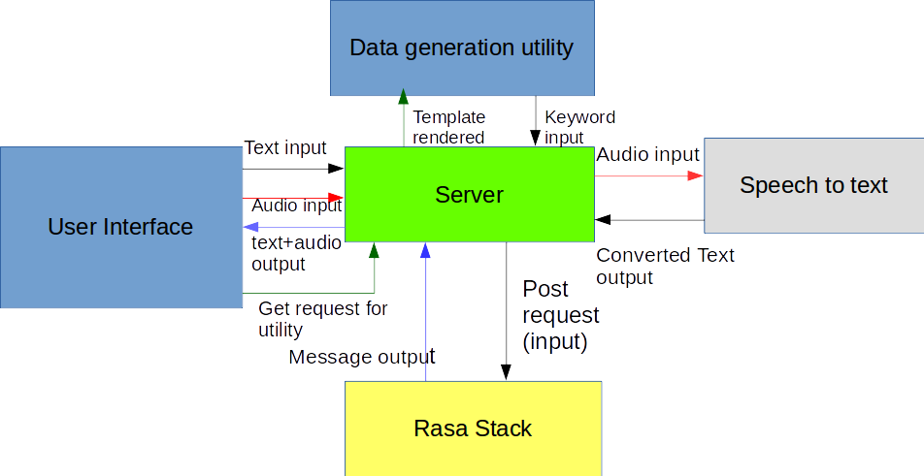

- UI sends text input to the server which makes a POST request with the text input to Rasa stack where the input is processed and out is sent back to the UI via the server
- UI sends an audio input to the server which sends it for Speech to text conversion. The text output is then sent as a post request to Rasa stack via the server and the output is sent to the UI
- UI make a GET request to the data generation utility through the server and it renders the UI template for the utility. The user then sends the necessary inputs to the server in the form of GET request. The server then processes the request and creates data to store in testData.json file.

2.2 Data Generation
A user can generate training data for the chatbot by clicking the ‘data generation’ button which accesses the Rasa data generation utility.
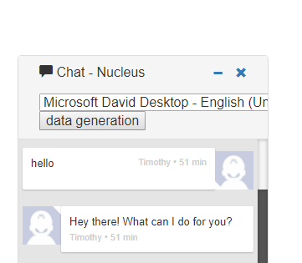

Rasa data generation utility helps generate training data based on the keywords provided and the type of questions chosen by the user. It gives the user the option to define his own intents and to choose whether he wants to define entities or not.

The types of questions provided are:
  - 1. What : eg. what do you mean by ____?
  - 2. How : eg. how is ____ done?
  - 3. How many : eg. how many __________?
  - 4. When : eg. When does _____ take place?
  - 5. After : eg. what happens after ____?
  - 6. Before : eg. what happens before ____?
  - 7. Where (process) : eg. where does ____ take place?
  - 8. Where (object) : eg. where is ____ located?
  - 9. Other : This type covers the question that do not classify under the above types. In this, intent has to be defined by the user.
eg. Keyword : hi
Intent: greet

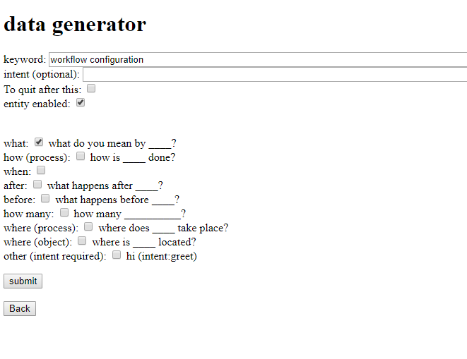
Data Generation Utility

After clicking 'Submit', the utility takes the data given by the user, creates the questions required and converts it into structured data in the form:

{
"text": "what is workflow configuration?",
"intent":"what_workflow_configuration",
"entity":[
{
"start":8,
"end":16,
"value":"workflow",
"entity":"workflow"
},

{
"start":17,
"end":30,
"value":"configuration",
"entity":"configuration"
}
]
}

The converted data is then stored in a file in the data folder of the application – testData.json.
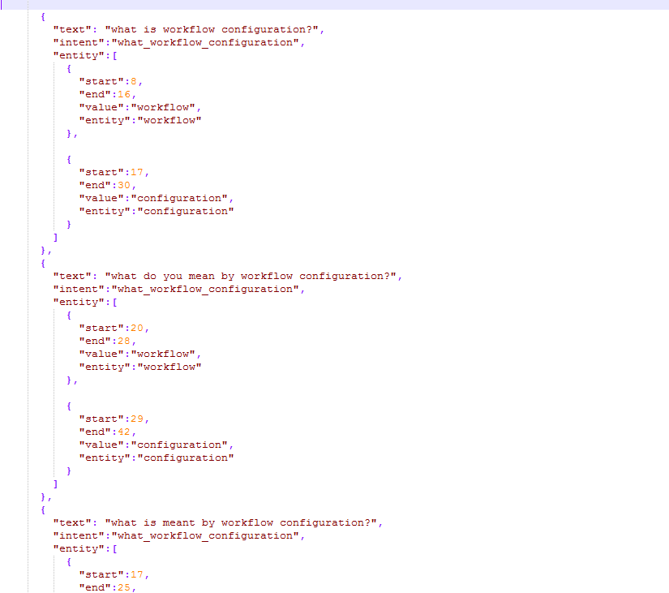
Snippet of testData.json

The data stored in testData.json can easily be copied into the main file - data.json.

1. The data made is used to first train the NLU interpreter and generate the models so that it recognises intents and entities.

2. The data is then used to train the dialogue models by either interactively training the bot (which also generates stories ) or letting Rasa train it by using arbitrary inputs.

2.3. Text based chat
The user can chat with the bot through text by writing in the text box provided. The bot will receive the message, interpret it and reply on the basis of the intent. With the addition of the Web Speech API, the bot also speaks out the replies given by the bot.
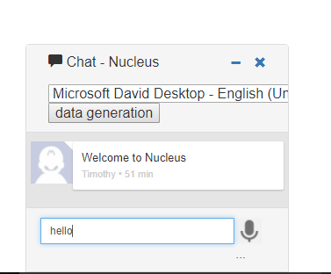
The user input

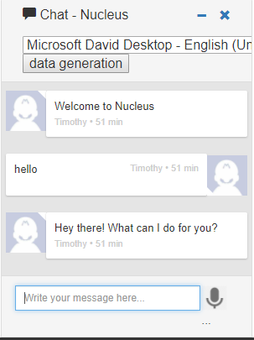
The reply by the bot on the basis of its interpretation of the input

2.4. Speech based chat
The user can chat with the bot through speech by clicking on the microphone icon and speaking in the microphone. The speech is converted into text and is displayed. The message is then interpreted by the bot and the reply is both written and spoken by the chat bot.
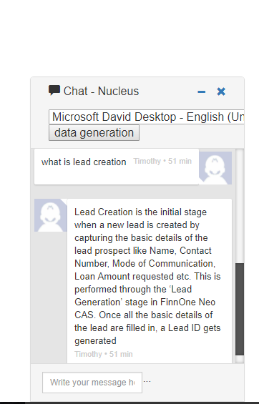

The user input through microphone

3. Technology Used:

3.1. Rasa Stack
It is an open source framework in python used to create chat bots. It has two components – Rasa NLU and Rasa Core:
  - Rasa NLU: This is responsible for the natural language understanding of the chatbot. Its purpose is to predict the intent and extract entities given an input sentence. Intent dictates how the chatbot should respond to an input from a user. Entities are used to make responses more customized
  - Rasa Core: The second component, Rasa Core, is the next component in Rasa stack pipeline. It takes structured input in the form of intents and entities (output of Rasa NLU or any other intent classification tool), and chooses which action the bot should take using a probabilistic model. It directs the flow of the conversation.

3.1.1 The flow of data within Rasa
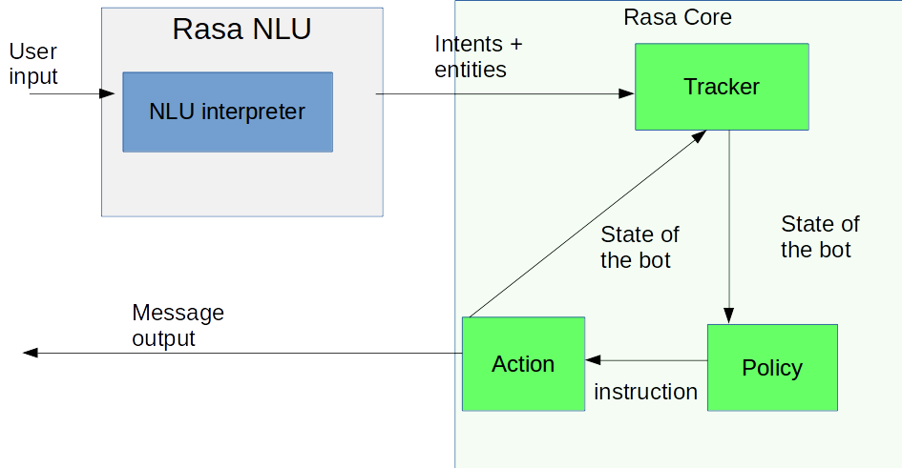

- The message is received and passed to an Interpreter, which converts it into a dictionary including the original text, the intent, and any entities that were found.
- The Tracker is the object which keeps track of conversation state. It receives the info that a new message has come in.
- The policy receives the current state of the tracker
- The policy chooses which action to take next.
- The chosen action is logged by the tracker
- A response is sent to the user

3.2. Flask
Flask is a micro web framework written in Python based on Werkzeug and Jinja2. It is used to connect web user interface with python backend. It is classified as a micro-framework because it does not require particular tools or libraries. It has no database abstraction layer, form validation, or any other components where pre-existing third-party libraries provide common functions.

3.3. Web Speech API
Web Speech API is used for speech recognition and text to speech. It defines a complex interface called SpeechRecognition. The only browser that supports this API is Google chrome. This is why my chatbot can only be used in Google Chrome.

4. Project in Detail

4.1 Folder structure
- Chatbot
  - data
    - data.json
    - stories.md
  - templates
    - layout.html
    - index.html
    - index_data.html
  - static
    - imgs
      - mic.jpg
    - js
      - cleantest.js
  - models
    - nlu
    - dialogues
  - domain.yml
  - nlu_model.py
  - nlu_model_config.py
  - train.py
  - train_online.py
  - run.py
  - custom2.py
  - actions.py

4.2. Important files used

4.2.1 Domain
- This is a YAML file in which the domain where the chat bot will work is defined. This includes definition of intents, entities, slots and actions.

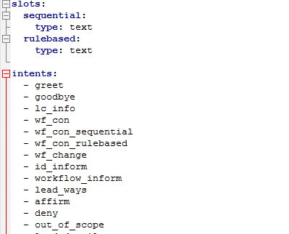

Snippet of the domain definition of my chat bot

4.2.2. Data
- This is a json file which contains the data on which the bot is trained. Each intent needs at least 10 different types of user inputs. Based on this data, a probabilistic model is created for Rasa Core to use to run the bot.

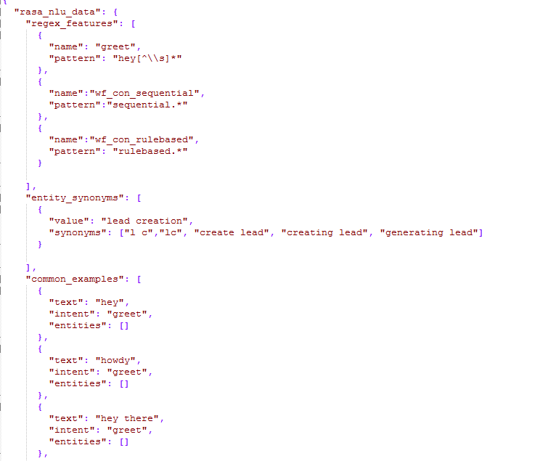
Snippet of data.json

4.2.3 Stories
- This is a MD file that defines all possible flows of conversation. This implements the unstructured form of dialogue, making the conversation with the chatbot more natural. Stories can be defined by the creator of chatbot or can be generated through training of the bot.

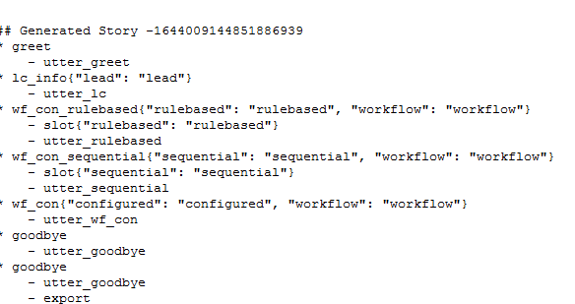

Snippet of stories.md

4.2.4. Nlu_model
- This is a python file used to create the NLU models and store them. The NLU models help identify intents and extract entities when the bot is running by determining the confidence level of the bot. The models are stored in the models folder.

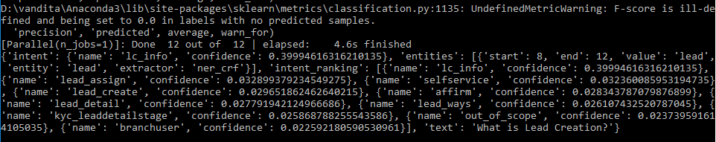
Output of nlu_model.py

4.2.5. Train
- This is a python file used to train the bot using arbitrary dialogue flows and storing the models formed (whichever will persist) in models folder

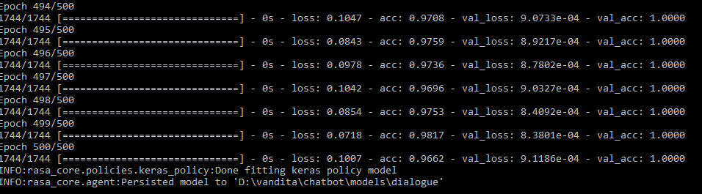
Output of train.py

4.2.6 Train_online
- This is used to interactively train the chatbot and generate stories in a process that is known as Supervised Learning
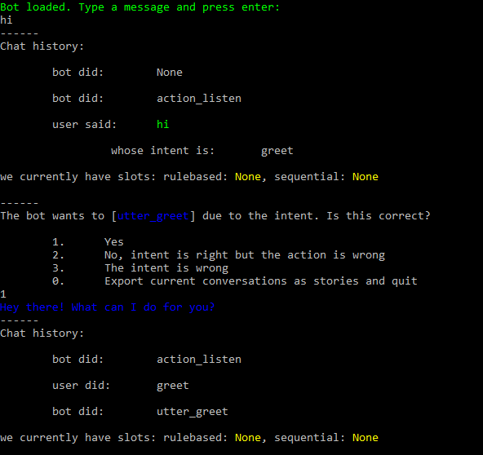
Output of train_online.py

4.2.7 Run
- This is the python file that runs the bot. It imports the custom channel created in the custom2.py. It defines the interpreter, tracker, domain as well as models to be used and thus calls the agent using these variables as parameters to implement the running of the chatbot.

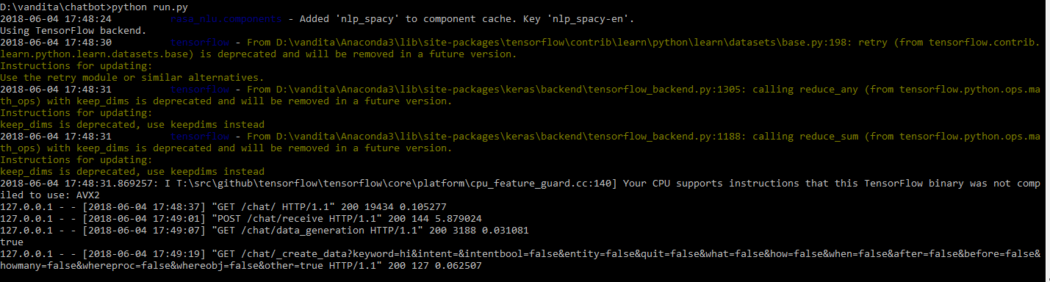

4.2.8. Custom2
- This is the python file in which I defined a customized channel for input and output of the chat bot. Using Flask, it serves the POST request which carries the user input to be interpreted and returns the chat bot reply as well as it services the GET requests for various html files and methods for data generation utility.

4.2.9. Cleartest
- This is the javascript file used to convert speech to text using the Web Speech API and then send the text as input to be interpreted.

4.3 Flow of data between Files:
- Execute the python file ‘run’. ‘run’ imports the CustomInputChannel class from the python file ‘custom2’.

- Browser sends a GET request which is received by custom2. Custom2 processes it and renders the html template ‘index’.

- On pressing the button Data Generation, the browser sends another GET request to custom2 which renders ‘index_data’ in response.(data generation utility)

- After filling the required details, Submit button is pressed which sends GET request to custom2. The function create_data is invoked which invokes the necessary functions to create data and store in testData.json. Back button takes the user back to ‘index’

- On typing out a question and entering, a function to create POST request is invoked. The POST request is received by custom2 which invokes a function called ‘receive’. This extracts the user input and invokes the function ‘on_new_message’ which in turn invokes ‘UserMessage’ with parameters - text (user input), out (output channel : object of CustomOutputChannel) and sender id.

- Output channel invokes the function ‘send_text_message’ with parameters recipient id and message (output message) which is stored in ‘out.responses’ and returned in UserMessage. ‘out.responses’ is returned to ‘index’ where it is displayed.

- The output message is sent as a parameter in the function ‘speak’ which in turn invokes speechSynthesis.speak which is a function of Web Speech API and converts text to speech.

- On clicking the ‘mic’ button, webkitSpeechRecognition() is invoked which is a part of Web Speech API and converts speech to text. The text is then sent as a parameter to ajaxcall function to create a POST request.

5. Conclusion:

This project aimed to create a chatbot to cater to the frequently asked questions about the services provided by Nucleus Softwares Exports Ltd.

Benefits of Bot:
- User-friendly
- No further programmer intervention required

Challenges Faced:
- Lack of proper documentation by Rasa
- Having to go through the entire Rasa core code to create and connect a custom input / output channel
- Due to the constraint of only being able to use open-source technology, it was difficult to find a suitable speech-to-text API.

Knowledge Gained:
In the process of making this project, I learnt many things :

- Basics of NLP
- Rasa NLU
- Rasa Core
- Basics of Jquery
- Different Speech to text APIs
- Flask in python

Future Roadmap:

There are certain features that will be available in its enhanced version:
- Training Module:
- Similar to the data generation utility provided with the chatbot, I plan to integrate the train_online module that has been provided by Rasa with the chatbot i created, so that the user has not only the option to add the data required but also train the bot using the training data

2. Integration of more data:
- The more data the bot is trained upon, the better it works

3. Develop a better intent classification function

______________________________________________________________________________

