Node JS Assignment

npm run test – unit testing  
npm run start-dev – running application

Employee portal application renders with login page, where user can either login or signup into the account if account has not been created yet. After the employee logs in the application, he is redirected to home page where all the opened openings can be viewed. When user clicks to see the details, he is redirected to details page where he can also apply for the opening. If user has already applied, then a response is send - “You have already applied for this opening”.

Pages:

Login page and register page where user is authorized and jwt token is used for authorization of other pages for user role types.

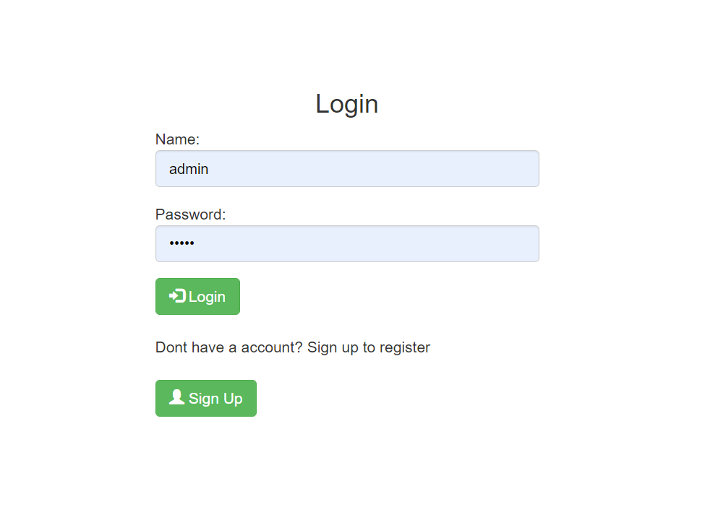 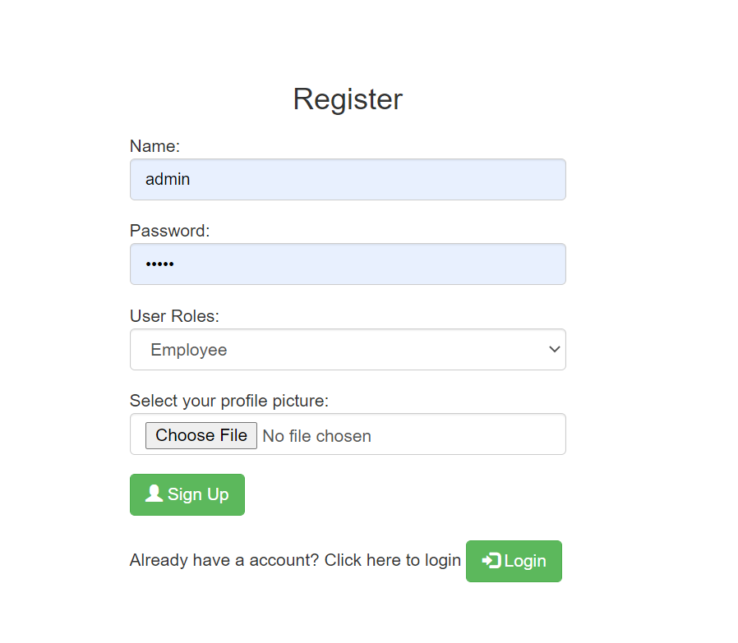

There are two type of user roles: 1) Employee 2) Manager

Now if employee logs in then he can see all opened openings otherwise if employee is manager, then he is not authorised to see this page.

**REST APIs:**

* **See a list of available openings in the company**

**if its employee -** **if its manager -**

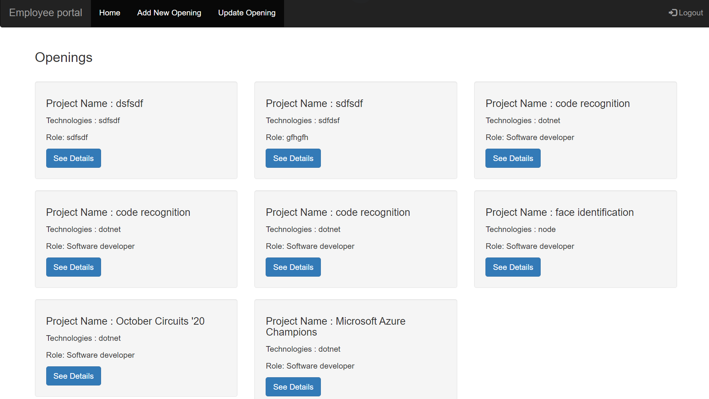

* **Check the details of any opening (using a valid identifier) – only authorized employee can apply for the same and if he has already applied, then a response that u have already applied for the same.**

When an employee applies for a position, a notification is sent to the recruiter. And that message is consoled.

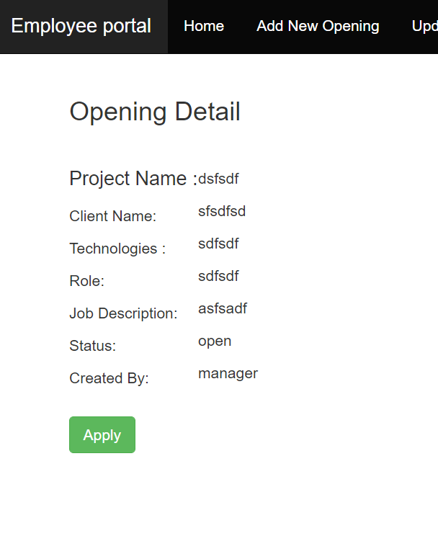

* **Add an opening – only manager can add a new opening with status open. And there is a form validation of required and if its not filled, error message is shown to fill all the details.**

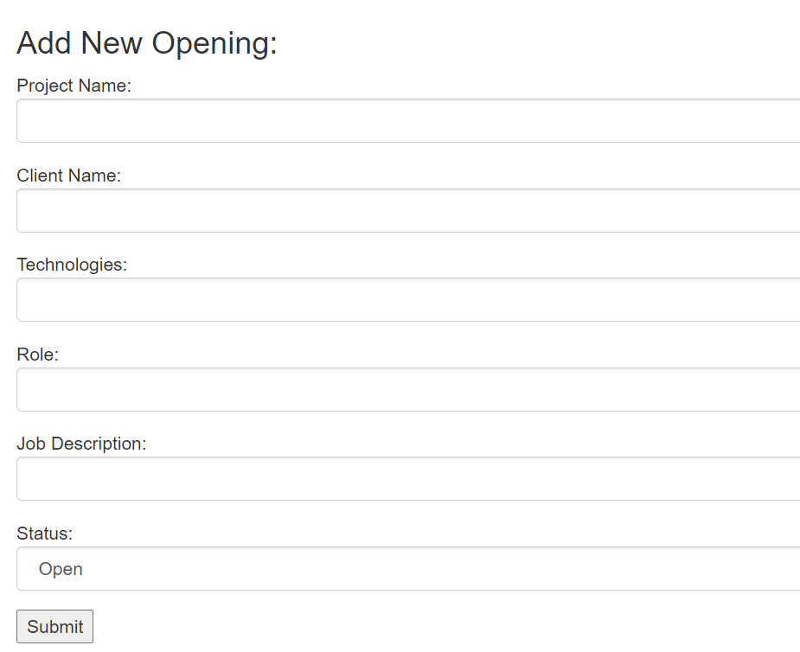

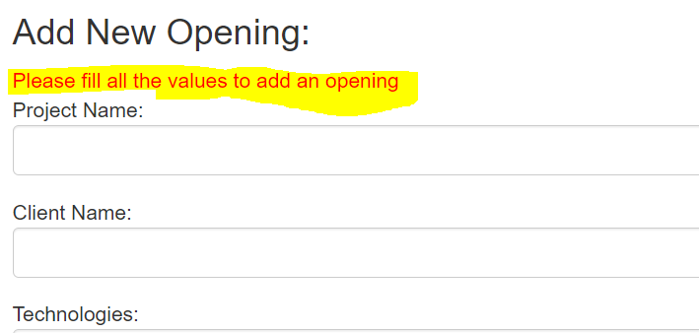

* **Update an opening – only manager can update the opening.** This API allows the recruiter to update the opening, if the opening position is closed, a notification should be sent to the employee who has shown an interest.

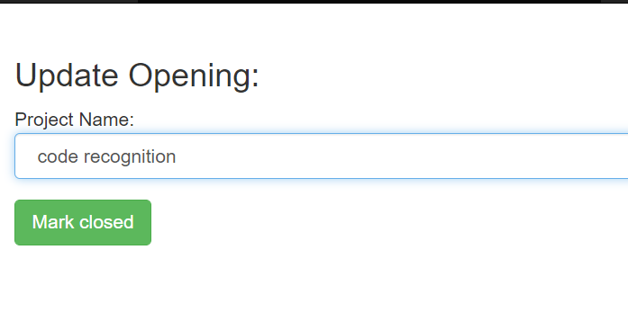

* **Authorization details :** 
  + Create an Opening – only Manager can create
  + Update an Opening – only Manager of the opening can update
  + Apply for Opening – Authenticated employee
  + Available Openings – Authenticated employee
  + Details of an opening - Authenticated employee
  + Login – Open to all
  + Register – Open to all