Report on learning practice # 4

Stationarity of the processes

Performed by:

Performed by:

Grandilevskii Aleksei

J4133c

Dubinin Ivan

Sorokin Mikhail

J4132c

Saint-Petersburg

2020

**Table of contents:**

1. Substantiation of chosen sampling.

This Lab we used to have timestamps in our dataset. Dataset we used in the previous works hasn’t them. But the specialized dataset from labs 1-3 is a processed squeeze from the raw data obtained using the Riot.API. (<https://www.kaggle.com/gyejr95/league-of-legendslol-ranked-games-2020-ver1#challenger_match_V2.csv>). The original dataset contains 7Gb of practically raw data from the API. We wrote our own script for parsing timestamps from raw data and already processed dataset.

*Pic.1. Timestamps parsing.*

As You can see in the code timestamps are timestamps are represented as Unix-ts, so our script also convert them into default Python 3 timestamps.

*Pic.2. Working dataset for lab 4 visualization.*

2. Stationary analysis.

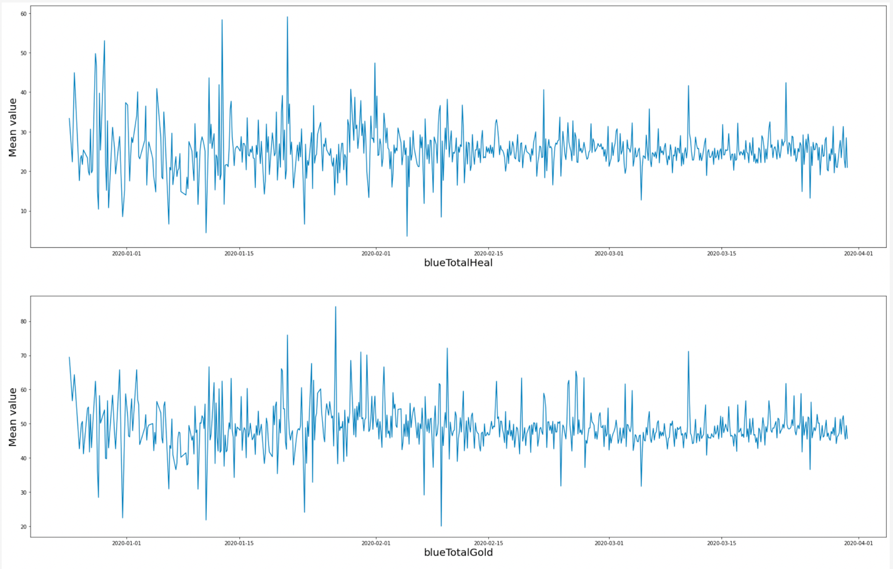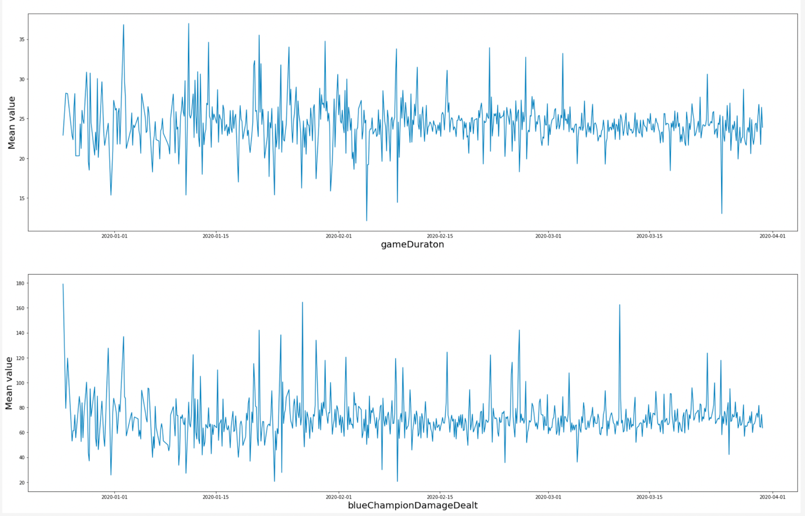

*Pic.3. IDK something clever.*

3. Covariance or correlation function analysis.

4. Noise filtration.

5. Estimation of spectral density function.

6. Auto-regression model.

7. Model in a form of linear dynamical system.

**Sourcecode:**

* The full repository with all the labs: <https://github.com/vandosik/M-M-MSA>
* The repo with Datasets and additional used Data info: <https://github.com/vandosik/M-M-MSA/tree/master/Datasets>
* The Lab 4 ipynb file: <https://github.com/vandosik/M-M-MSA/blob/master/Lab_4/lab_4.ipynb>

We recommend to use the first link because our GitHub project has README file with similar links and instructions which is really easy to use.

