Well-Sitting Meter Version 2

Mathew Thomas Vandover
Colorado Technical University
3151 S Vaughn Way
Aurora, C0 80439 USA

Abstract— The problem to be solved is that commercial meters used to detect where water is in the ground are very expensive and needed to accurately detect where to drill wells used to harvest drinking water. The purpose of phase two of the well sitting meter project is to make a device that can read the apparent resistivity of the ground for determining its suitability to be drilled for a water well. The problem is in many third world countries, clean drinking water is only found below the surface of the earth and the equipment for detecting the water is too expensive for the people trying to find water. In countries such as Tanzania the average well is only 30 meters underground where inexpensive hand pumps could be used to bring the water to the surface. This project aims at producing an economically priced well sitting meter that automates the version 1 meter refenced in the James Clark report. The well sitting meter is a good example of a project that has positive effect for everyone involved. This project is an open source project with the intent of providing third world countries with a reliable well sitting meter at an economical budget. This technology helps aid under developed countries gain access to clean drinking water, one of the most basic human needs.

High-Level System Design
The system will be based on the version two and one meters explained in the James Clark report. The system will be a modified version two as explained in the Clark report.
This system will be different because it will use a different relay configuration which will require duplicating parts of the original circuit. This circuit will use five single pole single throw(SPST) relays instead of a single SPST and two double pole double throw(DPDT) relays. This system will switch out the Arduino microcontroller for a Raspberry Pi(RPI) microcontroller. The automated version two well sitting meter will use current and voltage sensors for reading the apparent resistivity of the ground.

System Specifications
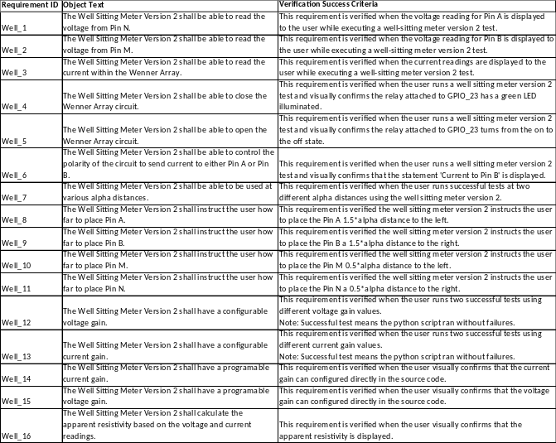
Figure 1 - System Requirements and Acceptance Criteria
Figure 1 defines the functional systems requirements and their acceptance criteria. The next step in systems engineering is to allocate the functions and requirements to specific components which will be included in the next report.

Accessing the RPI GPIO
The Raspberry Pi microcontroller is a versatile tool that allows a developer to interface a wide range of sensors with code they develop and deploy onto the microcontroller. The code uses libraries and modules to access the 40 General Purpose In and Out(GPIO) pins which can read and measure voltages from 0 to 5 volts. The pins by default are all digital meaning they only read as a 1 if there is a 5v signal or 0 if there is no signal. The pins can also be configured into different modes such as an input or an output. An input would read the voltage whereas the output would apply a voltage to the pin. The purpose of this section is to describe how to access and take full control of the raspberry pi’s General Purpose In and Out(GPIO) pins.

The first step in accessing the GPIO on the RPI is to make a decision on the coding language you would like to write you applications in. The two main coding languages on the RPI are python and C. This is because there is a standard set of libraries and modules for these languages that the developers can import. These libraries and modules contain classes that allows developers to read digital voltages and communicate using the I2C, UART, SPI, and PCM communication protocols. For C developers wiringPI libraries need to be installed. For Python developers the RPI.GPIO modules need to be installed. Once installed the developer can access the GPIO functions directly in their applications. For this project we will be using the python language for development.

Limitations and improvments
One limitation of the RPI is that it only reads digital signals, however there are a couple of techniques to mitigate this limitation and allow for analog capabilities. One method would be using pulse with modulation(PWM). PWM is based on the frequency of the signal rather than its amplitude. By changing the frequency at which a signal is generated information can be passed in the frequency allowing the signal to be interpreted in an analog way. Another method is using an analog to digital converting(ADC) chip. The modules and libraries installed in the previous section contain functions that allow the developer to communicate with the chip using the I2C interface. The ADC chip allows the python program to read analog inputs and apply an analog output. The accuracy of reading the analog input and setting an analog output will depend on the resolution of the ADC converter chip. A 16-bit converter will provide a higher resolution than an 8-bit converter.

Hardware Interfaces
There are plethora of different protocols and connections that the raspberry pi can make. This is partly why they are versatile and developers like to use them for rapid prototyping. The figure below shows the pin layout of the raspberry pi and also the different protocols and connections it is compatible with:

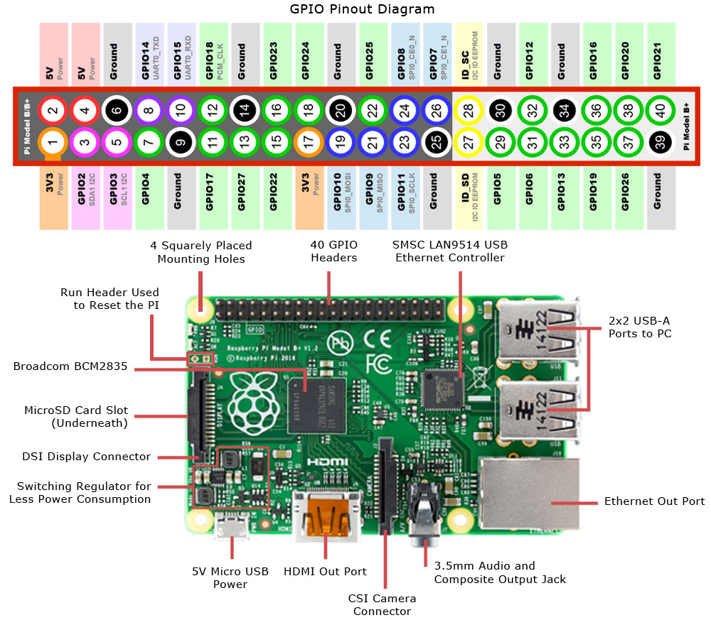
Figure 2 - RPI Pinout

Figure 1 shows the different interfaces the RPI supports. It shows the 40 GPIO pins and the I2C, UART, SPI, and PCM designated pins. It shows 4 usb, 1 ethernet, HDMI, micro usb, camera, display, audio port. All of these interfaces can be used to communicate with hardware. The most common hardware is a mouse, keyboard, video screen to be able to operate on the raspberry pi. However any device that already supports these interfaces can be connected to the raspberry pi and used in a project. The ADC chip interfaces with the RPI using pins 3 and 5 as shown highlighted pink in figure 1.

Applying the RPI to a Well-Sitting Meter Project

A Wenner Array will be used to measure the resistivity in the ground.

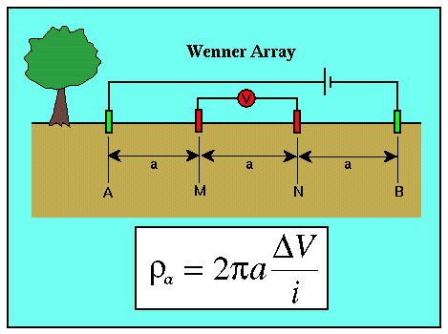
Figure 3 - Wenner Array

Figure 2 shows the placement of the four stakes(A, M, N, B) in the ground to form the Wenner Array. The Wenner Array will be supplied by a car battery that will be inverted into a 110 VAC signal, rectified back into a 120 VDC signal and applied to the two outside stakes in the ground to drive a current through it. An AC inverter with two 110 VAC outlet is preferred because the RPI power can be supplied through a 5V transformer plugged into the inverter outlet and the second outlet can be used to power the wenner array.

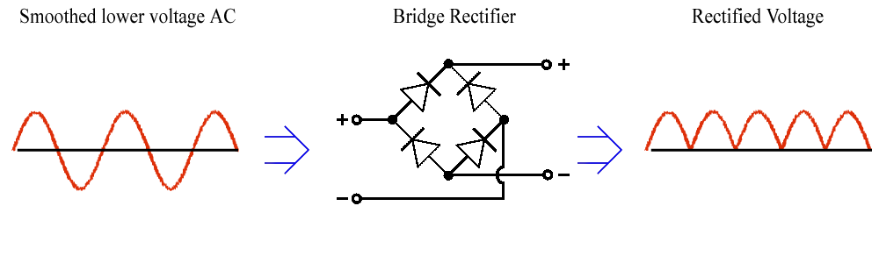
Figure 4 - Signal Rectification

Figure 3 shows how the 110 VAC signal would be rectified which is the process of translating the negative voltage cycles in in the waveform to positive ones. A capacitor is then configured in parallel with the rectifier to smooth the rectified signal.
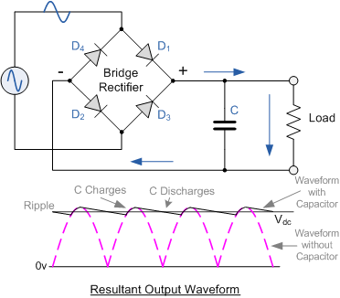
Figure 5 - Capacitor Smoothing

Figure 4 shows that the capacitor charges at the peak of the positive voltage cycle and discharges as the amplitude decreases back to zero. In turn this creates a signal that appears to be a fixed voltage of 120 VDC in this case. The RPI needs to be able to control the direction of the flow of current through the system. To accomplish this there is one SPST relay connected to turn the circuit on and off and there are four SPST relays to control the polarity of the circuit.
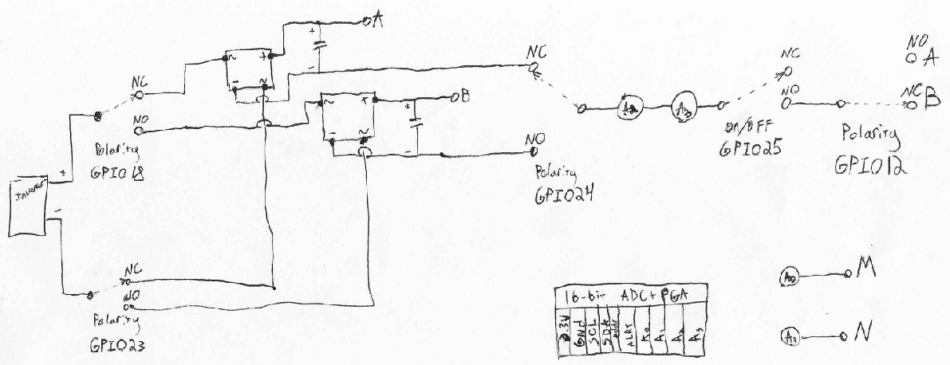
Figure 6 - RPI Wenner Circuit

Figure 5 shows the circuit that will control the Wenner Array. There are four single pole single throw(SPST) relays that control polarity. There is one SPST relay to turn the RPI Wenner Circuit on and off. The relays are connected to a five volt supply and a single GPIO pin configured as an output pin. In python, the voltage of the output pin can be set directly in the code to turn the relay on and off. Two different current sensors will be placed in line with the circuit to test out the difference in accuracy. One will be connected to a 3.3 volt supply and the other will connect to the 5 volt supply. Both current sesnors will have an output voltage that will connect to the ADC and be used to calculate current in the wenner array. The change in voltage will be measured on the inside stakes. Using these two readings the apparent resistance can be calculated with the formula pictured in Figure 2. Applying the equation in Figure 2 to the circuit above we see that we will get two apparent resistivity readings based on which current sensor we are using.

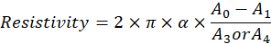

The raspberry pi uses the I2C bus interface to read data from the ADC and use it directly in the python application. The analog signal’s resolution will change based on the resolution of the analog digital converter. This project uses a 16-bit analog to digital converter that sends a 16-bit signed integer to the RPI. With the first bit being used to tell whether the voltage is positive or negative it leaves the RPI with a resolution of 2^15 = 32,768 equal segments. The actual accuracy of the voltage readings depend on what the ADC programmable gain has been set too. The ADC gain can be programmed using python to all the chip to read a plethora of voltage ranges. For this project we will start by having this set to the maximum range to minimize the risk of overpowering the chip.

Table 1 - ADC Gain Characteristics
Gain Setting | Voltage Range(V) | Resolution (V)
2/3 | 6.144 | 0.0001875
1 | 4.069 | 0.000124176
2 | 2.048 | 0.0000625
4 | 1.024 | 0.00003125
8 | 0.512 | 0.000015625
16 | 0.256 | 7.8125E-06
The accuracy of the 16-bit resolution would be Gain voltage range(6.144/32,768 = 0.00018volts = .18 mv. Increasing the gain will increase the accuracy of the resistivity calculations, but is also dependent on the accuracy of the current sensor, and voltage readings of the RPI.

Compoenents and Costs
There are plethora of different sensors and vendors that could be used to create this project. For this project I chose to select products that can be bought off amazon.com. I chose products that are sold by a variety of vendors in case one of the specific vendor goes out of business the component can still be replaced.

Table 2 - BOM
Bill of Materials
Component | Price
RPI | 37.99
5 SPST Relays | 6.99
Current Sensor Type 1 | 7.49
Current Sensor Type 2 | 3.536
16-bit ADC | 14.28
Full Wave Bridge Rectifiers | 15.26
AC Inverter Outlet | 6.99
AC Inverter | 42.99
2 Capacitors | 12.04
Total | 147.566

Table 2 shows the bare minimum components that someone would need to build this project. This assumes that the person building the project would have access to a keyboard, mouse and display to interface with the RPI. It also assumes the user would have access to a car battery to power to the equipment. If those assumptions hold true the system can be built for roughly one hundred and fifty dollars. If the user wanted, they could also purchase a stand and touch screen display for roughly another one hundred dollars to interface with the RPI.

The Code

Python is a scripting based language which means that it runs through the code file line by line in a sequential order. So in order to develop a python program to calculate the apparent resistivity of the ground. We first need to understand the operational flow.

The Steps are as follows:
- User enters the alpha distance that they configured.
- Application instructs user where to place Pin A.
- Application instructs user where to place Pin M.
- Application instructs user where to place Pin N.
- Application instructs user where to place Pin B.
- Application requires user confirmation before proceeding. Caution statement is given.
- Python code makes polarity so that A is the positive side.
- Application turns on the RPI Wenner Circuit.
- Python code reads sensors for configurable amount of time.
- Application turns off the RPI Wenner Circuit.
- Python code makes polarity so that B is the positive side.
- Application turns on the RPI Wenner Circuit.
- Python code reads sensors for configurable amount of time.

Note: configurable delays can be incorporated in between the polarity switching.
- Application turns off the RPI Wenner Circuit.
- Python code has a configurable number of repeats for steps 2-9.
- Python calculates and displays apparent resistivity.

Below I have pasted in the python code to the extent that it is completed today:

# Well-Sitting Meter Version 2.0 RPI - Python
# Author: Mathew Vandover
# License: Public Domain
########Import Modules############
import time

import RPi.GPIO as GPIO

# Import the ADS1x15 module.
import Adafruit_ADS1x15
########Modules####################

#########Defintions/Assignments###############

# Define Relay Output Pins
Relay1 = 25 #ON/OFF Relay
Relay2 = 20 #Polarity Relays
Relay3 = 21 #Polarity Relays
Relay4 = 12 #Polarity Relays
Relay5 = 18 #Polarity Relays
#########Defintions###############

########## ADAFRUIT MAKER NOTES ##############
# Create an ADS1115 ADC (16-bit) instance.
#adc = Adafruit_ADS1x15.ADS1115()
# Note you can change the I2C address from its default (0x48), and/or the I2C
# bus by passing in these optional parameters:
#adc = Adafruit_ADS1x15.ADS1015(address=0x49, busnum=1)
# Choose a gain of 1 for reading voltages from 0 to 4.09V.
# Or pick a different gain to change the range of voltages that are read:
# - 2/3 = +/-6.144V
# - 1 = +/-4.096V
# - 2 = +/-2.048V
# - 4 = +/-1.024V
# - 8 = +/-0.512V
# - 16 = +/-0.256V
# See table 3 in the ADS1015/ADS1115 datasheet for more info on gain.
############MAKER NOTES########################

#######Configure Pins#########################
# Create an ADS1115 ADC (16-bit) instance.
adc = Adafruit_ADS1x15.ADS1115()
# Max Voltage input for testing purposes
GAIN = 2/3
############Configuration######################
# Defintions
def toggleon():
GPIO.setmode(GPIO.BCM) # .BOARD Numbers GPIOs by physical location
GPIO.setup(Relay1, GPIO.OUT)
print('Circuit Live')
GPIO.output(Relay1, GPIO.LOW)
time.sleep(1) # 1 herts before reading to allow signal to stabilize.
def togglepolarity():
GPIO.setmode(GPIO.BCM)
GPIO.setup(Relay1, GPIO.OUT)
GPIO.setup(Relay2, GPIO.OUT)
GPIO.setup(Relay3, GPIO.OUT)
GPIO.setup(Relay4, GPIO.OUT)
GPIO.setup(Relay5, GPIO.OUT)
print('Changing Polarity')
GPIO.output(Relay2, GPIO.LOW)
GPIO.output(Relay3, GPIO.LOW)
GPIO.output(Relay4, GPIO.LOW)
GPIO.output(Relay5, GPIO.LOW)
print('Current to Pin B')
GPIO.output(Relay1, GPIO.LOW)
time.sleep(1) # 1 herts before reading to allow signal to stabilize.
def toggleoff():
print('Circuit Dead')
GPIO.cleanup()
time.sleep(0.5)

##################Script Body############################
# Start Script to toggle between sending current to pin A and B.
#Prompt user to enter the alpha distance to ensure they have set up the circuit.
#Currently no input validation. Future Oppertunity.
alpha = input('Enter your alpha distance in meters: ')
print('alpha is ',alpha,' meters')
alphaA = 1.5 * alpha
print('Place Pin A',alphaA,' meters to the left')
alphaM = 0.5 * alpha
print('Place Pin M',alphaM,' meters to the left')
print('Place Pin N',alpha,' meters to the right')
print('Place Pin B',alphaA,' meters to the right')
# Now that we know the circuit is setup make sure user is prepared to make the circuit live
#Wait till user enters the string ready
while True:
print('Tell others to stand back! Proceed with caution!')
n = raw_input('Enter the word ready to send current through the ground :')
if n.strip() == 'ready':
break

# User has confimred they are ready
#Send current to pin A
print('Applying Current to Electrode A')
#Turn on the circuit
toggleon()
print('Reading Analog values')
# Print nice channel column headers.
print('| {0:>6} | {1:>6} | {2:>6} | {3:>6} |'.format(*range(4)))
print('-' * 37)
# Read all the ADC channel values in a list.
# A0 = M
# A1 = N
# A2 = Current Sensor 1:RoboDyn ACS712(Black)Current Sensor Analog output: 185 mv/A 1.5 % error at 25 degree C
# A3 = Current Sensor 2:DAOKI ACS712 (little blue) Current Sensor Analog output: .185 V/A 1.5 % error at 25 degree C
# However the output is a 16 bit signed integer so the resolution is really only 2^15 = 32768
values = [0]*4
for i in range(4):
# Read the specified ADC channel using the previously set gain value.
values[i] = adc.read_adc(i, gain=GAIN)
# Note you can also pass in an optional data_rate parameter that controls
# the ADC conversion time (in samples/second). Each chip has a different
# set of allowed data rate values, see datasheet Table 9 config register
# DR bit values.
#values[i] = adc.read_adc(i, gain=GAIN, data_rate=128)
# Each value will be a 16 bit signed integer value
#Print the ADC values.
print('| {0:>6} | {1:>6} | {2:>6} | {3:>6} |'.format(*values))
#Pause for 1/10 a second.
time.sleep(0.1)
toggleoff()
# conversions and assignments
#define variables
VOLTM = values[0]
VOLTN = values[1]
CURRENT1 = values[2]
CURRENT2 = values[3]
#print raw 16-bit signed integer value
print('16-bit signed integer')
print(VOLTM)
print(VOLTN)
print(CURRENT1)
print(CURRENT2)
#Convert to Votls
VOLTM = VOLTM * 0.0001875
# gain of 1 = 0.0001250038
VOLTN = VOLTN * 0.0001875
#Convert to Amps
CURRENT1 = (CURRENT1 * 0.0001875)
CURRENT2 = (CURRENT2 * 0.0001875)
print('Converted Values')
print(VOLTM)
print(VOLTN)
print(CURRENT1)
print(CURRENT2)

#Calculations
RESISTIVITY1 = (2*pi*alpha*((VOLTM - VOLTN)/CURRENT1)
RESISTIVITY2 = (2*pi*alpha*((VOLTM - VOLTN)/CURRENT2)

#Print Resistivity
print(RESISTIVITY1)
print(RESISTIVITY2)

print('Applying Current to Electrode B')
#Switch Polarity
#Turn on the circuit
togglepolarity()
print('Reading Analog values')
# Print nice channel column headers.
print('| {0:>6} | {1:>6} | {2:>6} | {3:>6} |'.format(*range(4)))
print('-' * 37)
values = [0]*4
for i in range(4):
# Read the specified ADC channel using the previously set gain value.
values[i] = adc.read_adc(i, gain=GAIN)
print('| {0:>6} | {1:>6} | {2:>6} | {3:>6} |'.format(*values))
#Pause for 1/10 a second.
time.sleep(0.1)
toggleoff()
# conversions and assignments
#define variables
VOLTM = values[0]
VOLTN = values[1]
CURRENT1 = values[2]
CURRENT2 = values[3]
#print raw 16-bit signed integer value
print('16-bit signed integer')
print(VOLTM)
print(VOLTN)
print(CURRENT1)
print(CURRENT2)
#Convert to Votls
VOLTM = VOLTM * 0.0001875
VOLTN = VOLTN * 0.0001875
#Convert to Amps
CURRENT1 = (CURRENT1 * 0.0001875 * .185)
CURRENT2 = (CURRENT2 * 0.0001875 * .185)
print('Converted Values')
print(VOLTM)
print(VOLTN)
print(CURRENT1)
print(CURRENT2)

#Calculations/Reassignments
RESISTIVITY1 = (2*pi*alpha*((VOLTN - VOLTM)/CURRENT1)
RESISTIVITY2 = (2*pi*alpha*((VOLTN - VOLTM)/CURRENT2)

#Print Resistivity
print(RESISTIVITY1)
print(RESISTIVITY2)

The code above is the open source code that makes up the well sitting meter. It provides two resistivity calculations for each current sensor. For this project a public GitHub repository is used for change management and an easy way for other developers to clone the code directly to their machine via the web. The repository for my code can be found at the following web address: https://github.com/vandover/Well-Sitting-Meter-V-2.0

Conclusion

The raspberry pi is a very power tool but must configured properly first to ensure full functionality can be accessed. The developer must understand the hardware interfaces they have at their disposal and how to use them. For example, the GPIO provide a way to integrate directly into electrical circuits to analyze and control them using software applications running on the RPI. That is the high-level concept that makes raspberry pi so powerful. Most micro controllers do not offer as many interfaces as the RPI and do not run their own operating system. These features have set this microcontroller apart from the rest. When used for a project that provides a positive benefit for all stake holders the RPI transforms into a life saving device that finds clean water for the thirsty. The next stages of the project are to perform an initial test of the system, expand the program to make the user set multiple alpha distances, expand the program to save data as a file and generate a resistivity plot of the various depths.

References

- Clark, James A., et al. “Appropriate Geophysics Technology: Inexpensive Instruments for Water Exploration at a Local Level in Developing Nations.” Geoscience for the Public Good and Global Development: Toward a Sustainable Future Geological Society of America Special Papers, pp. 171–181., doi:10.1130/2016.2520(16).

- M. (n.d.). Connection to raspberry pi hardware. Retrieved August 07, 2017, from https://www.mathworks.com/help/supportpkg/raspberrypiio/connection-to-raspberry-pi-hardware.html

- M. (n.d.). Getting-started-with-matlab-support-package-for-raspberry-pi-hardware. Retrieved August 07, 2017, from https://www.mathworks.com/help/supportpkg/raspberrypiio/examples/getting-started-with-matlab-support-package-for-raspberry-pi-hardware.html

- (n.d.).Retrievedfromhttp://www.wcu.edu/WebGraphics/CCEFS_wennerarray.gif

- Why do rectified voltage boosts after adding a capacitor? (n.d.). RetrievedAugust23,2017,from https://electronics.stackexchange.com/questions/175474/why-do-rectified-voltage-boosts-after-adding-a-capacitor

- Power Rectification Explained. (2009, August 21). Retrieved August 23, 2017, from http://www.maxpierson.me/2009/03/17/power-rectification-explained/

- Robillard, S. (n.d.). Raspberry PI 2 can GPIO Pins 29-40 be used GPIO_GEN input output configurable in Python? Retrieved August 07, 2017,from https://raspberrypi.stackexchange.com/questions/40318/raspberry-pi-2-can-gpio-pins-29-40-be-used-gpio-gen-input-output-configurable-in

