Obsah
1 Introduction 1
1.1 Data analysis 1
2 Methods 3
2.1 Data sources 3
3 Results 4
3.1 Melanoma of skin incidence and mortality rates in 2022 4
3.2 Non-melanoma skin cancer incidence and mortality rates in 2022 5
3.2.1 Skin cancer and HDI 5
Bibliografie 6
Seznam obrázků 6

Introduction
Skin cancer is a malignant tumor originating in skin cells and represents one of the most common cancers worldwide.[1] Two main types of skin cancer which have been characterized include melanoma of skin, which originates from melanocytes, and non-melanoma skin cancer, which originates from keratinocytes. Non-melanoma skin cancer further includes basal cell carcinoma (BCC) and squamous cell carcinoma (SCC) of the skin, as well as other types of skin cancers.[2] Melanoma of skin is highly accretive, invasive, and metastatic, whereas BCC is generally slow-growing and rarely metastasizes, and some subtypes of malignant SCC squamous can be highly invasive and metastatic.[3] Globally, non-melanoma skin cancer is the most common malignant tumor among Caucasians and its incidence has been increasing. It is significantly more prevalent than melanoma and exerts a serious impact on global healthcare and well-being.[4] As based on Global Cancer 2020 data, the number of new non-melanoma skin cancer cases (except for BCC) was 1,198,073, accounting for 6.2% of all cancer cases. The incidence in males is approximately twice that of females and the overall number of deaths is 63,731, accounting for 0.6% of all cancer cases (including all cancer types). For melanoma, the number of new cases is 324,635, accounting for 1.7% of all new cancer cases, and the number of deaths is 57,043, accounting for 0.6% of all cancer deaths.[5] Risk factors for the development of skin cancer include prolonged exposure to ultraviolet (UV) light, family history, chemical carcinogens, and immunosuppressive agents. Among these factors, thymine dimers, produced by prolonged UV light exposure, can induce structural changes in DNA, which represents a significant basis for skin cancer.[3,6] Melanin, via its capacity for free radical scavenging, along with its antioxidant and UV-absorbing properties, can reduce the penetration of UV rays into the nuclei of keratinocytes.[7] As a result, the lower levels of melanin in lighter-skinned people place them at a greater risk for skin cancer. Although the incidence of skin cancer is lower in people of color compared to Caucasians, the incidence and mortality rates remain relatively high, with dark-skinned people being more prone to SCC. Therefore, skin cancer represents a disease that cannot be ignored in any of the races.[8] The aim of this paper is to update the data and global epidemiological patterns of skin cancer based on the incidence and mortality rates provided by the latest release of global cancer statistics for 2022. The factors contributing to differences in incidence and mortality rates among the different types of skin cancer are further analyzed and described. Such information can provide important, new perspectives for the prevention and treatment of skin cancer worldwide. GLOBOCAN 2022 data excludes BCC, but mortality rates include all types of non-melanoma skin cancers.

Data analysis
In this study, we presented a descriptive secondary analysis of skin cancer incidence and mortality rates along with their variations across regions and populations based on data from the GLOBOCAN 2022. We compared the number of new cases, deaths, crude death rates, ASIR, and ASMR between melanoma of skin and non-melanoma skin cancer within the five continents and top five countries and regions in each continent. We also described the most recent rankings of skin cancer in the GLOBOCAN 2022 database, the overall global ASIR and ASMR, and the number of new cases and deaths. The trends in ASIR and ASMR for both skin cancers were plotted according to age group. Data processing and analysis were carried out using Python 3.11. This software is maintained by the Python Software Foundation (Python Software Foundation, https://www.python.org/). Cancer incidence data from the Cancer Incidence in Five Continents Time Trends (CI5plus) database, which contains updated annual incidence rates for 124 selected populations from 108 cancer registries as published in CI5, were used to assess the temporal trends of melanoma. In order to include as many countries and regions as possible in the assessment, continuous melanoma surveillance data were extracted from databases for all five continents over the period from 1998 to 2012. In addition, the number of cases and populations at risk were recorded and the crude incidence rates and world standardized incidence rates, as calculated using the Segi’s World Standard Population, were also calculated along with the standard errors for crude rates and age-adjusted rates for time trend analyses. As age may impact analysis, results from the world standardized incidence rates were ultimately used to analyze trends. The Joinpoint 5.1.0 (https://surveillance.cancer.gov/joinpoint/) was then used to analyze time trends in incidence rates using a log-linear model with a model restriction of two linkages, as well as to calculate the annual average percent change (AAPC). The Human Development Index (HDI) classifies global levels of economic development into four tiers: very high, high, medium, and low. Correlation analyses were performed between HDI and ASIR and ASMR for the two skin cancers using GraphPad Prism 9.5.0 (http://www. graphpad.com). Spearman’s correlation coefficient was used to measure the monotonic relationship between the variables, with correlation coefficients ranging from −1 (perfect negative correlation) to 0 (no correlation) to +1 (perfect positive correlation).

Methods

Data sources
The International Classification of Diseases 10th Revision (ICD-10) codes C43 and C44 (excluding BCC incidence) for melanoma of skin and non-melanoma skin cancer incidence and mortality rates were obtained from the International Agency for Research on Cancer (IARC) Global Cancer 2022 (GLOBOCAN 2022) database. GLOBOCAN 2022 provides a comprehensive assessment of the incidence, mortality, and prevalence of 36 cancers in 185 countries or territories, separated by sex and within 18 distinct age groups at 5-year intervals (ages 0–4 years, 5–9 years, …, 80–84 years, and ≥85 years). Estimation methods vary by country, and the quality of national estimates depends on the coverage, accuracy, and timeliness of incidence and mortality data as recorded in a given country. Incidence and mortality can be expressed as the absolute number of cases per year within the entire population or as the incidence/mortality rates per 100,000 persons per year (age-standardized incidence rate [ASIR]/age-standardized mortality rate [ASMR]). Standardization is necessary when making comparisons among differently aged individuals, as age has a strong influence on cancer risk. These data are visualized in CANCER TODAY (https://gco.iarc.who. int/today/) as bar/pie charts, heat maps, scatter plots, and tables. It is important to note that the recent incidence of non-melanoma skin cancers as reported in the GLOBOCAN 2022 data excludes BCC, but mortality rates include all types of non-melanoma skin cancers.

Results

Melanoma of skin incidence and mortality rates in 2022
The GLOBOCAN 2022 data indicated that melanoma was the 17th most common cancer. An estimated 331,722 people were diagnosed with melanoma globally and approximately 58,667 died from this disease. Crude incidence and world ASIR per 100,000 people were 4.20 and 3.20, respectively. The incidence and mortality of melanoma varied significantly across continents and regions. Oceania, North America, and Europe had the top three ASIR per 100,000 people with rates being 29.80, 16.30, and 10.40, respectively. In Africa and Asia, ASIRs were substantially lower than that of world ASIR, with rates being 0.90 and 0.41 per 100,000 people, respectively. The highest incidence rates in countries and regions were in Australia with an ASIR of 37.00 per 100,000 people, followed by Denmark (31.10) and Norway (30.60). In Australia, melanoma accounted for 7.9% of all cancer cases with 16,819 cases (the top three cancers were breast, prostate, and colorectal), ranking fourth among all cancers. The number of deaths from melanoma was 1393, accounting for 2.7% of all cancers, ranking 12th among all cancers. [Table 1]. For ASMR, Oceania, Europe, and North America maintained their leading positions, with ASMR per 100,000 people being 2.30, 1.50, and 1.10, respectively. The ASMRs for Africa and Asia were again, markedly lower being 0.37 and 0.21 per 100,000 people, respectively. New Zealand had the highest mortality rates for melanoma, with an ASMR of 3.90 and a crude mortality rate of 9.20 per 100,000 people [Table 1]. An increasing trend in ASMR and ASIR as a function of age was observed within selected countries and regions (top five countries and regions in terms of age-standardized rates) in terms of continents. In all countries and regions investigated, the ASIRs of melanoma of skin were relatively low below the age of 20 years but increased thereafter [Supplementary Figure 1, http://links.lww.com/ CM9/C252]. In most countries and regions, ASMR and ASIR peaked at ≥80 years. Interestingly, in French Polynesia and France, La Réunion, ASMR peaked at 70 years of age [Supplementary Figures 1 and 2, http://links.lww. com/CM9/C252]. Based on the prevalence in the 1-year, 3-year, and 5-year analyses, European showed the highest prevalence of cases followed by America, with prevalent cases peaking at age 60 years in Europe [Figure 1]. With the exception of New Zealand and Australia, in most of the countries and regions surveyed, the ASIR of non-melanoma skin cancer was relatively low below the age of 40 years but increased after this age. In contrast, in New Zealand and Australia, there was a sharp increase in ASIR observed after 30 years of age [Supplementary Figure 3, http://links.lww.com/CM9/C252]. For ASMR, with the exception of countries and regions in Oceania, there was an increasing trend with age after age 40. In the Oceania countries and regions, with the exception of the Solomon Islands, there was a clear upward trend at about age 70 [Supplementary Figure 4, http://links.lww. com/CM9/C252]. America had the highest prevalence of cases with peaking at age 80 years. This was followed by Europe and Asia. With the increase of age, the prevalence of non-melanoma skin cancer in all countries and regions generally shows an upward trend, and non-melanoma skin cancer is more common among the elderly population [Figure 1]. For both skin cancers, there was a large difference in ASIR by countries and regions, but small differences in ASMR. For melanoma, ASIR varied by 154-fold between countries and regions, from 37.00 per 100,000 people in Australia to 0.24 in Mauritius. Such differences were even more pronounced for non-melanoma skin cancer, where ASIR varied by up to 3500-fold between countries and regions, from 140.10 per 100,000 people in Australia to 0.04 in France, La Réunion (Although French Polynesia has the smallest ASIR of 0, to calculate the difference between the largest and smallest countries and regions, we used data from La Réunion, which has the second-smallest ASIR after French Polynesia) [Table 1].

Non-melanoma skin cancer incidence and mortality rates in 2022
Non-melanoma skin cancer ranked as the 5th most common cancer. An estimated 1,234,533 people were diagnosed with non-melanoma skin cancer globally and approximately 69,416 died from this disease. The top three continents for ASIR were Oceania, North America, and Europe, which was consistent with that of melanoma. The highest ASIR was in Australia with an ASIR of 140.10 per 100,000 people and a crude incidence rate of 233.20 per 100,000 people, followed by ASIR of 127.50 and 63.30 per 100,000 in New Zealand and America, respectively. Similar significant variations across regions and countries, as well as mortality rates, were obtained for non-melanoma skin cancer as that observed with melanoma. However, differences between the two cancers were present with regard to countries and regions showing the highest ASMR, with the highest rate being in Papua New Guinea in Oceania, followed by Namibia in Africa and Georgia in Asia [Table 1].

Skin cancer and HDI
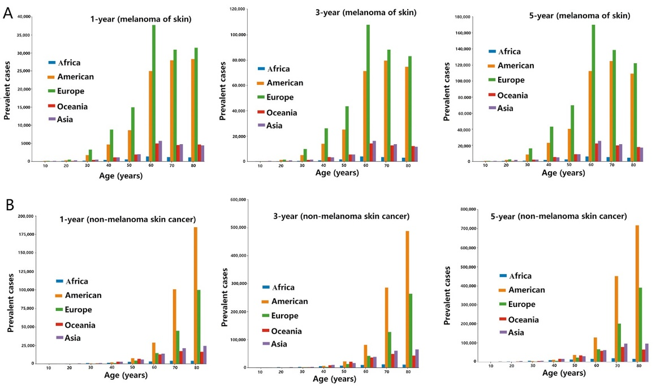
For non-melanoma skin cancer, the ASMR was the highest among countries with low HDI levels, reaching 1.30 per 100,000 people. While, the ASIR was the highest in the very high HDI levels, reaching 24.40 per 100,000 people. Countries with very high HDI levels had the highest ASIR (9.50) and ASMR (1.10) per 100,000 people for melanoma [Table 1]. For melanoma, the ASIR in countries with very high HDI levels was approximately 26 times greater and ASMR about 6 times greater than that in countries with medium HDI. For non-melanoma skin cancer, ASIR in countries with very high HDI levels was approximately 19 times that of countries with medium HDI, while the ASMR in countries with low HDI levels was approximately three times that as observed in countries with very high HDI levels. Countries with medium HDI had the lowest ASIR and ASMR for both skin cancers. Countries with very high HDI levels accounted for 85.58% of new melanoma cases and 66.46% of deaths, while countries with medium and low HDI levels accounted for 3.56% of new cases and 9.93% of deaths. For nonmelanoma skin cancers, countries with very high levels of HDI accounted for 84.56% of new cases and 34.34% of deaths, while countries with medium and low HDI levels accounted for 3.76% of new cases and 26.14% of deaths [Table 1]. Figure 2 contains a summary of results from the correlations performed between HDI and non-melanoma skin cancers and melanoma. The ASIR of non-melanoma skin cancers was positively correlated with HDI, with increases in ASIR being associated with increases in levels of HDI (r = 0.5083, P <0.0001). (1)
Obrázek 1 Prevalence of melanoma (A) and non-melanoma skin cancer (B) (1)

Bibliografie
1. Wang Mingyue, Gao Xinghua, Zhang Li. Recent global patterns in skin cancer incidence, mortality, and prevalence. Chenese medical Journal. 20. Leden 2025, stránky 185-192.

Seznam obrázků
Obrázek 1 Prevalence of melanoma (A) and non-melanoma skin cancer (B) 8

