2702242171 – Vanessa Santoso
Human Computer Interaction Lab
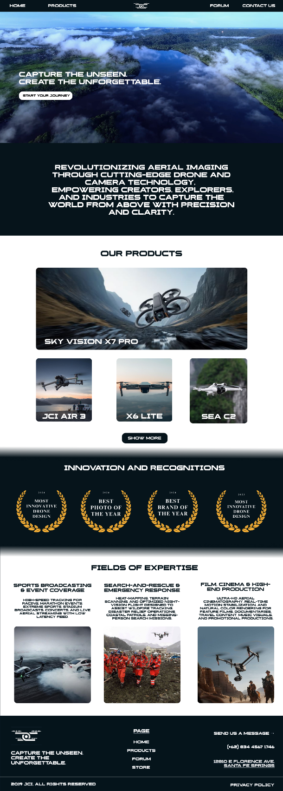
HOME PAGE
The landing page of JCI’s website features a navigation bar, company vision, a showcase of products, innovations and recognitions, fields of expertise, and a footer.
All images and videos are sourced from Pinterest and stock media, with a focus on drones as the main theme.
The navigation bar provides links to Home, Products, Forum, Contact Us, and displays the company logo.
The Products section highlights a selection of JCI’s offerings, while the Fields of Expertise section provides descriptions along with example images.
The page concludes with a footer containing the logo, tagline, and navigation links.

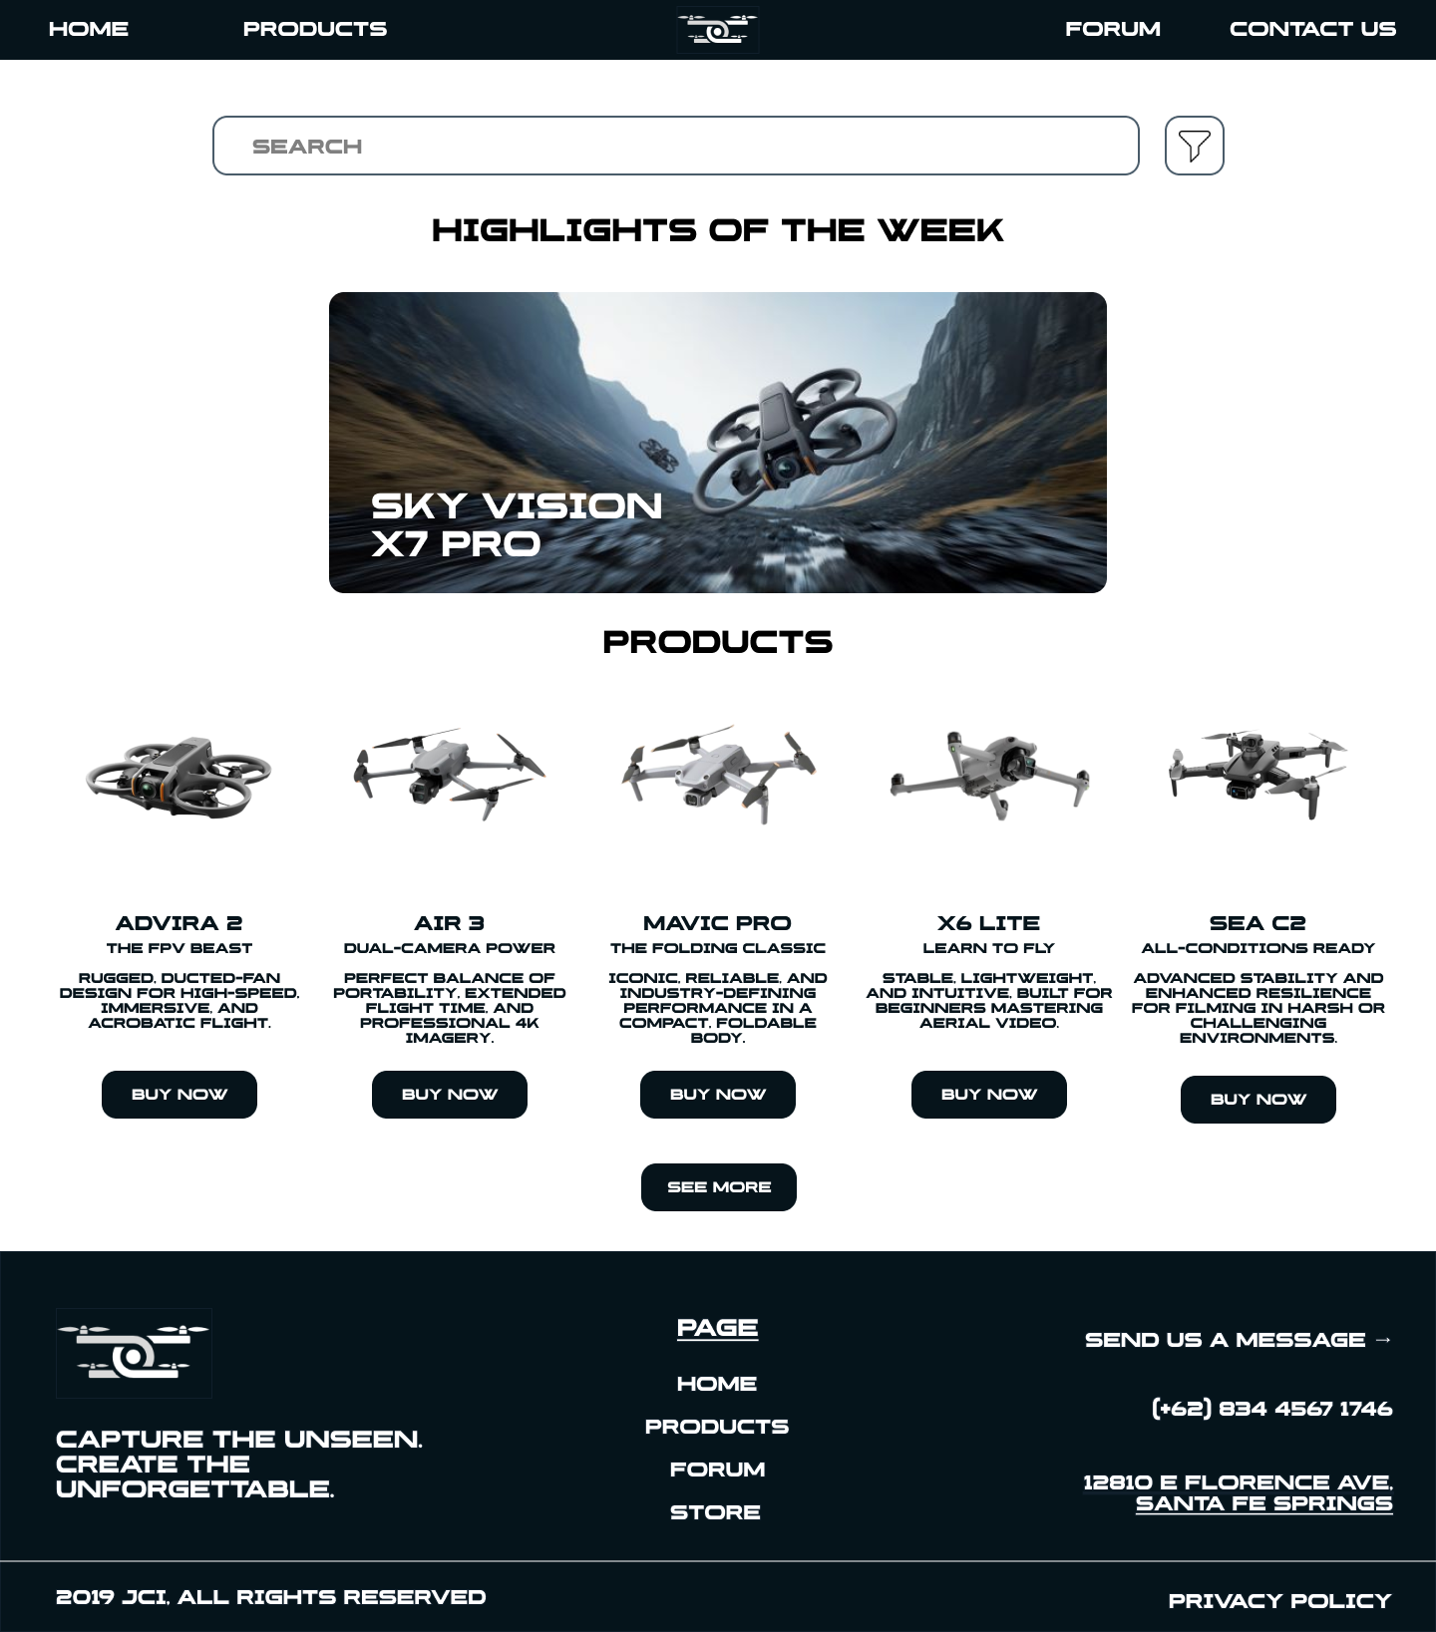
Products Page
This page include highlights of the week, where I include a carousel of three top-tier drone then followed by a brief look and description 5 of JCI’s products.
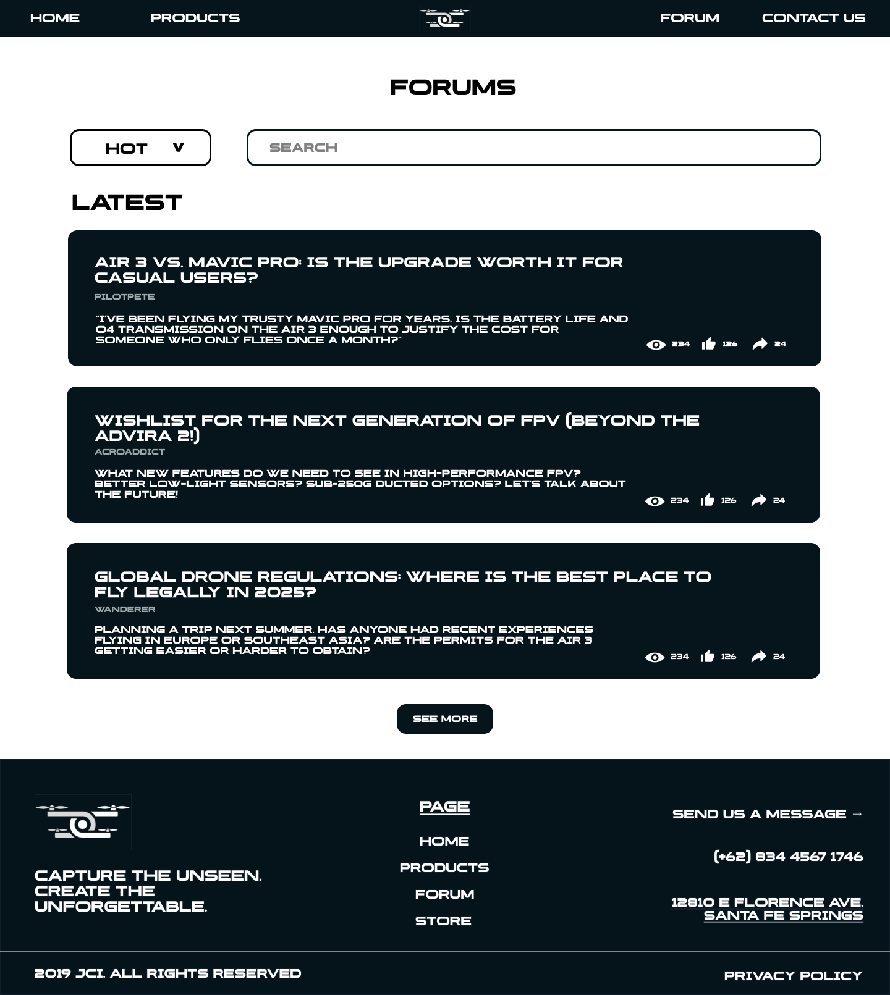
FORUM PAGE
This page includes a search bar as well as a dropdown link where you can choose the category of forum that you want. A container with dark background is filled with title, author, as well as a brief description. On the right, you can see the stats (view, likes, and shares) that the forum post have.
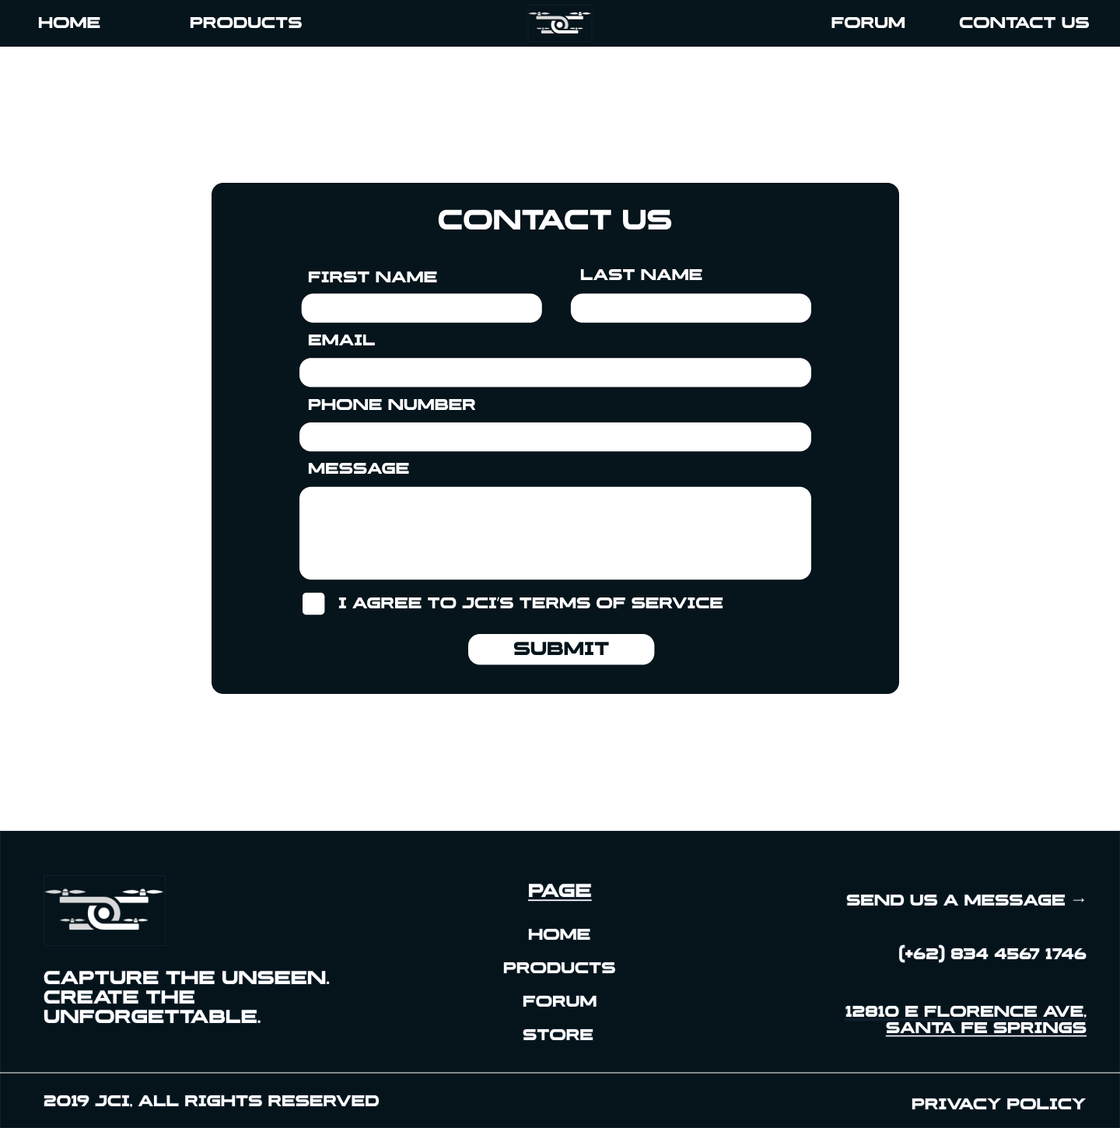
CONTACT US
A container where you can contact JCi’s headquarters by filling your personal information and the message you want to say. Users will be asked to agree to JCI’s terms of service so the data will not be misused. All the textbox has a validation on it to make sure that all the data is correct and the format is correct.
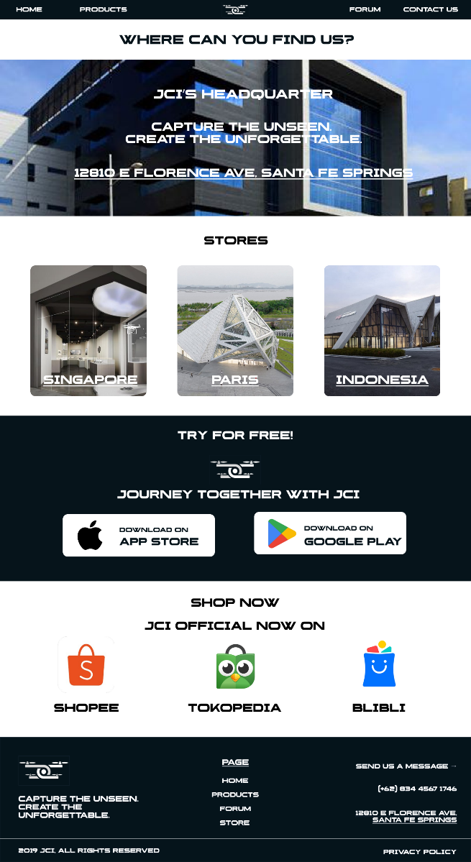
Store Page
This store page shows where the headquarters as well as the store – online of offline – that JCI has so that users can go to the stores themselves. The button for download can be clicked and users will be able to view where you can download it.

